Section 1: Ratio and Proportion

Lesson 2

1. Base = 1000, Part = 200, Rate = 20%
2. Base = 80, Part = 72, Rate = 90%
3. Base = 13700, Part = 2740, Rate = 20%
4. Base = 2000, Part = 500, Rate = 25%
5. Base = 40, Part = 60, Rate = 150%

11. A

12. D

Lesson 3

Lesson 3.1

1. 5
2. 180
3. 140
4. 95%
5. 25%

18. B

19. D

21. A

Lesson 3.2

1. $175
2. 280
3. 6.4
4. 200
5. 30

20. C

21. A

Lesson 6

1. 50%
2. 37.5%
3. 200%
4. 45%
5. 20%

14. C

15. B

Section 2: Algebraic expressions

Lesson 1.1

1. Y = x-7
2. Y = 3\*(x^2) + x
3. Y = 8\*x – 10
4. -3\*x – 2\*y
5. Y = (10/x) – 5
6. -8 + 7\*x = y
7. 16\*x + (x – 3y)
8. (x^2) + (x^4)
9. (X^2) + 4/7
10. 15 + (x ^ (1/2)) – 6

21. B

Lesson 1.2

1. (x^2) + 3\*x +2
2. 19y +13
3. -3x + 54
4. 6(x^3) + 31(x^2) + 4
5. 7y + 14

23. A

Lesson 3

1. Monomial
2. Monomial
3. Binomial
4. Trinomial
5. Binomial
6. Trinomial
7. Monomial
8. Monomial
9. Monomial
10. Binomial

16. 3x^4 is a 4th degree term, -2x^2 is a 2nd degree term, 3 is a constant term.

17. 12(a^2)bc is a 2nd degree term

18. 3g and -4h are both 1st degree terms

19. x^2 is a 2nd degree term, y is a 1st degree term

20. -4a is a 1st degree term, -3b^2 is a 2nd degree term, c is 1st degree term

21. 25 is a constant term

22. 4x^2 is a 2nd degree term, 3x is a 1st degree term, -7 is a constant term

23. 3x/8 is a 1st degree term

24. sqrt(25) is a constant term

31. B

32. -1

Lesson 4

1. Like
2. Like
3. Unlike
4. Unlike
5. Like
6. Unlike
7. Unlike
8. Like
9. Unlike
10. Unlike

Lesson 5

1. 5x + 6
2. 23y + 6
3. 8x^2 - 5x + 2
4. 15a^2 + 8a
5. 11x^2 + 2x +3

Lesson 6

1. 30x^2
2. 6xy^2
3. 28a(b^2)(c^2)
4. 12yz

9. 18xyz^2 + 12z^3

10. 42x^2 - 36xz

11. -15ab^2 + -55abc

12. (-18hf^3) + 24(f^4)g(h^2)

17. (x^2) – x – 30

18. (x^2) +2xy + (y^2)

25. A

Lesson 7

1. Y +15
2. X + 3
3. X + 5
4. A + B
5. (x^2) + 2\*x

13. 6x +2

14. 5x +3

15. 8y + 2

16. 6y + 7

17. 2y + 2

Section 3: Functions

Lesson 1

1. X = 9
2. M = 28
3. -1 = y
4. X = -64
5. A = 125
6. Y = -13
7. X = 27
8. C = 7
9. X = -4
10. B = -7

Lesson 1.2

1. X = 50
2. Y = -2
3. M = 2
4. X = -4
5. Y = 6

Lesson 2

1. 1800
2. D = 10, Q = 14
3. 24
4. 53.75
5. 8

Lesson 3

1. C
2. C
3. C
4. B
5. D

Lesson 4

1. (-4,5)
2. (3,6)
3. (0,3)
4. (6,-7)
5. (-5,0)
6. (-6,-4)
7. (2,0)
8. (7,-2)

Lesson 5

1. 2, 3, 4

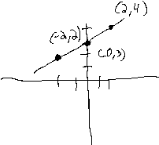

1. 2, -1, -4

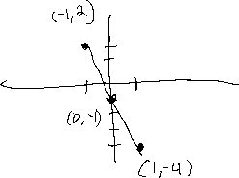

1. 1, 0, -1

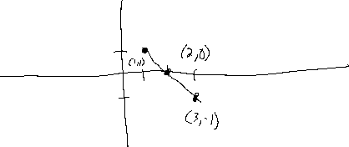

1. 3, 1, -1

