**Counter_mod**

library IEEE;

use IEEE.STD_LOGIC_1164.ALL;

use IEEE.NUMERIC_STD.ALL;

use IEEE.std_logic_unsigned.all;

entity counter_mod is

generic(modu : positive := 3);

Port ( clk : in STD_LOGIC;

reset : in STD_LOGIC;

m : in STD_LOGIC_VECTOR (modu downto 0);

q : out STD_LOGIC_VECTOR (modu downto 0));

end counter_mod;

architecture Behavioral of counter_mod is

signal next_state, output : std_logic_vector(modu downto 0) := x"0";

begin

process(clk, reset, m)

begin

if(rising_edge(clk)) then

if(reset = '1') then

output <= x"0";

next_state <= x"1";

elsif(next_state = m-1) then

output <= next_state;

next_state <= x"0";

else

output <= next_state;

next_state <= next_state + x"1";

end if;

end if;

end process;

q <= output;

end Behavioral;

**Counter_mod_tb**

library IEEE;

use IEEE.STD_LOGIC_1164.ALL;

use IEEE.NUMERIC_STD.ALL;

use IEEE.std_logic_unsigned.all;

use work.all;

entity counter_tb is

end counter_tb;

architecture Behavioral of counter_tb is

signal clk_tb, r : std_logic;

signal max, q_tb : std_logic_vector(3 downto 0);

begin

p0 : entity work.counter_mod(behavioral) port map (clk_tb, r, max, q_tb);

process

begin

wait for 25ns;

max <= "1100";

r <= '0';

clk_tb <= '0';

wait for 25ns;

clk_tb <= '1';

end process;

end Behavioral;

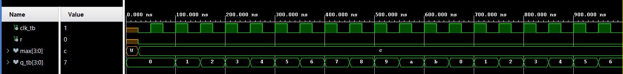

**Counter simulation**

**Counter_with_floor**

library IEEE;

use IEEE.STD_LOGIC_1164.ALL;

use IEEE.NUMERIC_STD.ALL;

use IEEE.std_logic_unsigned.all;

entity counter_with_floor is

generic(modu : positive := 3);

Port ( clk : in STD_LOGIC;

reset : in STD_LOGIC;

m : in STD_LOGIC_VECTOR (modu downto 0);

n : in STD_LOGIC_VECTOR (modu downto 0);

q : out STD_LOGIC_VECTOR (modu downto 0));

end counter_with_floor;

architecture Behavioral of counter_with_floor is

signal next_state, output : std_logic_vector(modu downto 0) := x"0";

begin

process(clk, reset, m, n)

begin

if(rising_edge(clk)) then

if(reset = '1') then

output <= n;

next_state <= n + 1;

elsif(next_state = m-1) then

output <= next_state;

next_state <= n;

elsif(next_state = x"0") then

output <= n;

next_state <= n + 1;

else

output <= next_state;

next_state <= next_state + x"1";

end if;

end if;

end process;

q <= output;

end Behavioral;

**Counter_with_floor_tb**

library IEEE;

use IEEE.STD_LOGIC_1164.ALL;

use IEEE.NUMERIC_STD.ALL;

use IEEE.std_logic_unsigned.all;

use work.all;

entity counter_with_floor_tb is

end counter_with_floor_tb;

architecture Behavioral of counter_with_floor_tb is

signal clk_tb, r : std_logic;

signal max, min, q_tb : std_logic_vector(3 downto 0);

begin

p1 : entity work.counter_with_floor(behavioral) port map (clk_tb, r, max, min, q_tb);

process

begin

wait for 25ns;

max <= "1100";

min <= "0110";

r <= '0';

clk_tb <= '0';

wait for 25ns;

clk_tb <= '1';

end process;

end Behavioral;

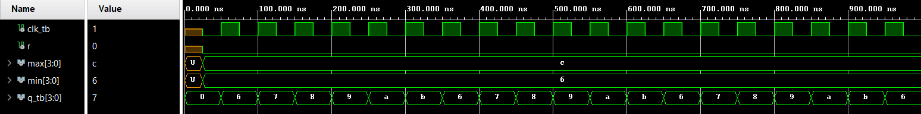

**Floored Counter Simulation**