Linnaeus University

|  |
| --- |
| Software Project |
| Hangman |
|  |
| **Christoffer Lundström** |
| **28/01-2019** |

Software Technology – IDV600

Teachers: Tobias Andersson Gidlund

Daniel Toll

Tobias Olsson



Contents

1. **Revision** **History………………………………………………………………………………………………………………………….3**
2. **General** **Information……………………………………………………………………………………………………………………4**
3. **Vision………………………………………………………………………………………………………………………………………….5**
4. **Project** **Plan**
   1. Introduction…………………………………………………………………………………………………………………………….6
   2. Justification……………………………………………………………………………………………………………………………..6
   3. Stakeholders**………………………………………………………………………………………………………………………..6**
   4. Resources**…………………………………………………………………………………………………………………………….6**
   5. Hard- and Software Requirements**………………………………………………………………………………………..6**
   6. Overall project schedule…………………**…………………………………………………………………………………….7**
   7. Scope, Constraints and Assumptions………………………………………………………………………………………8
   8. Reflection……………………………………………………………………………………………………………………………….8
5. **Iterations**
   1. Iteration 1**……………………………………………………………………………………………………………………………9**
   2. Iteration 2**……………………………………………………………………………………………………………………………9**
   3. Iteration 3**…………………………………………………………………………………………………………………………10**
   4. Iteration 4**…………………………………………………………………………………………………………………………10**
6. **Risk Analysis**
   1. List of risks**………………………………………………………………………………………………………………………….11**
   2. Strategies**…………………………………………………………………………………………………………………………..11**
7. **Time log…………………………………………………………………………………………………………………………………...10**
8. | Revision History

|  |  |  |  |
| --- | --- | --- | --- |
| Date | Version | Description | Author |
| 050219 | 0.1.1a | First iteration, planning and structure. | C.L |
|  |  |  |  |
|  |  |  |  |
|  |  |  |  |

1. | General Information

|  |  |
| --- | --- |
| **Project Summary** | |
| Project Name | Project ID |
| Hangman | V 0.1.1a |
| Project Manager | Main Client |
| Christoffer Lundström | IDV600 @ LNU |
| Key Stakeholders | |
| The product owner will be the sole stakeholder of this product. | |
| Executive Summary | |
| Current requirements of the course IDV600 at Linnaeus University include a new open source Hangman game single-handedly developed and organized by specified project manager.  The project will exclusively involve software development through an iterative software process and the goal is to design and implement a rudimentary console-based UI and basic game logic to meet the demand.  Estimations suggest that the project will be completed and unit tested by March 2019 prior to its due date currently *t.b.d. | |

1. | Vision

The vision of this project include creating a text-based game of Hangman. This will be a simple but stable game with basic functionality such as *play*, *highscore* and *exit*. It will be written in Java to ensure platform independence and to possibly reach a broader audience.

**User Interface**

Each respective category will be enumerated and be navigated through by an easily comprehensible user interaction. Each UI element will in turn lead to its designated target logic.

*Play* will initiate a round of Hangman by first prompting the user for a name and a difficulty. Preferably constrained to 20 characters or so for formatting. After a name has been entered a player object will be created and a Scene object will be loaded from the game directory.

*Highscore* will lead to a list of the top ranking players and the score will be determined by an algorithm.

**Game Logic**

After the Scene is set up a blank field will be generated of the same size as a randomly fetched word from a dictionary and a first round is ready to begin. A user will be asked to guess a character.

Should the character be wrong the next *Scene* of hangman will be rendered. If the man is eventually hanged the correct word and the amount of guesses will be printed to console.

**Scenes & I/O**

The idea is to have Scenes drawn in standard ANSI or UTF-8 format and saved to a text-file. They will represent the progression of the Hangman scenes of events, much like frames in a movie. They will be loaded to memory and printed onto the console window.

**Reflection**

To ensure that the management, dev-team are working towards the same end goal it is essential to reflect upon these ideas and share the same vision.

This not only creates a foundation for the software process but also facilitates efficiency and in extension longevity and quality of the end product. Having a clear and concise vision arguably, is a form of risk minimization strategy which will not only mitigate confusion, but also establish faith in the product and management.

1. | Project Plan
   1. Introduction

This is the project plan for the console based game Hangman. The project will be written in Java SE 11 using IntelliJ 2.0 and GitHub for version control.

The project will start off with the creation of this project plan as a first iteration out of four, following an agile task based method.

* 1. Justiﬁcation

This product will be produced by demand of the course Software Technology IDV600 of Linnaeus University.

* 1. Stakeholders

Stakeholders in this project will be management (Christoffer Lundström) and end users of IDV600 at Linnaeus University.

* 1. Resources

Resources consist of a sole project worker and an IDE. In this case IntelliJ 2.0 community edition with JDK SE 11 will be utilized.

* 1. Hard- and Software Requirements

Software requirements in this project is Java Virtual Machine version 11 or later and a computer compatible with JVM and IntelliJ 2.0.

* 1. 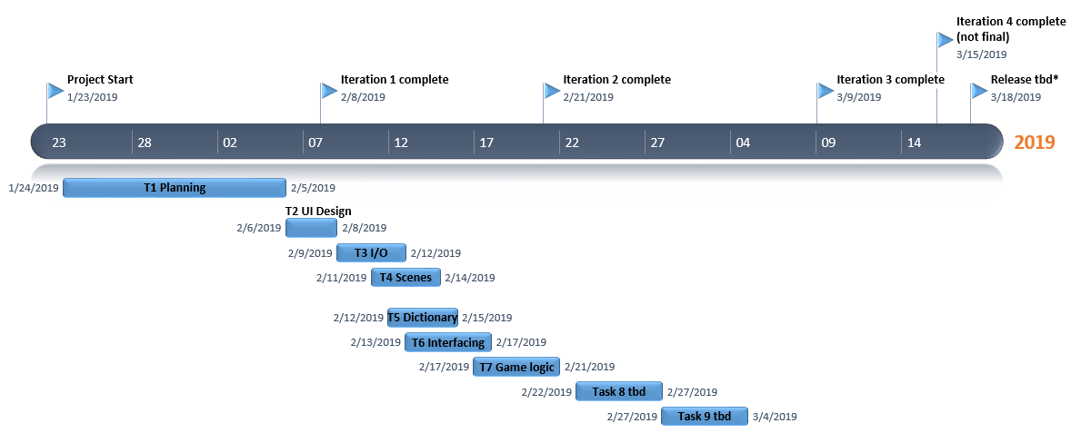Overall Project Schedule

Deadlines:

**Iteration 1** **- v0.1.1a – 8th of February**

Complete project scheduling and basic UI implementation.

**Iteration 2, v0.1.2a – 21th of February**

Complete I/O file operations.

Create scenes for Hangman.

Provide a dictionary.

Design interfaces between the software components.

Design and implementation of game logic.

**Iteration 3, v0.1.3a - 9th of March**

Extra *Highscore* functionality added.

Unit tests complete.

**Iteration 4, v0.1.4a - to be determined.**

Ready for beta testing and release.

* 1. Scope, Constraints and Assumptions

The scope of this project will be within the limits of the strict deadlines. This will be the most constraining factor to the scale of the project. Another one is staff resource and budget.

Assuming the project only require a single threaded application with basic knowledge of Java the scope will perfectly within reach.

* 1. Reflection

During this scheduling phase I found it particularly difficult estimating the time each task will take. A lot of them are pure guesses based on own coding speed.

Even though these guesses might be off target they provide a foundation and structure which seem easy to comprehend. Dividing the project into tasks seems less overwhelming than starting from nowhere. The importance of these plans must be substantial in a larger scoped projects.

Creating the project schedule and reviewing it draws me to make a parallel with my recent construction work where the same type of schedules are used for dividing tasks to sub-contractors in large enterprises.

5. | Iterations

* 1. Iteration 1

Summary: The goal of the first iteration is to complete Task 1 and 2 and have the basic structure for the game designed and implemented.

**Total time estimated: 25h.**

**Task 1:**

The first task will be to do some research regarding the general concept of Hangman, finding influences and inspiration. Which will be followed by analysing the requirements and writing a project plan, breaking down each requirement to a task.

GitHub repository will be set up and provided for version control. Will also include creation a basic game directory structure where assets will be divided into respective category together with a simple markdown readme.

**Estimated time: 20h.**

**Task 2**:

Rudimentary console design. Will provide basic functionality and type-safety for the application. Implementation of console-based menu using numbers to walk through menus and sub-menus.

**Estimated time: 5h.**

* 1. Iteration 2

Summary: The goal of the second iteration is to have a bare minimum functional game.

**Total time estimated: 25h**

**Task 3**:

Design and implement the necessary I/O and read-functions which will load each frame from file, will later be used when implementing highscore (T8).

**Estimated time: 8h.**

**Task 4**:

Draw each *scene* of *Hangman* in separate read-only text-files. This will be done in notepad or notepad++.

**Estimated time: 2h.**

**Task 5**: Implementing and integration of a list of words which will be used in later tasks. Words will be saved in notepad and encoded in UTF-8 or ANSI using notepad++. All values should be separated by semi-colons in the format “comma-separated value” .csv.

**Estimated time: 2h**

**Task 6**: Designing and implementation of the interface between game scenes and menus using the read functions written in Task 4.

**Estimated time: 5h**

**Task 7:** Design and implement game logic. Will include designing the interaction between the user and the Scenes.

**Estimated time: 8h**

* 1. Iteration 3

Summary: By the end of this iteration the application should be functional and bug-tested. Should time allow this is the iteration for additional implementations.

**Total time estimated: 14h**

**Task 8**: Implementation of a basic *Highscore* list. It will provide a top 10 list of players sorted by score. Score will in turn be defined by the number of victories by a player.

**Estimated time: 4h**

**Task 9**: Unit testing and fine tuning.

**Estimated time: 10h**

* 1. Iteration 4

Summary: The goal is for all tasks to be completed and the game should be unit tested and ready for release by the end of this iteration.

6. | Risk Analysis

* 1. List of risks

|  |  |  |  |
| --- | --- | --- | --- |
| **Risks** | **Affect** | **Probability** | **Effects** |
| Sudden hardware failure | Project | Low | Low |
| Staff illness | Project | Low | Catastrophic |
| Changes to software requirements | Project | High | Moderate |
| Wrong time estimations | Project | High | Moderate |
| Training of staff need for new requirements | Project | Moderate | Moderate |
| Entire software remodelling | Project | Low | Catastrophic |
| Misestimating scope and size of project | Project | Medium | Moderate |
| Organizational restructure | Project | Negligible | Low |
| Relocation of Linnaeus university. | Client | In Effect | Low |

* 1. Strategies

As a first step in risk avoidance all work is saved on cloud based Google One (formerly known as Drive). Both the Java repositories and project plans. Google One is in turn synced to a work laptop and a stationary PC. This should render the risk of losing all work through a hardware crash extremely unlikely.

Sudden staff illness is always a huge risk for tiny projects, especially for a one man project like this. Should this happen, the project may or may not fail completely, all depending on the situation. In a real work scenario the damage caused by said event might be minimized by changing shifts or personnel.

Other risks as such as changes to the software requirements or wrong time-estimations are extremely likely due to the fact that this is a learning exercise and the effects of these changes could delay the project substantially.

To minimize the effects of changing software requirements the project has been chosen to be simple, agile and loosely coupled. Misestimating time is almost inevitable given the lack of software planning experience and changing course material.

Currently the client Linnaeus University is relocating. This might have an impact on the client and in extension the project albeit minimal, since most of the technology faculty is already up and running as regular.

**Contingency & Monitoring**

Following the project and re-evaluating the risks and time required of each iteration might decrease the likelihood of project failure. This will be done each iteration.

Should there be a catastrophic failure due to staff illness or the need to remodel the entire project there are extended second chance deadlines to aim for.

**Reflection**

The importance of proper risk analysis should not be underestimated. Depending on the business, project and product the funds, integrity or even safety of customers and clients might be compromised by failure in this software process.

Furthermore the risk minimization strategies will reduce the already calculated risks and hopefully provide security and stability for the project and its affiliates. Should the risk factor still occur there ought to be thorough contingency plans ready to deploy.

Given the simulative nature and scope of this project, this might be the only exception to the rule.

1. | Time log

Below is a time log spanning the time estimated and taken to complete each task.

|  |  |  |  |  |
| --- | --- | --- | --- | --- |
| **Date** | **Task** | **Estimated** | **Actual** | **Diff +/-** |
| 280119 | Task 1: Fill in basics of project template | 1h | 1h | 0 |
| 290119 | Task 1: Game idea research | 1h | 1h | 0 |
| 300119 | Task 1: Setting up GitHub repository | 1h | 0.5h | -0.5 |
| 310119 | Task 1: Sketch game logic design | 2h | 1h | -1 |
| 020219 | Rewrite project template | 2h | 2h | 0 |
| 040219 | Task 1: Project summary & vision | 2h | 4h | +2 |
| 050219 | Task 1: Project plan & iterations | 4h | 6h | +2 |
| 060219 | Task 1: Risk analysis | 3h | 5h | +2 |
| 070219 | Task 1: Risk analysis cont. | 2h | 1h | -1 |
| 070219 | Task 2: Implement basic UI | 2h | 1h | -1 |
| >>>>>>>>>> | **Iteration 1** | 20h | 22 | +2 |
|  |  |  |  |  |