Muhammad Talha
K25-7605 MS-AI
Assignment 3
Image Colorization using Regression, Classification and UNet
Note: Implementation and results are based on self-implementation and experimentation. The complete notebook is attached with the submission.

Colorization as Regression
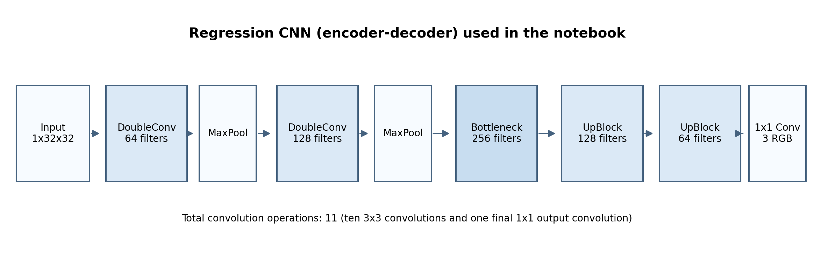
Figure 2. Regression CNN architecture.
The model has 11 convolution operations in total. Ten are 3×3 convolutions and the final layer is a 1×1 convolution that outputs 3 RGB channels.
Layer | Channels | Kernel
enc1 conv1 | 1 → 64 | 3×3
enc1 conv2 | 64 → 64 | 3×3
enc2 conv1 | 64 → 128 | 3×3
enc2 conv2 | 128 → 128 | 3×3
bottleneck conv1 | 128 → 256 | 3×3
bottleneck conv2 | 256 → 256 | 3×3
up1 conv1 | 256 → 128 | 3×3
up1 conv2 | 128 → 128 | 3×3
up2 conv1 | 128 → 64 | 3×3
up2 conv2 | 64 → 64 | 3×3
output conv | 64 → 3 | 1×1

The model was trained for 5, 10 and 20 epochs. The results show that training for more epochs improved the model overall.
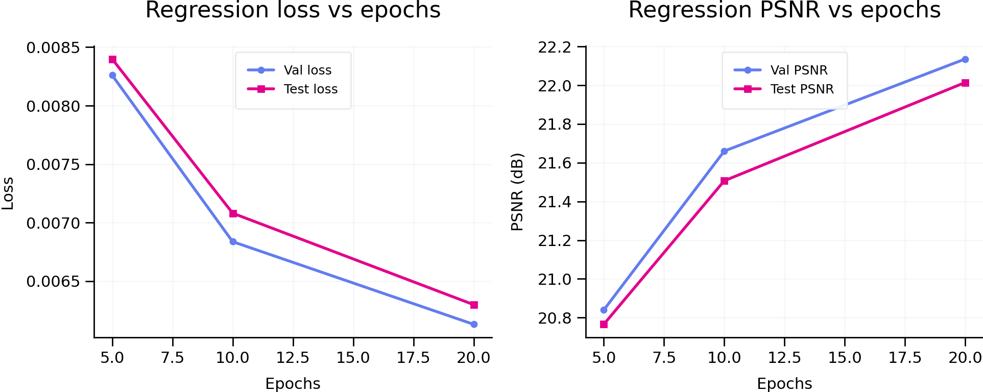
Figure 3. Regression results from the uploaded logs.
- 5 epochs: validation loss = 0.00826, validation PSNR = 20.84 dB; test loss = 0.00840, test PSNR = 20.77 dB.
- 10 epochs: validation loss = 0.00684, validation PSNR = 21.66 dB; test loss = 0.00708, test PSNR = 21.51 dB.
- 20 epochs: validation loss = 0.00613, validation PSNR = 22.14 dB; test loss = 0.00630, test PSNR = 22.01 dB.
The 20-epoch model performed best out of the three runs, so longer training helped the regression model in this experiment.

Colorization as Classification
The best validation loss for this model was 1.57034 at epoch 15, the best validation accuracy was 41.88% at epoch 15, and the best validation RGB-MSE was 0.00775 at epoch 16.
- Classification loss converges more slowly than regression.
- Accuracy improves steadily but plateaus earlier.
- Regression produces natural but desaturated images.
- Classification produces stronger colors but with visible binning artifacts.
- Classification did not consistently outperform regression in validation loss but showed improved perceptual contrast in some cases.
A fair point is that the regression loss and the classification loss are not the same type of objective, so their raw loss values should not be compared directly. Accuracy only makes sense for the classification-style models.

UNet with skip connections
The best validation loss was 1.05702 at epoch 18, the best validation accuracy was 58.35% at epoch 18, and the best validation RGB-MSE was 0.00510 at epoch 12.
So yes, the skip connections improved the validation results inside the same classification setup. The UNet model achieved better validation loss, better validation accuracy, and better RGB-MSE than the plain classification CNN.
- Lower validation loss compared to plain classification CNN.
- Faster convergence and smoother training
- Sharper object boundaries (horse legs, mane).
- Better color consistency across spatial regions.
- Reduced checkerboard and quantization artifacts.
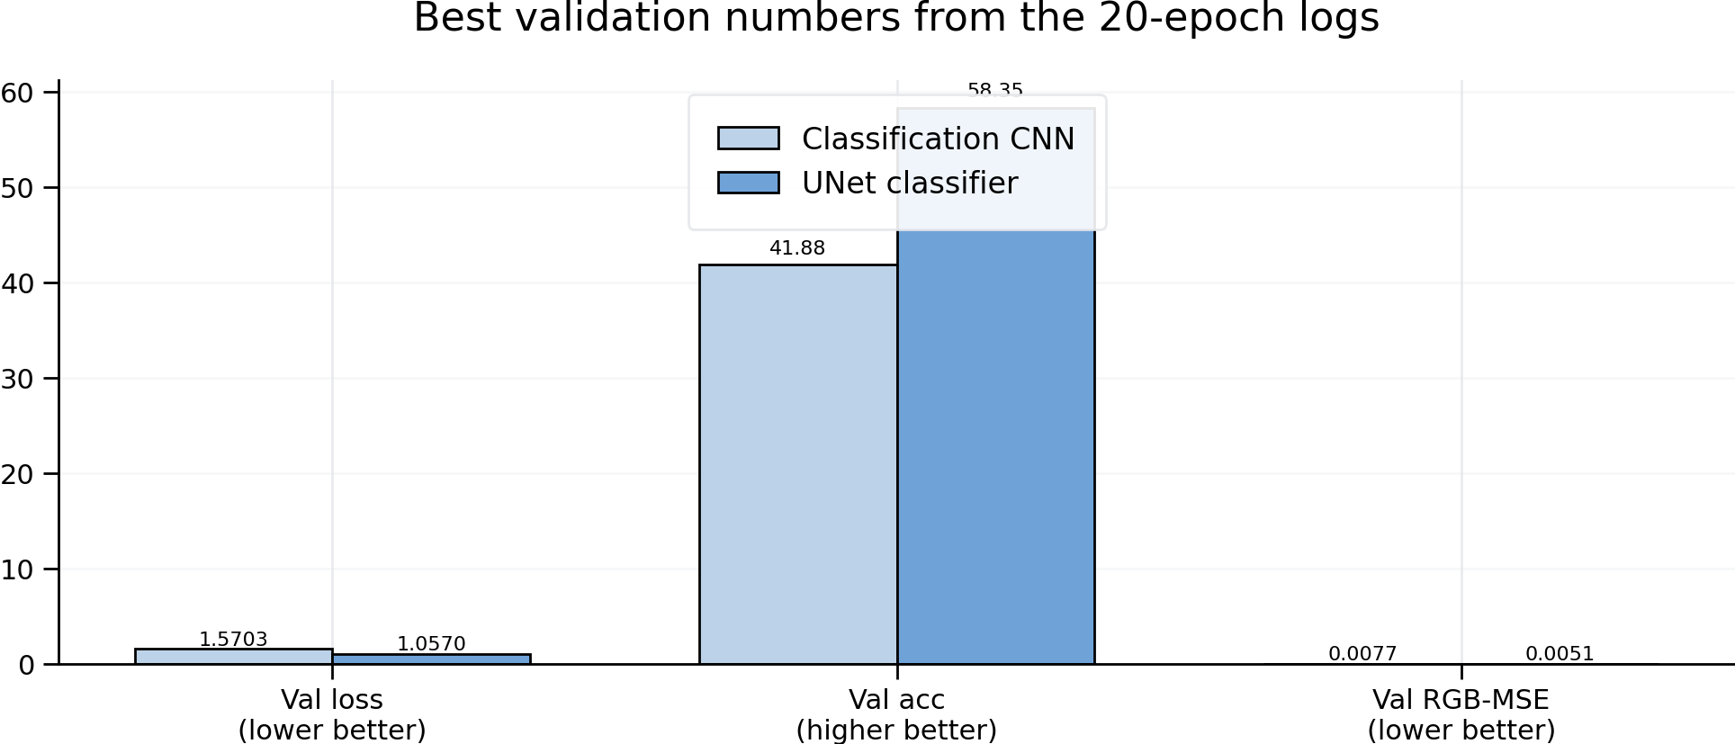
Figure 4. Plain classification CNN vs UNet classifier (best validation values from the logs).
- Skip connections keep high-resolution information that might be lost after pooling.
- They also make training easier because gradients can move through the network more effectively.
- They help the decoder combine global context with local detail.

5. Activations
The early CNN layers would mainly pick up simple things such as edges and small texture patterns, while deeper layers would focus more on larger structures and image context.
- Early layers: Edge detectors, gradients, simple textures.
- Mid layers: Shape fragments (horse body parts).
- Deep layers: Abstract semantic regions (object-level grouping
Spatial resolution decreases with depth, while feature abstraction increases.

In the UNet, the skip connections should make those later features more spatially precise because earlier high-resolution information is added back into the decoder.
- UNet retains high-frequency details at later stages.
- Activations are spatially aligned with input due to skipping connections.
- CNN-only model loses fine details after pooling.
UNet activations show stronger localization and semantic coherence.
Improving Evaluation Beyond Pixel-Level Loss:
Pixel-wise MSE / Cross-Entropy poorly correlate with human perception.
Better alternatives:
- Perceptual loss (VGG feature-space loss).
- SSIM / MS-SSIM for structural similarity.
- Human preference studies or pairwise ranking.
Colorizing Images Larger than 32×32:
The trained models can handle larger images because:
- They are fully convolutional (no fully connected layers).
- Convolutions slide over arbitrary spatial dimensions.
Adaptation steps:
- Resize input grayscale image to desired size.
- Forward pass through the same network.
- Output scales accordingly without retraining.
This allows inference on high-resolution images despite training on 32×32 CIFAR-10 data.

