Carlos Medina 9/18/17

IT 202-003 FALL 2017

PROTOYPE 1

Define A

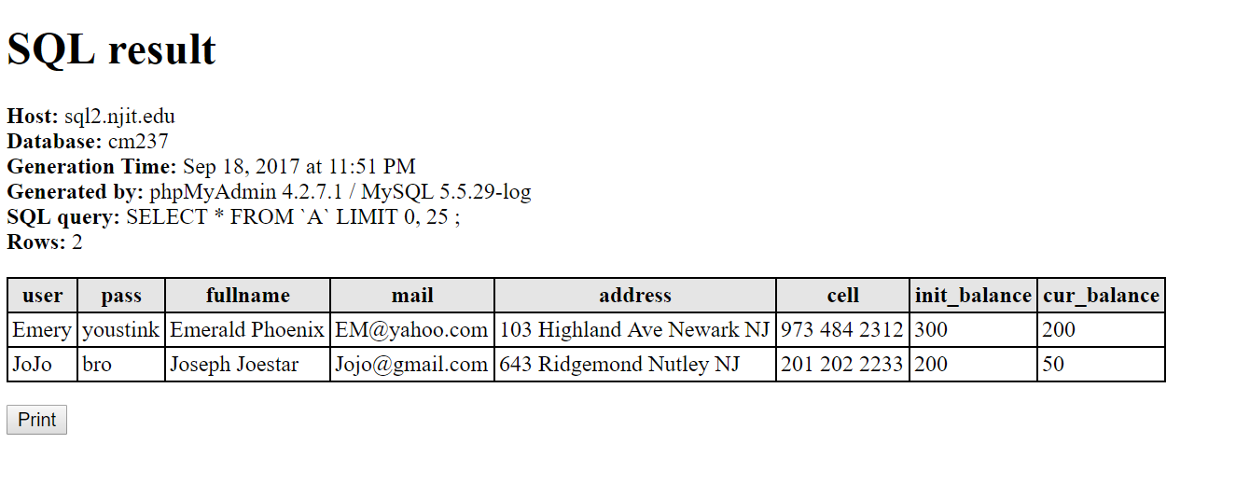Define T

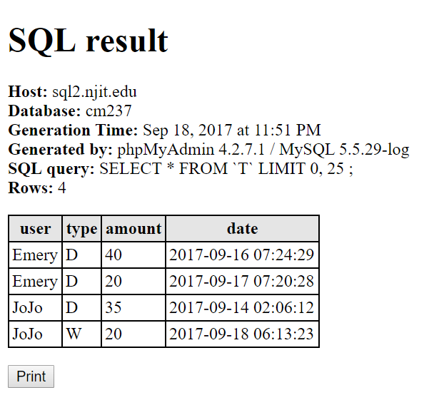

**Populate A**

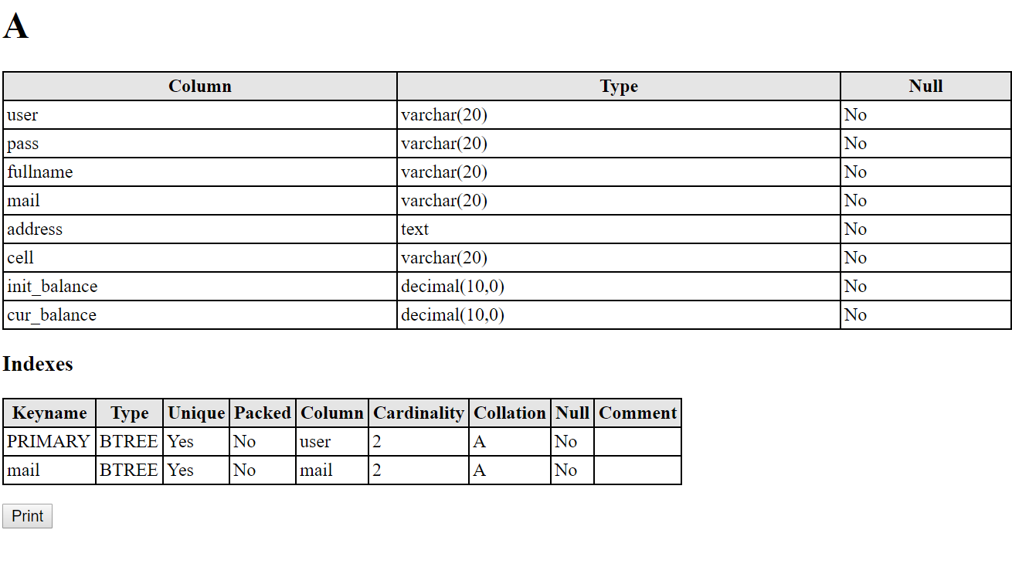

**Populate T**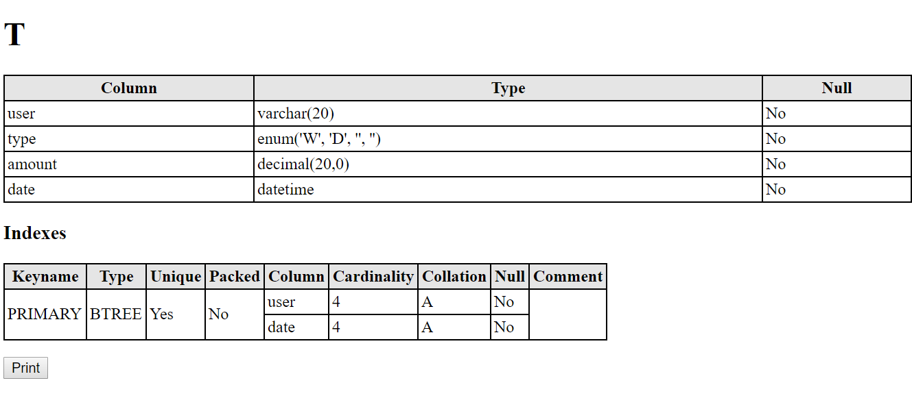

**Using Command Line to interface with your MySQL database.**

**Database changed**

MySQL [cm237]> describe A;

+--------------+---------------+------+-----+---------+-------+

| Field | Type | Null | Key | Default | Extra |

+--------------+---------------+------+-----+---------+-------+

| user | varchar(20) | NO | PRI | NULL | |

| pass | varchar(20) | NO | | NULL | |

| fullname | varchar(20) | NO | | NULL | |

| mail | varchar(20) | NO | UNI | NULL | |

| address | text | NO | | NULL | |

| cell | varchar(20) | NO | | NULL | |

| init_balance | decimal(10,0) | NO | | NULL | |

| cur_balance | decimal(10,0) | NO | | NULL | |

+--------------+---------------+------+-----+---------+-------+

**8 rows in set (0.00 sec)**

MySQL [cm237]> select * from A;

+-------+----------+-----------------+----------------+----------------------------+--------------+--------------+-------------+

| user | pass | fullname | mail | address | cell | init_balance | cur_balance |

+-------+----------+-----------------+----------------+----------------------------+--------------+--------------+-------------+

| Emery | youstink | Emerald Phoenix | EM@yahoo.com | 103 Highland Ave Newark NJ | 973 484 2312 | 300 | 200 |

| JoJo | bro | Joseph Joestar | Jojo@gmail.com | 643 Ridgemond Nutley NJ | 201 202 2233 | 200 | 50 |

+-------+----------+-----------------+----------------+----------------------------+--------------+--------------+-------------+

**2 rows in set (0.01 sec)**

MySQL [cm237]> describe T;

+--------+---------------------+------+-----+---------+-------+

| Field | Type | Null | Key | Default | Extra |

+--------+---------------------+------+-----+---------+-------+

| user | varchar(20) | NO | PRI | NULL | |

| type | enum('W','D','','') | NO | | NULL | |

| amount | decimal(20,0) | NO | | NULL | |

| date | datetime | NO | PRI | NULL | |

+--------+---------------------+------+-----+---------+-------+

**4 rows in set (0.00 sec)**

MySQL [cm237]> select * from T;

+-------+------+--------+---------------------+

| user | type | amount | date |

+-------+------+--------+---------------------+

| Emery | D | 40 | 2017-09-16 07:24:29 |

| Emery | D | 20 | 2017-09-17 07:20:28 |

| JoJo | D | 35 | 2017-09-14 02:06:12 |

| JoJo | W | 20 | 2017-09-18 06:13:23 |

+-------+------+--------+---------------------+

**4 rows in set (0.00 sec)**

MySQL [cm237]>