Steps to Setup and Run the Trip-Based Model (beginning with c22q2)

# Tips and Troubleshooting

* **Instructions on installing the new trip-based model on a server** – use [these instructions](https://cmapil.sharepoint.com/:w:/r/sites/CMAPTrip-BasedModelUpdateFY21/_layouts/15/Doc.aspx?sourcedoc=%7B252C6998-47E6-45E3-804A-AA066238E381%7D&file=FY22%20Trip-Based%20Model%20Installation%20instructions.docx&action=default&mobileredirect=true) until the CMAP repo is set up.
* **Using Emme for the first time on a specific server** – open Emme and accept the software user agreement.
* **Using Emme for the first time after a new version has been installed** – open Emme and accept the software user agreement.
* **The command prompt abruptly closes after submitting trip_gen.bat or Submit_Full_Regional_Model.bat** – Delete the “env” folder in Database and resubmit.
* **The command prompt states that emme is not recognized** – Set the Windows environment variable using [these instructions](http://wiki.cmap.local/mediawiki/index.php/Fixing_Emme_path_in_Windows_environment_variables).

# ON TO 2050 Plan Update Scenarios

|  |  |  |
| --- | --- | --- |
| **Scenario number** | **Analysis year** |  |
| 100 | 2019 |  |
| 200 | 2025 |  |
| 300 | 2030 |  |
| 400 | 2035 |  |
| 500 | 2040 |  |
| 600 | 2045 | *Used for UrbanSim but not Conformity analyses* |
| 700 | 2050 |  |

# **Setting up the Trip Generation model**

## **Input files and settings**

* 1. **UrbanSim files (..\Database\tg\UrbanSim_inputs)**

All appropriate UrbanSim files for the scenario must be stored in the folder (no other files should be present). The set of files should have the same scenario year and UrbanSim run number. File labels may differ from those shown below but each of the seven files must be present and contain one of the key words in the file name:

* buildings – the seven-county building file (used for heavy commercial vehicle trip allocation)
* hhtm, xhhtm – household files for the seven-county area and the external modeling area
* persons, xpersons – person files for the seven-county area and the external modeling area
* subzonetm, xsubzonetm – subzone files for the seven-county area and the external modeling area

* 1. **Heavy commercial vehicle allocation files (..\Database\data)**

These files are required to develop the heavy commercial vehicle trip allocation weights.

* hcv_building_naics_corresp.csv – correspondence between building type and NAICS industry.
* hcv_intermodal.csv – estimate of 2018 truck trips for intermodal facilities in the region, which would not be reflected by relying on truck trips by building type from UrbanSim.
* hcv_sqft_per_job.csv – average square feet per job (by building type) used to inform UrbanSim.
* hcv_tg_rates.txt – heavy truck trip generation rates (per 1,000 SQFT of space by building type) from NCHRP 298, which uses Quick Response Freight Manual rates.
  1. **UrbanSim data processing scripts (..\Database\tg\scripts)**

Two scripts are required to process the UrbanSim files into data usable by the trip generation model:

* urbansim_hcv_allocation.py – creates the heavy truck trip allocations weights, written to ..Database\data\mo20.txt.
* urbansim_update_tg_input_files.py – creates ATTR_IN.TXT, HH_IN.TXT and POPSYN_HH.CSV from the trip generation model. It also creates files of synthetic households and persons for the work from home allocation model.
  1. **Airport and school files (..\Database\tg\fortran)**

Ensure scenario-appropriate versions of these files are in place:

* Airport_sz.csv – identifies airport subzones (future scenarios include the South Suburban Airport).
* School_in.csv – lists subzone level school enrollment (high school and college combined).
  1. **Work from home allocation model**

This model identifies specific synthetic households that include at least one worker who works from home on the simulated day. The work from home allocation model is controlled by two rates: the overall share of workers who usually work from home (*usualwfhpct*) and the overall share of workers who work remotely 1-4 days per week (*tc14pct*). These rates must be set in **trip_gen.bat** before submitting it.

The *usualwfhpct* and *tc14pct* values vary by scenario.

|  |  |  |  |  |  |  |  |
| --- | --- | --- | --- | --- | --- | --- | --- |
|  | **2019** | **2025** | **2030** | **2035** | **2040** | **2045** | **2050** |
| usualwfhpct | 0.0510* | 0.0869 | 0.0875 | 0.0880 | 0.0884 | 0.0884 | 0.0882 |
| tc14pct | 0.1031 | 0.1257 | 0.1263 | 0.1270 | 0.1273 | 0.1272 | 0.1269 |

* Uses ACS rate rather than My Daily Travel.

The appropriate industry mix file (*indusmix.csv*) for the scenario must be copied into the wfhmodule folder. This file lists the *usualwfhpct* and *tc14pct* values for each industry.

* 1. **Growth rates**

The growth factors in the following scripts must reflect simple 1% growth per year from a 2000 base year. So the growth factor for a 2035 scenario is 1.35.

* prep_macros\distribute.trucks– ~r104 variable must be updated.
* prep_macros\distribute.poes– ~r5 variable must be updated.

## **Submitting trip generation**

There are three modules that can be selected to execute; running module 3 is recommended as it will execute all tasks.

Processing the UrbanSim files looks like this:

Work from home module processing looks like this:

Once the work from home module is finished, press a key to submit the actual trip generation model code.

# **Setting up the full model**

## **Updating scenario networks**

* 1. Submit useful_macros\cleanup.for.rerun <3-digit scenario>: Deletes extraneous scenarios, matrices, and report files.
  2. Submit prep_macros\build_tod_transit <3-digit scenario> <transit network code>: Creates the transit network from the batchin files.
     1. The transit network code entered should be **zero** (only the AM Peak and Midday skimming networks will be built).
     2. ~t2 variable must be changed to the location of the files.
     3. Calls *prep_macros\build_transit_error_check.bat* to verify successful batchin file import.
  3. Submit useful_macros\delete.initial.batchin.scenarios <3-digit scenario>: Removes any remaining highway network scenarios, leaving only transit.
  4. Submit prep_macros\initialize.scenarios <3-digit scenario>: Builds time-of-day highway networks.
     1. ~t2 variable must be changed to the location of the batchin files.
     2. Calls *prep_macros\call\Ftime.Capacity* to calculate link capacity.
     3. Calls *prep_macros\call\Arterial.Delay* to calculate intersection delay.

## **Updating DISTR and M01 files**

DISTR files contain zonal transit approach distribution parameters, which are used by the destination-mode choice model. The M01 file contains zonal transit availability information and zonal median household income used by the destination-mode choice model. These files must be updated if any of the following conditions are met:

* New transit networks are created
* Existing transit service is modified in some way
* New socioeconomic files are used

The current procedures require a machine with Emme, SAS and ArcGIS installed so the following PCs can be used (accessed using RDP):

* COM1541lenm725.cmap.local
* COM1546lenm725.cmap.local
* COM1550lenm725.cmap.local
* COM1555lenm725.cmap.local

Submit ***prep_macros\create_DISTR_M01.bat***to create scenario network-specific DISTR and M01 files.

* User is prompted to enter 3-digit scenario number and verify it.
  + *Note: The geoprocessing procedures require an ArcGIS Desktop Advanced license.*
  + Calls *prep_macros\distr_m01_data.mac* to punch transit network attributes and store files in prep_macros\temp\.
  + Calls *prep_macros\create_distr_m01_files.sas* to process the Emme network data and format files for spatial analysis.
  + Calls *prep_macros\distr_m01_spatial_analysis.py* to perform all spatial analyses (using ArcGIS tools).
  + Calls *prep_macros\create_distr_m01_files.sas* to write DISTR and M01 files.
  + All temporary files used for the analysis are written to prep_macros\temp\, which is deleted are the end of the processing.
  + Two shapefiles must be present in Database\data\distr\:
    - A shapefile of the current zone system (including a SQMI field).
    - A shapefile of the current subzone system centroids (including a ZONE field).

## **Input files and settings**

* 1. **Visitor trip growth rate**

The new model includes a base year visitor demand table developed using location-based services data. The following factors should be used the increase his demand in future year scenarios.

|  |  |
| --- | --- |
| Scenario Year | Visitor trip growth factor |
| 2019 | 1.00 |
| 2025 | 1.05 |
| 2030 | 1.18 |
| 2035 | 1.34 |
| 2040 | 1.51 |
| 2045 | 1.70 |
| 2050 | 1.92 |

This value is updated in ..Database\cmap_trip_config.yaml.



* 1. **TNC Surcharge**

The file ..Database\cmap_trip_config.yaml includes the pricing structure for TNC trips (both regular and pooled service). The City of Chicago implemented a downtown surcharge in 2020 that should be reflected in all scenarios after 2019. This surcharge should be 175 ($1.75 in cents) and is applied to both single rider and pooled service, so values on lines 124 and 165 must be updated.

* 1. **Pre-load congested travel times**

A set of files used to pre-load congested travel times is stored in Database\default_base_year. By providing reasonable congested conditions for global iteration 0 of the model, it allows us to run fewer global iterations and provides for greater stability between model iterations. These files must be loaded or updated when a new model scenario is created. Congested files for a 2050 RSP scenario can come from the 2050 scenario of the most recent Conformity runs.

Copy *useful_macros\input_data.mac* from the new model setup into the source Emmebank and run the macro. The output files can then be copied into the new model run.

# **Submitting the full model**

The updated Submit_Full_Regional_Model.bat offers two options on running the destination choice-mode choice model.

Option 1 is recommended. More than one model run can be submitted on a server using option 1 to minimize run time – the key is to offset the start of the runs so they aren’t both running destination choice-mode choice at the same time. Once the first run is submitted, wait until it says the mode, destination and TOD models are finished (about two hours after starting), then the second run can be submitted.

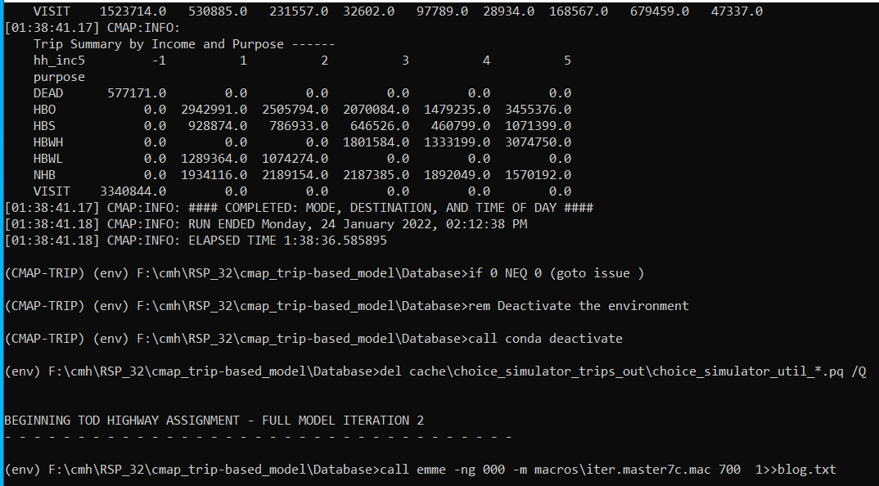

Edit the 3-digit scenario number in the batch file if necessary.

Model run steps summary

1. The Python virtual environment will be activated.
2. Submits useful_macros\cleanup.for.rerun and prep_macros\free.skim.mac.
3. Checks for a set of files stored in ..\defaults_base_year\ to pre-load congested travel times and distances into Emme.
   * If all of the files are present, prep_macros\preload_congested_times.mac is submitted to replace the free skim macros with congested times and distances (this is the preferred option).
4. Submits macros\call\skim.transit.all to do the transit skimming.
   * Calls macros\call\transit_skim_final_matrices1.py – performs the matrix convolution portion of the transit skimming procedures for the AM peak period.
   * Calls macros\call\transit_skim_final_matrices2.py – performs the matrix convolution portion of the transit skimming procedures for the midday period.
   * Calls macros\call\finish.transit.skims – moves transit skim matrices into final locations.
5. Runs macros\init_HOVsim_databk.mac to initialize the matrices in the emmebank.
6. Runs the destination choice-mode choice-time of day choice model.
   * Calls cmap_modedest with arguments:
     1. --njobs: Number of jobs to process in parallel.
     2. --max_zone_chunk: Maximum number of zones to process in one chunk.

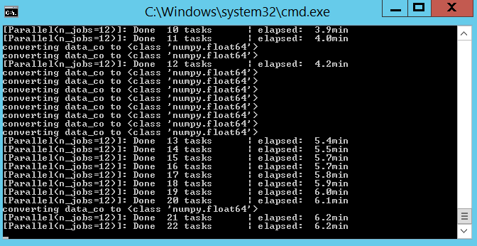

1. Runs macros\iter.master7c.mac
   * Calls macros\call\ttables.mac – creates time-of-day user class demand matrices.
   * Calls macros\call\net5I_7c.mac – prepares time-of-day highway networks.
   * Calls macros\call\assign5I_7c.mac – performs the time-of-day traffic assignment.
   * Calls macros\call\balance5I_7c.mac – balances user class link volumes (with the assignment from the prior Global Iteration) using the Method of Successive Averages.
   * Calls macros\call\skimtod5I_7c.mac – creates time and distance skims for each time-of-day period.
   * After the last time period is assigned:
     1. Calls macros\call\skim5I_7c.mac – creates time and distance skims for the AM peak and midday periods, used to inform the next Global Iteration.
     2. Calls macros\call\toll_skims.mac – generates toll skims along accumulated paths for the auto user classes.
     3. Calls useful_macros\delete.matrices – deletes a set of matrices (mf143-mf208) to reduce storage space.
2. After the final global iteration, runs macros\Daily.Total.Asmt5I_7c.mac, which tabulates time-of-day link volumes from the final Global Iteration runs into daily link volumes (stored in scenario xxxx9).
   * Calls macros\call\vht.summary_v3_7c.mac – calculates vehicle hours of travel for each time-of-day period in the final Global Iteration and stores the accumulated values in scenario xxxx9.

# **Post model run procedures**

## **Create MOVES Model Input Data**

* + Submit post_macros\punch.moves.data.mac <3-digit scenario> to create data files for processing.
    - Calls *post_macros\run_vmt_statistics.mac <3-digit scenario>* to create a summary of VMT values by district and facility type.
  + Run ***post_macros\create.MOVES.input.file.IMversion.sas*** to create final MOVES data file.
    - Update project, run and year variables prior to running.

## **To Run a Transit Assignment following the full TOD Model Run**

Three macros are included in the Database\transit_asmt_macros\:

* Submit transit_stats.v2.mac <3-digit scenario>: This serves as a wrapper macro to run all transit assignment procedures. After calling the two macros listed below, two files of transit assignment results are created (one for HW transit trips and one for non-work transit trips).
  + Calls *transit_asmt_setup.v2.mac <3-digit scenario>* – prepares separate work and non-work transit demand matrices using work and non-work station index files so trips can be assigned to their respective networks.
  + Calls *assign_transit.v2.mac <3-digit scenario>* – performs the transit assignments: work trips on the AM peak network and non-work trips on the Midday network. This was used for 2015 model validation so it contains line weights and a few other variations from the transit skimming procedures, which are noted in the macro. A set of control files for Metra and CTA rail lines are stored in \cntl and are used to apply the line weights.

## **To Run a Select Link Analysis following the full TOD Model Run**

Follow the instructions provided in Database\select_link_analysis\.