Deliverable D2.4

|  |  |
| --- | --- |
| Project Title: | Developing an efficient e-infrastructure, standards and data-flow for metabolomics and its interface to biomedical and life science e-infrastructures in Europe and world-wide |
| Project Acronym: | COSMOS |
| Grant agreement no.: | 312941 |
|  | Research Infrastructures, FP7 Capacities Specific Program; [INFRA-2011-2.3.2.] “Implementation of common solutions for a cluster of ESFRI infrastructures in the field of "Life sciences" |
| Deliverable title: | Definition of NMR-ML Schema, initial MSI-NMR ontology, example files |
| WP No. | 2 |
| Lead Beneficiary: | 11. IPB |
| WP Title | Standards Development |
| Contractual delivery date: | 30 September 2013 |
| Actual delivery date: | 07 November 2013 |
| WP leader: | Steffen Neumann (Daniel Schober) 11. IPB |
| Contributing partner(s): | 11. IPB, Michael Wilson from the Wishart Lab, University of Alberta, Edmonton Canada, 1.EBI , 12 UB2, 13 UBHam, 14 UOXF |

*Authors: Daniel Schober, Michael Wilson, Annick Moing, Daniel Jacobs, Steffen Neumann*

Content

1 Executive summary 3

2 Project objectives 3

3 Detailed report on the deliverable 3

Background 3

Description of Work 4

Development process and achievements 4

Requirement analysis and use case specification 5

Basic overall design considerations 5

XSD Development 6

CV development history and current status 9

Source files and documentation 11

Example implementations 12

Next steps 12

4 Publications 13

5 Delivery and schedule 13

6 Adjustments made 13

7 Efforts for this deliverable 13

Appendices 13

Background information 18

References 19

# 1 Executive summary

Nuclear magnetic resonance (NMR) spectroscopy is an important analytical method in metabolomics experiments. The instrument vendors typically provide the software to process the vendor specific data. Alternative data analysis software needs to put considerable efforts into reading and writing these specific vendor formats. Currently existing standard data formats such as the JCAMP family have several drawbacks, especially in metabolomics applications.

In this deliverable D 2.4 we have coordinated efforts from multiple international groups who are working in NMR and metabolomics related software to design and establish a vendor agnostic nmrML data format, based on the experience with the PSI (Proteomics Standards Initiative)[1] mzML[2] format for mass spectrometry. As a result, the standards development work package (COSMOS WP2) here delivers the essential exchange standard for NMR-based metabolomics raw data. After the formulation of UML use case diagrams for the nmrML core specification, we agreed upon design principles (technical and content-wise) and the overall development setup. We prepared a set of documents to define the format as well as documentation and example files to demonstrate the intended use to our target users. The current versions of these documents were distributed via nmrml.org as release candidates with the goal of generating initial user feedback and to facilitate the integration and development of software tools before the first finalized version is released.

Rudimentary nmrML parsers are available, which read in Bruker or Varian NMR raw data files and generate nmrML schema compliant XML instances (see Next Steps).

The parsers are developed in close collaboration with two important open-access NMR data processing tool developers (Batman[3], rNMR[4]).

The development mood is good and we are in line with the given time scheme and deliverable.

# 2 Project objectives

With this deliverable, the project has contributed the following objectives:

|  |  |  |  |
| --- | --- | --- | --- |
| **No.** | **Objective** | **Yes** | **No** |
| 1 | Exchange format for metabolomics raw data (XSD) | X |  |
| 2 | Exchange format for metabolomics raw data (CV) | X |  |
| 3 | Example xml files illustrating usage of the standard with example data | X |  |

# 3 Detailed report on the deliverable

## Background

NMR is an important analytical method in metabolomics experiments. The instrument vendors (the dominant ones are Bruker, Varian and JEOL) typically provide the software to process the vendor specific data. Alternative data analysis software needs to put considerable efforts into reading and writing these specific vendor format, this applies both to commercial software such as NmrPipe, MestReNova (Mnova) or Chenomx NMR Suite, but even more so to community developed open source efforts such as Metaboquant[5] (Matlab-based), the Batman R package or rNMR. Currently existing standard data formats such as the JCAMP family have several drawbacks, especially in metabolomics applications. One problem is that there is no semantic validation of JCAMP-DX files, and that the JCAMP-DX website says even about their own test data[6] that “*these files do not always comply 100% to the written standard but do represent files commonly found -- they do not claim to cover all possible allowed variations but are a good starting point to test your software.*” This was the starting point that a new, well-specified NMR data standard was needed.

In this deliverable, we are building on several previous efforts: 1)The Proteomics Standards initiative (PSI) has developed a number of XML based data exchange standards for mass spectrometry based proteomics, which proved of great usability in proteomics data standardization and intelligent data access 2) from 2005 to 2009 the Metabolomics Standards Initiative (MSI)[7] had kicked off the development to standardize NMR based metabolomics data, including reporting guidelines and an ontology for NMR[8].

To restart this effort, to leverage and canonize existing predecessor artifacts and to coordinate further developments, the COSMOS EU project was granted. Our aim as COSMOS WP 2, leading the standards development, is to create an open exchange data standard to allow metabolomics data, especially NMR raw data to be shared and stored in an agreed-upon stable and persistent, yet flexible XML format. A bird’s eye view on the envisioned nmrML use cases is provided in Fig. 1.

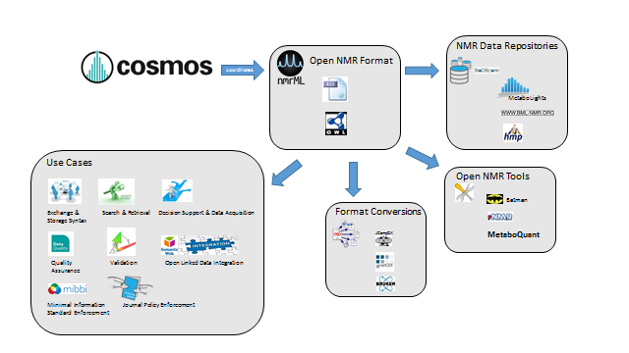**Figure 1**:Illustration of data management facilitation by means of a common nmrML standard

## Description of Work

### Development process and achievements

All work was coordinated via a new mailing list and bi-weekly video conferences and during a workshop at EMBL-EBI in Cambridge (April 2013). After the first year of developments we held another workshop at the IPB in Halle (October 2013) to finalize the foundation of nmrML.

### Requirement analysis and use case specification

The first step in the development is the collection of use cases and requirements which the new standard should meet. We developed a UML use case diagram (Fig. 2) to illustrate the distinct usages of nmrML in a standardized manner.

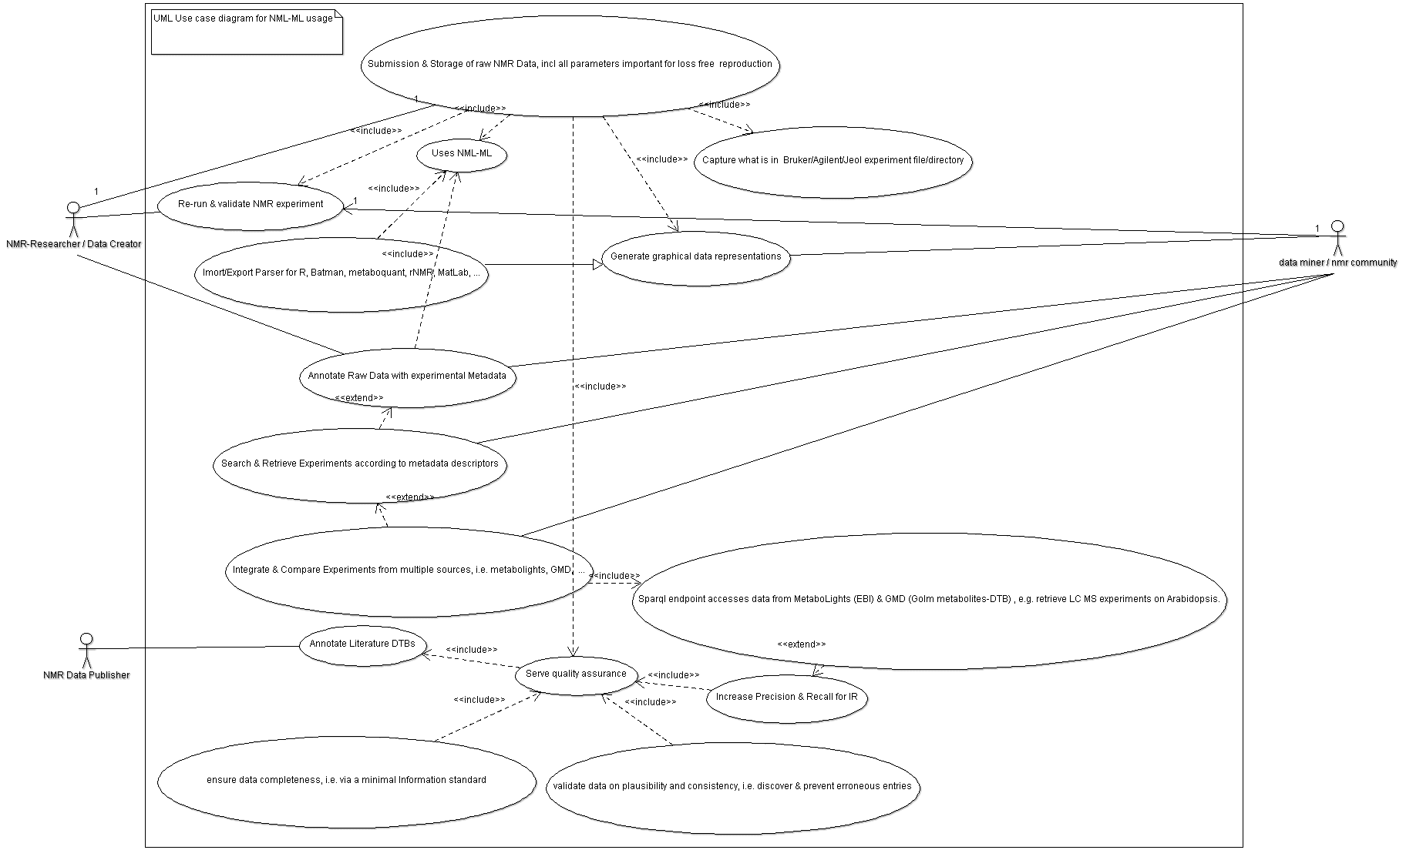**Figure 2:** UML use case diagram illustrating the usage of the nmrML standard

After formulating Competency questions to test the coverage of the CV, we specified inclusion criteria for good NMR example data sets. For details, we refer to the Annex B and C.

### Basic overall design considerations

We had several overarching goals that guided our decision making process. The data format should:

* Allow NMR data to be easily shared in a vendor agnostic manner
* Record enough information about an NMR spectrum acquisition to allow for further processing of the raw spectrum without referring to the original vendor files.
* The data format should reference the original files for the sake of posterity and in the case where original vendor specific information is required.
* The data format should be flexible and allow for multiple use cases of NMR experiments.
* The data format should be easy for developers to understand and integrate into software.

As in our PSI role model, we agreed on implementing a combined standard using XML and accompanying CV terms (Fig. 3), as this allows multiple validation levels to be established: XML syntax and structural validity of XML instances (xml element and attribute positions, order and cardinality) are validated by the XML parser against the XML Schema.

The mapping files enforce semantic validity[9] by specifying which CV terms are allowed in an element as well as the order and cardinality those terms. A proprietary validator tool, to be developed for the next deliverable) checks that the criteria outlined by the mapping file are being met in a given XML instance. The mapping file combined with the CV can also be used when creating an interface that records NMR experiment information for example to populate a drop down menu or an autocomplete box.

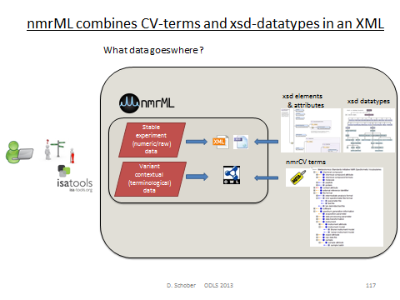**Figure. 3:** nmrML consists of an XSD specification capturing the more data-near and less variant raw data and a CV, capturing the more variant contextual terminology on NMR.

### XSD Development

We used the ideas from the past work and publications to guide what information we needed to capture. We started the nmrML.xsd development by modification of the J. Cruz XSD predecessor[10] and under amendment with elements and structures from the BML-NMR XSD developed by Christian Ludwig and Denis Rubtsov in Birmingham[11].

Regarding NMR specific information our aim was to capture all details required for both reproduction of the NMR acquisition as well as further processing of the raw data.

We decided on which acquisition parameters must be captured through consultation with domain experts, and reference to past work that attempts to define the minimal information required to describe an NMR acquisition.

In cases where the variability in information to be captured is very high, we rely on the CV to capture relevant information. For example when capturing information about the NMR instrument configuration there are many different possibilities such as probe heads, auto-samplers, brands, models, etc.

Another point that that is difficult to capture here is the pulse sequence, which can be completely customized by a user. In this case we opted to capture the names of several of the most common pulse sequences or allowing a reference (via a URI) to the pulse sequence program source code. While not readable in a vendor agnostic manor this decision still allows for most experiments to be easily reproduced while also allowing more custom information to be captured.

While vendor formats have multiple different methods of encoding the free induction decay (FID) signal, each with various pros and cons, we decided to standardize the encoding with the goal of making the format easier to read and integrate into software, and following some common practices for encoding binary data in XML. While the binary FID data ends up being the bulk of the bytes in an nmrML instance, the file size remains easily small enough that an nmrML file is easily transferable via web or email. The ‘encodedLength’ attribute in the tag surrounding the FID data allows for software that skips these bytes when reading the file if they are not needed. The format also allows for the capture of a processed FID and information about the processing of the spectra. It is common to transform the FID from time domain to frequency domain before any further analysis and we felt that this process is so common that it could be considered another form of raw data. Capturing the transformed data makes the nmrML format more practical since time domain data is not usually viewed by users and allows other formats such as IdentML, or QuantML to reference the spectra contained in an nmrML instance.

#### XSD top level structure

An nmrML instance is split up into multiple sections that organize the information in an intuitive way that facilitates easy understanding of the format as well as making development of software application easier. The current top level structure of the nmrML XSD is described in Fig. 4.

**Figure 4:** The root near xml elements of the current nmrML.xsd schema, illustrating its main elements. For detailed documentation we refer to the HTML documentation, or the XSD itself, in which extensive element annotations explain the usage of the elements.

Reference to the CVs used in the instance are recorded in the ‘cvList’ element at the top, which allows for unambiguous references to CV terms. The ‘fileDescription’ element captures a general description about the file and its contents which allows for easy categorization of different types of nmrML instances e.g. 1D vs. 2D. The ‘contactList’ element captures information that allows one to contact the original creators of a file in the case that further clarification is needed. The ‘sourceFileList’ contains information about the original files used to make the nmrML instance including files that were required during the acquisition of the spectrum, for example a Varian processing parameter file or a source code file for a pulse program. Similarly the ‘softwareList’ element captures references to software that was used during data acquisition and processing, and may include several different pieces of software. The ‘informationConfigurationList’ element contains information about the configuration of an instrument beyond the acquisition parameters, for example the brand and model of the instrument. The ‘acquisition’ element captures the processing parameters used during the acquisition. Since vendors have their own set of names for each of these parameters, we have standardized them with intuitive clear names. This element also contains the captured FID data. The ‘spectrumList’ element contains 1 or more spectra in the frequency domain.

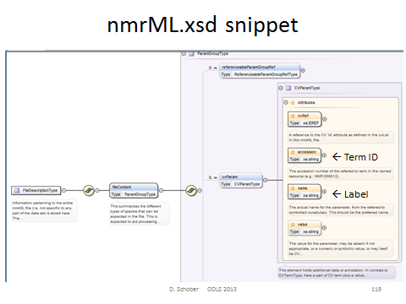**Figure 5**: Specification of CV term usage via the CVParam element in the XSD

An example of how a CV term is used in an example XML instance can be found in Fig. 6.

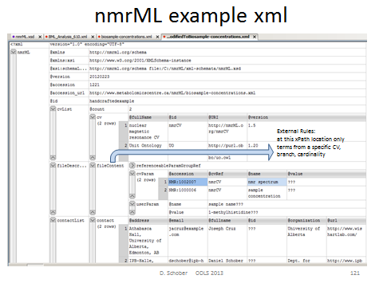**Figure 6**: Example xml instance (grid view) illustrating instantiation of CV terms to describe a concrete file content via CV Parameters.

### CV development history and current status

After agreement on the set up of development tools (Protégé 4), we formulated our CV design principles, namely agreed on file names, format syntax, namespaces, (auto) term ID schemes, a term obsoletion policy, as well as versioning & release procedures. We analyzed existing CVs on suitability and modelling errors[12]. From the given predecessor CVs we proceeded in a bottom-up and middle out Approach to expand the CV. We first added CV terms as required in the XSD leafs, i.e. where CVTermType, CVParamType, CVParamWithUnitType references occur in XSD elements. For a more detailed view on these CV reference elements we refer to Annex A. After this we continued in a use case driven term population. No high throughput term-additions were attempted in our early design phase, as this would clutter CV with terms of doubtful need, impair orientation in the term tree as too many terms distract us from getting the main structure right. A detailed version history of the nmrCV can be found in Annex E.

The nmrCV.owl ontology momentarily contains ~ 600 classes under nmr namespace. Around 2000 terms are imported from the units ontology and BioTopLight. So are the 62 object properties (relations).

#### CV design decisions

We choose the **OWL Syntax over the OBO format** as exchange syntax for the CV. The reasons were that the OBO tools are instable, the OBO format is only established in the biology domain (lack of off-the-shelf development tools, OBO expressivity not as formal as OWL-DL) and there are hence less resources to integrate with.

We maintain a pure taxonomy without use of axiomatic definitions. Multiple parenthood is however allowed, but needs to be maintained manually, as DL reasoning is not possible without DL axiomatisations. The mechanism how to re-use external CV terms is outlined in Annex F. Criteria defining the border between CV and XSD are outlined in Annex C. When creating new terms, we adhere to naming convention as outlined in Annex G.

##### Minimal metadata on a CV term

Representational Unit (RU) metadata is captured via standardized owl annotation properties drawn from imported artefacts like DC, SKOS and IAO. Not all of our terms currently have natural language definitions as these are time-intensive. None has deeper provenance data explicitly annotated (there is only an implicit indication on from which predecessor CV a term came in the ID ranges). We try to avoid getting stuck in the meta-ether, and had been pragmatic about this.

A term batch submission table should have the following mandatory fields:

term name (rdfs:label)

term definition in natural language (IAO_0000115, or skos ?)

superclass (ideally a term from the current nmrCV.owl, or an own suggestion)

Optional fields:

synonym (oboInOwl:hasExactSynonym)

term definition source (dc:source)

dc:contributor

dc:creator

example of usage (skos:example)

##### Top Level Ontology usage

There are a few top and upper level ontologies established in the ontology domain. From BFO, OBILight & BioTopLight (btl2), we choose btl2 as top level ontology to guide our CV upper level development. The reason was that the WP2 leads are involved in btl2 development (fast to react) and btl2 provides a proper set of object properties (close to Relations Ontology). At the moment only a few relations from unit ontology (UO) are used. Bridges from btl2 to BFO & other TLOs exist and we can at some later point still switch the TLO, as we do not use any axioms anyway (It‘s only ~10 classes anyway, rebinning is easy). It can be argued why we use a TLO when developing a CV not an Ontology. There has already been a case where the TLO provided modeling restrictions that allowed an automatic DL reasoner to discover CV modelling errors, e.g.<https://github.com/nmrML/nmrML/issues/62>

Nevertheless, at the moment we avoid any usage of object properties from the CV. E.g. for a software vendors file format, we could have in the CV:

NMR Instrument hasVendor Vendor

Instead, we say in the mapping file that for an Instrument, the Name and Vendor has to be specified.

### Source files and documentation

The following describes the files and documents that we have prepared and their respective download locations:

**nmrML.xsd (nmrml.org/schema/1.0.rc1/nmrML.xsd):** An xml schema that defines the structure, content and semantics of the nmrML documents. The XML schema definition (XSD) is in the XML Schema 1.1 format following the W3C recommendation (w3.org/XML/Schema). The schema allows for the capture of raw NMR spectrum data and acquisition parameters for both one-dimensional and two-dimensional spectra, including two-dimensional J-resolved spectra.

**nmrCV.owl (nmrml.org/cv/2.0.rc1/nmrCV.owl):** The controlled vocabulary (CV) describing the more variant terminology in an unambiguous and standardized way. This ontology is the MSI-sanctioned successor of artifacts developed previously at EMBL-EBI, Hinxton, UK (D. Schober, Sansone Group) and the Wishart Research Group, Edmonton, Canada (J. Cruz). This CV currently covers the description of NMR spectrum acquisition set up and raw data generated during the acquisition. There is less coverage of data generated by analysis of the spectrum such as metabolite quantification and identification. The CV terms are used within the nmrML xml file, at positions specified in the XSD, e.g. by CVParam references.

**xml example files (https://github.com/nmrML/nmrML/tree/master/examples/working.tmp/nmrML & https://github.com/nmrML/nmrML/tree/master/examples):** Four XML instances complying with the XSD were generated to illustrate the usage of nmrML in a practical experiment data annotation. These instances also served to test the XSD and CV on coverage, structural soundness and to test parser software.

**XSDToCV mapping file (nmrml.org/schema/1.0.rc1/nmrml-mapping.xml):** An xml file specifying rules to constrain data entry and to verify validness of CV term usage in the nmrML XML files and to be able to enforce minimal metadata standards[13]. Only a very first draft has been created for testing purposes.

**HTML documentation files (nmrml.org/schema/1.0.rc1/doc & nmrml.org/cv/1.0.rc1/doc):** Documentation was generated with automated tools that describes the nmrML XSD and the CV OWL and made available via nmrml.org. The documentation allows non-XML and non-ontology savvy end-users open, browse and comment on the standards as well as facilitating the use of the data format by developers and the implementation of tools that use the read or write nmrML.

To further ease adoption we also created supplemental documentation and tutorials made available via the same site.

All source files are available on the project Github pages, together with an accompanying readme file.

**GitHub:** <https://github.com/nmrML/nmrML>**Cosmos website:** [http://www.cosmos-fp7.eu](http://www.cosmos-fp7.eu/)

**nmrML website:** [http://nmrml.org](http://nmrml.org/)**nmrML wiki:** <http://cosmos-fp7.eu/nmrML/>

**nmrML google forum:** [https://groups.google.com/forum/#!forum/nmrml](https://groups.google.com/forum/)

### Example implementations

We created two example xml files from our use cases to serve as data-driven check on the format. Criteria for good example data are outlined in Annex D.

**Example 1:** At first, we analyzed, if our schema compensated for all data required by the original predecessor. The original J. Cruz nmrML XML example was taken from <http://www.metabolomicscentre.ca/nmrML/biosample-concentrations.xml> and was transliterated into an nmrML XML instance generated via Oxygen as described at <http://www.oxygenxml.com/doc/ug-editor/topics/xml-schema-instance-generator.html>Where the correct entity usage for some values was doubtful, value entries were marked with the String "???". Not used elements and attributes containing the mere default autogenerated values were deleted in the final version.

**Example 2:** An example was created from a reference spectrum obtained from HMDB (<http://www.hmdb.ca/spectra/nmr_one_d/1024>). The file was initially written manually by hand, obtaining values to fill in the file from the Varian procpar file and a python script for encoding the raw FID data into the correct format. This example also proved useful for creating the conversion software since the output could be compared.

After we developed the conversion software, more example files were generated from MetaboLights entries MTBLS1 and 25 data as well as for IPB Hop data[14].

## Next steps

The next step is to plan the first release of the core XSD and initial CV.

Further testing of the XSD is required with diverse experimental configurations, to ensure that our goal of flexibility has been achieved. We must also ensure that the schema is compatible with the steps we are taking toward QuantML and IdentML.

Continuing to improve the documentation and building a community of users will provide further feedback for improvements to the Schema. At the same time we will continue the data-driven CV expansions and add new terms according to the additional examples selected by our different partners. On the CV side we also need to integrate new EBI-NMR CV classes (using tabular mass term import).

In general we have to extend the format specification, e.g. adding more experimental metadata, such as sample types as well as more information on metabolite identification and quantification (both XSD and CV side).

Also we need to work out an evaluation pipeline. As part of the next deliverable (D2.5 - Real data, Converters, Validators and Parsers for NMR-ML, m24), we will implement the CV-aware validator software and extensive mapping files containing the verification rules to check xml instances on semantic errors and completeness.

In parallel we will implement the parsers for format conversions and I/O to open source tools. The creation of ISA Tab specifications for easy tabular data entry and minimal reporting requirement enforcement is considered a further next step (D2.6).

# 4 Publications

Schober D., Mayer G., Moing A., Eisenacher M., Neumann S., **Ontological analysis of controlled vocabularies used in PSI/MSI supported XML standards**, Workshop: ODLS 2013, GI-Edition Lecture Notes in Informatics, *Proceedings of the Jahrestagung der Gesellschaft für Informatik 2013*, Matthias Horbach (Hrsg.), Koblenz, Germany, 16.–20. September 2013, p. 1875-1888,<https://wiki.imise.uni-leipzig.de/Gruppen/OBML/Workshops/2013-ODLS-en>

# 5 Delivery and schedule

The delivery is delayed: ◻ Yes ☑ No

# 6 Adjustments made

None.

# 7 Efforts for this deliverable

|  |  |  |  |
| --- | --- | --- | --- |
| **Institute** | **Person-months (PM)** |  | **Period** |
|  | **actual** | **estimated** |  |
| 11. IPB | 3 | 3 |  |
| Michael Wilson, Wishart Lab | 1 (contribution of permanent staff not paid by COSMOS) |  |  |
| 12. UB2 | 2 (contribution of permanent staff not paid by COSMOS) |  |  |
| Total | 6 |  |  |

# Appendices

#### A. CV term referencing mechanism

We here outline how CV term usage is specified in the XSD. The requirement for a CV term occurrence in an xml is specified in the XSD by *reference elements* as illustrated in Table 1. Keep in mind that the last element captures free text and makes no CV reference.

**Table 1:** Illustration how xml element types are used for CV and user parameter entry.

|  |  |  |  |
| --- | --- | --- | --- |
| **Reference Type** | **Definition** | **Attributes** | **Comment** |
| CVTermType | This element holds additional data or annotation as a simple CV term with no further values (Parameters) associated with it. Only controlled CV terms are allowed here. | *CVRef, accession, name* | The “CVRef” attribute contains an id unique to the XML instance that is defined in the cvList element. This allows for multiple CVs to be referenced unambiguously. The “accession” attribute contains the ID of the CVterm which is unique within the CV. The “name” attribute contains the term which allows using the term in a program (for example displaying it to a user) without requiring the CV file to be downloaded and parsed. |
| CVParamType | This element holds additional data or annotation. In contrast to CVTermType, here a pair of CV term plus a value (=Parameter) is captured. Only controlled terms are allowed here. | CVRef, accession, name, *value* | The ‘value’ attribute stores the parameter to be captured as value. |
| CVParamWithUnitType | This element holds additional data or annotation, i.e. a controlled term describing a parameter, as well as a value and a description of the unit the value is recorded in. Only controlled values are allowed here. The unit ontology is typically used to provide the terms for the unit. | CVRef, accession, name, value, *unitCVRef, unitAccession, unitName* | The ‘unitCvRef’, ‘unitAccession’ and ‘unitName’ attributes are used in the same way to describe the unit as the ‘cvRef’, ‘accession’ and ‘name’ terms are used to describe other CVTerms. |
| ValueWithUnitType | This element holds additional data or annotation. Only controlled values are allowed here. For cases where only a Value with an ontologically defined Unit should be given. Elements of this type hold a value and a reference to the unit the value is recorded in, but is used in locations where the type of value is already defined by the element, but the unit of the value still needs to be recorded. | Value, unitAccession, unitName, unitCvRef |  |
| UserParamType | This element holds uncontrolled user parameters (essentially allowing free text). For cases where no suitable CV term exists. Before using these, one should verify whether there is an appropriate CV term available, and if so, use the CV term instead. This list can however later be exploited to generate corresponding term requests in given ontologies or CVs. | Name, *valueType,* value, unitAccession, unitName, unitCvRef | The ‘valueType’ attribute |

#### B. Competency Questions for CV development

A set of Competency Questions (CQ)[15] was defined for nmrCV & nmrML. CQs are exemplary queries for a data resource based on the CV. The finished CV should then cover the required areas to annotate the data for successful retrieval and serve to evaluate the format for coverage and structural suitability at the later evaluation phase. Possible queries for raw data annotations could be the following:

* Find 1D 1H NMR spectra from 500MHz field-strength Bruker machines (on human urine samples for doping chemicals).
* Find spectra generated via Bruker CryoProbe and D 2O solvent.
* Find spectra that used a flow high resolution probe in the instrument?
* Find experiments generated with sample pH range from 6.5 to 7.
* Find spectra according to decoupling method for fluxomics (1H{13C}).
* Find NMR spectra that have been Fast Fourier Transformed and were smoothed with Gaussian smoothing.
* Find reference spectra for 1-Methylhistidine with a frequency of 600 MHz.

Additional CQs for nmrCV expansions for Identification and quantification (IdentML & QuantML):

* Find 1D spectra with doublets in ppm range 2.5 to 3.
* Find NMR spectra for changes in metabolites involved in TCA cycle after fat consumption in human.
* How does the aromatic amino acid fraction differ in (Hop) plant variants ?
* Find spectra that were generated via a certain NMR software.

#### C. Criteria defining the border between XSD and CV

The XSD branches out into CV-usage, where:

* The terms describe contextual metadata, rather than NMR raw data
* The terms are unstable, variant & dynamically evolving, or need to be changed and updated often
* The terms refer to software names/versions, processing parameters etc.
* The terms are better maintained by a fast reacting NMR user community
* The terms reside at the domains leaf node level
* The terms are search attributes for data querying and DTB-integration
* The terms should be accessible to rule-based reasoning and validation
* The terms should be exploited by profiting from robust subsumption, i.e. exploiting the taxonomic CV backbone

#### D. Selecting good example NMR data sets for nmrML xml instances

We defined characteristics of what we believe is a good example data set:

* The data was gathered in a prototypical, abundant experiment set up, representative for metabolomics data acquisition
* The data should stem from a simple experimental set-up (e.g. 1D 1H NMR data)
* The data has a published paper available (not a method-, but a research-paper)
* The data has a database entry available, e.g. in MetaboLights[16] or HMDB[17]
* The data has accompanying original data files (FIDs)
* The data is using an abundant vendor format like Bruker or Varian standard files
* The data is associated with a responsive contact person, in case someone needs to get back to the data producers to be able to gather additional information or resolve questions
* The data has been analyzed further with open source tools like Batman or MetaboQuant, so that we can later reproduce the same results based on the converted nmrML data.

According to these criteria we have collated example data sets to be converted into nmrML. These example instances can be found in the corresponding github ‘example’ folder, together with an accompanying readme file illustrating its generation or on the documentation page at nmrml.org/schema.

#### E. Detailed version history of the CV

* v.1 initial result from the Obo Edit OBO to OWL conversion
* v.2 added RA Metadata (just using standard annotation properties, i.e. DC)
* v.3 added BFO 1.1 import (better for OBO backwards compatibility)
* v.4 This version as v.3, but importing BFO 2.0 instead of non-DL BFO 1.1. BFO 2.0 is experimental, but has a rich set of relations integrated from RO, For BF0 2.0, see http://ncorwiki.buffalo.edu/index.php/Basic_Formal_Ontology_2.0:_Tutorial_at_ICBO/FOIS, file loads from http://bfo.googlecode.com/svn/releases/2012-11-15-bugfix/owl-group/bfo.owl
* v.5 This version as v.4, but additionally importing MSI NMR.owl developed at EBI
* v.6 This version as v.5, but importing BiotopLight2.0 instead of BFO 2.0 as top level ontology
* v.7 This version is a complete new start (as v.6 ended up being too complex and error prone). For this version we removed the unit import from the Wishart nmr.obo, converted it into owl and imported BioTop Light 2 and the msi-nmr.owl. To make editing easier, we will merge the owl files physically rather than importing the msi-nmr.owl. The top level classes from OBI and BFO will then vanish as well.
* v.8 This version as v.7, but namespace set to NMR, added _purgatory helperclass and started rebinning under BiotopLight 2.
* v.9 This version as v.8, but Wishart CV binned under biotopLight2 (btl2). Added RA metadata.
* v1.0 As v.9, but removed OBI temporary and outdated IDs and Refs.Taxonomic re-binning of classes that part_of /is_a 'Metabolomics Standards Initiative NMR Spectrometry Vocabularies' under appropriate Biotop classes. Integration of required xsd leaf nodes into CV (see below). Removed Wishart Top Level nodes of doubtful justification, i.e. 'Metabolomics Standards Initiative NMR Spectrometry Vocabularies' and 'spectrum generation information' and 'spectrum interpretation'.
* v1.1 Merged msi namespace nmr ontology (Schober NMR) into Wishart CV (using P4 Refactoring/Merge) in order to get rid of import statements and restriction overriding.
* v1.2 Entity (ID) renaming of newly (physically) integrated MSI NMR Terms from MSI namespace to Cosmos nmrML namespace.
* v1.3 File renaming to get rid of version in Filename (now stores as RA annotation property) infile. New Namespace (now set to http://nmrML.org/nmrCV to distinguish it from xsd namespace). Alignment of ID schemes:To archieve this, we substituted 541 occurrences of "nmrCV_" for "nmrCV#NMR:" in the complete owl file. Then we substituted 710 occurrences of "nmrCV#MSI_" with "nmrCV#NMR:1" to align the old MSI IDs to the new NMR prefix and 7 digit length. Importing DOAP, added RA metadata using http://usefulinc.com/ns/doap#, then removed doap import to get rid of confusing class top level.
* v1.4 Empty outdated namespace declarations and NS prefix declarations were removed from the file. The following object properties were taken out of the owl file:

http://nmrML.org/nmrCV#has_regexp

http://nmrML.org/nmrCV#has_units

http://nmrML.org/nmrCV#part_of

Their usage in the old Cruz obo file was minor and has to be recreated by hand, but ideally with relations from btl2.

* v1.5 Major restructuring and redundancy removal, i.e. instruments are now captured as instrument attribute/models.
* v1.6 CV is now also covering the term-needs for the BML-NMR XSD. But, again, the CV is still considered to be a prototype. Its coverage can be very shallow at times. For some cases there is merely a corresponding CV Entry Class available (to be referenceable by the XSD), which has no further subclasses. These leaf nodes will have to be expanded successively via our use cases and later by term-requests from the practitioners/users. We can expect the CV to grow from currently to about 2500 Terms (as in PSI MS CV). Labels were aligned to be consistent, i.e. NMR_spectrum_post-processing_parameter_set was changed to NMR_data_post-processing_parameter_set to be in harmony with the existing NMR_data_pre-processing_parameter_set. 'run attribute' was moved into purgatory. Use acquisition parameter instead. This version imports the owl versions of Unit Ontology and PATO (Qualities).
* v1.7 Stop any notion of pre and post-processing (there is no agreement on meaning and start/end). We now use 'frequency domain processing' and 'time domain processing' as sortals for processing parameters.

#### F. External ontology term reference and import mechanism

There are four possible ways to reuse existing CV terms from other ontologies. We majorly used the first method:

1. use the terms in the CV by ID reference (e.g. as done with IAO metadata). This option is fast and flexible, but no metadata on used terms available.

2. use the MIREOT term referencing method. This option is too complicated and relies on outdated scripts

3. use full owl:import statements (e.g. as done for UO). This option however clutters the CV with seldom used terms, occupies RAM, but retains all metadata. This option is overshot for most use cases.

4. use dbxref statements. These are easy but not a standard way in OWL (these annotation properties are provided by the OBOinOWL namespace).

#### G. CV term naming conventions

We apply a labelling scheme in accordance to <http://www.obofoundry.org/wiki/index.php/FP_012_naming_conventions>. The OntoCheck P.4 plugin[18] is used to avoid term redundancies, i.e. to check on redundant labels, e.g. it detected that ‘TecMag’ was included twice, once under http://nmrML.org/nmrCV#NMR_400285 (NMR data format) and once under http://nmrML.org/nmrCV#NMR:1400255 (NMR_vendor). This redundancy could then be removed by specifying a more explicit label.

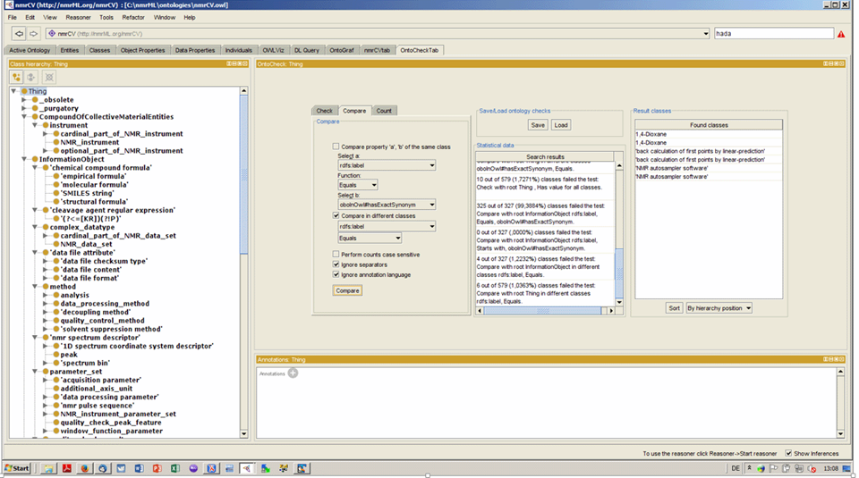

**Figure 6:** A screenshot displaying maintenance of the CV in the ontology editor Protégé 4. The OntoCheck Tab is shown which displays the CV term hierarchy to the left and allows to specify and label comparison check to discover redundant labels.

# Background information

|  |
| --- |
| UPDATE WITH WP INFO  This deliverable relates to WP2; background information on this WP as originally indicated in the description of work (DoW) is included below.  WP2 Title: Standards Development  Lead: Steffen Neumann, IPB-Halle  Participants: Michael Wilson, Wishart Group, Edmonton Canada, 1.EBI , 14 UOXF, 12 UB2, 13 UBHam  In this deliverable D 2.4 we have coordinated efforts from multiple international groups who are working in NMR and metabolomics related software to design and establish a vendor agnostic nmrML data format. The standards development work package (COSMOS WP2) here delivers the essential exchange standard for NMR-based metabolomics raw data. |

|  |  |  |  |
| --- | --- | --- | --- |
| **Work package number** | WP2 | **Start date or starting event:** | month X |

|  |  |
| --- | --- |
| **Work package title** | Insert WP title |
| **Activity Type** | Insert activity type (e.g. RTD, MGT) |

|  |  |  |  |  |  |  |  |  |
| --- | --- | --- | --- | --- | --- | --- | --- | --- |
| **Participant number** | No: partner | 11. IPB | No: partner | No: partner | No: partner | No: partner | No: partner | No: partner |
| **Person months per participant** | XX |  | XX | XX | XX | XX | XX | XX |

|  |
| --- |
| **Objectives**     1. Insert objective 1 2. Insert objective 2 |
| **Description of work and role of participants**  Insert WP description, tasks etc. |
| **Deliverables** |

|  |  |  |
| --- | --- | --- |
| **No.** | **Name** | **Due**  **month** |
| DX.X | Insert deliverable title | X |
| DX.X | Insert deliverable title | X |

# References

1. <http://www.psidev.info/>
2. Martens,L., Chambers,M., Sturm,M. et al. (2011) mzML—a community standard for mass spectrometry data. Mol. Cell Proteomics, 10, R110000133. http://www.ncbi.nlm.nih.gov/pubmed/20716697
3. Hao, J., Astle, W., De Iorio, M., & Ebbels, T. M. (2012). BATMAN--an R package for the automated quantification of metabolites from nuclear magnetic resonance spectra using a Bayesian model. *Bioinformatics, 28*(15), 2088-2090, doi:10.1093/bioinformatics/bts308.
4. Lewis, I. A., Schommer, S. C., & Markley, J. L. (2009). rNMR: open source software for identifying and quantifying metabolites in NMR spectra. *Magn Reson Chem, 47 Suppl 1*, S123-126, doi:10.1002/mrc.2526.
5. Wolfram Gronwald, Matthias Klein and Peter Oefner (submitted ?), MetaboQuant: A Tool Combining Individual Peak Calibration and Outlier Detection for Accurate Quantification from NMR Spectra
6. <http://www.jcamp-dx.org/testdata.html>
7. Sansone,S.A., Fan,T., Goodacre,R. et al. (2007) The metabolomics standards initiative. Nat. Biotechnol., 25, 846–848.
8. Sansone SA, Schober D, Atherton HJ, Fiehn O, Jenkins H, Rocca-Serra P, Rubtsov DV, Spasic I, Soldatova L, Taylor C, Tseng A, Viant MR (2007) Metabolomics standards initiative: ontology working group work in progress. Metabolomics 3, 249-256. ISSN 1573-3882
9. Montecchi-Palazzi L., Kerrien S., Reisinger F. et al. (2009) The PSI semantic validator: a framework to check MIAPE compliance of proteomics data. Proteomics, 9, 5112–5119.
10. <http://www.metabolomicscentre.ca/exchangeformats.htm>
11. Taylor CF, Field D, Sansone SA, et al., Promoting coherent minimum reporting guidelines for biological and biomedical investigations: the MIBBI project, Nat Biotechnol. 2008 Aug;26(8):889-96. doi: 10.1038/nbt.1411. , PMID:18688244
12. Schober D., Mayer G., Moing A., Eisenacher M., Neumann S., Ontological analysis of controlled vocabularies used in PSI/MSI supported XML standards, Workshop: ODLS 2013, GI-Edition Lecture Notes in Informatics, Proceedings of the Jahrestagung der Gesellschaft für Informatik 2013, Matthias Horbach (Hrsg.), Koblenz, Germany, 16.–20. September 2013, p. 1875-1888, https://wiki.imise.uni-leipzig.de/Gruppen/OBML/Workshops/2013-ODLS-en
13.
14. Farag, M., Porzel, A., Schmidt, J. & Wessjohann, L. Metabolite profiling and fingerprinting of commercial cultivars of Humulus lupulus L. (hop) - a comparision of MS and NMR methods in metabolomics Metabolomics 8, 492-507, (2012)
15. <http://citeseerx.ist.psu.edu/viewdoc/summary?doi=10.1.1.11.9054>
16. Haug, K., Salek, R. M., Conesa, P., Hastings, J., de Matos, P., Rijnbeek, M., et al. (2013). MetaboLights--an open-access general-purpose repository for metabolomics studies and associated meta-data. [Research Support, Non-U.S. Gov't]. *Nucleic acids research, 41*(Database issue), D781-786, doi:10.1093/nar/gks1004.
17. Wishart, D. S., Jewison, T., Guo, A. C., Wilson, M., Knox, C., Liu, Y., et al. (2013). HMDB 3.0--The Human Metabolome Database in 2013. [Research Support, Non-U.S. Gov't]. *Nucleic acids research, 41*(Database issue), D801-807, doi:10.1093/nar/gks1065.

    Rubtsov DV, Jenkins H, Ludwig C, Easton J, Viant MR, Günther U, Griffin JL, Hardy N (2007) Proposed reporting requirements for the description of NMR-based metabolomics experiments. Metabolomics 3, 223–229.
18. <http://www.ncbi.nlm.nih.gov/pubmed/23046606>