Deliverable D2.4

|  |  |
| --- | --- |
| Project Title: | Developing an efficient e-infrastructure, standards and data-flow for metabolomics and its interface to biomedical and life science e-infrastructures in Europe and world-wide |
| Project Acronym: | COSMOS |
| Grant agreement no.: | 312941 |
|  | Research Infrastructures, FP7 Capacities Specific Programme; [INFRA-2011-2.3.2.] “Implementation of common solutions for a cluster of ESFRI infrastructures in the field of "Life sciences" |
| Deliverable title: |  |
| WP No. | 2 |
| Lead Beneficiary: | 11. IPB |
| WP Title | Standards Development |
| Contractual delivery date: | 30 September 2013 |
| Actual delivery date: | 30 September 2013 |
| WP leader: | Neumann 11. IPB |
| Contributing partner(s): | 11. IPB, 1.EBI , 14 UOXF, 12 UB2, 13 UBHam  and others WP participants providing data  Michael Wilson |

*Authors: Daniel Schober, Steffen Neumann, Michael Wilson*

**Contents**

1 Executive summary 3

2 Project objectives 3

3 Detailed report on the deliverable 4

3.1 Background 4

3.3 Description of Work 4

3.3.1 Requirement analysis and Use case specification 4

3.3.2 Basic overall Design Considerations 6

3.3.4 XSD Development history 10

XSD Issues 10

CV Development History 10

3.4 Next steps 14

4 Publications 15

5 Delivery and schedule 15

6 Adjustments made 15

7 Efforts for this deliverable 15

Appendices 15

Background information 16

# 1 Executive summary

The Standards development work package (WP2) here delivers the essential exchange standard for NMR-based metabolomics raw data. After the formulation of UML use case diagrams for the nmrML core specification, we agreed upon design principles (technical and content-wise) and the overall development setup.

The following files were released in a prototype state, mainly for parser testing and to gather initial user feedback:

● **nmrML.xsd**

○ The specification of the NMR raw data exchange format in XML Schema syntax, with focus on raw FID NMR data. Currently 1D and basic 2D experimental setups are covered.

● **nmrCV.owl**

○ The controlled vocabulary (CV) describing the more variant terminology in a standardized way. This ontology is the MSI-sanctioned successor of artifacts developed previously at EMBL-EBI, Hinxton, UK (D. Schober, Sansone Group) and the David Wishard Group, Edmonton, Canada (J. Cruz). This CV momentarily covers raw data descriptions and has less coverage on experimental- and quantification/Identification metadata. The CV terms are used within the nmrML xml file, at positions specified in the xsd, e.g by CVParam references.

● **xml example files**

○ Four XML instances complying with the XSD were generated to illustrate the usage of nmrML in a practical experiment data annotation. These instances also served to test the XSD and CV on coverage, structural soundness and to test parser software.

● **mapping file**

○ SHOULD WE DELIVER THIS ALREADY or for D2.5? To constrain data entry and to verify validness of CV term usage in the nmrML XML files and to be able to enforce minimal metadata standards [Ref].

● **HTML documentation files**

○ The nmrML XSD and the CV OWL file were serialized into hyperlinked browser-friendly HTML files, to let non-XML and non-ontology savvy end-users open, browse and comment on the standards.

Rudimentary nmrML parsers are available, which read in Bruker or Varian NMR raw data files and generate nmrML schema compliant XML instances.

The parsers are developed in close collaboration with the main open-access NMR data processing tool developers (Batman, rNMR).

The development mood is good and we believe we are in line with the given time scheme and deliverable.

# 2 Project objectives

With this deliverable, the project has contributed the following objectives:

|  |  |  |  |
| --- | --- | --- | --- |
| **No.** | **Objective** | **Yes** | **No** |
| 1 | Exchange format for metabolomics raw data (XSD) | X |  |
| 2 | Exchange format for metabolomics raw data (CV) | X |  |
| 3 | Example xml files illustrating usage of the standard with example data | X |  |

# 3 Detailed report on the deliverable

## Background

The Proteomics Standards initiative (PSI) has developed a number of XML based data exchange standards, which proved of great usability in proteomics data standardization and intelligent data access. Leveraging on this success the Metabolomics Standards Initiative (MSI) had kicked off an analogous development program with the aim to standardize NMR based metabolomics data. To restart this effort, to leverage and canonize existing predecessor artifacts and to coordinate further developments, the COSMOS EU project was granted. Our aim as COSMOS WP 2, leading the standards development, is to create an open exchange data standard to allow metabolomics data, especially NMR raw data to be shared and stored in an agreed-upon stable and persistent, yet flexible XML format. A bird’s eye view on the envisioned nmrML use cases is provided in Fig. 1.

**Figure 1**: ALL PICS WILL BE PUT IN LATER IN BETTER RESOLUTION.Illustration of data management facilitation by means of a common nmrML standard

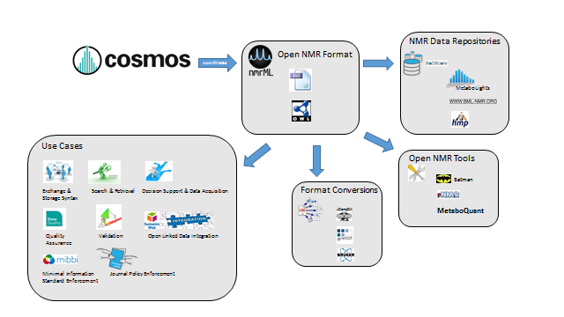

## Description of Work

### Requirement analysis and use case specification

The detailed usage of nmrML is outlined in Figure 2.

**Figure 2**: The detailed role of the nmrML xsd and CV within multiple agreed-upon use cases is shown.

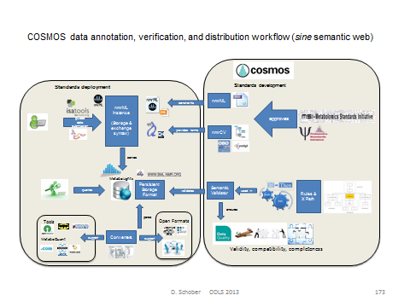

#### UML Use case diagram

We developed a UML use case diagram (Fig. 3) to illustrate the distinct usages of nmrML in a standardized manner.

**Figure 3:** UML use case diagram illustrating the usage of the nmrML standard

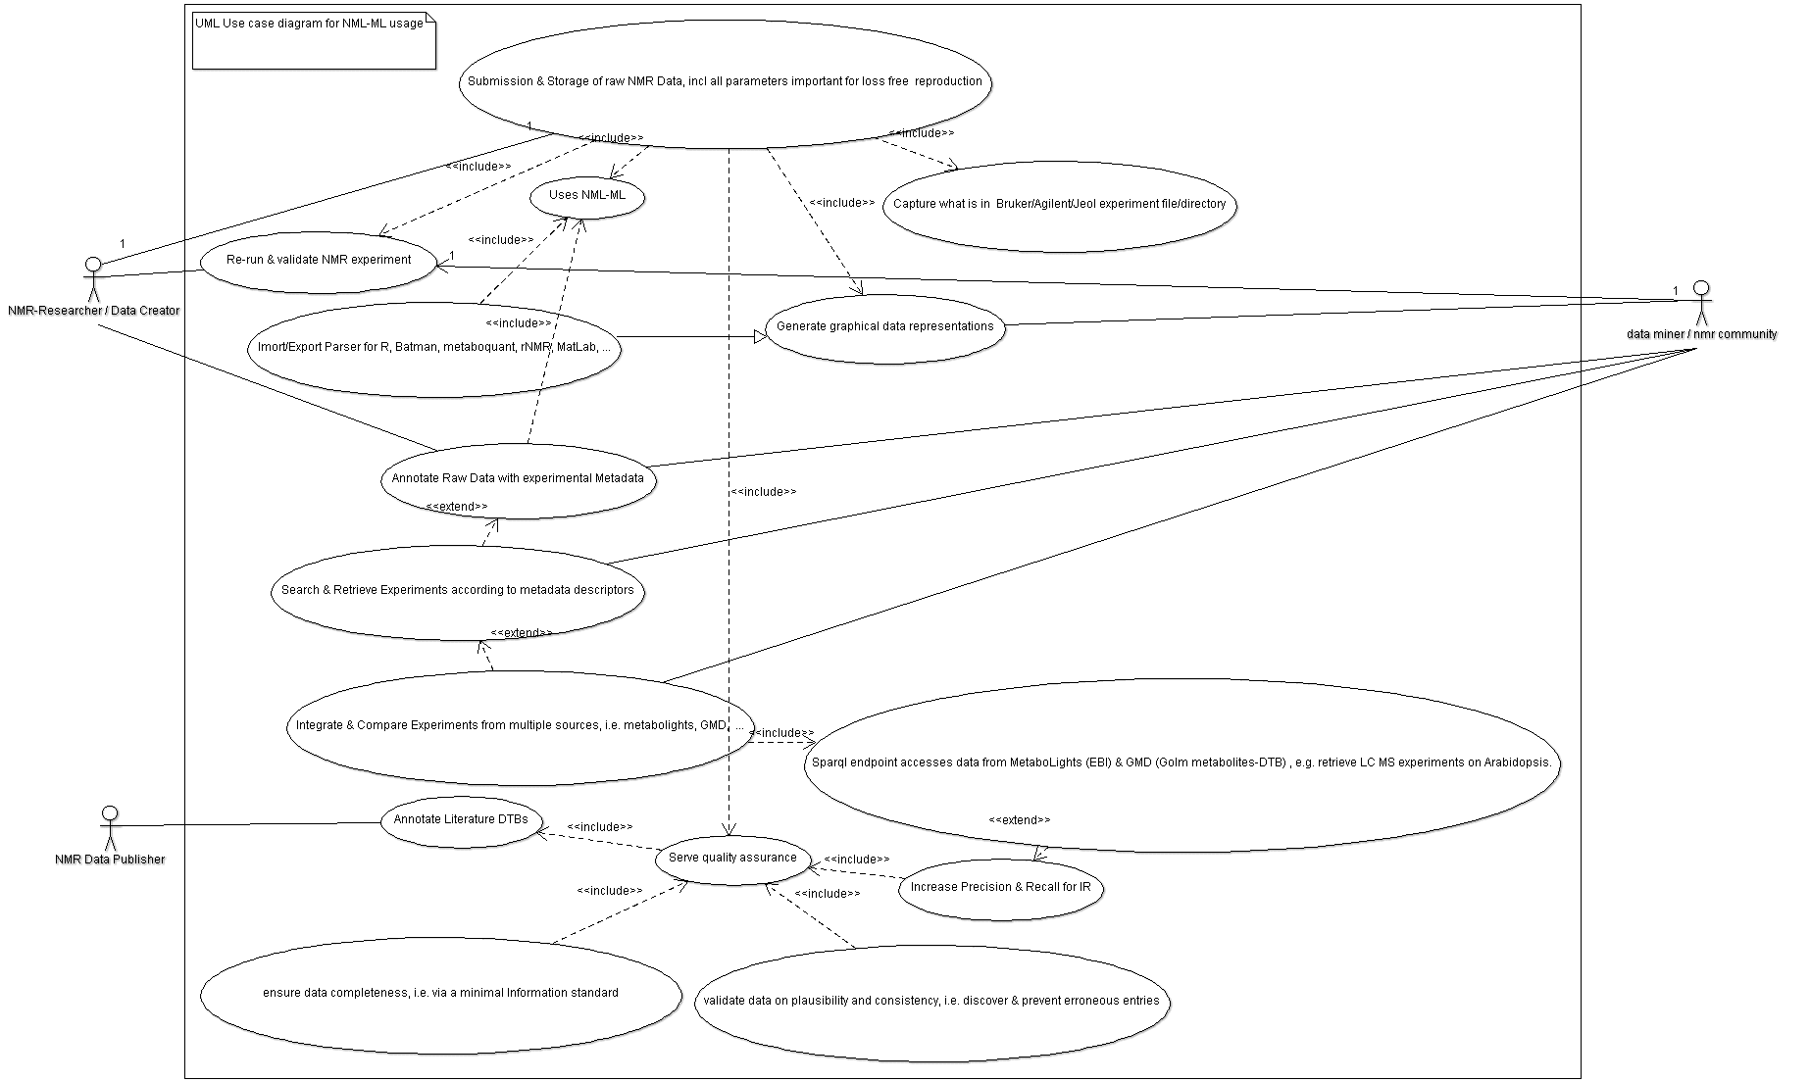

#### Selecting good example data sets

We defined characteristics of what we believe is a good example data set:

* *The data was gathered in a* p*rototypical, abundant experiment set up, representative for metabolomics data acquisition*
* *The data should stem from a simple experimental set-up (e.g. 1D H+ NMR data)*
* *The data has a published paper available (not a method-, but a research-paper)*
* *The data has a database entry available, e.g. in Metabolights*
* *The data has accompanying original data files (FIDs)*
* *The data is using an abundant vendor format like Bruker or Varian standard files*
* *The data is associated with a a responsive contact person, in case we like to get back to the data producers to be able to gather additional Info & resolve questions*
* *The data has been worked on with open source tools like Batman or metaboquant*

According to these criteria we have collated example data sets to be converted into nmrML. These example instances can be found in the corresponding github ‘example’ folder, together with an accompanying readme file illustrating its generation.

#### Competency Questions for CV development

A set of Competency Questions (CQ) was defined for nmrCV & nmrML. Quite in accordance to unit tests in software development, these CQ serve to evaluate the format for coverage and structural suitability at the later evaluation phase:

MOVE INTO ANNEX ?

* Get spectra generated on a 500Mz Bruker machine in 1D set-up and H+ as acquisition nucleus (on Human Urine samples for doping chemicals).
* Get spectra generated via Bruker CryoProbe and D2O solvent.
* Show experiments generated with samples with a pH range from 6.5 to 8
* Get spectra according to decoupling method.
* Get nmr Spectra that have been FT transformed and were smoothed via Gaussian smoothing.
* Show me reference spectra for xyz compound.
* What spectra used flow high resolution probe in the instrument?

CQs for nmrCV and IdentML CV:

* Get 1D spectra with doublets in ppm range x to y.
* Show me nmr spectra for changes in metabolites involved in citrate circle after fat consumption in human.
* How does the aromatic amino acid fraction differ in Hop plant variants ?
* Get spectra that were generated via open source nmr software.

### Basic overall design considerations

As in our PSI role model, we agreed on implementing a combined standard using XML and accompanying CV terms (Fig. 4), as this allows multiple validation levels to be established: XML syntax correctness is validated by the XML parser. Structural validity of XML instances (xml element and attribute positions, order and cardinality) are validated by correlation with the XSD. Semantic validity, i.e. terms form what CV, what CV branch and their order and cardinality allowed for a certain XSD position are validated by so called mapping files and a proprietary validator tool to be developed for the next deliverable.

**Figure. 4:** nmrML consists of an XSD specification capturing the more data-near and less variant raw data and a CV, capturing the more variant contextual terminology on NMR.

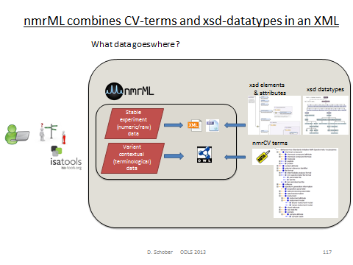

#### Criteria defining the border between XSD and CV

PUT IN ANNEX?

The XSD branches out into CV-usage, where:

* The terms describe contextual metadata, rather than NMR raw data
* The terms are unstable, variant & dynamically evolving, or need to be changed and updated often
* The terms refer to software names/versions, processing parameters etc.
* The terms are better maintained by a fast reacting NMR user community
* The terms reside at the domains leaf node level
* The terms are search attributes for data querying and DTB-integration
* The terms should be accessible to rule-based reasoning and validation
* The terms should be exploited by profiting from robust subsumption, i.e. exploiting the taxonomic CV backbone

### XSD Development

We started the nmrML.xsd development by modification of the J. Cruz xsd predecessor and under amendment with elements and structures from the BML-NMR xsd developed by Christian Ludwig and Denis Rubtsov in Birmingham.

MICHAEL, COULD YOU ADD SOME MORE TO THIS SECTION ?

#### XSD top level structure

The current top level structure of the nmrML xsd is described in Fig. 5.

**Figure 5:** The root near xml elements of the current nmrML.xsd schema, illustrating its main elements. For detailed documentation we refer to the HTML documentation, or the XSD itself, in which extensive element annotations explain the usage of the elements.



#### CV term referencing mechanism

We here outline how CV term usage is specified in the XSD (See Fig. 6). The requirement for a CV term occurrence in an xml is specified in the XSD by *reference elements* as illustrated in Table 1. Keep in mind that the last element captures free text and makes no CV reference.

SHOULD WE PUT THIS IN ANNEX ?

**Table 1:**Illustration xml element tapes used for CV and user parameter entry.

|  |  |  |  |  |
| --- | --- | --- | --- | --- |
| **Reference Element** | **Definition** | **Attributes** | **Example** | **Comment** |
| CVTermType | This element holds additional data or annotation as a simple CV term with no further values (Parameters) associated with it. Only controlled CV terms values are allowed here. | CVRef, accession, name | DO WE NEED THE LAST TWO COLUMNS ? |  |
| CVParamType | This element holds additional data or annotation. In contrast to CVTermType, here a pair of CV term plus a value (=Parameter) is captured. Only controlled values are allowed here. | CVRef, accession, name, value |  |  |
| CVParamWithUnitType | This element holds additional data or annotation. Only controlled values are allowed here. | CVRef, accession, name, value, unitCVRef, unitAccession, unitName |  |  |
| ValueWithUnitType | This element holds additional data or annotation. Only controlled values are allowed here. For cases where only a Value with an ontologically defined Unit should be given | Value, unitAccession, unitName, unitCvRef |  |  |
| UserParamType | Uncontrolled user parameters (essentially allowing free text). For cases where no suitable CV term exists. Before using these, one should verify whether there is an appropriate CV term available, and if so, use the CV term instead. This list can however later be exploited to generate corresponding term requests in given ontologies or CVs. | Name, valueType, value, unitAccession, unitName, unitCvRef |  |  |

**Figure 6**: Specification of CV term usage via the CVParam element in the XSD

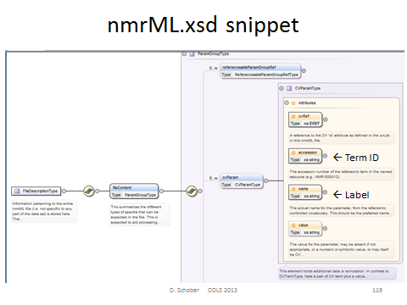

An example of how a CV term is used in an example XML instance can be found in Fig. 7.

**Figure 7**: Example xml instance illustrating instantiation of CV terms to describe a concrete file content via CV Parameters

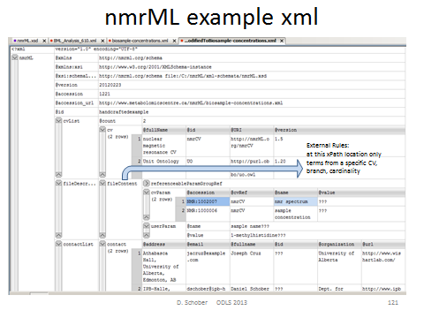

### nmrML Validation approach

Semantic validity of CV terms used in a valid XML instance (allowed CV terms, position/relation to each other and cardinality) is validated by rule-based proprietary validators which exploit xsdToCV mapping files (ready by next deliverable). By means of cardinality specifications and XPath expressions defined in an XML mapping file (an instances of the CvMappingRules.xsd), we define what CV terms are allowed in a specific location of the XSD data model (Fig. 8).

**Figure 8:** Multiple validation layers constrain data entry and support quality assurance

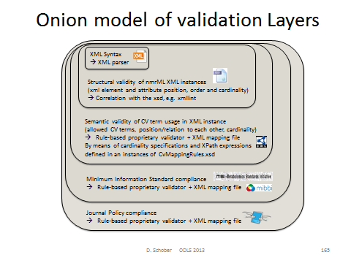

#### An example of syntactic validation of the xml

We see from the Oxygen xerces test on the example xml (homolog to the J.Cruz example) how the XSD already helps constraining the user Input to senseful data, e.g. in the following case for the pH value which is defined to be of type double in the XSD, but was put as String “n/a” in the xml instance, which hence lead to an error message as shown in this GUI screenshot: PUT IN ANNEX ?

**Figure 9**: xerces xml parser error message on wrong data type in xml instance

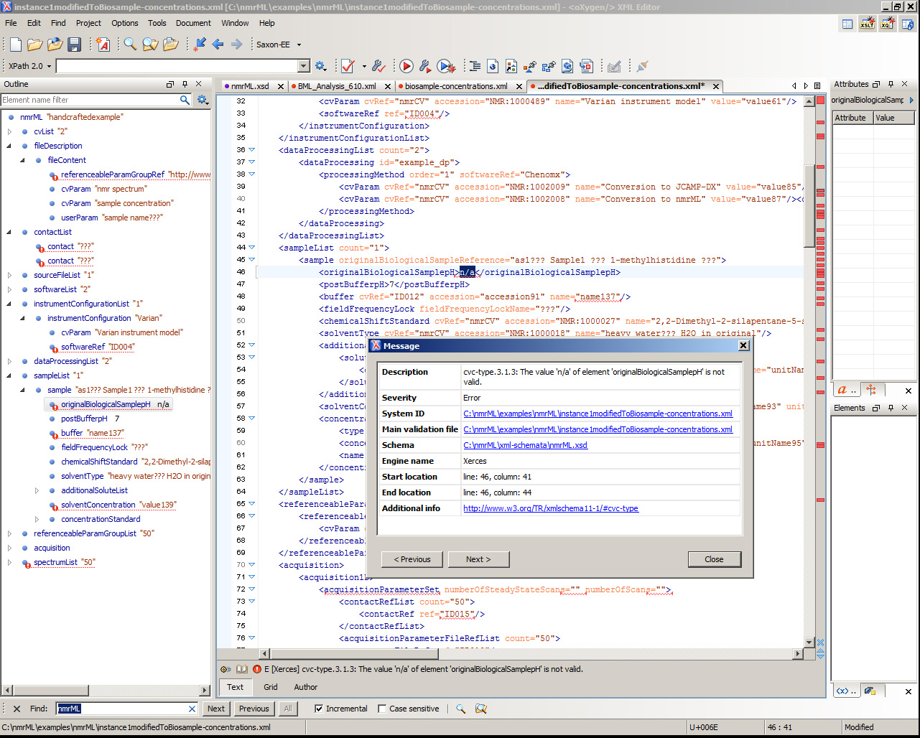

### CV development history

After agreement on the set up of development tools (Protégé 4), we formulated our CV design principles, namely agreed on file names, format syntax, namespaces, (auto) term ID schemes, a term obsoletion policy, as well as versioning & release procedures. From the given predecessor CVs we proceeded in a bottom-up and middle out Approach to expand the CV. We first added CV terms as required in the XSD leafs, i.e. where CVTermType, CVParamType, CVParamWithUnitType references occure in XSD elements. After this we continued in a use case driven term population. No high throughput term-additions were attempted in our early design phase, as this would clutter CV with terms of doubtful need, impair orientation in the term tree as too many terms distract us from getting the main structure right.

### CV design decisions

#### Choosing a CV exchange syntax

We choose the **OWL Syntax over the OBO format** as exchange syntax for the CV. The reasons were that the OBO tools are instable, the OBO format is only established in the biology domain (lack of off-the-shelf development tools, OBO expressivity not as formal as OWL-DL) and there are hence less resources to integrate with.

#### CV expressivity and semantics

We maintain a pure taxonomy without use of axiomatic definitions. Multiple parenthood is however allowed but needs to be maintained manually, as DL reasoning is not possible without DL axiomatisations.

#### Minimal metadata on a CV term

Representational Unit (RU) metadata is captured via standardized owl annotation properties drawn from imported artefacts like DC, skos and IAO. Not all of our terms currently have natural language definitions as these are time-intensive. None has deeper provenance data explicitly annotated (there is only an implicit indication on from which predecessor CV a term came in the ID ranges). We try to avoid getting stuck in the meta-ether, and had been pragmatic about this.

A term batch submission table should have the following mandatory fields:

term name (rdfs:label)

term definition in natural language (IAO_0000115, or skos ?)

superclass (ideally a term from the current nmrCV.owl, or an own suggestion)

Optional fields:

synonym (oboInOwl:hasExactSynonym)

term definition source (dc:source)

dc:contributor

dc:creator

example of usage (skos:example)

#### Top Level Ontology usage

There are a few top and upper level ontologies established in the ontology domain. From BFO, OBILight & BioTopLight (btl2), we choosed btl2 as top level ontology to guide our CV upper level development. The reason was that the WP2 leads are involved in btl2 development (fast to react) and btl2 provides a proper set of object properties (close to Relations Ontology). At the moment only a few relations from unit ontology (UO) are used. Bridges from btl2 to BFO & other TLOs exist and we can at some later point still switch the TLO, as we don‘t use any axioms anyway (It‘s only ~10 classes anyway, rebinning is easy). It can be argued why we use a TLO when developing a CV not an Ontology. There has already been a case where the TLO provided modeling restrictions that allowed an automatic DL reasoner to discover CV modelling errors, e.g.<https://github.com/nmrML/nmrML/issues/62>

Nevertheless, at the moment we avoid any usage of object properties from the CV. E.g. for a software vendors file format, we could have in the CV:

NMR Instrument hasVendor Vendor

Instead, we say in the mapping file that for an Instrument, the Name and Vendor has to be specified.

#### Term reference and import mechanism

There are four possible ways to reuse existing CV terms from other ontologies. We majorily used the first method:

1. use the terms in the CV by ID reference (e.g. as done with IAO metadata). This option is fast and flexible, but no metadata on used terms available.

2. use the MIREOT term referencing method. This option is too complicated and relies on outdated scripts

3. use full owl:import statements (e.g. as done for UO). This option however clutters the CV with seldomly used terms, occupies RAM, but retains all metadata. This option is overshot for most use cases.

4. use dbxref statements. These are easy but not a standard way in OWL (these annotation properties are provided by the OBOinOWL namespace)

#### Term naming conventions

We apply a labelling scheme in accordance to <http://www.obofoundry.org/wiki/index.php/FP_012_naming_conventions>. The OntoCheck P.4 plugin (Fig. 10) is used to avoid term redundancies, i.e. to check on redundant labels, e.g. it detected that ‘TecMag’ was included twice, once under http://nmrML.org/nmrCV#NMR_400285 (NMR data format) and once under http://nmrML.org/nmrCV#NMR:1400255 (NMR_vendor). This redundancy could then be removed by specifying a more explicit label.

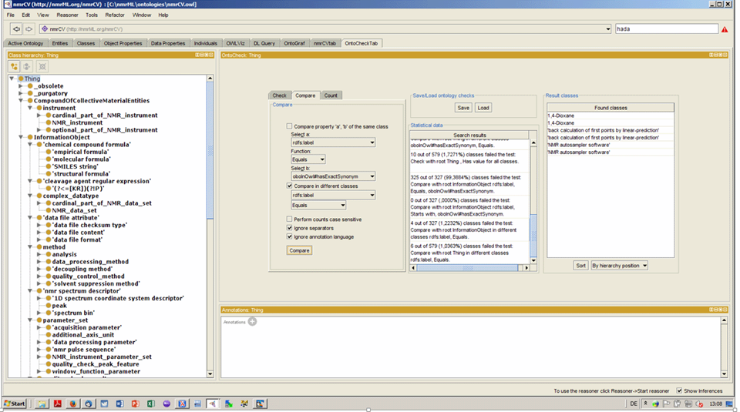

**Figure 10:** A screenshot displaying maintenance of the CV in the ontology editor Protégé 4. The OntoCheck Tab is shown which displays the CV term hierarchy to the left and allows to specify and label comparison check to discover redundant labels.

### XSD current status and metrics

[Michael: todo]

### CV current status and metrics

We here provide the statistics describing the CV (Figure 11).

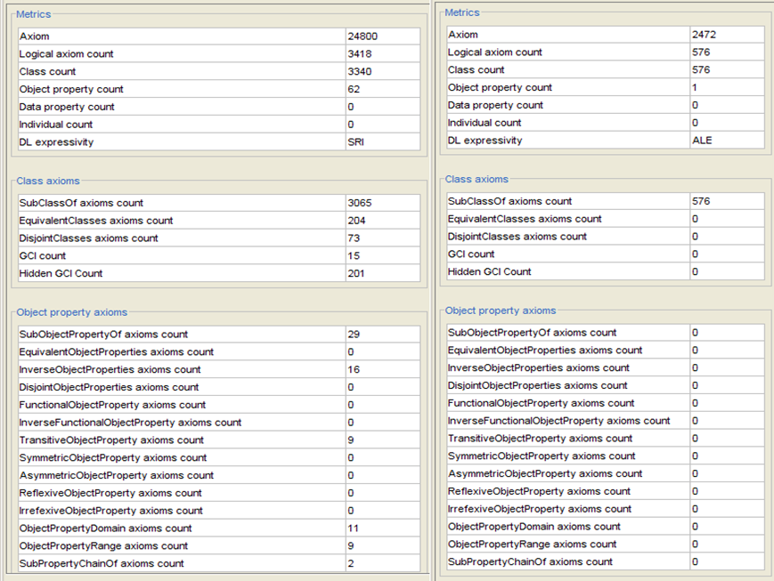

**Figure 11**: The left side displays the metrics of the nmrML-CV with, the right side without the imported ontologies (btl2 and UO).

### Source files and documentation

All source files are available on the project Github pages, together with an accompanying readme file. A first prototype version of the nmrML XSD, accompanying CV and example XML instances are available under the Github development pages.

**The nmrML XML Schema (XSD):**

<https://github.com/nmrML/nmrML/blob/master/xml-schemata/nmrML.xsd>

**The nmrML Controlled Vocabulary (CV):**

<https://github.com/nmrML/nmrML/blob/master/ontologies/nmrCV.owl>

**The nmrML example files:**

<https://github.com/nmrML/nmrML/tree/master/examples/working.tmp/nmrML> &

<https://github.com/nmrML/nmrML/tree/master/examples>

Browsable HTML serializations of the XSD and the CV can be found in the github folders nmrML\docs\SchemaDocumentation\HTML_Serialisations and nmrML\docs\CVDocumentation\OwlDoc respectively.

**GitHub:** <https://github.com/nmrML/nmrML>**Cosmos website:** [http://www.cosmos-fp7.eu](http://www.cosmos-fp7.eu/)

**nmrML website:** [http://nmrml.org](http://nmrml.org/)**nmrML wiki:** <http://cosmos-fp7.eu/nmrML/>

**nmrML google forum:** [https://groups.google.com/forum/#!forum/nmrml](https://groups.google.com/forum/)

### Example implementations

We created two example xml files from our use cases to serve as data-driven check on the format.

**Example 1:**

At first, we analyzed, if our schema compensated for all data required by the original predecessor. The original J Cruz nmrML XML example was taken from <http://www.metabolomicscentre.ca/nmrML/biosample-concentrations.xml> and was transliterated into an nmrML XML instance generated via Oxygen as described at <http://www.oxygenxml.com/doc/ug-editor/topics/xml-schema-instance-generator.html>Where the correct entity usage for some values were doubtful, value entries were marked with the String "???". Not used elements and attributes containing the mere default autogenerated values were deleted in the final version.

**Example 2:**

MW, please add a few lines here.

Further example files were generated from metabolights entry MTBLS1 and 25 data as well as for IPB Hop data [Ref].

## Next steps

[MW, please add what’s missing on the XSD-next steps]

The next step is to plan the first release of the core xsd and initial CV. At the same time we will continue the data-driven CV expansions and add new terms according to the additional examples selected by our different partners. On the CV side we also need to integrate new EBI-NMR CV classes (using tabular mass term import).

In general we have to extend the format specification, e.g. adding more experimental metadata, such as sample types as well as more information on metabolite identification and quantification (both XSD and CV side). Also we need to work out an evaluation pipeline. As part of the next deliverable (D2.5 - Real data, Converters, Validators and Parsers for NMR-ML, m24), we will implement the CV-aware validator software and mapping files containing verification rules in order to check xml instances on semantic errors and completeness. In parallel we implement parsers for format conversions and I/O to open source tools. The creation of ISA Tab specifications for easy tabular data entry and minimal reporting requirement enforcement is considered a further next step (D2.6).

# 4 Publications

Schober D., Mayer G., Moing A., Eisenacher M., Neumann S., **Ontological analysis of controlled vocabularies used in PSI/MSI supported XML standards**, Workshop: ODLS 2013, GI-Edition Lecture Notes in Informatics, *Proceedings of the Jahrestagung der Gesellschaft für Informatik 2013*, Matthias Horbach (Hrsg.), Koblenz, Germany, 16.–20. September 2013, p. 1875-1888,<https://wiki.imise.uni-leipzig.de/Gruppen/OBML/Workshops/2013-ODLS-en>

Metabolomics letter/paper ?

# 5 Delivery and schedule

The delivery is delayed: ◻ Yes ☑ No

# 6 Adjustments made

None.

# 7 Efforts for this deliverable

|  |  |  |  |
| --- | --- | --- | --- |
| **Institute** | **Person-months (PM)** |  | **Period** |
|  | **actual** | **estimated** |  |
| 11. IPB | 3 | 3 | 6 |
| Total |  |  |  |

# Appendices

**Detailed version history of the CV**

* v.1 initial result from the Obo Edit OBO to OWL conversion
* v.2 added RA Metadata (just using standard annotation properties, i.e. DC)
* v.3 added BFO 1.1 import (better for OBO backwards compatibility)
* v.4 This version as v.3, but importing BFO 2.0 instead of non-DL BFO 1.1. BFO 2.0 is experimental, but has a rich set of relations integrated from RO, For BF0 2.0, see http://ncorwiki.buffalo.edu/index.php/Basic_Formal_Ontology_2.0:_Tutorial_at_ICBO/FOIS, file loads from http://bfo.googlecode.com/svn/releases/2012-11-15-bugfix/owl-group/bfo.owl
* v.5 This version as v.4, but additionally importing MSI NMR.owl developed at EBI
* v.6 This version as v.5, but importing BiotopLight2.0 instead of BFO 2.0 as top level ontology
* v.7 This version is a complete new start (as v.6 ended up being too complex and error prone). For this version I removed the unit import from the Wishard nmr.obo, converted it into owl and imported biotop light 2 and the msi-nmr.owl. To make editing easier, I will merge the owl files physically rather than importing the msi-nmr.owl. The tol level classes from OBI and BFO will then vanish as well.
* v.8 This version as v.7, but namespace set to NMR, added _purgatory helperclass and started rebinning under BiotopLight 2.
* v.9 This version as v.8, but Wishard CV binned under biotopLight2 (btl2). Added RA metadata.
* v1.0 As v.9, but removed OBI temporary and outdated IDs and Refs.Taxonomic re-binning of classes that part_of /is_a 'Metabolomics Standards Initiative NMR Spectrometry Vocabularies' under appropriate Biotop classes. Integration of required xsd leaf nodes into CV (see below). Removed Wishard Top Level nodes of doubtful justification, i.e. 'Metabolomics Standards Initiative NMR Spectrometry Vocabularies' and 'spectrum generation information' and 'spectrum interpretation'.
* v1.1 Merged msi namespace nmr ontology (Schober NMR) into Wishard CV (using P4 Refactoring/Merge) in order to get rid of import statements and restriction overriding.
* v1.2 Entity (ID) renaming of newly (physically) integrated MSI NMR Terms from MSI namespace to Cosmos nmrML namespace.
* v1.3 File renaming to get rid of version in Filname (now stores as RA annotation property) infile. New Namespace (now set to http://nmrML.org/nmrCV to distinguish it from xsd namespace). Alignment of ID schemes:To archieve this, we substituted 541 occurances of "nmrCV_" for "nmrCV#NMR:" in the complete owl file. Then we substituited 710 occurrances of "nmrCV#MSI_" with "nmrCV#NMR:1" to align the old MSI IDs to the new NMR prefix and 7 digit length. Importing DOAP, added RA metadata using http://usefulinc.com/ns/doap#, then removed doap import to get rid of confusing class top level.
* v1.4 Empty outdated namespace declarations and NS prefix declarations were removed from the file. The following object properties were taken out of the owl file:

http://nmrML.org/nmrCV#has_regexp

http://nmrML.org/nmrCV#has_units

http://nmrML.org/nmrCV#part_of

Their usage in the old Cruz obo file was minor and has to be recreated by hand, but ideally with relations from btl2.

* v1.5 Major restructuring and redundancy removal, i.e. instruments are now captured as instrument attribute/models.
* v1.6 CV is now also covering the term-needs for the BML-NMR XSD. But, again, the CV is still considered to be a prototype. Its coverage can be very shallow at times. For some cases there is merely a corresponding CV Entry Class available (to be referenceable by the xsd), which has no further subclasses. These leaf nodes will have to be expanded successively via our use cases and later by term-requests from the practitioners/users. We can expect the CV to grow from currently to about 2500 Terms (as in PSI MS CV). Labels were aligned to be consistent, i.e. NMR_spectrum_post-processing_parameter_set was changed to NMR_data_post-processing_parameter_set to be in harmony with the existing NMR_data_pre-processing_parameter_set. 'run attribute' was moved into purgatory. Use acquisition parameter instead. This version imports the owl versions of Unit Ontology and PATO (Qualities).
* v1.7 Stop any notion of pre and post-processing (there is no agreement on meaning and start/end). We now use 'frequence domain processing' and 'time domain processing' as sortals for processing parameters.

**CV Issues**

•Reduplication in disjoint trees, e.g. software names or Vendors in file formats, …

•Classifying spectrum prosessing methods according to pre/post acqu, or pre/post FT ?

–Agreed on Time domain Processing and Frequency domain processing

•Border nmrCV (raw data) to nmrIdentCV ?

– Both in one & the same nmrCV file, but could add slim indicator for that.

# Background information

|  |
| --- |
| UPDATE WITH WP INFO  This deliverable relates to WPX; background information on this WP as originally indicated in the description of work (DoW) is included below.  WPX Title: Insert WP title  Lead: Insert WPL name, affiliation  Participants: Insert partners involved in WP  Insert WP summary |

|  |  |  |  |
| --- | --- | --- | --- |
| **Work package number** | WPX | **Start date or starting event:** | month X |

|  |  |
| --- | --- |
| **Work package title** | Insert WP title |
| **Activity Type** | Insert activity type (e.g. RTD, MGT) |

|  |  |  |  |  |  |  |  |  |
| --- | --- | --- | --- | --- | --- | --- | --- | --- |
| **Participant number** | No: partner | 11. IPB | No: partner | No: partner | No: partner | No: partner | No: partner | No: partner |
| **Person months per participant** | XX |  | XX | XX | XX | XX | XX | XX |

|  |
| --- |
| **Objectives**     1. Insert objective 1 2. Insert objective 2 |
| **Description of work and role of participants**  Insert WP description, tasks etc. |
| **Deliverables** |

|  |  |  |
| --- | --- | --- |
| **No.** | **Name** | **Due**  **month** |
| DX.X | Insert deliverable title | X |
| DX.X | Insert deliverable title | X |