# UNIX/Linux Course

Module 1 Assignment

**Problem Statement:**

You are assigned a task to install a web server, in order to control multiple worker processes from one master process. After you've done your research you found out that NGINX is the best suitable option in this scenario. Update the host system and install NGINX. Check the version installed.

Solution :

* The Process of installing NGINX web server in our host system .
* First we are creating a ec2 instance with ubuntu os

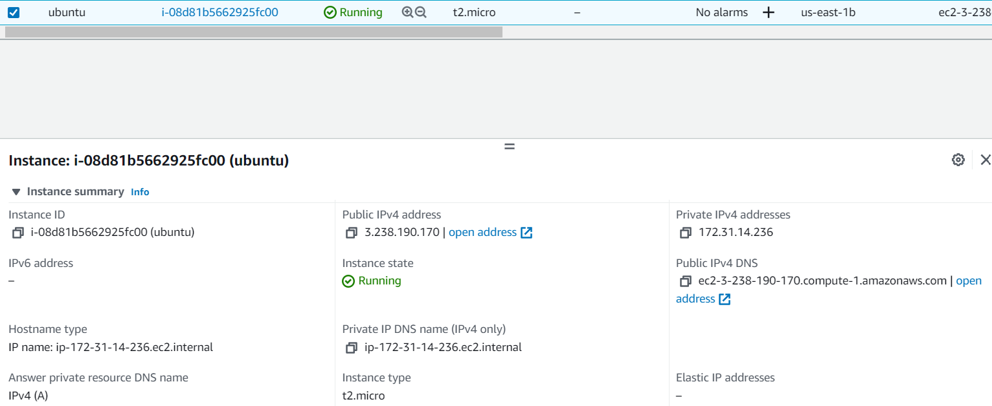

* After that we are connecting the instance through putty

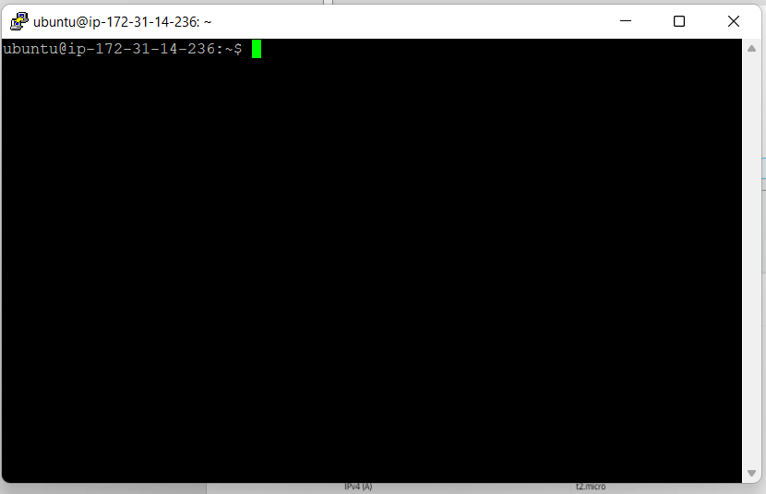

* And the we are updating the system with command sudo apt-get update

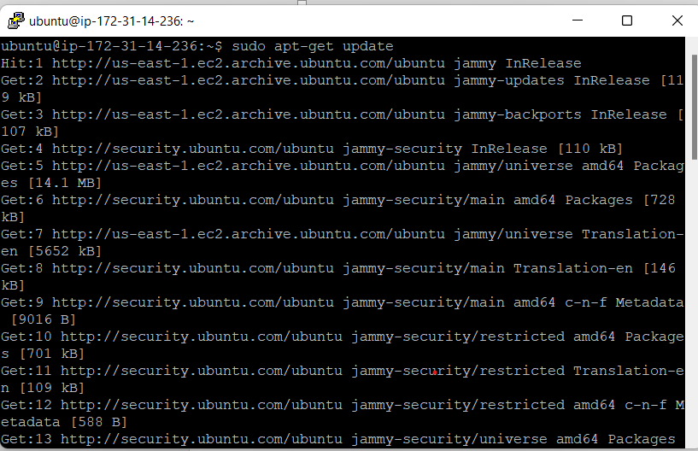

* Now we are installing our web server NGINX server by using command sudo apt-get install nginx

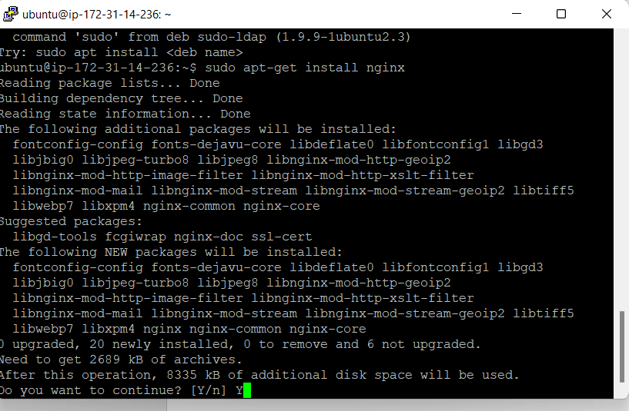

* Now checking the version of out nginx server

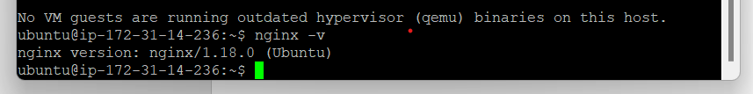

Thank you

# [support@intellipaat.com](mailto:support@intellipaat.com) - +91-7022374614 - US: 1-800-216-8930 (Toll Free)