**KPIs –**

**Total Loan Application –**

select * from Bank_Loandata

/* Total Loan Application from banl loan data */

select count(id) as Total_Loan_Application from Bank_Loandata

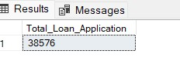

/*MTD Loan Application*/

select count(id) as MTD_Total_Loan_Application from Bank_Loandata

where MONTH(issue_date) = 12 and YEAR(issue_date) = 2021

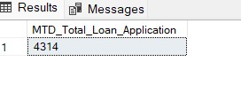

/*Previous Month To Date Loan Application*/

select count(id) as PMTD_Total_Loan_Application from Bank_Loandata

where MONTH(issue_date) = 11 and YEAR(issue_date) = 2021

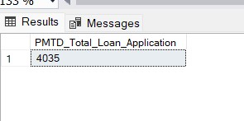

/* Total Funded Amounts */

select sum(loan_amount) as Total_Funded_Amounts from Bank_Loandata



/*Month Of Total Funded Amounts*/

select sum(loan_amount) as Month_Of_Total_Funded_Amounts from Bank_Loandata

where MONTH(issue_date) = 12 and YEAR(issue_date) = 2021

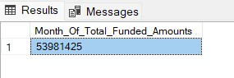

/* Previous Month Of Total Funded Amounts */

select sum(loan_amount) as Previous_Month_Of_Total_Funded_Amounts from Bank_Loandata

where MONTH(issue_date) = 11 and YEAR(issue_date) = 2021

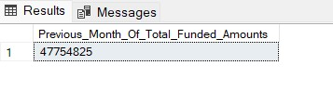

/* Total Amount received */

select sum(total_payment) as Total_Amount_Collected from Bank_Loandata

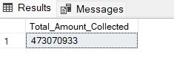

/*MTD Total Amount Received */

select sum(total_payment) as MTD_Total_Amount_Collected from Bank_Loandata

where MONTH(issue_date) = 12 and YEAR(issue_date) = 2021

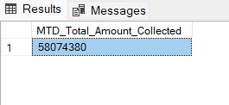

/*PMTD Total Amount Received */

select sum(total_payment) as PMTD_Total_Amount_Collected from Bank_Loandata

where MONTH(issue_date) = 11 and YEAR(issue_date) = 2021

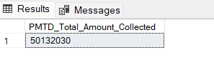

/* Average Interest Rate */

select round(avg(int_rate), 4)*100 as Avg_Interest_Rate from Bank_Loandata

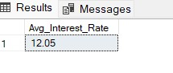

/* Average MTD Interest Rate */

select round(avg(int_rate), 4)*100 as MTD_Avg_Interest_Rate from Bank_Loandata

where MONTH(issue_date) = 12 and YEAR(issue_date) = 2021

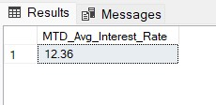

/* Average PMTD Interest Rate */

select round(avg(int_rate), 4)*100 as PMTD_Avg_Interest_Rate from Bank_Loandata

where MONTH(issue_date) = 11 and YEAR(issue_date) = 2021

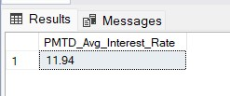

/* Average DTI */

select round(avg(dti), 4)*100 as Avg_DTI from Bank_Loandata

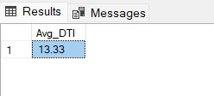

/* Average MTD DTI */

select round(avg(dti), 4)*100 as MTD_Avg_DTI from Bank_Loandata

where MONTH(issue_date) = 12 and YEAR(issue_date) = 2021

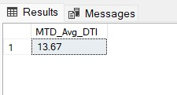

/* Average PMTD DTI */

select round(avg(dti), 4)*100 as PMTD_Avg_DTI from Bank_Loandata

where MONTH(issue_date) = 11 and YEAR(issue_date) = 2021

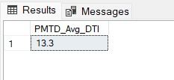

/* Good Loan Issued */

select * from Bank_Loandata

/* Good Loan Percentage */

select loan_status from Bank_Loandata

select

(count(case when loan_status = 'Fully Paid' or loan_status = 'Current' then id END) * 100)

/

count(id) as Good_Loan_Percentage

from Bank_Loandata

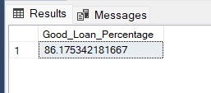

/* Good Loan Application */

select count(id) as Good_Loan_Application from Bank_Loandata

where loan_status = 'Fully Paid' OR loan_status = 'Current'

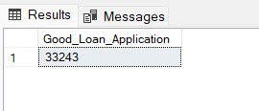

/* Good Loan Funded Amount */

select sum(loan_amount) as Good_Loan_Funded_Amount from Bank_Loandata

where loan_status = 'Fully Paid' OR loan_status = 'Current'

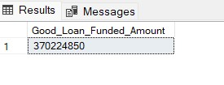

/* Good Loan Amount Received */

select sum(total_payment) as Good_Loan_Amount_Received from Bank_Loandata

where loan_status = 'Fully Paid' OR loan_status = 'Current'

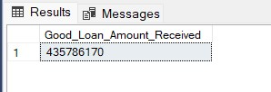

/* Bad Loan Percentage */

select

(count(case when loan_status = 'Charged Off' then id END) * 100.0)

/

count(id) as Bad_Loan_Percentage

from Bank_Loandata

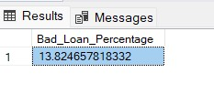

/* Bad Loan Application */

select count(id) as Bad_Loan_Application from Bank_Loandata

where loan_status = 'Charged Off'

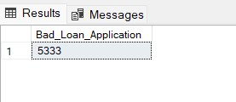

/* Bad Loan Funded Amount */

select sum(loan_amount) as Bad_Loan_Funded_Amount from Bank_Loandata

where loan_status = 'Charged Off'

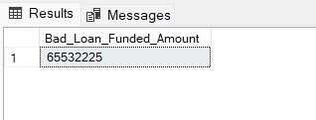

/* Bad Loan Amount Received */

select sum(total_payment) as Bad_Loan_Amount_Received from Bank_Loandata

where loan_status = 'Charged Off'

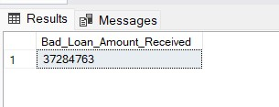

select

loan_status,

count(id) as Total_Loan_Applications,

sum(total_payment) as Total_Amount_Received,

sum(loan_amount) as Total_Funded_Amount,

avg(int_rate * 100) as Interest_Rate,

avg(dti * 100) as DTI

from

Bank_Loandata

group by

loan_status

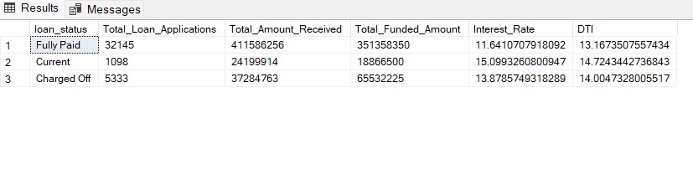

select

loan_status,

sum(total_payment) as MTD_Total_Amount_Received,

sum(loan_amount) as MTD_Total_Funded_Amount

from Bank_Loandata

where month(issue_date) = 12

group by loan_status

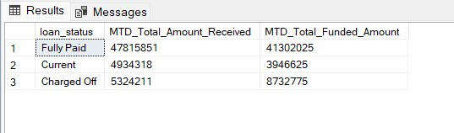

/* Dashboard 2 Overview */

/* Bank Loan Report Overview */

select * from Bank_Loandata

select

MONTH(issue_date) as Month_Number,

DATENAME(MONTH, issue_date) as Month_Name,

COUNT(id) as Total_Loan_Application,

SUM(loan_amount) as Total_Funded_Amount,

SUM(total_payment) as Total_Received_Amount

from Bank_Loandata

GROUP BY MONTH(issue_date), DATENAME(MONTH, issue_date)

ORDER BY MONTH(issue_date)

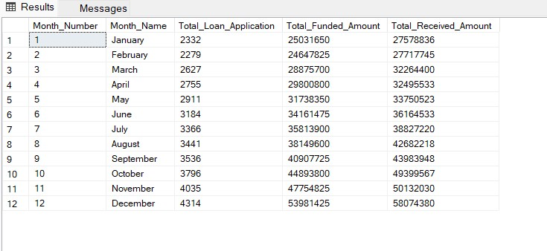

/* Regional Analysis By State */

select address_state,

COUNT(id) as Total_Loan_Application,

SUM(loan_amount) as Total_Funded_Amount,

SUM(total_payment) as Total_Received_Amount

from Bank_Loandata

Group By address_state

Order By SUM(loan_amount) DESC

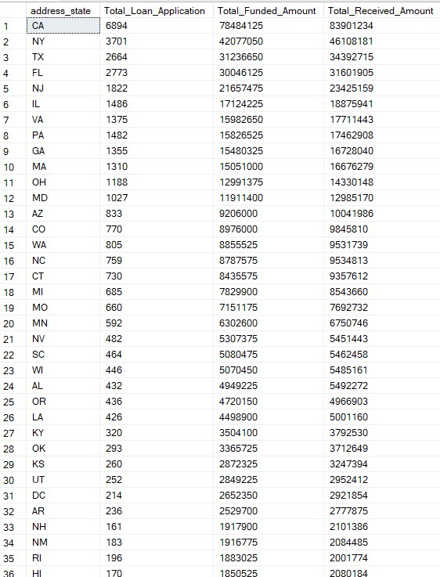

select address_state as State,

COUNT(id) as Total_Loan_Application,

SUM(loan_amount) as Total_Funded_Amount,

SUM(total_payment) as Total_Received_Amount

from Bank_Loandata

Group By address_state

Order By address_state

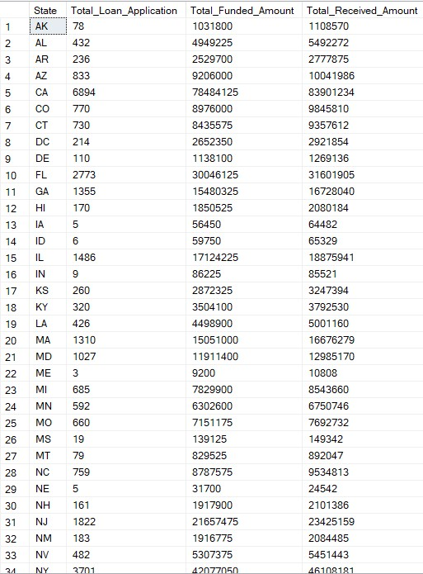

/* Term */

select term as Term,

COUNT(id) as Total_Loan_Application,

SUM(loan_amount) as Total_Funded_Amount,

SUM(total_payment) as Total_Received_Amount

from Bank_Loandata

Group By term

Order By term

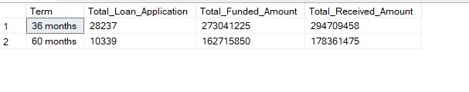

/* Employee Length */

select emp_length as Employee_Length,

COUNT(id) as Total_Loan_Application,

SUM(loan_amount) as Total_Funded_Amount,

SUM(total_payment) as Total_Received_Amount

from Bank_Loandata

Group By emp_length

Order By emp_length

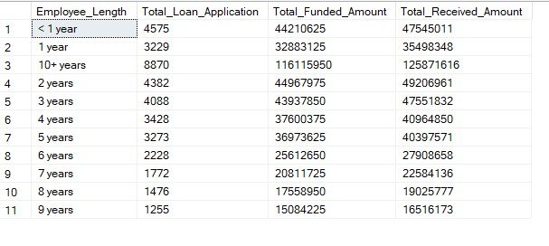

/* With Respect To Purpose */

select * from Bank_Loandata

select purpose as Purpose,

COUNT(id) as Total_Loan_Application,

SUM(loan_amount) as Total_Funded_Amount,

SUM(total_payment) as Total_Received_Amount

from Bank_Loandata

Group By purpose

Order By purpose

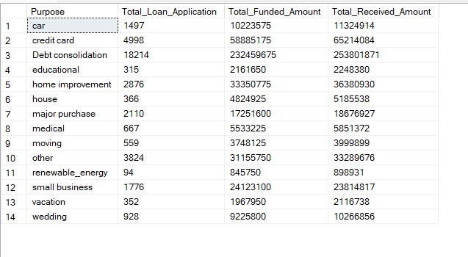

/* with respect to home ownership */

select home_ownership as HomeOwnership,

COUNT(id) as Total_Loan_Application,

SUM(loan_amount) as Total_Funded_Amount,

SUM(total_payment) as Total_Received_Amount

from Bank_Loandata

Group By home_ownership

Order By home_ownership

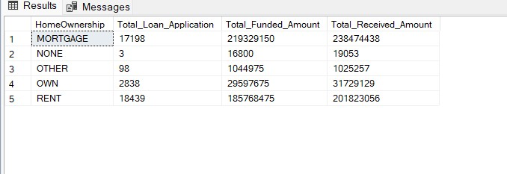

select purpose as Purpose,

COUNT(id) as Total_Loan_Application,

SUM(loan_amount) as Total_Funded_Amount,

SUM(total_payment) as Total_Received_Amount

from Bank_Loandata

where grade = 'A'

Group By purpose

Order By purpose

