**Title of Problem:**

- A Cat, a Parrot, and a Bag of Seed.

Discussion of – or Defining the Problem:

- This is nothing more than a simplification of the variant problem of transporting multiple persons/things whilst containing certain pre-determined disallowed solutions. What makes every version of this problem difficult is not finding the solution, but working around the *disallowed* solutions.

In this variant – we need only concern ourselves with three unique identifiers (the cat, the parrot, and the bag of seed.) – which immediately invites the notion that the potential solutions will be limited. If I can only ferry one across at a time – this of course limits the variables. There is also a hidden “assumption” that many make – and that is that one would return with NOTHING to the original side. After all – why go back and undo what you did already?

The overall goal is to “be on the other side” of the river – with all of the possessions in question, whilst losing none due to failure to observe the rules. Simply put: get all of the man’s possessions to the other side.

Breaking Apart the Problem:

* The Constraints:
  + It needs to be noted that here – there are essentially three constraints.
  + Only one object can move at a time.
  + The bird cannot be *alone* with the cat
  + The bird cannot be *alone* with the seed.
* Why the emphasis on the word “alone”? --
  + This emphasis helps to show that RETURNING with an object is essential to the solution.
  + This shows that as long as the man is on the same side as the conflicting possessions – their “disallowed state” will not trigger.
* The Sub-Goals:
  + We need to get the Parrot to the other side.
  + We need to get the Seed to the other side.
  + We need to get the Cat to the other side.
  + We cannot allow any possession to eat any other possession.

Identifying Potential Solutions:

Initially, most of those who pay attention will notice that the bird is the single greatest point of failure (more situations where this possession’s presence defaults to failure.) This would lead most to view that the Parrot needs to move first. Therefore, one potential solution is to cross the river with each object – one at a time, returning empty-handed; and subsequently retrieving another item. In theory, this would literally accomplish each of the first three sub-goals.

If we evaluate C = Cat, P = Parrot, and S = Bag of Seed, then this solution looks like this: ( This “|” rivers to each side of the river.)

Step 1) C S | P

Step 2) Return from right to left

Step 3) S | C P

Step 4) Return from right to left

Step 5) | C S P

Step 6) Complete

Another solution is to make sure that whenever the man must interact with another object – other than the bird: he gets the bird back in his possession. This can be done by carrying the bird any time there is at least one of the other objects on any given side of the river.

If we evaluate

If we evaluate C = Cat, P = Parrot, and S = Bag of Seed, then this solution looks like this: ( This “|” rivers to each side of the river.)

Step 1) C S | P

Step 2) Return from right to left

Step 3) S | C P M

Step 4) Return from right to left WITH PARROT! (thus we include a new factor – the presence of the man (M) as a solution):

S P M | C

Step 5) P | C S M

Step 6) Return from right to left

Step 7) | C S P M

Step 8) Complete

Evaluating Solutions:

* Unfortunately the first solution does not meet all the goals as it fails to account for the failure value of one object eating another. Whilst initially beating this during the first step of removing the Parrot – it fails in later steps by either bringing the Cat or the Seed and failing to remove the Parrot from the situation
* The second solution *does* meet all of the goals – however; this takes more steps to evaluate and complete. Success, however; is the goal.

Implementing a Solution:

We must now test – using better visual aids, if the solution works:

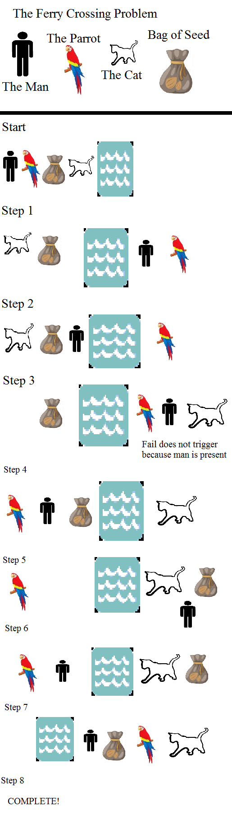

YES! Also, we learn there are TWO potential, successful solutions – Upon reaching Step 3 – it does not matter if we decide to bring the seed OR the cat over first. Either will evaluate as success.