In today's world, more than 70% of businesses have used some variant of Agile model in their IT projects (NEED BA MAY CITATIONS?). The researchers or developers will use the Agile Software Development Life Cycle and to be more effective researchers will follow the two software development models, the Scrum model and Kanban model which is under the agile SDLC. Agile SDLC and models are iterative development, intensive communication, and early customer feedback (NEED BA MAY CITATIONS?). Each Agile iteration usually lasts a few weeks and results in a partially functional software version. The agile SDLC models place a greater emphasis on rapidly delivering a functional part of the software rather than thorough software documentations such as detailed requirement specifications and architecture descriptions, and be likely more on software testing activities. Agile SDLC also resembles the form of frequent software version releases, which allows for ongoing software improvement through simple fixes and changes, quick upgrades, and feature additions, and aids in the delivery of software that better meet the demands and needs of users.

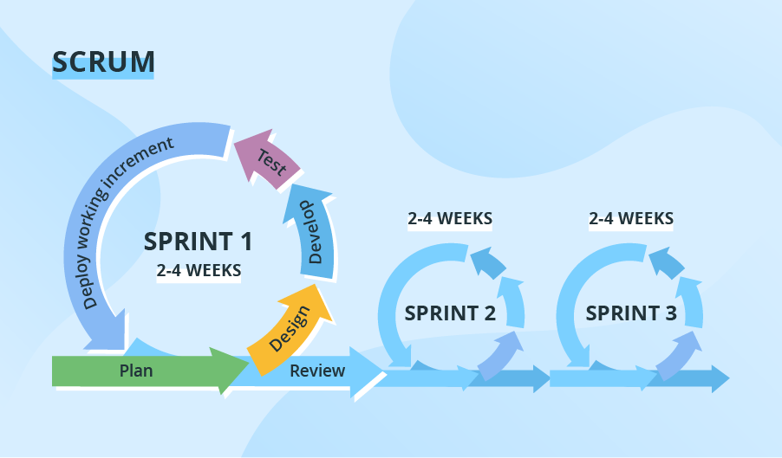

Figure 1. Representation of Scrum model from ScienceSoft website

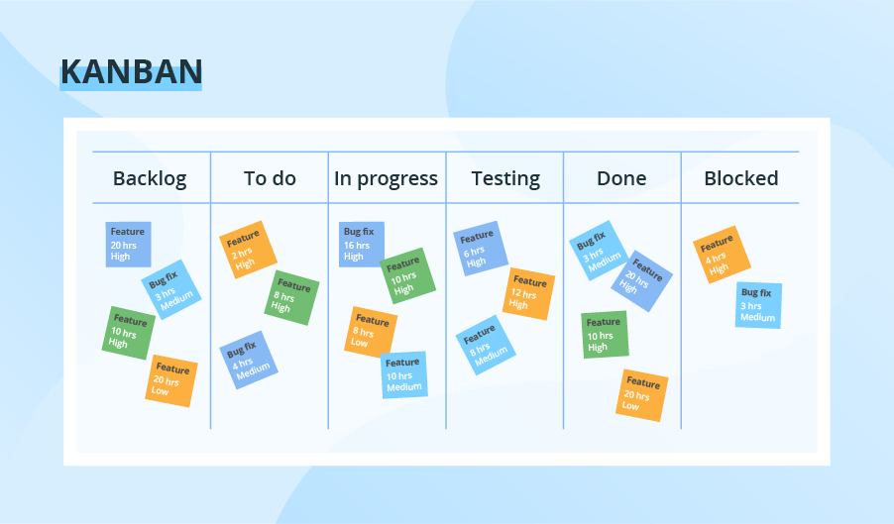

Figure 2. Representation of Kanban model from ScienceSoft website

Scrum is the most widely used Agile methodology model. The iterations ('sprints') last a week or a month and are preceded by comprehensive planning and a previous sprint review. For more effective usage of this model researchers will also use one of the most used method nowadays the Kanban model that every task is emphasis and is placed on plan visualization. The researchers or development team uses the Kanban board tool that provides a clear representation of all project activities, their number, responsible persons, and progress and this leads to the transparency of each tasks that estimates to most urgent tasks needs to be done leading to more accurate product.

In this kind of software development life cycle and models the researchers will be able to deliver a quality patch version release of the software. Giving more advantage to the researchers since the agile SDLC gets more feedback from its clients from testing phase in which will be reserved as a sprint or iteration issue that needs to be solve and fix on the next patch release of the system software.