**Form 3: RESEARCH/CAPSTONE CONSULTATION RECORD**

No. V8_3-9

*Please write legibly and in BLOCK LETTERS.*

****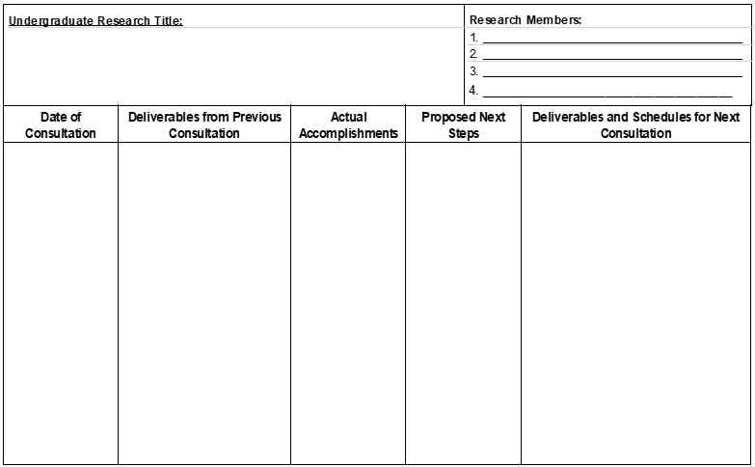

* Title, Chapter 1, and Chapter 2
* Chapter 1 & 2

N/A

* Finalize title, chapter 2 to re-finalize chapter 1, and other parts

11/25/21

* Chapter 1 & 2
* Finish the chapter 2 to re-finalize chapter 1 and other parts of research.

1. TITLE

N/A

11/09/21

HERRERA, CHARLES MAVERICK

ROCHE, JOANNE RAZELLE L.

CLARIN, MART YAZEN MIKHAIL

MATIMTIM, EL JOHN S.

*To the students:* Always bring previous Consultation Record during your consultation hours with the technical adviser. Students should accomplish this form.

*To the technical adviser:* Kindly implement a “No previous Consultation Record, no Consultation policy”.

Use another sheet if necessary. Please write clearly and legibly on this document. All Consultation Records shall be compiled and will be part of the Appendix of your final manuscript.

____________________________

Faculty Technical Adviser

*(Signature over printed name/Date)*