* What’s a microservice?

a microservice is a small, loosely coupled, distributed service.
Microservices allow you to take a large application and decompose it into easy-to-
manage components with narrowly defined responsibilities. Microservices help combat
the traditional problems of complexity in a large code base by decomposing the large
code base down into small, well-defined pieces.

A microservice architecture has the following characteristics:

- Application logic is broken down into small-grained components with welldefined
boundaries of responsibility that coordinate to deliver a solution.

- Each component has a small domain of responsibility and is deployed completely
independently of one another. Microservices should have responsibility
for a single part of a business domain.
Also, a microservice should be reusable across multiple applications.

- Microservices communicate based on a few basic principles (notice I said principles, not standards) and employ lightweight communication protocols such as
HTTP and JSON (JavaScript Object Notation) for exchanging data between the
service consumer and service provider.

- The underlying technical implementation
of the service is irrelevant because the applications always communicate with a
technology-neutral protocol ( JSON is the most common).
This means an application built using a microservice application could be built
with multiple languages and technologies.

- Microservices—by their small, independent, and distributed nature—allow
organizations to have small development teams with well-defined areas of
responsibility. These teams might work toward a single goal such as delivering
an application, but each team is responsible only for the services on which
they’re working.

* When not to use microservices

- Complexity of building distributed systems:

Because microservices are distributed and fine-grained (small),
they introduce a level of complexity into your application
that wouldn’t be there in more monolithic applications.
Microservice architectures require a high degree of operational maturity.
Don’t consider using microservices unless your organization is willing to invest
in the automation and operational work (monitoring, scaling) that a highly
distributed application needs to be successful.

- Server sprawl

One of the most common deployment models for microservices is to have one
microservice instance deployed on one server. In a large microservices-based
application, you might end up with 50 to 100 servers or containers (usually virtual)
that have to be built and maintained in production alone.
Even with the lower cost of running these services in the cloud, the operational
complexity of having to manage and monitor these servers can be tremendous.

- Type of application

Microservices are geared toward reusability and are extremely useful for building
large applications that need to be highly resilient and scalable. This is one of the reasons why so many cloud-based companies have adopted microservices. If you’re building small, departmental-level applications or applications with a small user base, the complexity associated with building on a distributed model such as microservices might be more expense then it’s worth.

- Data transformations and consistency

As you begin looking at microservices, you need to think through the data usage pat-
terns of your services and how service consumers are going to use them. A microser-
vice wraps around and abstracts away a small number of tables and works well as a
mechanism for performing “operational” tasks such as creating, adding, and perform-
ing simple (non-complex) queries against a store.
If your applications need to do complex data aggregation or transformation across
multiple sources of data, the distributed nature of microservices will make this work difficult. Your microservices will invariably take on too much responsibility and can also become vulnerable to performance problems.
Also keep in mind that no standard exists for performing transactions across
microservices. If you need transaction management, you will need to build that logic
yourself. In addition, as you’ll see in chapter 7, microservices can communicate
amongst themselves by using messages. Messaging introduces latency in data updates.
Your applications need to handle eventual consistency where updates that are applied
to your data might not immediately appear.

* Cloud configuration server

four principles

1. Segregate:
We want to completely separate the services configuration informa-
tion from the actual physical deployment of a service. Application configura-
tion shouldn’t be deployed with the service instance. Instead, configuration
information should either be passed to the starting service as environment vari-
ables or read from a centralized repository when the service starts.

2. Abstract:
Abstract the access of the configuration data behind a service interface. Rather than writing code that directly accesses the service repository (that
is, read the data out of a file or a database using JDBC ), have the application use a REST -based JSON service to retrieve the configuration data.

3. Centralize:
Because a cloud-based application might literally have hundreds of
services, it’s critical to minimize the number of different repositories used to
hold configuration information. Centralize your application configuration into
as few repositories as possible.

4. Harden:
Because your application configuration information is going to be
completely segregated from your deployed service and centralized, it’s critical
that whatever solution you utilize can be implemented to be highly available
and redundant.

Microservices Patterns:

○ Core development patterns
○ Routing patterns
○ Client resiliency patterns
○ Security patterns
○ Logging and tracing patterns
○ Build and deployment patterns

- 1. Microservice routing patterns

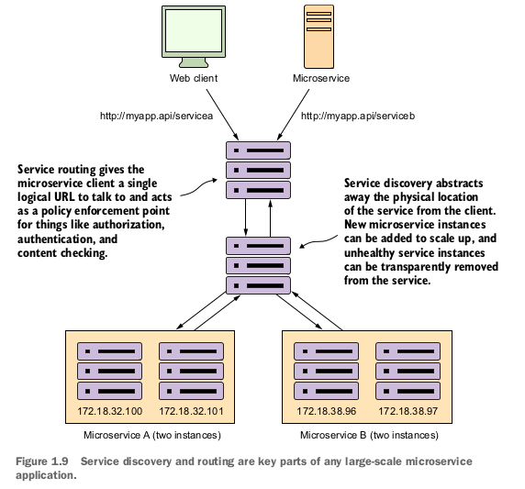

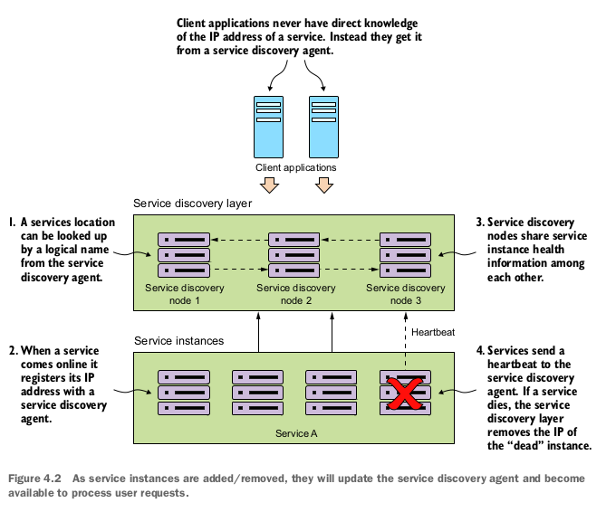

- 1.1 Client-side load balancing

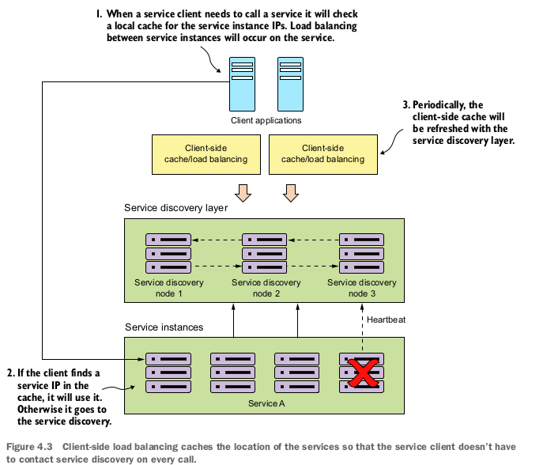

1.2

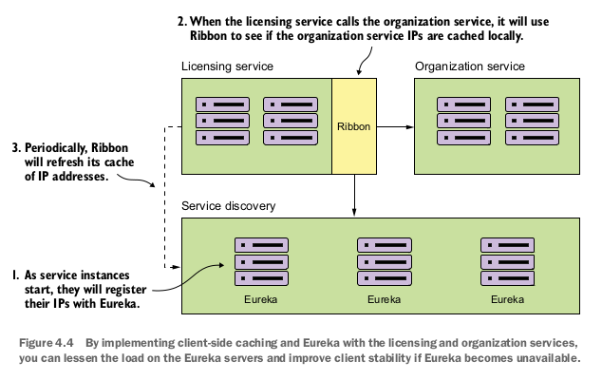

2 . Microservice client resiliency patterns

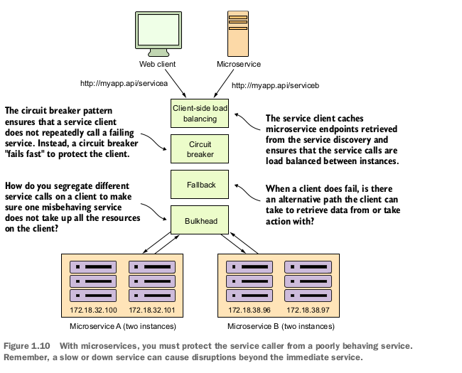

2.1 Client side load balancing

Client-side load balancing involves having the
client look up all of a service’s individual instances from a service discovery agent (like
Netflix Eureka) and then caching the physical location of said service instances.

Whenever a service consumer needs to call that service instance, the client-side load
balancer will return a location from the pool of service locations it’s maintaining.
Because the client-side load balancer sits between the service client and the service
consumer, the load balancer can detect if a service instance is throwing errors or
behaving poorly. If the client-side load balancer detects a problem, it can remove that
service instance from the pool of available service locations and prevent any future
service calls from hitting that service instance.

2.2 Circuit breaker

when a remote service is called, the circuit breaker
will monitor the call. If the calls take too long, the circuit breaker will intercede and
kill the call. In addition, the circuit breaker will monitor all calls to a remote resource
and if enough calls fail, the circuit break implementation will pop, failing fast and pre-
venting future calls to the failing remote resource.

2.3 Fallback Processing

With the fallback pattern, when a remote service call fails, rather than generating an
exception, the service consumer will execute an alternative code path and try to carry
out an action through another means. This usually involves looking for data from
another data source or queueing the user’s request for future processing. The user’s
call will not be shown an exception indicating a problem, but they may be notified
that their request will have to be fulfilled at a later date

2.4 Bulkheads

By using the bulkhead pattern, you can break the calls to remote
resources into their own thread pools and reduce the risk that a problem with one
slow remote resource call will take down the entire application. The thread pools act
as the bulkheads for your service. Each remote resource is segregated and assigned to
the thread pool. If one service is responding slowly, the thread pool for that one type
of service call will become saturated and stop processing requests. Service calls to
other services won’t become saturated because they’re assigned to other thread pools.

Using a single thead pool (avoid this):

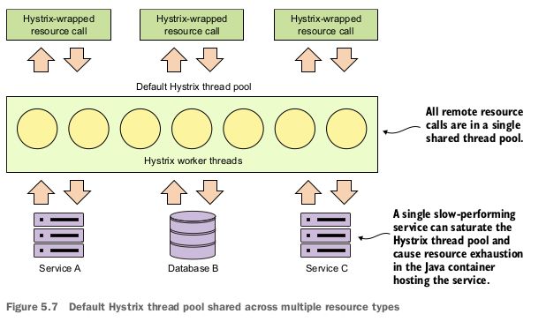

This model works fine when you have a small number of remote resources being
accessed within an application and the call volumes for the individual services are rel-
atively evenly distributed. The problem is if you have services that have far higher vol-
umes or longer completion times then other services, you can end up introducing
thread exhaustion into your Hystrix thread pools because one service ends up domi-
nating all of the threads in the default thread pool.

Using segregated theard pools

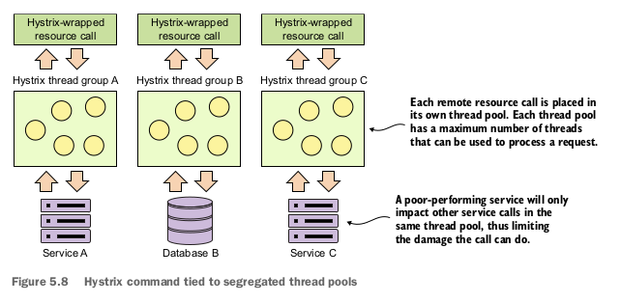
What’s the proper sizing for a custom thread pool? Netflix recommends the follow-
ing formula:
(requests per second at peak when the service is healthy * 99th percentile latency in
seconds) + small amount of extra threads for overhead

- Microservice security patterns

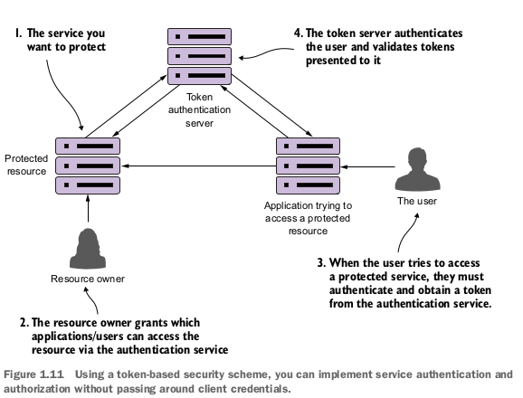

- Microservice logging and tracing patterns
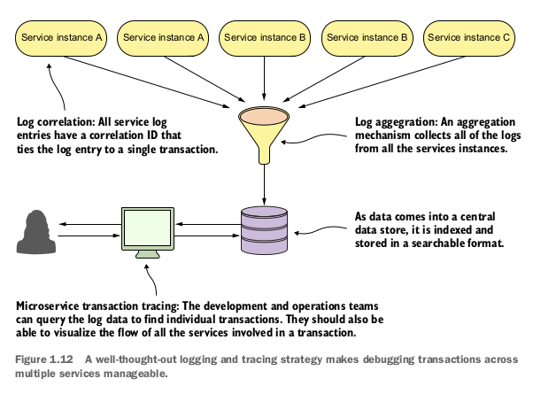

- Controlling configuration

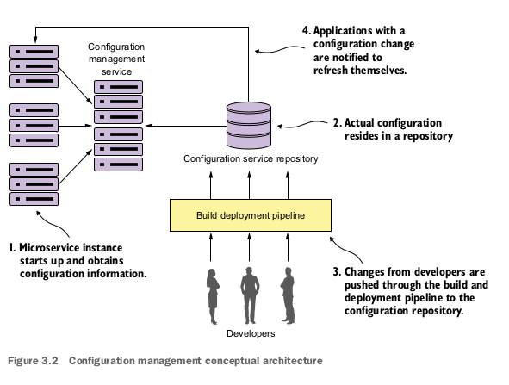

- Microservice discovery

