**Team 13 phase1 report**

|  |  |  |
| --- | --- | --- |
| **Name** | **Sec** | **BN** |
| Mahmoud Ossama Mahmoud Khattab | 2 | 15 |
| Malek Hossam Abdelfattah Ismail | 2 | 4 |
| Ibrahim Tarek abdelazem | 1 | 3 |
| Ahmed mohamed Omar | 1 | 11 |

**Project idea and need :**

The project aims to target the hand position and movements in a real-time video and concludes the movement direction of the hand based on the previous frames.

The project will utilize machine learning algorithms such as the SVM algorithm, and it will use an algorithm called LBP algorithm. At the same time, we’ll classify the hand shape and color for the detection.

**Block diagram**

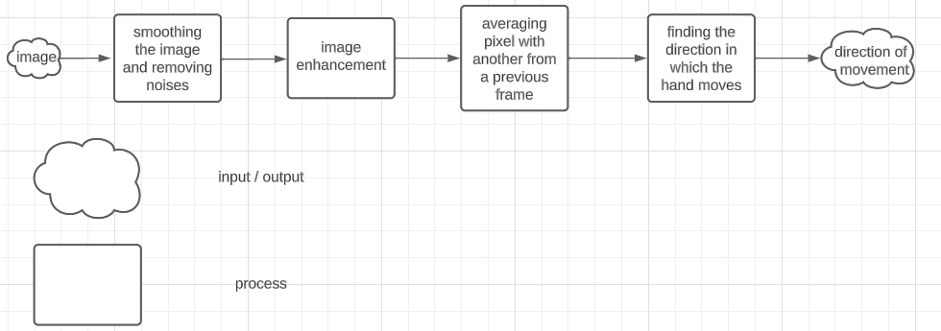

**Non-primitive functions:**

* Detecting the current hand position
* Detecting the hand movements
* Implementation of the visual descriptor (LBP algorithm).
* Training of the SVM model.
* Decision function that derives a conclusion from the hand movement patterns.

**Research papers:**

* <https://oa.upm.es/41394/1/PFC_ANA_ISABEL_MAQUEDA_NIETO.pdf>
* <https://link.springer.com/article/10.1007/s41060-016-0008-z>