PATENT & INNOVATION PORTFOLIO

[Your Full Name], PhD

Inventor | Researcher | Academic Innovator

[Institution Name] | [City, India]

[Email Address] | [Phone Number]

12  Utility Patents | 7  Design Patents | 3  Granted Patents | 6+  Govt Grants Received

1  Commercialized Products | 5  High UAE Relevance Patents | 7+  Years of Innovation | 5  Patent Domains

Prepared for: UAE Ministry of Economy (Golden Visa — Innovators & Inventors) & UAE Employment Applications

May 2026

1. Inventor Profile

This portfolio presents the complete patent and innovation record of [Your Full Name], PhD — an academic inventor and researcher with over seven years of active innovation across five technology domains. The portfolio comprises 12 utility patents and 7 design patents (19 total), spanning medical devices, agricultural engineering, industrial safety, energy storage, and smart transport systems.

Three patents have been granted by the Indian Patent Office, including the most recent grant in March 2026 (Breathing Retraining Device). One innovation — the Spine Mobilization Device — has been successfully commercialized and is currently available in the market, representing the only device of its kind globally at the time of filing. Innovation activity has been recognized and funded by multiple Government of India bodies including DST, SSIP Gujarat, Gujcost, and the Industrial Commissionerate.

Name | [Your Full Name]
Qualification | Doctor of Philosophy (PhD)
Current Designation | [Position] — [Institution Name]
Innovation Domains | Mechanical Engineering | Biomedical Devices | AgriTech | Energy | Transport
Total Patents | 19 (12 Utility + 7 Design)
Granted Patents | 3 (Indian Patent Office)
Commercialized Products | 1 — Spine Mobilization Device (currently in market)
Govt Grants Received | 6+ grants from DST, SSIP, Gujcost, Industrial Commissionerate
Email | [Your Email]
Phone | [Your Phone]
ORCID / LinkedIn | [Your URL]

2. Alignment with UAE National Priorities

All patents have been assessed against UAE Vision 2031, UAE Net Zero 2050, UAE Health Strategy 2030, National Food Security Strategy 2051, UAE Water Security Strategy, UAE Energy Strategy 2050, National Urban Mobility Plan 2030, and the National Policy for People with Disabilities. Five patents demonstrate high strategic relevance; seven demonstrate medium relevance.

UAE National Strategy | Relevant Patent(s) | Relevance | Status
UAE Health Strategy 2030 | Spine Mobilizer (#7), Breathing Device (#9) | HIGH | Commercialized + Granted
UAE Energy Strategy 2050 / Net Zero | Heat Prevent Box (#11) | HIGH | Published
Food Security Strategy 2051 | Tractor Trolley (#4), Oil Expeller (#10) | HIGH | Granted + Published
Water Security Strategy | Irrigation Joint Ring (#8) | HIGH | Filed
National Urban Mobility Plan 2030 | Retractable Seat (#1, #6) | MEDIUM | Granted + Published
Occupational Health & Safety | Gas Cylinder Dragger (#5), Gas Cylinder (#3) | MEDIUM | Published
Disability Inclusion Strategy | Adjustable Chair (#12) | MEDIUM | Filed

3. Utility Patents — Detailed Portfolio

All 12 utility patents are registered with the Indian Patent Office. Three are granted, eight are published, and one is filed. CAD and 3D renderings shown below. Certified copies of all patent certificates are available upon request.

1. Supplementary Seat for Public Transport with Retractable Hanging Support
GRANTED | 201921006650 | ◆ MEDIUM UAE RELEVANCE
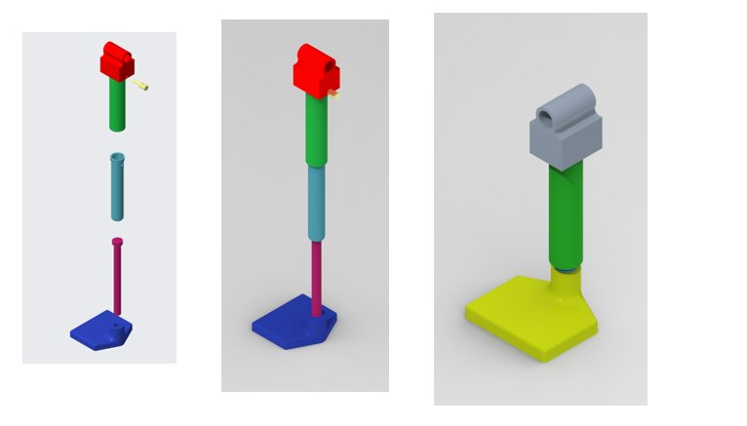
Dates | Published: March 2019 | Granted: June 2023
Design Registrations | Design No. 326481-001 (January 2020)
UAE Strategic Alignment | UAE National Urban Mobility Plan 2030 — public transport comfort & capacity optimisation
UAE Market Application | Dubai Metro and Abu Dhabi bus networks face peak-hour overcrowding. Retractable hanging seats add capacity without structural modification — deployable by Roads and Transport Authority (RTA).
Innovation Impact | Granted patent. Novel retractable telescopic mechanism. No equivalent prior art in public transport sector. SSIP-funded proof of concept completed.
Funding / Recognition | SSIP PoC Grant + IPR Grant

2. Mechanically Operated Self-Stirring Container
PUBLISHED | 201921019035 | ◇ STANDARD
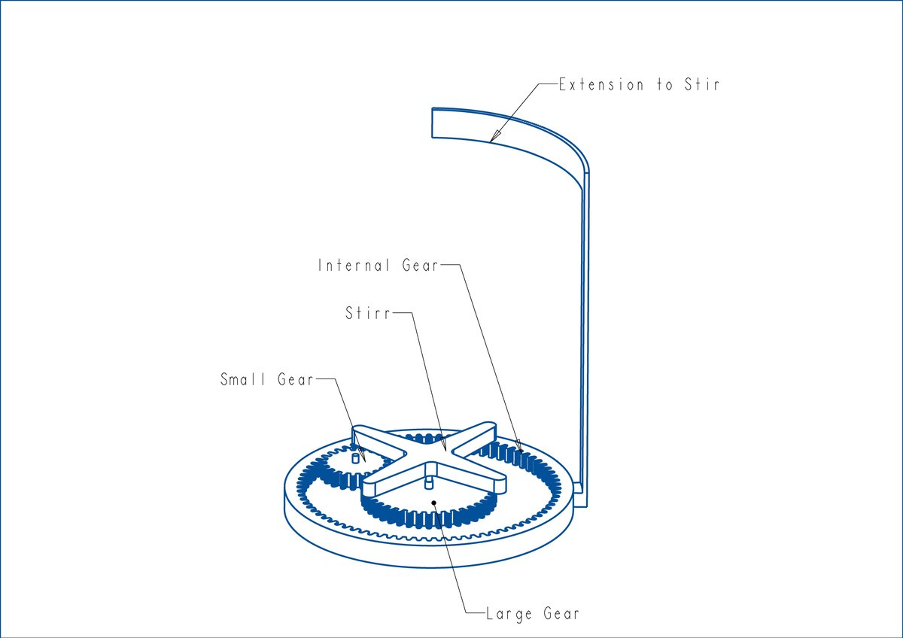
Dates | Published: May 2019
Design Registrations | Design No. 326482-001 (August 2020)
UAE Strategic Alignment | Consumer product innovation — UAE hospitality, food service and retail sector
UAE Market Application | Applicable to UAE hospitality and food service industry. No electrical components — safe for diverse consumer use and corporate gifting.
Innovation Impact | Published patent. Mechanical beverage stirrer using internal gear mechanism. Zero electricity required.
Funding / Recognition | SSIP PoC Grant

3. A Single Unit Gas Cylinder with Partition
PUBLISHED | 201821044415 | ◆ MEDIUM UAE RELEVANCE
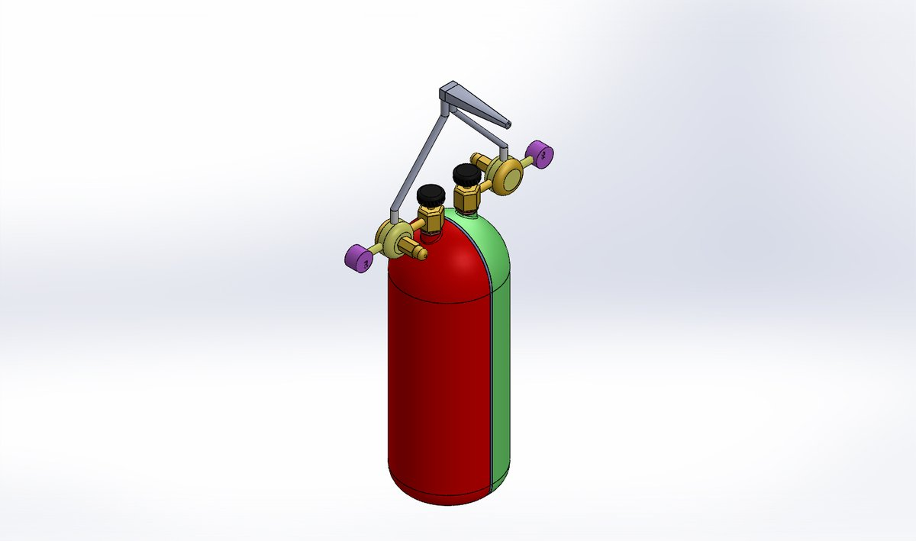
Dates | Published: June 2019
Design Registrations | Design No. 326480-001 (September 2020)
UAE Strategic Alignment | UAE Industrial Safety & Manufacturing — construction, welding and fabrication sectors
UAE Market Application | UAE construction and industrial sectors use dual cylinders for welding. Single-unit dual-chamber design reduces handling hazards — applicable to UAE mega-construction projects and ADNOC supply chains.
Innovation Impact | Dual-chamber design replacing two separate cylinders. Reduces workplace gas handling risk and logistical footprint.
Funding / Recognition | SSIP IPR Grant

4. Multipurpose Tractor Trolley with Chaff Cutter and Distribution Assembly
GRANTED | 202021024990 | ★ HIGH UAE RELEVANCE
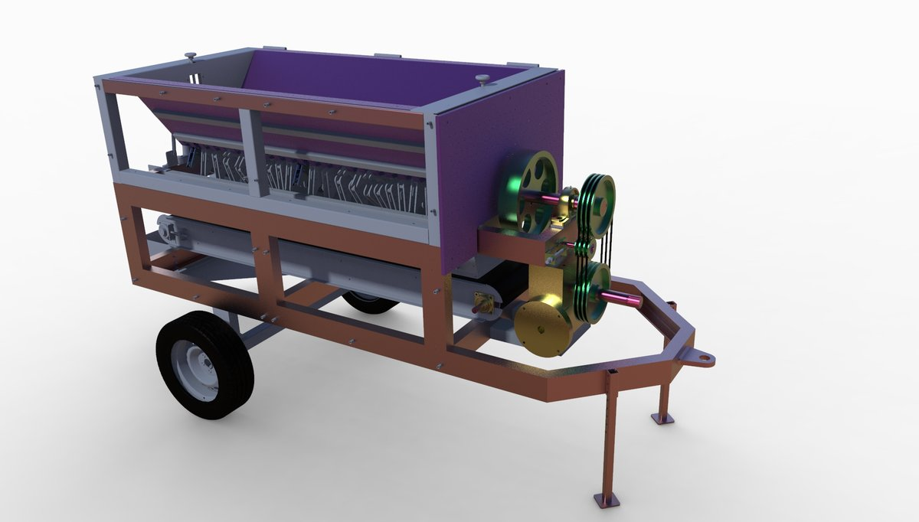
Dates | Filed: 2020 | Granted: October 2023
Design Registrations | None
UAE Strategic Alignment | UAE National Food Security Strategy 2051 — domestic agricultural productivity, cost reduction and rural mechanisation
UAE Market Application | UAE invests in indoor and desert farming for food self-sufficiency. Device reduces forage collection time by 75% and cost by 70% — applicable to UAE agricultural cooperatives, camel farms and livestock operations in Al Ain and Ras Al Khaimah.
Innovation Impact | Granted patent. 75% time saving, 70% cost reduction demonstrated. Multi-function design. SSIP PoC and startup grants awarded.
Funding / Recognition | SSIP PoC Grant (INR 98,800) + IPR Grant (INR 50,000) + Startup Grant

5. A Dragging Device for the Gas Cylinders
PUBLISHED | 202121044960 | ◆ MEDIUM UAE RELEVANCE
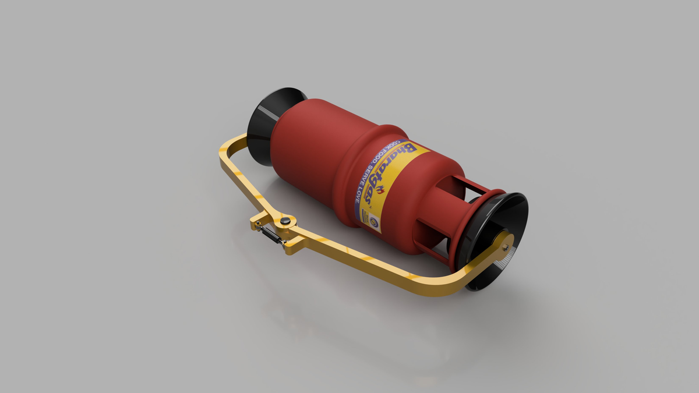
Dates | Published: October 2021
Design Registrations | None
UAE Strategic Alignment | UAE Occupational Health & Safety (OSHAD) — construction, manufacturing and oil & gas sectors
UAE Market Application | Addresses manual handling injury risk in UAE large industrial workforce. Adjustable cylinder transport device eliminates manual lifting — relevant to OSHAD compliance across UAE construction and industrial sites.
Innovation Impact | Ergonomic wheeled cradle device eliminating manual lifting of heavy gas cylinders. Applicable to any industrial or construction site.
Funding / Recognition | Self-funded

6. A Design and Development of Retractable Hanging Seat
PUBLISHED | 202121001209 | ◆ MEDIUM UAE RELEVANCE
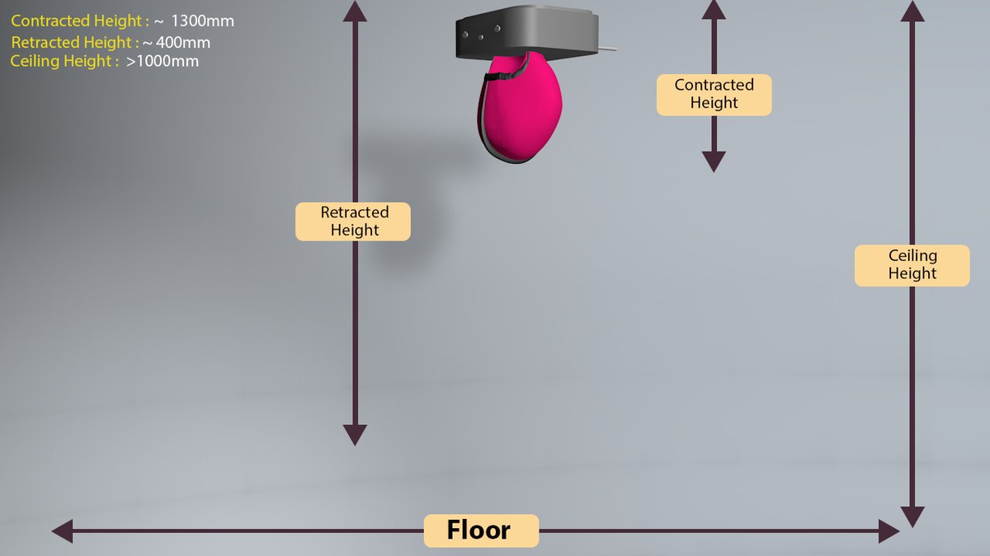
Dates | Published: July 2022
Design Registrations | None
UAE Strategic Alignment | UAE Urban Mobility & Smart City Infrastructure — metro, tram and bus transit systems
UAE Market Application | Follow-on development of Patent No. 1 with enhanced mechanism. Applicable across UAE metro, tram and bus rapid transit systems operated by RTA Dubai and DoT Abu Dhabi.
Innovation Impact | Advanced variant with improved ergonomics. Retracted height ~400mm, contracted height ~1300mm. Dimensionally validated.
Funding / Recognition | SSIP IPR Grant (INR 50,000)

7. A Spine Mobilization Device
PUBLISHED | IN 202221059481 | ★ HIGH UAE RELEVANCE
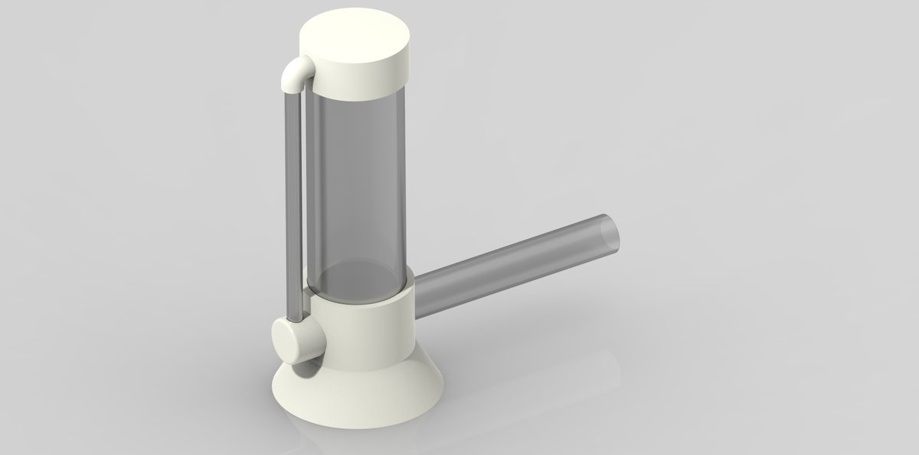
Dates | Published: October 2022
Design Registrations | Design No. 379188-001 (Feb 2023), Design No. 379193-001 (Feb 2023)
UAE Strategic Alignment | UAE Health Strategy 2030 — musculoskeletal rehabilitation, physiotherapy innovation and medical tourism
UAE Market Application | UAE has 900+ physiotherapy clinics. Only handheld spine mobilization device of its kind globally at time of filing. Currently commercialized — immediate market-ready technology transfer to UAE physiotherapy chains (Aster, NMC, Burjeel, Mediclinic).
Innovation Impact | COMMERCIALIZED — currently sold in market. First-of-kind globally. Two design registrations. DST Nidhi ITB Startup Grant awarded.
Funding / Recognition | DST Nidhi ITB Startup Grant (INR 4,85,000) + SSIP

8. A Joint Ring for Extension Pipe in Irrigation System
PUBLISHED | IN 202221065844 | ★ HIGH UAE RELEVANCE
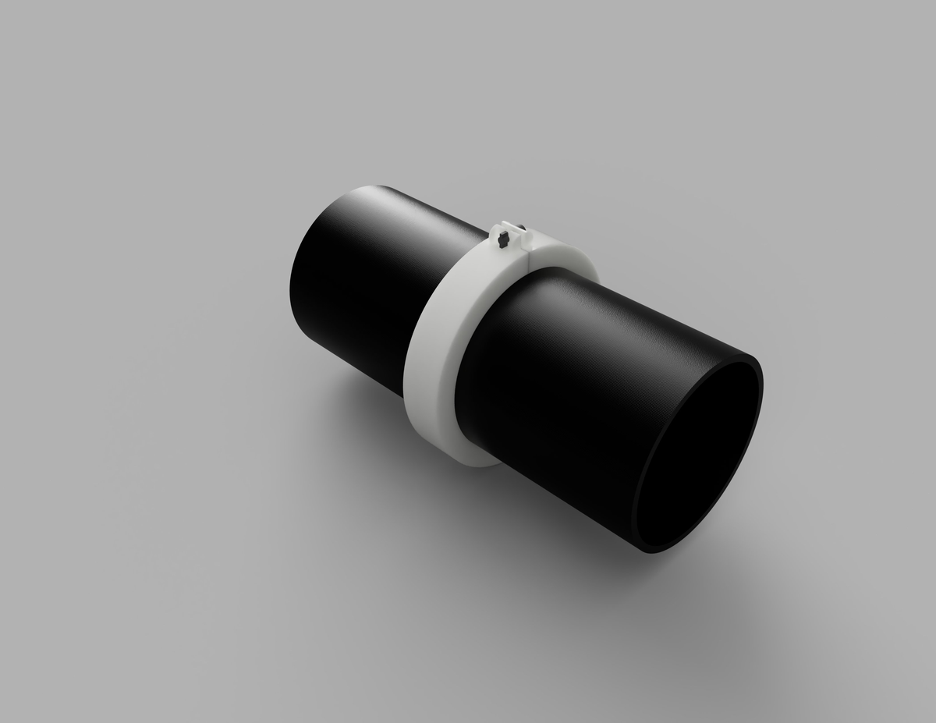
Dates | Filed: November 2022
Design Registrations | None
UAE Strategic Alignment | UAE Water Security Strategy — precision irrigation, water-use efficiency and desert agriculture
UAE Market Application | Water scarcity is a critical national priority. Improved irrigation pipe joint reduces leakage and improves flow efficiency — applicable to UAE drip irrigation networks, vertical farms and desert agriculture in Al Dhafra and Liwa regions.
Innovation Impact | Solves structural weaknesses in conventional irrigation pipe extension joints. SSIP IPR grant validates commercial potential.
Funding / Recognition | SSIP IPR Grant (INR 50,000)

9. A Breathing Retraining Device
GRANTED | IN 202321018886 | ★ HIGH UAE RELEVANCE
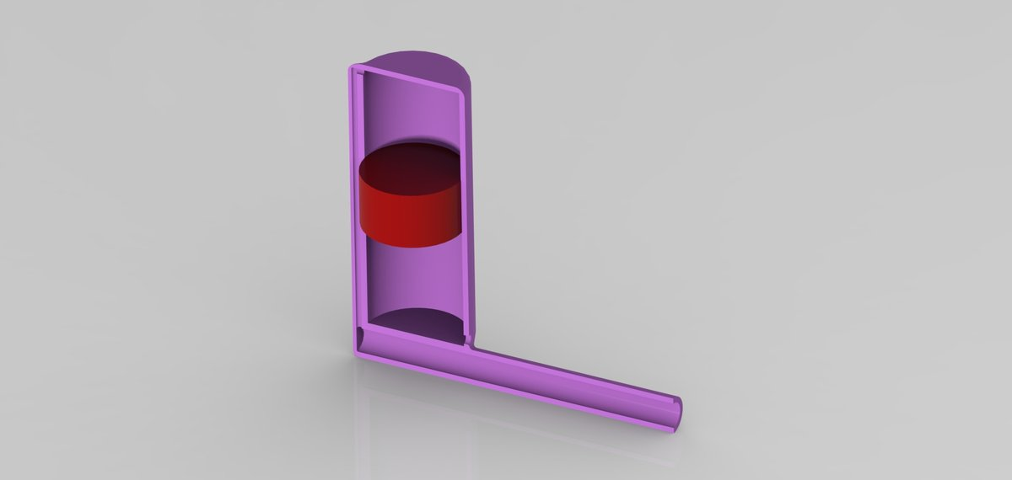
Dates | Published: April 2023 | Granted: March 2026
Design Registrations | None
UAE Strategic Alignment | UAE Health Strategy 2030 — respiratory health, home-based rehabilitation, post-COVID care and preventive medicine
UAE Market Application | Respiratory conditions — post-COVID complications, occupational lung disease in UAE construction workers, and pediatric asthma — represent a significant underserved clinical burden. Strong technology transfer pathway to UAE hospital networks and home-care segment.
Innovation Impact | MOST RECENT GRANT — March 2026. Only multi-parameter device measuring volume, pressure and resistance simultaneously. Strong commercial and clinical development pathway.
Funding / Recognition | Multidisciplinary institutional research

10. Dual Chamber Oil Expeller
PUBLISHED | IN 202321062068 | ◆ MEDIUM UAE RELEVANCE
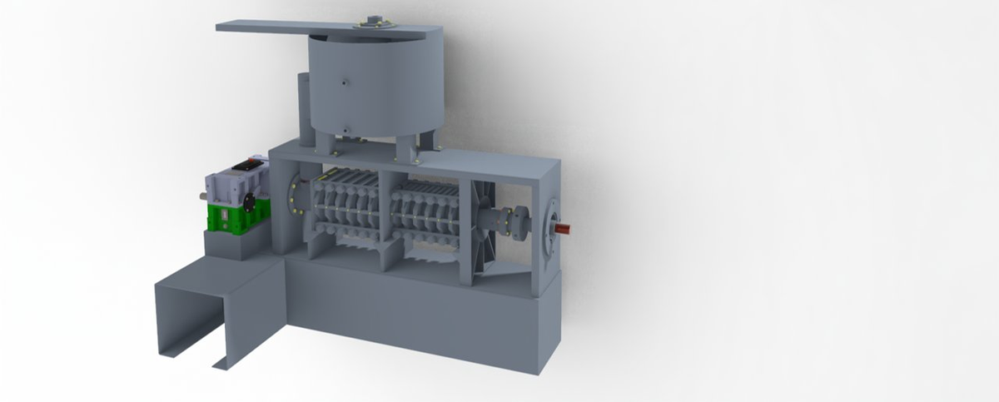
Dates | Published: December 2023
Design Registrations | None
UAE Strategic Alignment | UAE Food Security Strategy 2051 — food processing and agri-industrial value addition
UAE Market Application | UAE's growing focus on domestic food processing. Dual-chamber design improves throughput and oil yield — applicable to UAE agri-food SMEs and cooperative processing units.
Innovation Impact | Dual-chamber expeller with improved oil extraction efficiency. Novel design over conventional single-chamber units.
Funding / Recognition | Institutional research

11. The Apparatus for Heat Storage: Heat Prevent Box
PUBLISHED | IN 202321072149 A | ★ HIGH UAE RELEVANCE
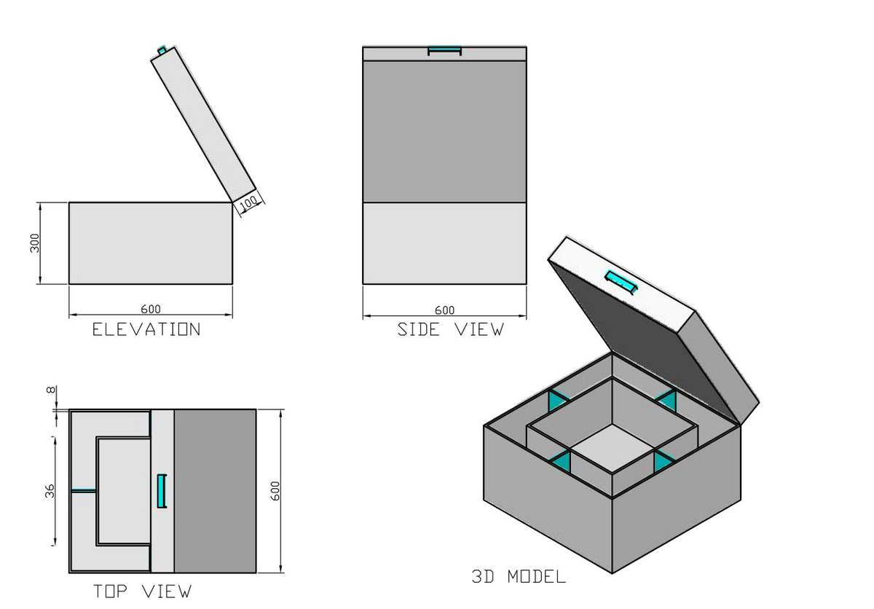
Dates | Published: November 2023
Design Registrations | None
UAE Strategic Alignment | UAE Energy Strategy 2050 & Net Zero 2050 — thermal energy storage, solar energy integration and building energy management
UAE Market Application | Thermal energy storage is a critical enabling technology for UAE solar power. Apparatus addresses heat retention and prevention — applicable to UAE solar thermal storage, cold chain logistics in extreme heat and building energy management. Aligns with DEWA renewable energy roadmap.
Innovation Impact | Novel heat storage apparatus. Partitioned thermal chamber. Specifically applicable to UAE extreme climate conditions. Dimensioned engineering design (600×600×300mm).
Funding / Recognition | Institutional research

12. A Multipurpose Adjustable Chair
PUBLISHED | IN 202521014193 | ◆ MEDIUM UAE RELEVANCE
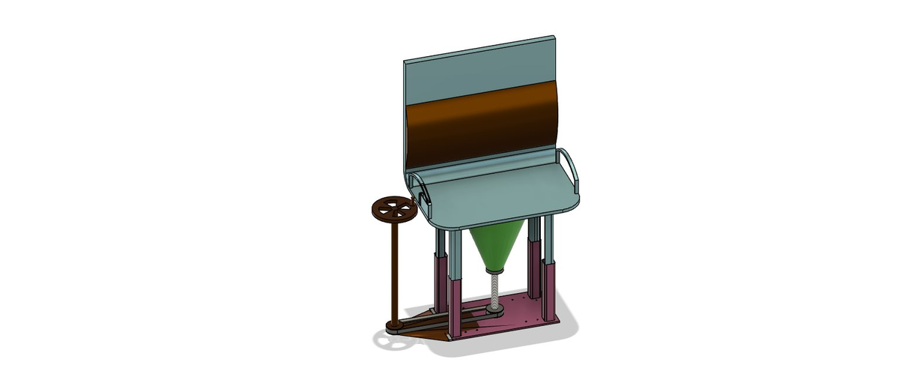
Dates | Filed: February 2025
Design Registrations | None
UAE Strategic Alignment | UAE Disability Inclusion Strategy — assistive technology, accessible design and inclusive infrastructure
UAE Market Application | UAE is committed to disability inclusion under the National Policy for People with Disabilities. Multipurpose adjustable chair addresses diverse mobility needs — applicable to UAE healthcare facilities, schools, elderly care homes and inclusive public spaces.
Innovation Impact | Filed February 2025. Multipurpose ergonomic and assistive seating with screw-jack height adjustment and foldable modular design.
Funding / Recognition | Self-funded

4. Innovation Visual Gallery

Additional CAD views, multi-angle renders, and commercialization evidence for key patents in the portfolio.

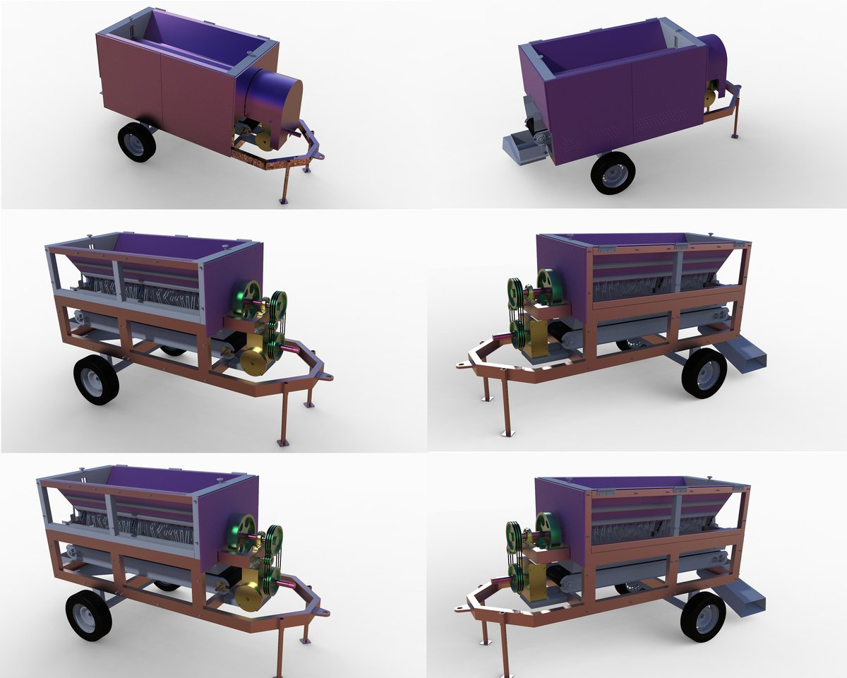  Patent #4 — Tractor Trolley (6-view)  Granted October 2023 | 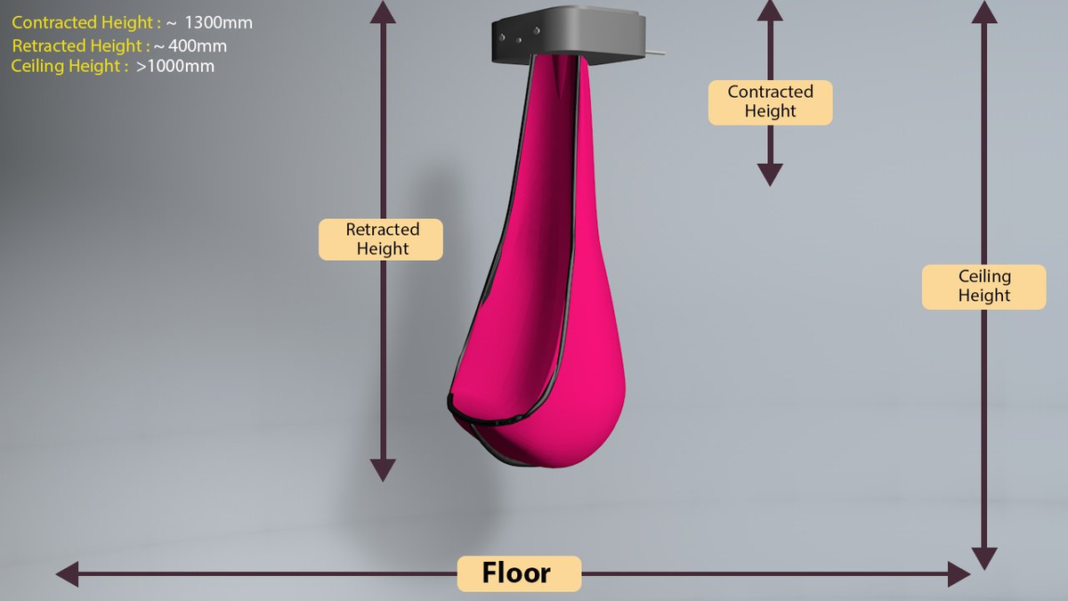  Patent #6 — Hanging Seat (retracted)  Retracted height ~400mm
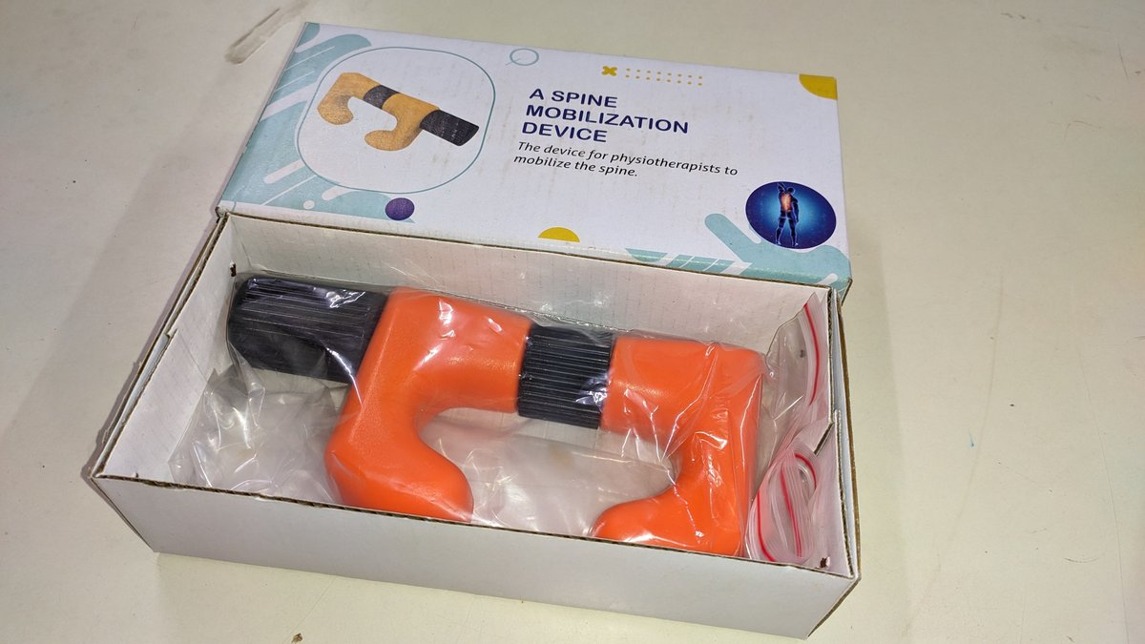  Patent #7 — Spine Mobilizer (product)  Commercialized — in market | 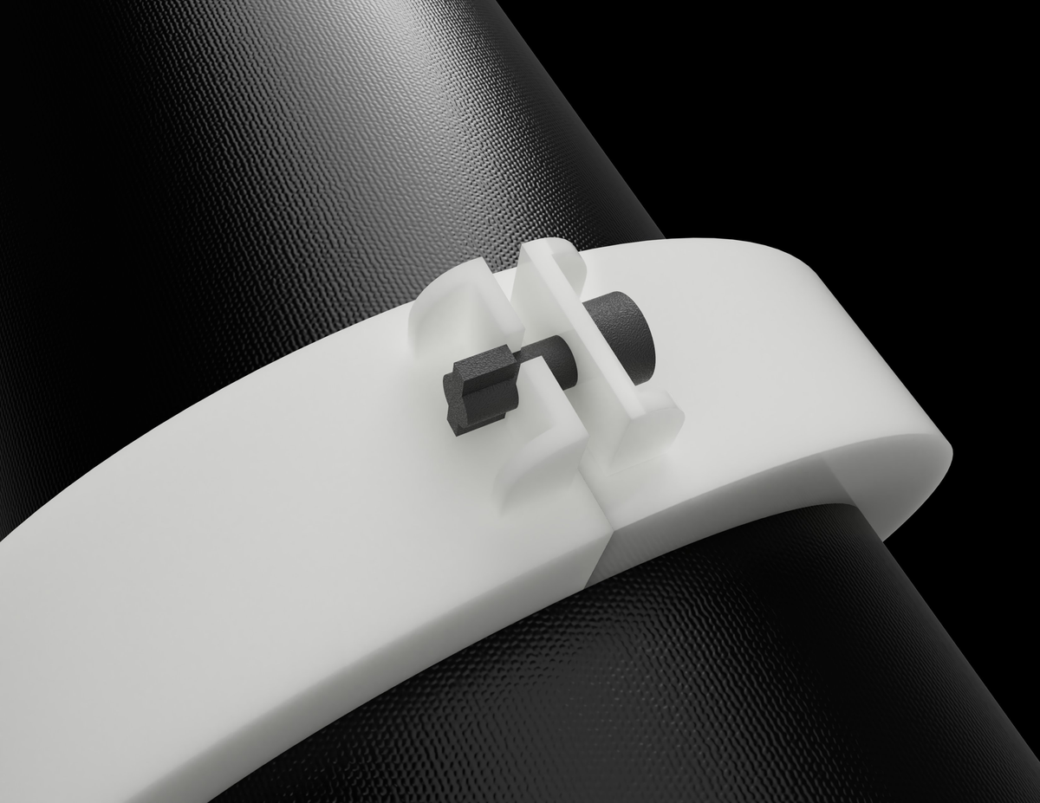  Patent #8 — Irrigation Joint (locking detail)  Novel locking tab mechanism
  Patent #9 — Breathing Device (transparent)  Granted March 2026 | 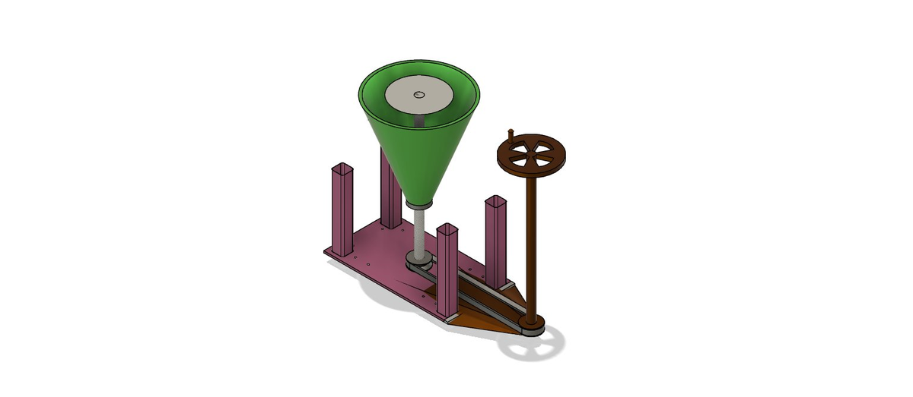  Patent #12 — Adjustable Chair (base mechanism)  Screw-jack height adjustment

5. Design Patents — Registered Portfolio

Seven design patents are registered with the Indian Patent Office, covering the aesthetic and ornamental aspects of inventions within this portfolio. Design registrations provide complementary IP protection alongside utility patents and strengthen licensing and technology transfer positions.

# | Title | Design No. | Issued | Linked Utility Patent
D1 | Supplementary Seat for Public Transport with Retractable Hanging Support | 326481-001 | January 2020 | Utility Patent #1 (201921006650)
D2 | Mechanically Operated Self-Stirring Container | 326482-001 | August 2020 | Utility Patent #2 (201921019035)
D3 | A Single Unit Gas Cylinder with Partition | 326480-001 | September 2020 | Utility Patent #3 (201821044415)
D4 | Mobile Stand | 361786-001 | April 2022 | Standalone design registration
D5 | Mobile Stand (Variant) | 361787-001 | April 2022 | Standalone design registration
D6 | Spine Mobilizer | 379188-001 | February 2023 | Utility Patent #7 (202221059481)
D7 | Spine Mobilizer (Variant) | 379193-001 | February 2023 | Utility Patent #7 (202221059481)

6. Government Grants & Institutional Recognition

The innovations in this portfolio have been independently validated and funded by multiple Government of India bodies. These grants represent official recognition of technical merit, commercial viability, and societal impact — providing authoritative third-party endorsement beyond patent registrations.

Funding Body | Scheme / Purpose | Amount (INR) | Related Innovation
Dept of Science & Technology (DST), Govt of India | Nidhi ITB Startup Grant — Spine Mobilizer commercialization | INR 4,85,000 | Spine Mobilization Device
SSIP Gujarat | Proof of Concept Grant — Tractor Trolley | INR 98,800 | Multipurpose Tractor Trolley
SSIP Gujarat | IPR Grant — Multiple utility patents | INR 50,000 per patent | Various utility patents
Gujcost | Research & Innovation Grant | As sanctioned | Multiple projects
Industrial Commissionerate, Gujarat | Startup and Innovation support | As sanctioned | Spine Mobilizer startup
SSIP Gujarat | Student Innovation Fund — PoC projects | Multiple grants | Retractable Seat, Gas Cylinder, Stirrer

7. Commercialization & Technology Transfer Readiness

Spine Mobilization Device — Commercialized (Market-Ready)
Status: Commercially available — currently sold in market
Patent: IN 202221059481 + Design Nos. 379188-001 & 379193-001
Global position: Only handheld spine mobilization device of its kind globally at time of filing
Clinical use: Used by physiotherapists for spinal joint mobilization — reduces practitioner effort and improves treatment precision
UAE opportunity: 900+ physiotherapy clinics in UAE. Transfer targets: Aster, NMC Health, Burjeel, Mediclinic hospital chains
Funding: DST Nidhi ITB Startup Grant (INR 4,85,000)

Breathing Retraining Device — Technology Transfer Ready (Granted March 2026)
Status: Granted — March 2026 (most recent grant)
Patent: IN 202321018886
Unique capability: Only multi-parameter device measuring volume, pressure and resistance simultaneously for breathing retraining
UAE opportunity: Post-COVID pulmonary rehabilitation, occupational respiratory health, pediatric asthma — all high-demand in UAE
Transfer pathway: Licensing to UAE hospital networks, home-care companies or medical device distributors

Multipurpose Tractor Trolley — AgriTech Licensing Opportunity (Granted October 2023)
Status: Granted — October 2023
Patent: IN 202021024990
Performance: 75% reduction in forage collection time; 70% reduction in operational cost — validated by proof of concept
UAE opportunity: Agricultural cooperatives, camel and livestock farms (Al Ain, RAK) and indoor vertical farms seeking cost-efficient forage management

8. Innovation Domain Summary

Domain | Patents | Key Inventions | UAE Priority Area
Medical Devices & Rehabilitation | #7, #9, #12 | Spine Mobilizer (commercialized), Breathing Device (granted) | Health Strategy 2030
Agricultural Engineering | #4, #8, #10 | Tractor Trolley (granted), Irrigation Joint, Oil Expeller | Food Security 2051
Energy & Thermal Management | #11 | Heat Storage Apparatus | Energy Strategy 2050
Smart Transport & Seating | #1, #6 | Retractable Hanging Seat (granted) | Urban Mobility Plan
Industrial Safety & Tools | #2, #3, #5 | Gas Cylinder systems, Self-Stirring Container | OHS / Manufacturing

9. Declaration

I hereby declare that all information presented in this portfolio is accurate, complete, and verifiable. Certified copies of all patent certificates, grant sanction letters, product commercialization evidence, and supporting documents are available upon request for verification by the UAE Ministry of Economy or any prospective employer.

All innovations listed herein represent original work conceived and developed under my direct involvement as lead inventor or supervising faculty. All government grants were awarded through competitive evaluation processes by the respective funding bodies of the Government of India and the Government of Gujarat.

[Your Full Name], PhD
[Designation] | [Institution Name]
[Email Address] | [Phone Number]

Date: May 2026

Prepared for UAE Ministry of Economy (Golden Visa — Innovators & Inventors Category) and UAE employment applications. All patent data sourced from Indian Patent Office records.

