CMPG311 LAB1 ASSIGNMENT

North-West University | [Company address]

MySQL

rm Ramagole 27596176

2020

Table of Contents

1. Screenshots of Tables and identification of attributes 2

3. Populate all tables 2

4. Screenshots of Bidvest Bank 6

5. SQL CODE 7

# 1. Screenshots of Tables and identification of attributes

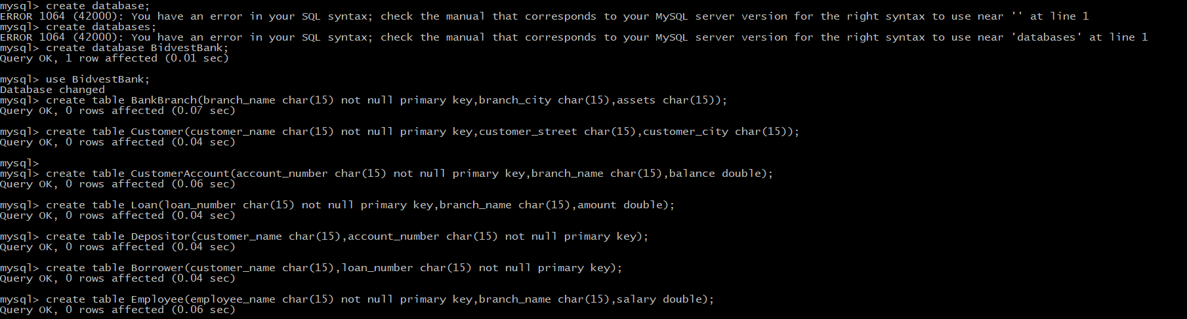

# 3. Populate all tables

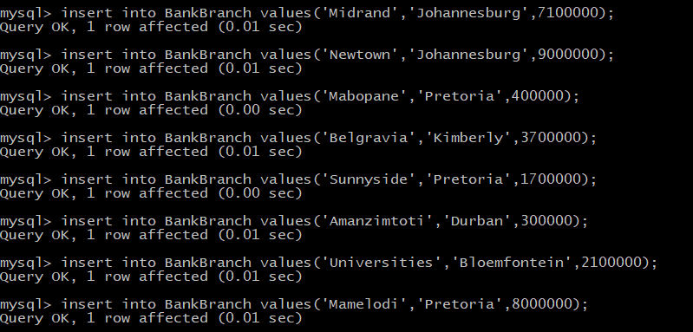

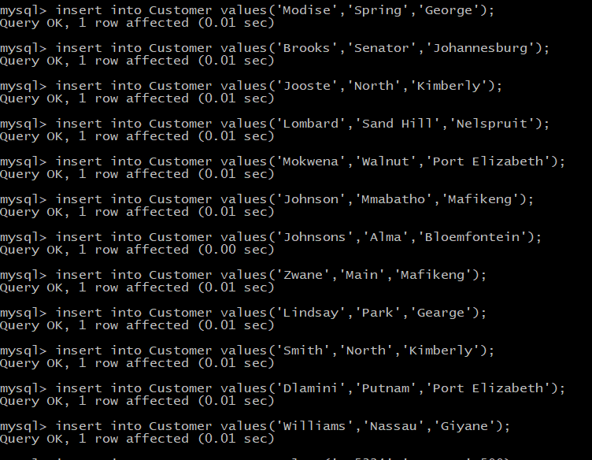

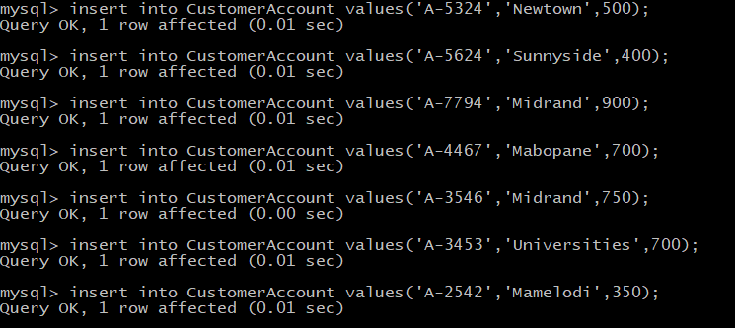

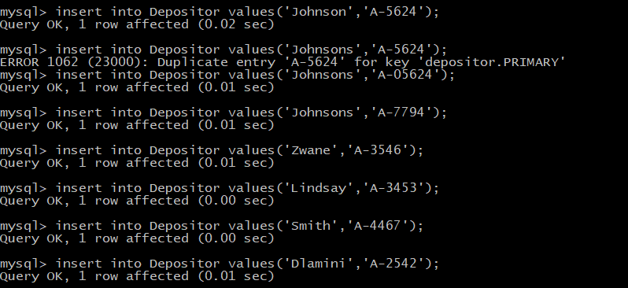

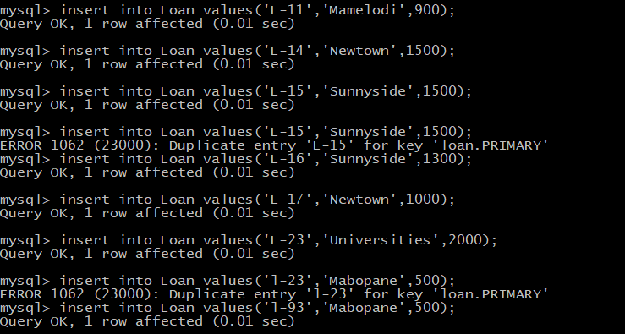

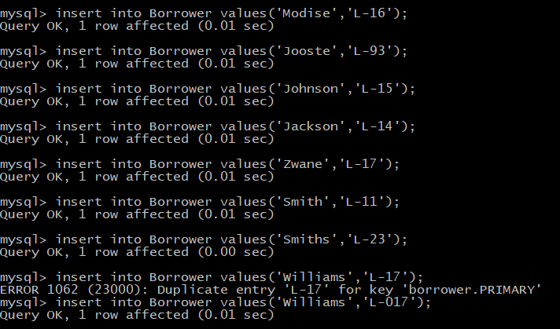

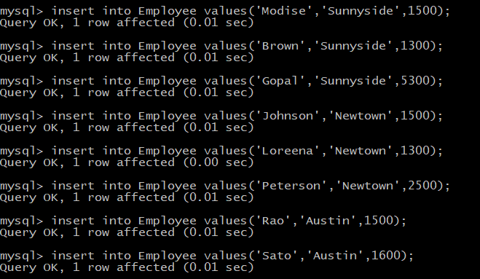

# 4. Screenshots of Bidvest Bank

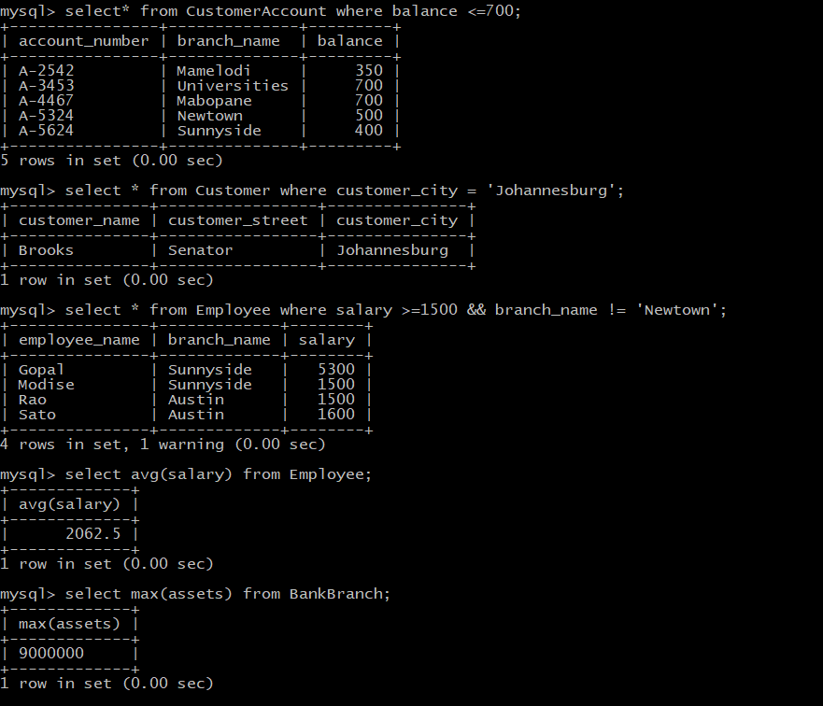

# 5. SQL CODE

