ASSIGNMENT 1

T.J MOKGATLE

28748263

**4.1 Find all customer accounts whose balance is smaller than R700.**

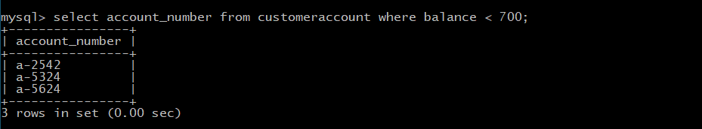

**4.2 Find all name of customers whose city is in Johannesburg.**

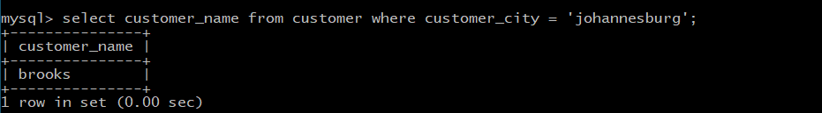

**4.3 Find all employees whose salary is greater than R1500 and working branch is not Newtown.**

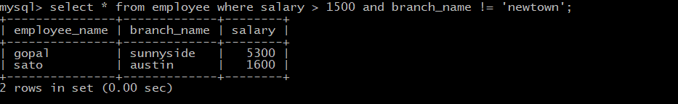

**4.4 Calculate the average salary of all employees and show the average salary as “avg_salary”**

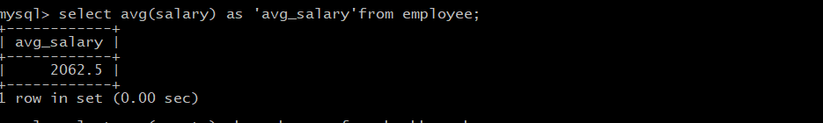

**4.5 Display the bank with the largest number of Assets.**

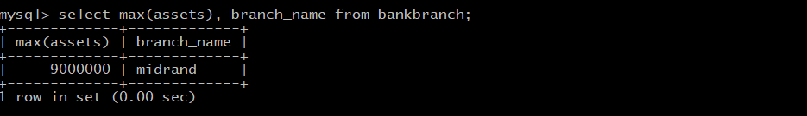

**5.1 Display the names of all employees who work in Sunnyside branch.**

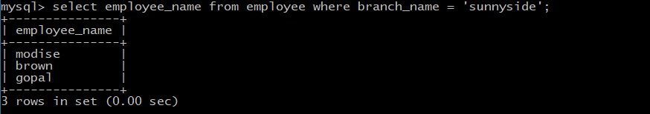

**5.2 Display the borrower table.**

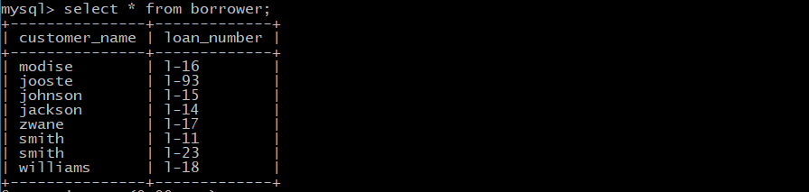

**5.3 Find the account number for all accounts where the balance is greater than R900.**

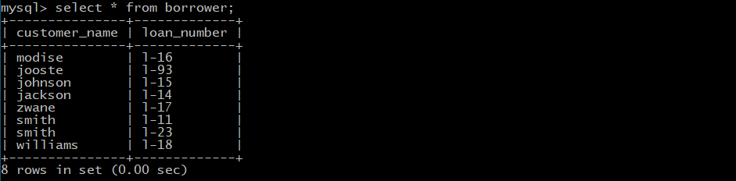

**5.4 Find the account number and balance for all accounts from Newtown where the balance is greater than R600.**



**5.5 Display the branch name and assets from all branches.**

