***MASEKO SW***

***30089662***

4

1. select * from customeraccount where balance < 700; 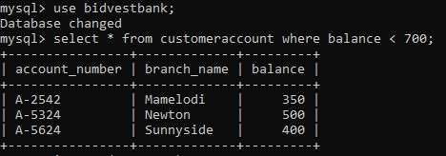
2. select customer_name from customer where customer_city = 'Johannesburg';A close up of a logo

   Description automatically generated
3. select * from employee where salary > 1500 and branch_name <> 'Newton';A screenshot of a computer

   Description automatically generated
4. select avg(salary) as avg_salary from employee;A screenshot of a cell phone

   Description automatically generated
5. select MAX(assets) from bankbranch;A screenshot of a cell phone

   Description automatically generated

5.

1. Select * from employee where branch_name = ‘Sunnyside’;A picture containing text

   Description automatically generated
2. Select * from borrower; A close up of text on a black background

   Description automatically generated
3. Select account_number from customeraccount where balance > 900;
4. Select account_number, balance from customeraccount where branch_name = ‘Newton’ and balance > 600;
5. Select branch_name, assets from bank_branch;A picture containing text

   Description automatically generated