MZ MOLEFE

29088089

CMPG311

GitHub Assignment1

Special Queries(Screenshots)

4.1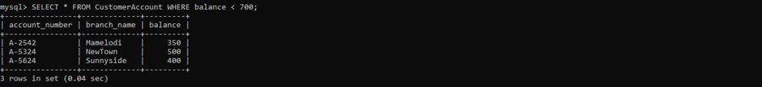

4.2



4.3

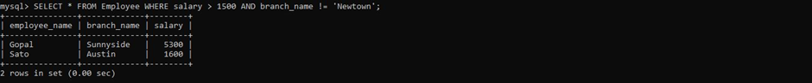

4.4



4.5



5.1

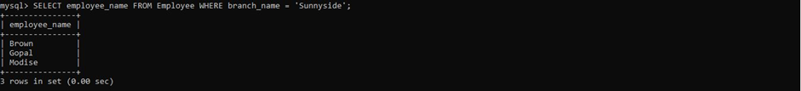

5.2

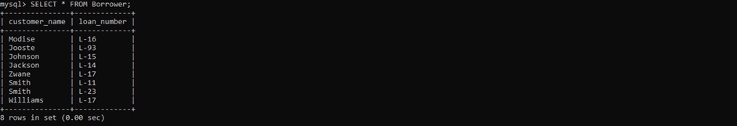

5.3



5.4



5.5

