|  |  |  |
| --- | --- | --- |
| **Qatar University**  **College of Engineering**  **Dept. of Computer Science & Eng.** | **quLogo94x89NT** | **Software Engineering**  **CMPS 310** |

**Name: Alreem zainal ID: 202103014**

**Task 4.1: Paste your DSD for “Sell item” <<Here>>:**

**Task 4.2: Paste your DSD for “Buy on auction” <<Here>>:**

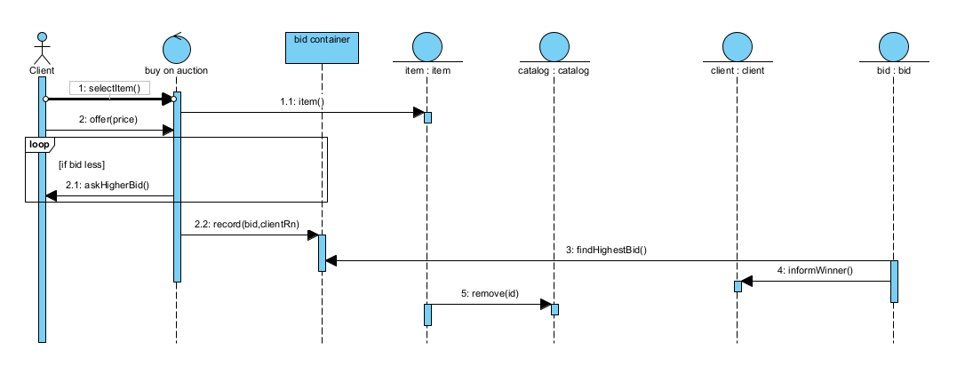

**Task 4.3: Paste your updated class diagram <<Here>>:**