**Application Architecture Diagram**

**Class Diagram**

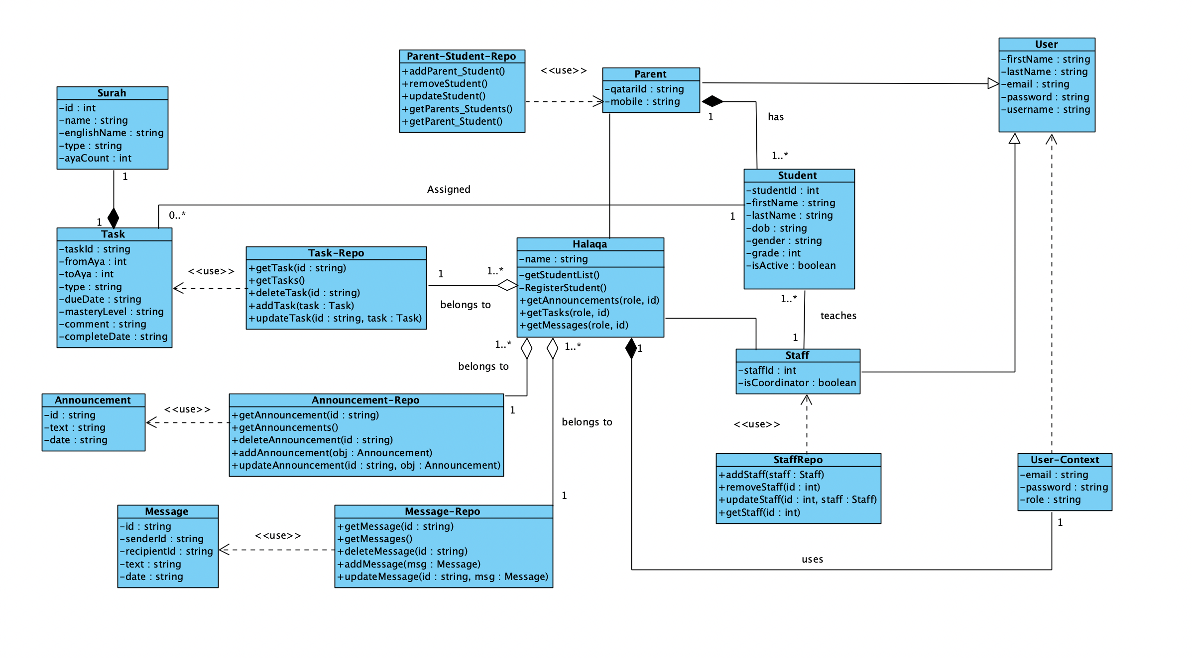

**UI Design and Navigation Diagram**

