**Operation System Project**

**Phase-1**

Instructor: Eng. Heba Dawoud

Lab Section No: B01 – B02

Submission date: 22nd March 2025

**Effort distribution:**

Hateim Elagha –202104575 – B02 – Effort (30%) Task1 (Server) -Task2 – Task4

Moaz Jemmieh – 202208449– B02 – Effort (25%) Task1 (Client) – Task5

Basheer Alabbasi – 202205895– B02 – Effort (25%) Task2 (Client) – Task5

Abdelrahman Abdelwahed – 202207121– B01 – Effort (20%) Task3 – Testing

**Screenshots:**

**Server Side:**

SQL Status after bootup:

**Task 1: Advanced User and Group Configuration**

* 1. **Nested Group Creation:**

Created Groups and their users:

* 1. **Shared Directories with ACLs:**

Before executing the script:

After executing the script:

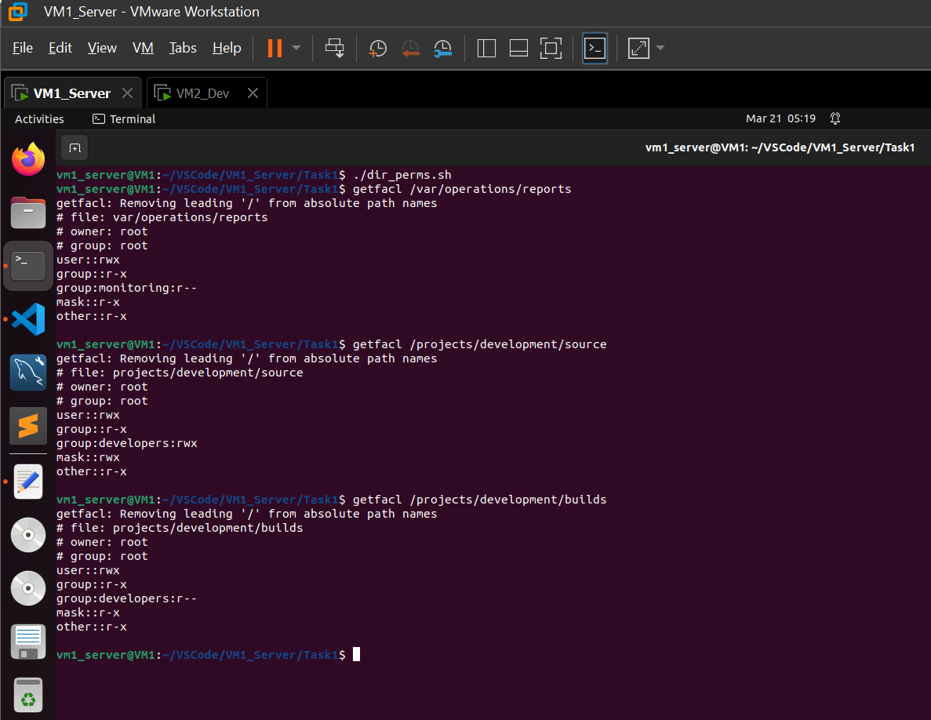

**Task 2: Security Hardening:**

**2.1 SSH Key-Based Authentication:**

* 1. **Automatic Security Updates:**
  2. **Configure Message of the Day (MOTD):**

**Task 3: System Monitoring & Automation:**

**3.1** **Metric Collection Script:**

**3.2 File Activity Monitor:**

**Task 4: MySQL User Management and Database Exploration:**

**4.1 MySQL User Creation:**

**4.2 User Authentication and Verification:**

**4.3 Database and Table Exploration:**

**4.4 Logging and Audit Trail:**

**Task 5: Network Connectivity Monitoring:**

**Client Side:**

**Task 1: Development Team (VM2):**

**1.1 Login Attempt Monitoring:**

**1.2 Permission Cleanup Script:**

**Task 2: Operations Team (VM3):**

**2.1 Resource Reporting Script:**

**2.2 Quota Enforcement:**