Name: Shaoxiong Lan NSID: shl864 Student Number: 11193044

Report of Assignment 3

**The order of running:** \i ‘C355A31.txt’, \i ‘C355A32.txt’, \i ‘C355A33.txt’, \i ‘C355A34.txt’, \i ‘C355A35.txt’

* **The whole E-R diagram:**

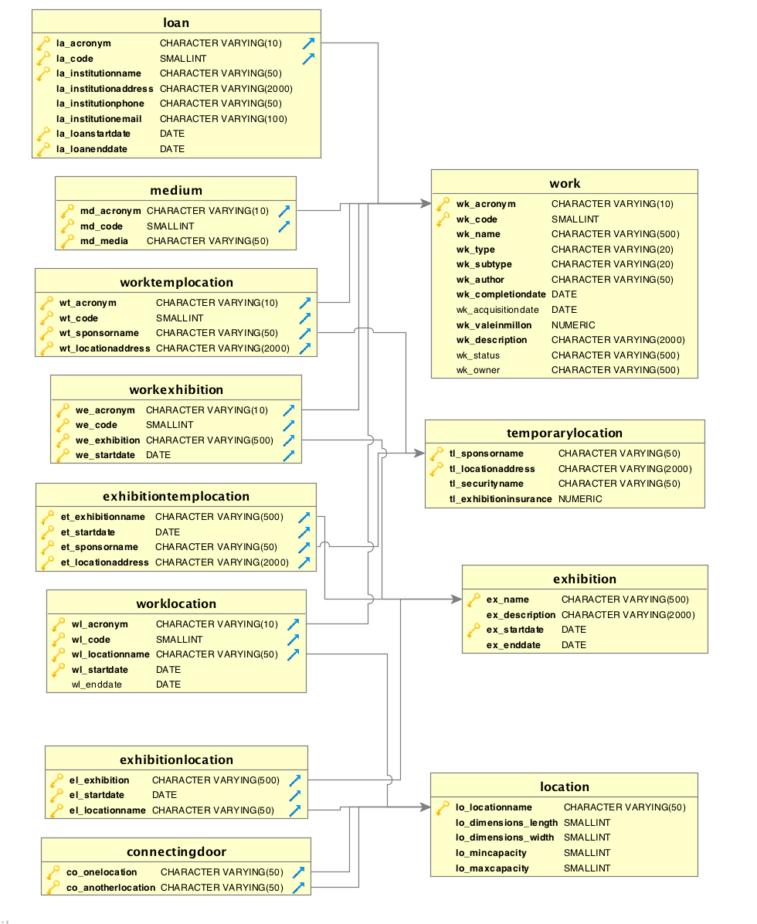

* **expanding current exhibitions**
  + first Run \i ‘C355A31.txt’
  + add works from storage to current exhibitions (exhibition1, exhibition2 and exhibition3) and future exhibitions (exhibition4, exhibition5 and exhibition6) to the maximum recommended capacity of the locations where the exhibition is taking place
* exhibition1 and exhibition4 are in gallery A, so adding the number of works to 16
* exhibition2 and exhibition5 are in gallery B, so adding the number of works to 16
* exhibition3 and exhibition6 are in gallery C, so adding the number of works to 24
* So we should insert values on workExhibition table and update workLocation table
* **Evolving the Collection**
  + Run \i ‘C355A32.txt’
  + Add two column wl_StartDate and wl_EndDate in the table workLocation to in order to ensure that I can access the different locations of a work for the period of time when your museum owned or borrowed it.
  + Revise date definition to make (wl_Acronym, wl_Code, wl_LocationName, wl_StartDate) become the primary key of workLocation table
  + Add another 15 purchased works to the Work and insert into the workLocation table on the ‘2016-10-25’
  + For the 3 sold works, just update Work table to change the owner and status on the ‘‘2016-10-21’ and delete those 3 rows on the workLocation.
  + The following E-R diagram:

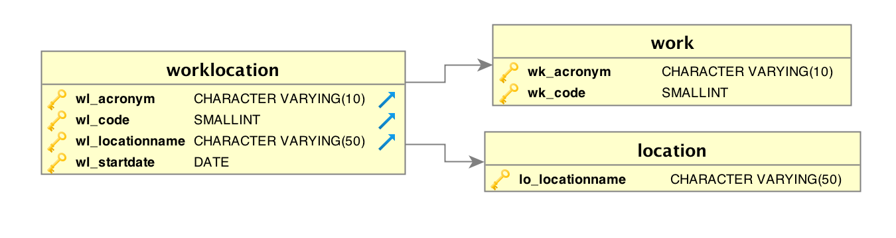

* **Record the history**
  + Run \i ‘C355A33.txt’
  + Firstly, initializing all location in workLocation to ‘storage’ and the wl_StartDate to the acquisition Date of museum and all the wl_EndDate to the ‘null’ to indicate the all works in storage at the origin state
  + Then, Create trigger to wait the movement of work. If so, update the endDate of previous state, which is the startDate of new state.
  + Then insert 3 old exhibitions with 10 works prior to exhibition1, which are ‘old_exhibition1’, ‘old_exhibition2’ and ‘old_exhibition3’. Then record movement on the workLocation from storage to gallery and from gallery back to storage again after the endDate of 3 old exhibitions
  + Then insert 3 current exhibitions (exhibition1, exhibition2 and exhibition3). Then record the movement on the workLocation from storage to the gallery
  + The data result in Dbvisualizer
  + 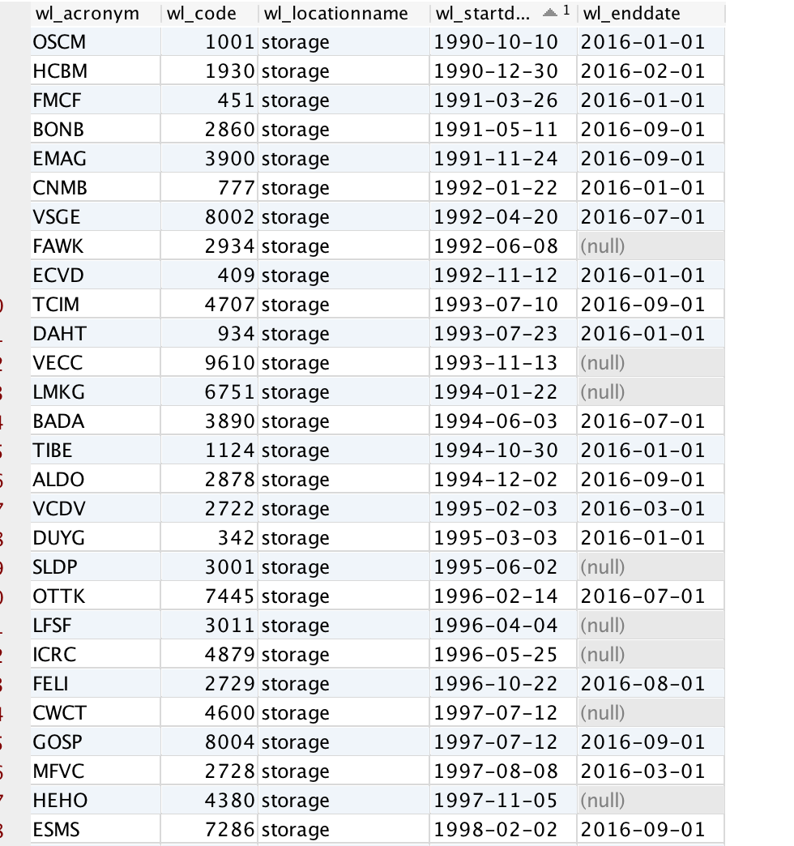
  + the result of first query:

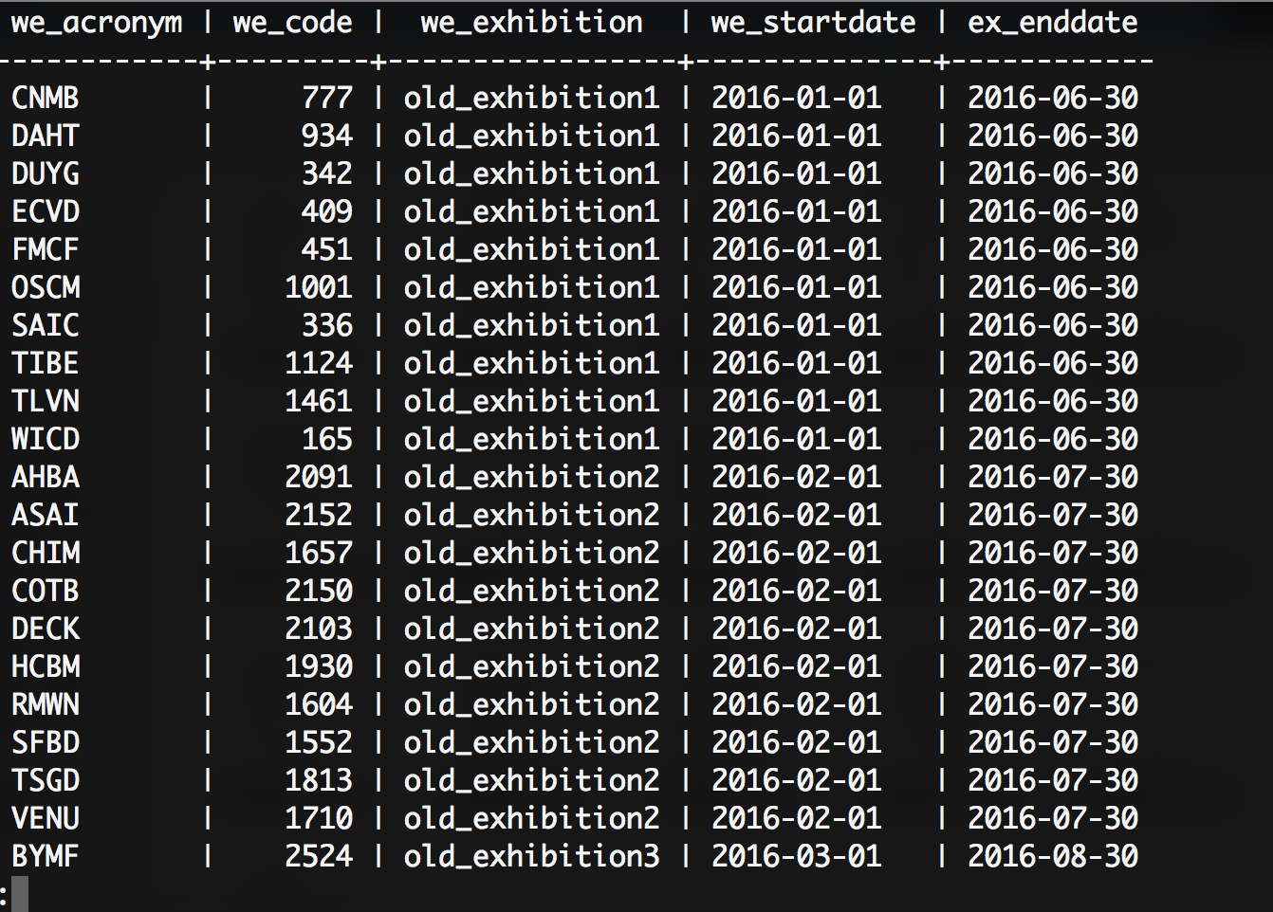

* + the result of second query:

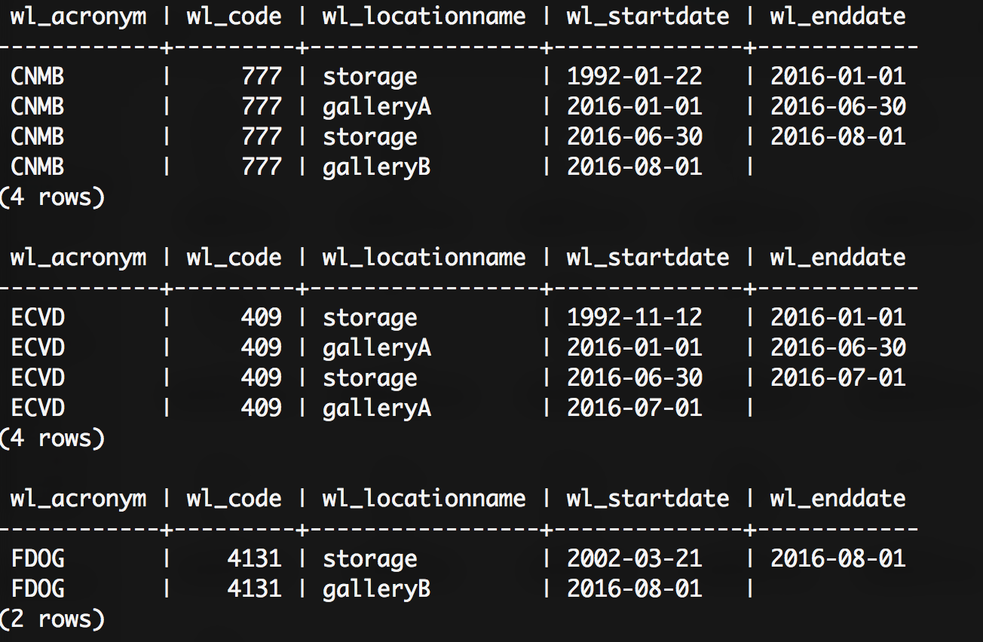

* + the result of third query:

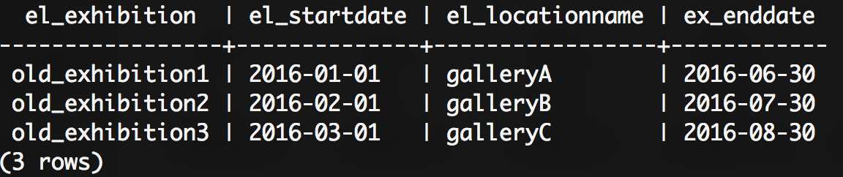

* **Outgoing Loans**
  + Run \i ‘C355A34.txt’
  + Create new table Loan to keep track of the relationship between the work and loan
  + Then insert 6 loans into Loan table.
  + Move the work to the ‘onLoan’ on workLocation table when current date is larger than the loan startDate, then process loans
  + Move the work back to the ‘storage’ on workLocation when current date is larger than the loan endDate, then process the return of works
  + The following E-R diagram:

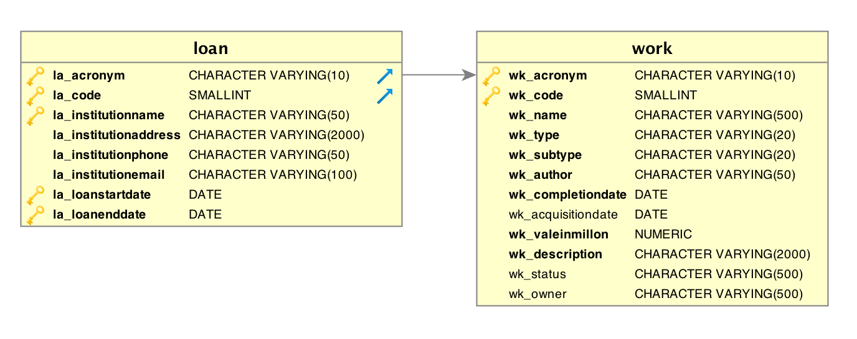

* **Traveling Exhibitions**
  + Run \i ‘C355A35.txt’
  + Create new table temporaryLocation to record the name of sponsor of traveling exhibition, the address of the temporary location, the name of individual in charge of security amount of insurance provided for exhibition
  + Insert 5 temporary location into table temporaryLocation
  + Insert 5 travellingExhibition into exhibition table
  + Create and fill the connecting table ExhibitionTempLocation between the exhibition and temporaryLocation
  + Insert the workExhibition table, each travellingExhibiton has the same 8 works that are available during the travelling.
  + Create and fill the connecting table workTempLocation between the work and temporaryLocation
  + The E-R diagram:

