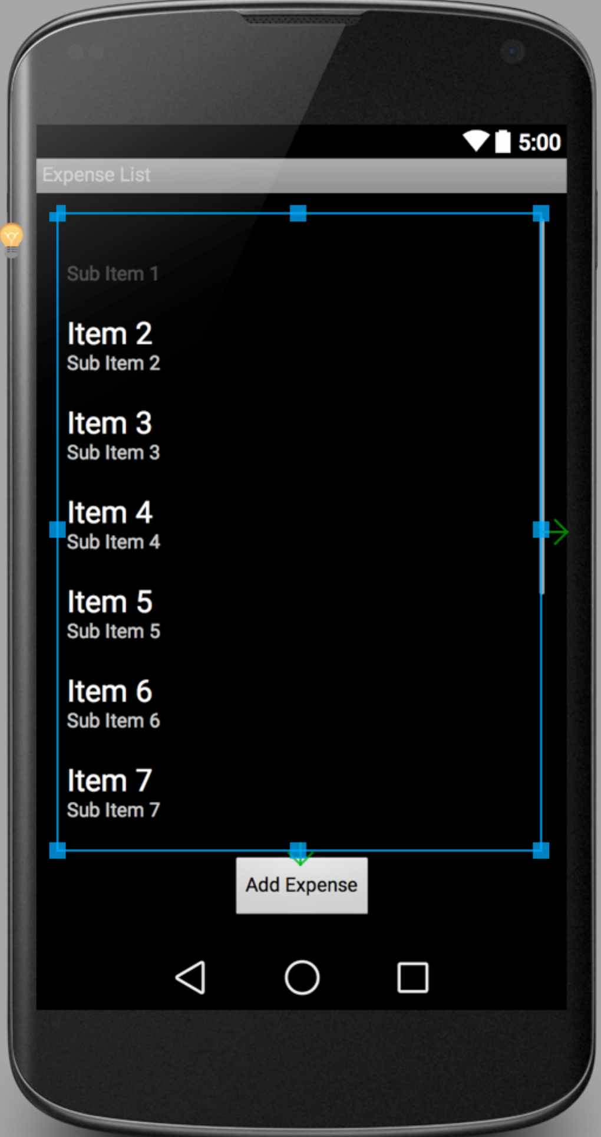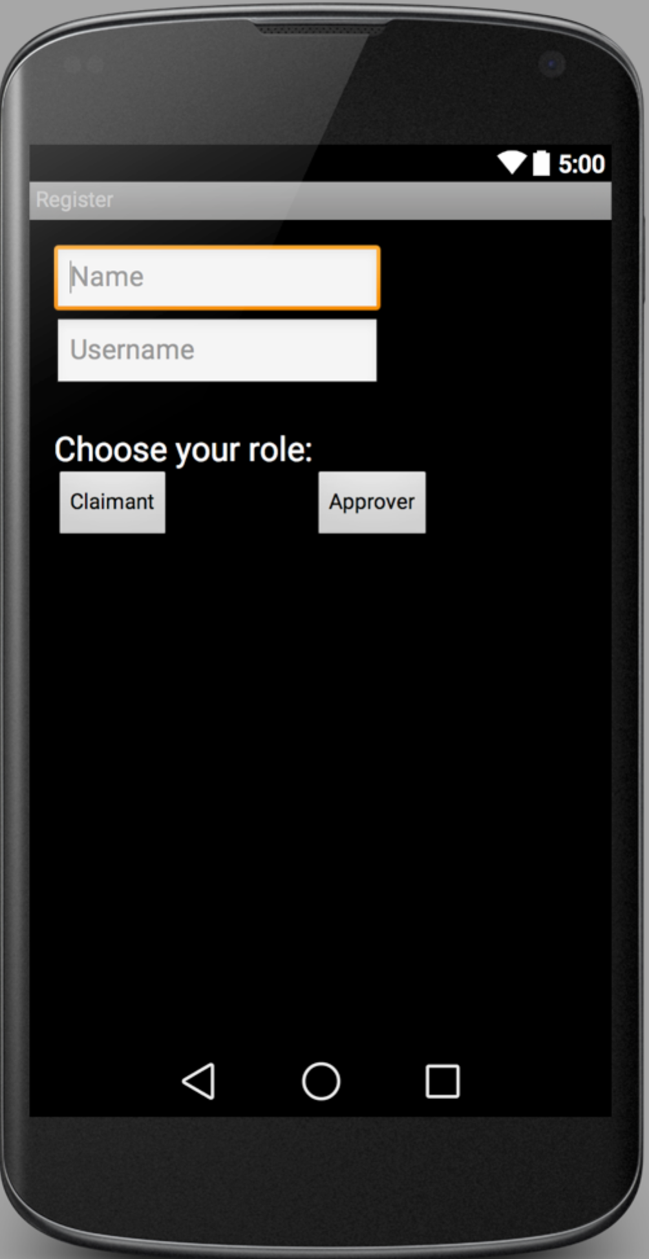

After clicking “View/Add Expenses”, clicking “Save” or “ Submit” to finish. Then go back to Claim List Page.

After clicking “Create New Account”

After choosing either “Claimant” or “Approver”, user will go back to main page and login with their username.

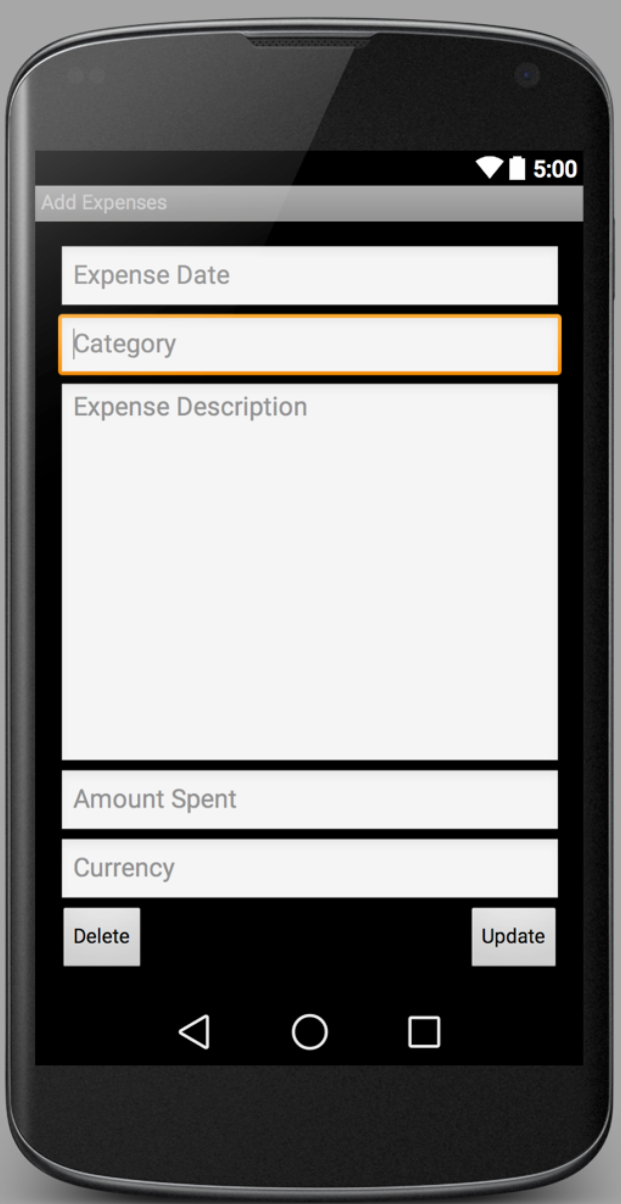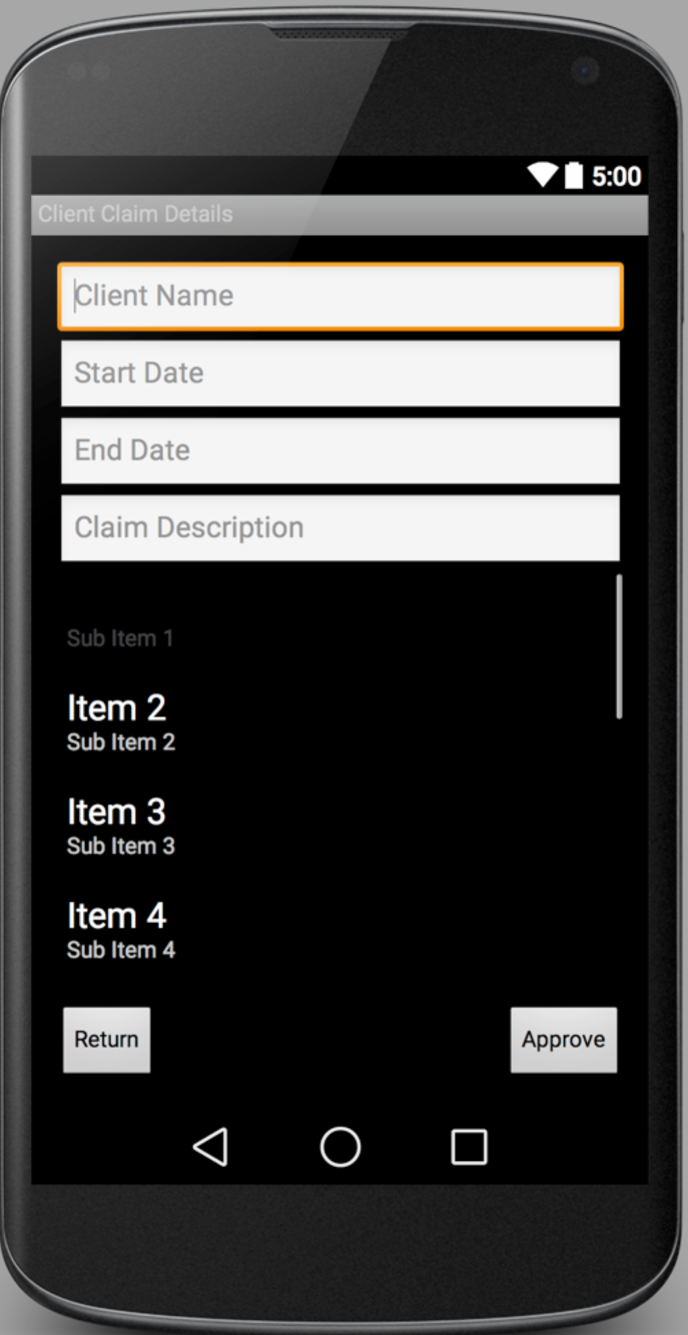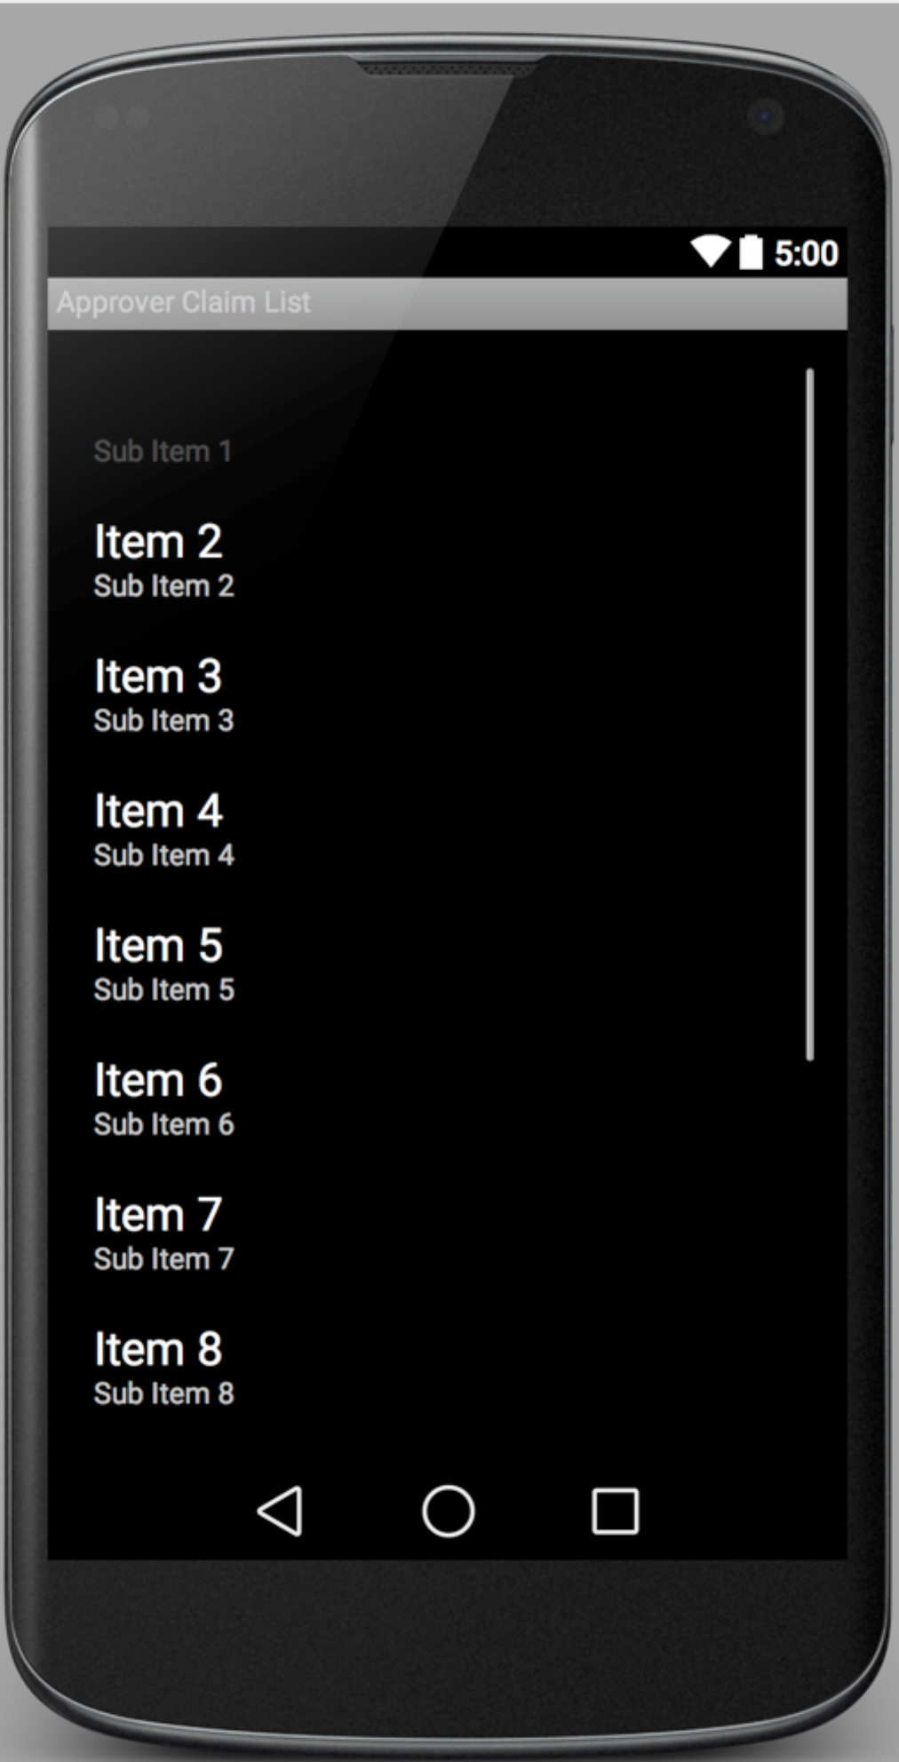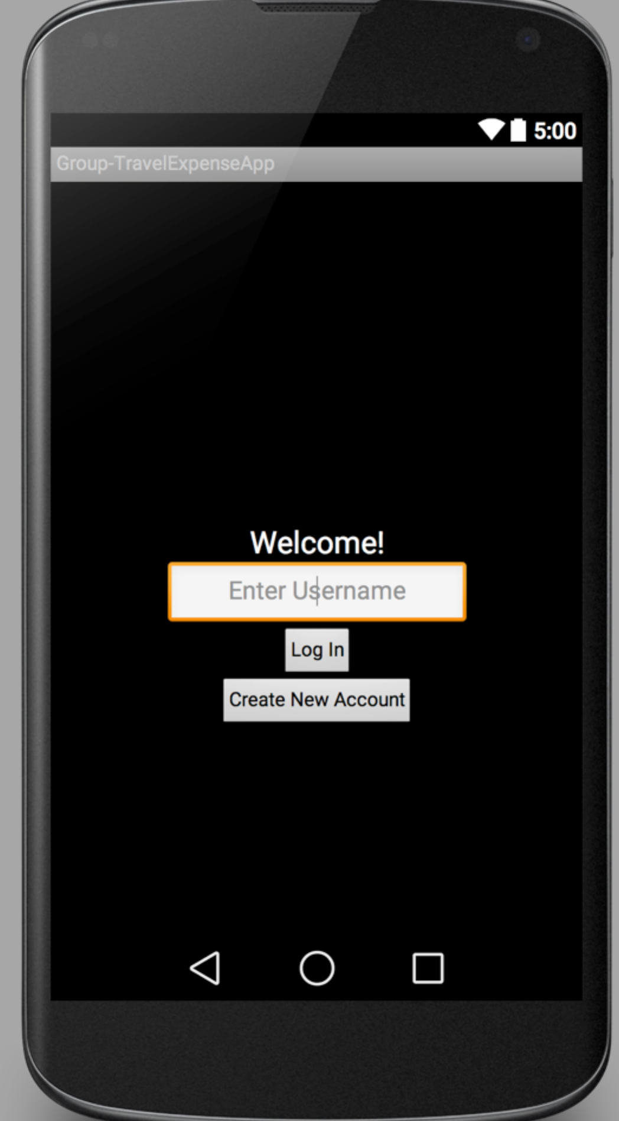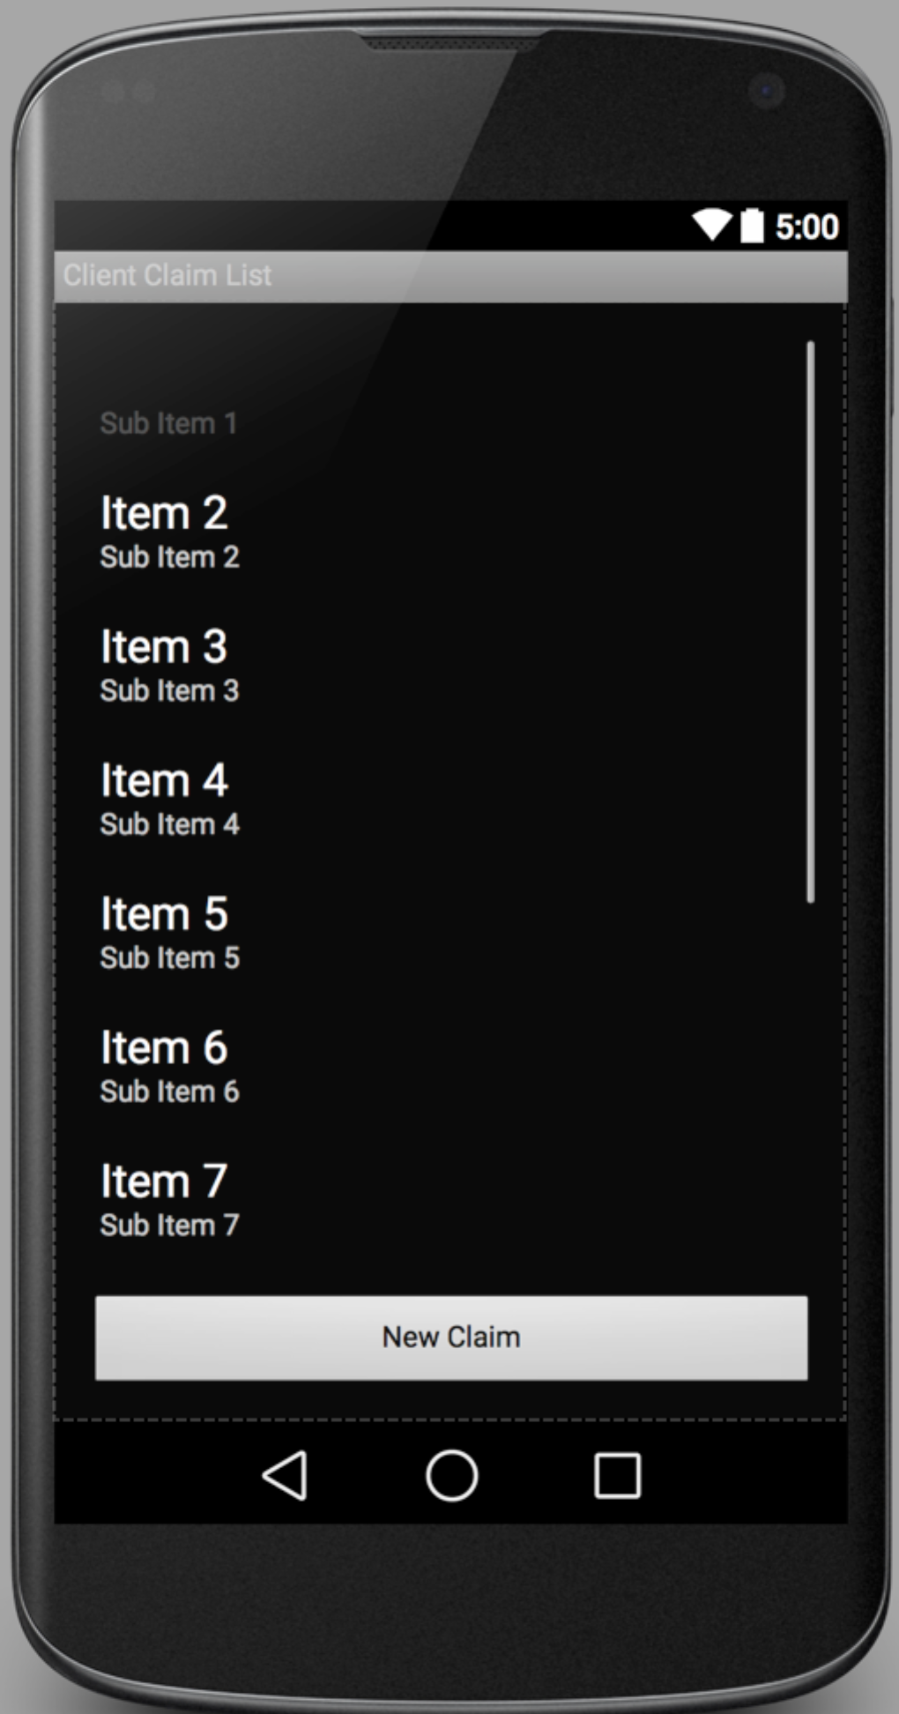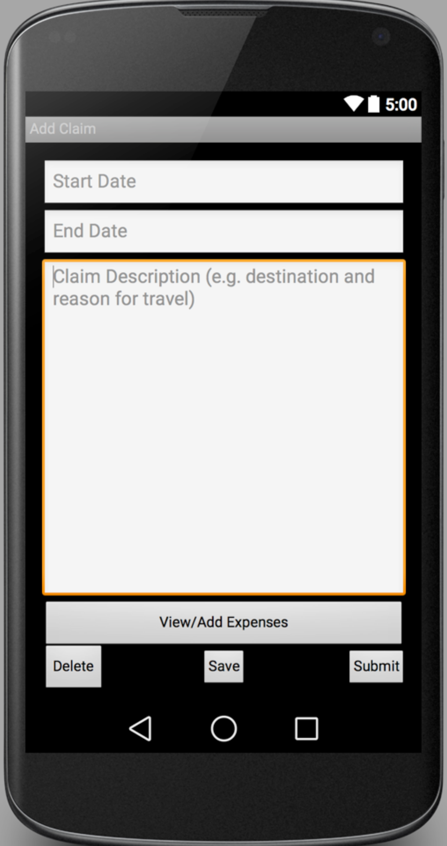

After checking all the details, clicking “Return” for returned purpose or “Approve” for approval. Then go back to Claimant Claim List.

After login as approver

After login as claimant

After clicking a specific claim item, you will get to view all the details of the specific claim.

After entering all the details, clicking “Update” to finish add one expense item. Then go back to Expense List Page.

After clicking “Add Expense”

After clicking “New Claim”