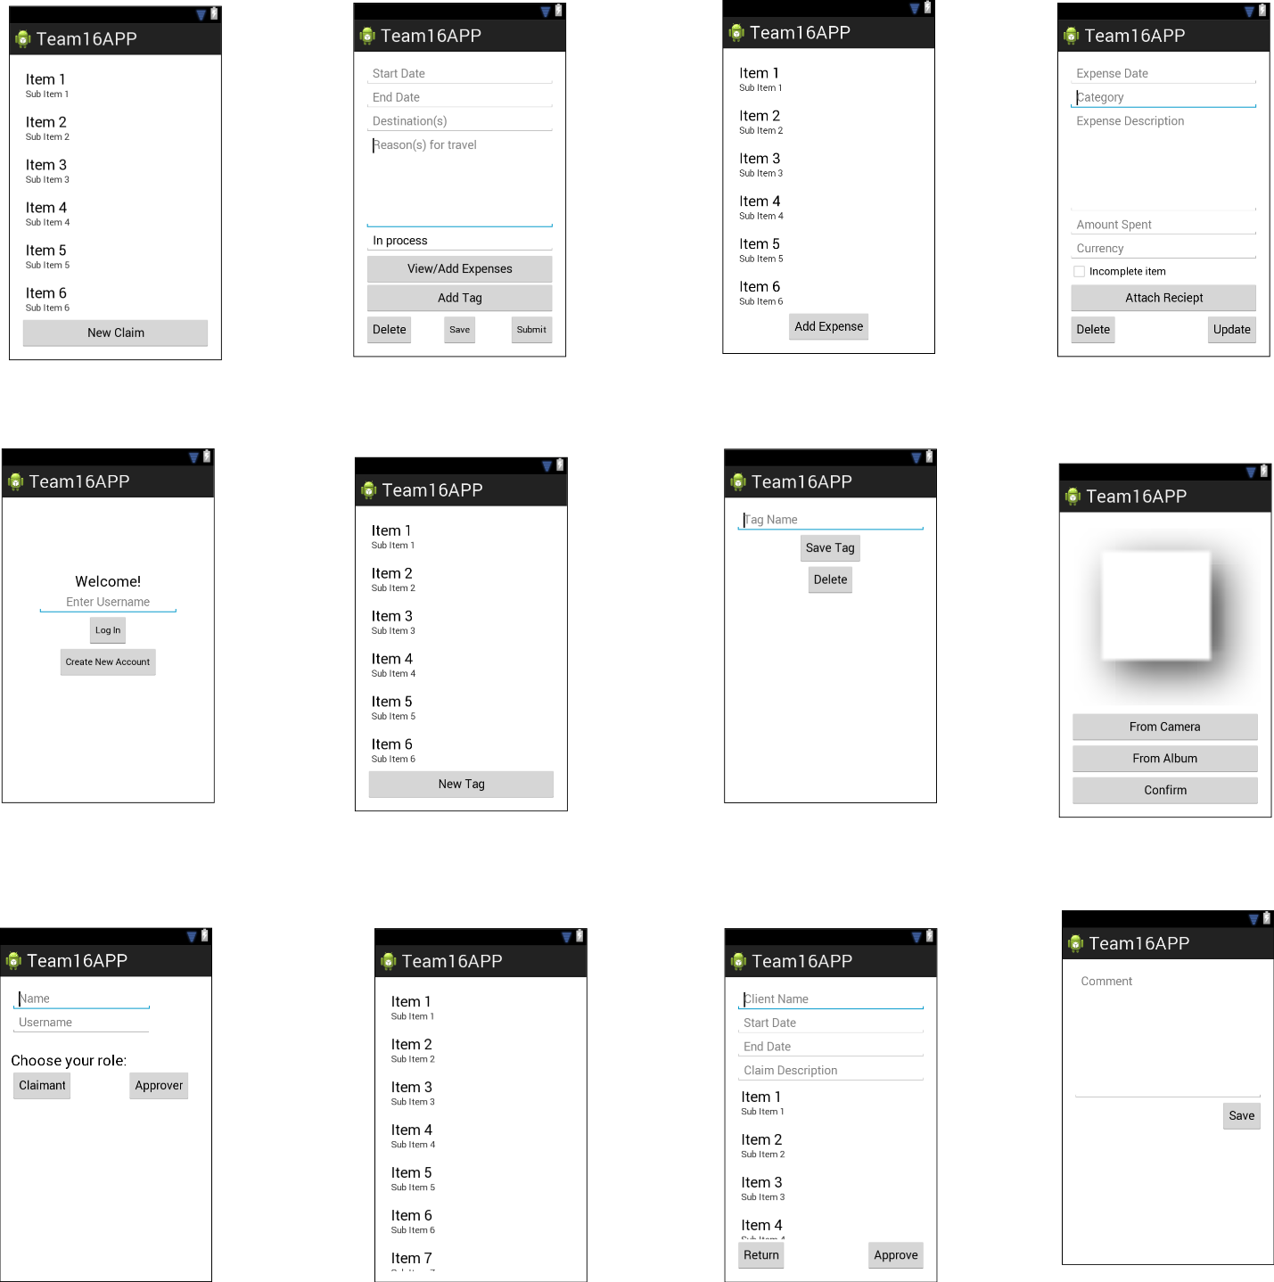

List of expenses. Clicking on   
an expense allows for editing

Button to add new tag. Sends user to tag menu

After typing comments, click “Save” goes back to Approver Claim Menu Screen.

Clicking “Approve” goes back to Approver Claim Menu Screen.

Clicking the item to view claim details.

Buttons to save, delete tags which sends user back to tag menu screen

Buttons to delete, save, submit claim which sends user back to claim menu screen

Button to add picture to expense item. Takes user to add photo screen

List of claims, if any

Button to create new tag

List of tags, if any

Text fields for claim start date, end date, destination and reason for travel

Button to create new claim

Buttons to select where to get picture

**Add photo Screen**

Delete and Update buttons, which take user back to Claimant expense menu screen

Button to add new expense

Text field for Name

Here the user can choose either the Claimant or Approver account which each give access to different features. Once a role is chosen, user is taken back to the Login screen

Text field for Username

Button to create a new account if user does not have an account.

Button for log in

Text field for Username

The username would either be an Approver username or a Claimant username and will send the user to the right menu screen

List of claims, if any

Button to go to the expense menu

Text fields for expense date, category, description, amount spent and currency

Preview of picture to be added

Button to add picture to expense item. Takes user back to add/edit expense screen

When approver clicks “Return”, approver needs to write comment for that particular claim.

**Approver Comments View**

**Add/Edit Expense Screen**

**Claim Details (Approver View)**

**Create Tag Screen**

**Tag Menu Screen**

**Approver Claim Menu Screen**

**New Claim Screen**

**Claimant Expense Menu Screen**

**Claimant’s Claim Menu Screen**

**Login Screen**

**Create Account Screen**