CMPUT 302 W14

Project Final Report

April 12th, 2014

Augmented Pen & Paper Interface

Team 4

Group Name: Pen & Paper

Group Members: Ashley Dawn Brown, James Cadek, Gerald Manweiler, Eddie Tai, Yi Zou

Division of Labour:

Division of labour is fluid and determined by each team member’s current academic workload, unique skill sets, interests, and project requirements & deadlines. Workload will be managed by consensus and twice weekly meetings. Workload will be communicated via meetings, email, Trello. Project tasks that lend themselves to one team member being the primary will always be supported by team consensus. All team members have design input, but one team member will be responsible for final prototype copy. Project management will generally be handled by one team member and documentation by another. There will be one primary programmer, but all team members will contribute to the code base. One team member will lead the experimental testing methodology design, but all members will contribute.

Project Description:

The main objective of this project is to capture and digitize graphical annotation on a paper geographic information system/land use/topographical maps, and be synchronized with relevant audio and video information in a portable fashion.

The project source is Trevor Wiens of [Apropos Information Systems](http://aproposinfosystems.com/). Trevor hopes to use this product with his main product [LOUIS Heritage](http://louistk.ca/EN/heritage-home/), a tool to help indigenous people in preserving, protecting and promoting their traditional knowledge and values. LOUIS Heritage allows text, maps and media files to be stored and used together.

The project is scientifically interesting because a portable geographic map annotation digital capture system integrated with [Natural Language Processing coding](http://louistk.ca/EN/heritage-home/heritage-features/), and based on tracking an infrared source, and does not currently exist. Current partial solutions rely on a [projector](http://en.wikipedia.org/wiki/Interactive_whiteboard#Operation_of_a_portable_ultrasonic.2C_IR_pen-based_interactive_whiteboard) or a uniquely patterned paper and a digital pen (such as [anoto pen & paper](http://www.anoto.com/lng/en/mode/sublist/documentId/1150/pid/480/)) to save written content to a computer. This project aims to remove the need of these requirements for the capture system, which may be beneficial and inspirational to many other scientific developments.

The functionality of the system will be tracking and geo-referencing an infrared dot from a pen on a paper map. First, the map will be calibrated. An audio/video recording will capture the entire session and provide a date/time stamp for cross referencing. When the system picks up infrared signal from the pen, the system will record the coordinates from the map and the date/time stamp of the infrared signal. Wiimotes will be used as the infrared sensors.

The software interface will feature a main screen with menu bar that lets a user enter basic session info on a laptop (map unique identifier, interviewer(s), interviewee(s), date & time), an interface to calibrate the infrared pen to the land use map, an interface to give real time feedback of infrared coordinate capture points in relation to location on the land use map, and menu to control video/audio recording of the session.

Evaluation of Interface/Experimental Testing Methodology:

We executed three tests to evaluate our system.

Test 1. Comparison with Google Maps

Our client had mentioned that the current best alternative is the use of Google Maps. Hence, we intend to compare the speed of using our product with the speed of using Google Maps. We will have location that we pick beforehand and know the result of. We will then ask an individual to select this location using our technology and then using Google Maps. (The order of testing will be randomized to insure fair testing).  Both situations will be timed and we will then evaluate and see if either is significantly faster than the other is.

|  |  |  |  |  |  |  |
| --- | --- | --- | --- | --- | --- | --- |
| paper time | | | | google time | | |
| 4.72 | | | | 2.01 | | |
| 3.36 | | | | 10.81 | | |
| 15.49 | | | | 3.51 | | |
| 6.33 | | | | 13.3 | | |
| 2.86 | | | | 36.39 | | |
|  | | | |  | | |
| Column | n | Mean | Variance | | Std. dev. | Std. err. | Median | Range | Min | Max | Q1 | Q3 |
| paper | 5 | 6.552 | 26.7783 | | 5.1748 | 2.3142 | 4.72 | 12.63 | 2.86 | 15.49 | 3.36 | 6.33 |
| Column | n | Mean | Variance | | Std. dev. | Std. err. | Median | Range | Min | Max | Q1 | Q3 |
| google | 5 | 13.204 | 190.6525 | | 13.8077 | 6.1750 | 10.81 | 34.38 | 2.01 | 36.39 | 3.51 | 13.3 |

Protocol

1. Experiment was randomized
2. Subjects assigned randomly to treatment groups
3. Randomizing the experiment gave independent groups

**Note**: Because of the small sample size of 5 per group, normal probability cannot be assumed.

1)Null and Alternate Hypothesis

We want to know if there is a difference between the time to find the same target with a paper map versus google maps.

H0: the difference between paper map time and google map time is zero

     

  the difference between paper map time and google map time is not zero

    ≠  

2) Level of Significance

α = 0.05

3) Test Statistic

Since largest std. dev. / smallest std. dev > 2, t-test without pooling

4) Rejection Region

  ≠    we reject H0 if TS > = 2.7764 or TS < = - 2.7764

5) Calculate Test Statistic

Hypothesis test results:  
μ1 : Mean of paper time  
μ2 : Mean of google time  
μ1 - μ2 : Difference between two means  
H0 : μ1 - μ2 = 0  
HA : μ1 - μ2 ≠ 0  
(without pooled variances)

|  |  |  |  |  |  |
| --- | --- | --- | --- | --- | --- |
| Difference | Sample Diff. | Std. Err. | DF | T-Stat | P-value |
| μ1 - μ2 | -6.652 | 6.5944044 | 5.1019085 | -1.008734 | 0.3585 |

95% confidence interval results:  
μ1 : Mean of paper time  
μ2 : Mean of google time  
μ1 - μ2 : Difference between two means  
(without pooled variances)

|  |  |  |  |  |  |
| --- | --- | --- | --- | --- | --- |
| Difference | Sample Diff. | Std. Err. | DF | L. Limit | U. Limit |
| μ1 - μ2 | -6.652 | 6.5944044 | 5.1019085 | -23.502117 | 10.198117 |

6) Conclusion

Since TS=-1.0087 < 2.7764 and -1.0087 > -2.7764 we fail to reject H0**.** At α = .05, there is not enough evidence to conclude the time to find the same target with a paper map versus google maps is not zero. Since P-value 0.3585 is greater than α = .05, we fail to reject H0.

Since zero is in the confidence interval, we fail to reject      vs     ≠  . We conclude there is no difference in the time to find the same target with a paper map versus google maps. However, it is clear to us after testing and use that this failure to reject is resultant of a small sample size n = 5.

Test 2. Comparison of tracing or writing with an offset

Our client would like to have both physical written annotations as well as the digital copy we will record. To provide him with this we have two methods, write the annotations first and trace them with our IR pen, or tape a pen/pencil to our IR pen and have an offset calculated.  To test which is a better idea we want to analyse the accuracy of both methods.  We will have a pre-made design on our map which individual will be asked to trace with both set ups (again order of testing will be randomized). We will then compare the output of both methods to the pre-calculated output and see the level of accuracy of both. We want to see if one method is significantly more accurate than the other.

We anticipated two possible ways to meet our client’s need of having a physical feedback. One way is to ask the user to write on the map with a writing utensil, then trace over the lines with the IR pen. The other method is to attach a writing utensil to the IR pen, and write directly on the map. This test will calculate that without using any built-in offset calculation, are the differences between the two writing methods significant.

To extract the data in a meaningful way for statistical analysis, a line of best fit is drawn using the coordinate points collected by the program. The slope and intercept of the lines of best fit for each participant’s sample data will be compared individually. The slope represents the presence of any jittering as user traces the horizontal line. The difference in intercept is a measurement of any offsets required due to the angular orientation of the IR pen.

Our hypotheses for the tests are the following:

H0- There is no difference between the two methods.

H1- There is a difference between the two methods.

As the data on the two groups are produced by the same study participants, a paired t-test is the most appropriate statistical test. However, from the histograms shown below, normality cannot be assumed in the slope data, as there is a clear violation. The data for intercepts looks roughly normal.

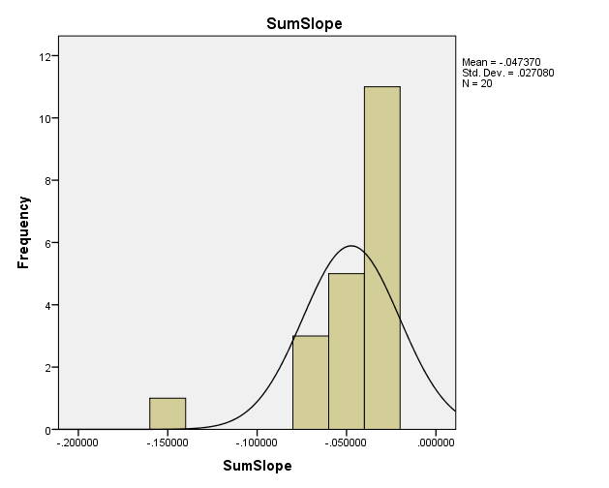

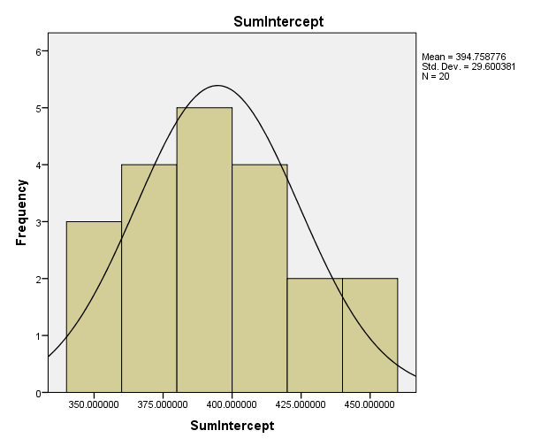

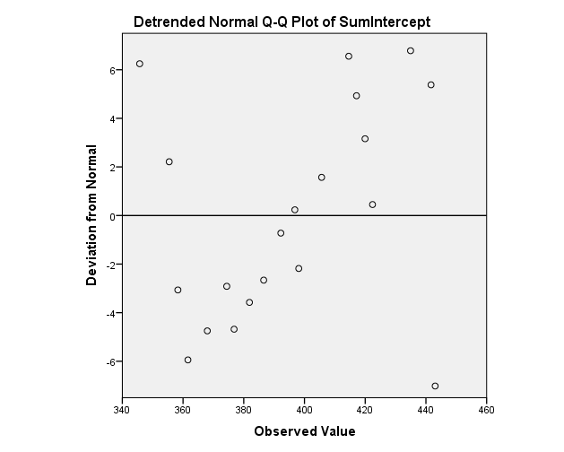

A QQ plot is done for the intercept data to further analyze if normality can be assumed, and the detrended QQ plot shows that data are not spread out very evenly. Normality assumption is violated in both cases.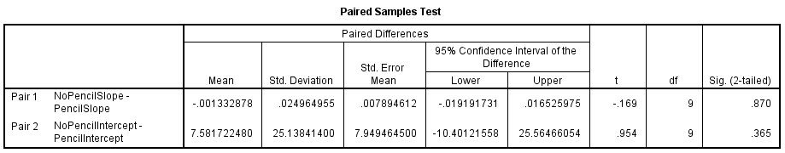

The paired T-test is carried out as shown above, and for both cases, the significance is above 0.05. Therefore, we failed to reject the null hypotheses in both cases. There is no difference between the two methods. Writing with the IR pen alone or with a writing utensil attached to the IR pen produce no statistically noticeable differences in the participants’ jitter and offsets required due to angular orientations. However, this conclusion is reached with the violation of the normality assumption. It is strongly recommended that the tests should be repeated with at least 30 participants to ensure normality for the statistical tests in the future.

Test 3. Effect of Pen Orientation on Accuracy

The final test will be a simple yet important test regarding how participants will be holding the IR pen. As the participants perform the previous test, they hold the pen in what is the most intuitive manner to them. In this test, they will be asked to hold the pen in a different manner (either holding the pen with thumb on the pen’s button, or the pen is rotated by 180 degrees where the button is held by other fingers), and repeat the trace of a line like in the previous test.

|  |  |  |  |  |
| --- | --- | --- | --- | --- |
| Finger | Thumb | Finger | Thumb | Finger |
| Finger | Finger | Finger | Finger | Finger |

Totals:

Finger = 8, Thumb = 2

X2 = (8-5)2/5 + (2-5)2/5 = 18/5 = 3.6

df = 1

X2-crit = 3.86

H0 = There is no difference between groups

HA = There is a difference between groups

Because X2 of 3.6 < 3.86, we fail to reject the null hypothesis, and therefore there is no significant difference between groups. However, it is clear to us after testing and use that an 80%:20% split between groups should be a significant difference, and this failure to reject is resultant of a small sample size n = 10.

Heuristic Analysis:

A heuristic analysis will be conducted per the guidelines suggested by Jakob Neilsen. The analysis will be done by 4 evaluators.

<http://www.nngroup.com/articles/how-to-conduct-a-heuristic-evaluation/>

<http://www.nngroup.com/articles/ten-usability-heuristics/>

<http://www.nngroup.com/articles/how-to-rate-the-severity-of-usability-problems/>

The following 0 to 4 rating scale will be used to rate the severity of usability problems:

**0** = I don't agree that this is a usability problem at all   
**1** = Cosmetic problem only: need not be fixed unless extra time is available on project   
**2** = Minor usability problem: fixing this should be given low priority   
**3** = Major usability problem: important to fix, so should be given high priority   
**4** = Usability catastrophe: imperative to fix this before product can be released

1. Visibility of System Status

The GUI does not have feedback when wii remotes disconnect. GUI stops working and the user will have no idea about what goes wrong.

Severity Rating - 2

2. Match between System and Real World

No problems about this part. We adequately adapt glossaries from the client and reuse them in the program. The words are intuitive enough to be understood.

Severity Rating - 0

3. User Control and Freedom

Once the user calibrates and starts recording he/she is forbidden to fill in the rest of the form. The only data stored will the information obtained from the recording session.

Severity Rating - 1

4. Consistency and Standard

The client provided all relevant technical terms. The workers using the GUI are fully trained to understand all the terms.

Severity Rating - 0

5. Error Prevention

The correct data type will be checked and the wrong data type will be erased.

Severity Rating - 0

Due to hardware limitation, we are not able to stabilize the wii remote controller in a real interview setting.

Severity Rating -1

6. Recognition rather than recall

No real problems. Everything a user needs to input are labeled on the GUI. The GUI is intuitive thus the user does not need to remember any instructions.

Severity Rating - 0

7. Flexibility and efficiency of use

There is no accelerator since the program is designed for minimal use. Inexperienced users are not taken into consideration since all users using this particular program are assumed having experience in the related field.

Severity Rating - 0

8. Aesthetic and minimalist designed

All buttons are clearly labeled and serve a specific function. Tool tips are available when mouse hovering over the input box and disappear when moving away.

Severity Rating - 0

9 Help users recognize, diagnose, and recover from errors

When you input wrong data type into the input box the wrong data will be cleared away. However there are no dialogue boxes to inform the user about the error.

Severity Rating - 2

10 Help and documentation

Once the program is initiated there are instructions boxes included. There are also installation documentation written to complement the software.

Severity Rating – 0

Sources:

https://github.com/CMPUT302W14T04/Interface/wiki

http://aproposinfosystems.com/

http://louistk.ca/EN/heritage-home/

http://louistk.ca/EN/heritage-home/heritage-features/

http://en.wikipedia.org/wiki/Interactive_whiteboard#Operation_of_a_portable_ultrasonic.2C_IR_pen-based_interactive_whiteboard

http://www.anoto.com/lng/en/mode/sublist/documentId/1150/pid/480/

http://www.nngroup.com/articles/how-to-conduct-a-heuristic-evaluation/

http://www.nngroup.com/articles/ten-usability-heuristics/

http://www.nngroup.com/articles/how-to-rate-the-severity-of-usability-problems/