CMPUT 302 W14

Project Halfway Prototype Milestone

March 24th, 2014

Augmented Pen & Paper Interface

Team 4

Group Name: Pen & Paper

Group Members: Ashley Dawn Brown, James Cadek, Gerald Manweiler, Eddie Tai, Yi Zou

Division of Labour:

Division of labour is fluid and determined by each team member’s current academic workload, unique skill sets, interests, and project requirements & deadlines. Workload will be managed by consensus and twice weekly meetings. Workload will be communicated via meetings, email, Trello. Project tasks that lend themselves to one team member being the primary will always be supported by team consensus. All team members have design input, but one team member will be responsible for final prototype copy. Project management will generally be handled by one team member and documentation by another. There will be one primary programmer, but all team members will contribute to the code base. One team member will lead the experimental testing methodology design, but all members will contribute.

Project Description:

The main objective of this project is to capture and digitize graphical annotation on a paper geographic information system/land use/topographical maps, and be synchronized with relevant audio and video information in a portable fashion.

The project source is Trevor Wiens of [Apropos Information Systems](http://aproposinfosystems.com/). Trevor hopes to use this product with his main product [LOUIS Heritage](http://louistk.ca/EN/heritage-home/), a tool to help indigenous people in preserving, protecting and promoting their traditional knowledge and values. LOUIS Heritage allows text, maps and media files to be stored and used together.

The project is scientifically interesting because a portable geographic map annotation digital capture system integrated with [Natural Language Processing coding](http://louistk.ca/EN/heritage-home/heritage-features/), and based on tracking an infrared source, and does not currently exist. Current partial solutions rely on a [projector](http://en.wikipedia.org/wiki/Interactive_whiteboard#Operation_of_a_portable_ultrasonic.2C_IR_pen-based_interactive_whiteboard) or a uniquely patterned paper and a digital pen (such as [anoto pen & paper](http://www.anoto.com/lng/en/mode/sublist/documentId/1150/pid/480/)) to save written content to a computer. This project aims to remove the need of these requirements for the capture system, which may be beneficial and inspirational to many other scientific developments.

The functionality of the system will be tracking and geo-referencing an infrared dot from a pen on a paper map. First, the map will be calibrated. An audio/video recording will capture the entire session and provide a date/time stamp for cross referencing. When the system picks up infrared signal from the pen, the system will record the coordinates from the map and the date/time stamp of the infrared signal. Wiimotes will be used as the infrared sensors.

The software interface will feature a main screen with menu bar that lets a user enter basic session info on a laptop (map unique identifier, interviewer(s), interviewee(s), date & time), an interface to calibrate the infrared pen to the land use map, an interface to give real time feedback of infrared coordinate capture points in relation to location on the land use map, and menu to control video/audio recording of the session.

Evaluation of Interface/Experimental Testing Methodology:

We intend to execute three tests to evaluate our system.

Test 1. Comparison with Google Maps

Our client had mentioned that the current best alternative is the use of Google Maps. Hence, we intend to compare the speed of using our product with the speed of using Google Maps. We will have location that we pick beforehand and know the result of. We will then ask an individual to select this location using our technology and then using Google Maps. (The order of testing will be randomized to insure fair testing).  Both situations will be timed and we will then evaluate and see if either is significantly faster than the other is.

Test 2. Comparison of tracing or writing with an offset

Our client would like to have both physical written annotations as well as the digital copy we will record. To provide him with this we have two methods, write the annotations first and trace them with our IR pen, or tape a pen/pencil to our IR pen and have an offset calculated.  To test which is a better idea we want to analyse the accuracy of both methods.  We will have a pre-made design on our map which individual will be asked to trace with both set ups (again order of testing will be randomized). We will then compare the output of both methods to the pre-calculated output and see the level of accuracy of both. We want to see if one method is significantly more accurate than the other.

Test 3. Effect of Pen Orientation on Accuracy

The final test will be a simple yet important test regarding how participants will be holding the IR pen. As the participants perform the previous test, they hold the pen in what is the most intuitive manner to them. In this test, they will be asked to hold the pen in a different manner (either holding the pen with thumb on the pen’s button, or the pen is rotated by 180 degrees where the button is held by other fingers), and repeat the trace of a line like in the previous test.

Remainder of project Schedule:

* Calculate and implement spatial geometry for 4 wiimote setup
* Integrate 2 wiimote and 4 wiimote into a single deliverable
* Program wiimote accelerometer to detect wiimote movement
* Generate new UI after setting calibration points for 4 wiimotes
* Build 3rd identical IR pen
* Do heuristic analysis of prototype
* Write consent form for testing participants
* Recruit testing participants
* Test prototype with participants and analyze results
* Final Report Document
* Do heuristic analysis of prototype
* NLP Icon selection before IR drawing
* Load map background image
* Recognizing series of dots as one "image" based on proximity in time
* Improve saving to save images and NLP icons instead of just points

Client Need Analysis:

* Portability, ease of use and the ability to use paper maps are the utmost priority for the client
* The client wants to reduce manpower costs from a multi-person interview team to a one person interview team.
* The client wants to digitally capture and geo-reference annotations made on a paper map. Resolution of 1.5 mm required on 1:50000 scale maps.
* The client wants digitized map feedback of the IR capture.
* The client wants to verbally anchor map annotation with audio recording of unique feature id of map annotation. This will be used by the Natural Language Processing (NLP) functionality of the client’s product LOUIS Heritage (Land Occupancy and Use Information System) to integrate map annotation. The audio anchoring will be done by timestamp matching to the IR coordinates capture.
* The client needs map/audio/video session data saved in a format compatible with the client’s product LOUIS Heritage.
* The client wants a single video/audio recording of the session.
* The client has specified that the system should work with any operating systems.
* The client specified a maximum map size of 4 feet by 6 feet.
* The client a maximum map bearing surface of a conference room table.

Constraint Analysis:

* All hardware and software setup for an interview session must be done by the interviewer. Therefore, set up time should be minimal.
* Furthermore, the interviewer is not an IT professional. Therefore, some, but not extensive, user training will be required. The training would consist of how to setup, calibrate and use the infrared tracking hardware, and how to record audio/video.
* Further corollary, the physical weight and size of the hardware should be in order of 2 cubic feet and 5 pounds weight.
* Due to time constraints in development, this program will only be supported for Windows initially. If time allows then we will develop support for other operating systems.
* The largest map feasible for use is 24 inches by 36 inches
* The smallest map bearing surface is an average kitchen table.
* We will capture all IR annotations but will not be able to do optical character recognition.

Paper Prototypes:

The computer interface is based on a utilizing three major tabs of “Session Info,” “Map Calibration” and “Recording.” Each tab is responsible for an important aspect requested by the client, as mentioned by the project description. The first version of the prototype, based on the first meeting with the client, is shown below as the first 3 images. The hardware setup is also demonstrated in the paper prototype for “Map Calibration” in terms of usage for the wiimotes.

After the second meeting with the client, some questions have been clarified regarding a need for a video feedback. The client also expressed that a continuous audio/video recording is preferred for each session over spliced audio record whenever a mark with the IR pen is made. The interface is modified to suit these needs. Most of the changes are in the “Recording” tab. Many aspects from the first prototype are carried over. Any properties mentioned in the first prototype are also present in this second prototype, unless the feature is explicitly mentioned to be dropped in the annotations. The 4th to 6th images shown here are the version 2 paper prototypes.

In the “Map Calibration” drawing for the 2nd version of the prototypes, it shows the potential setup using 4 wii remotes instead of 2 wii remotes as well.

Not shown in the paper drawings are the wii remotes. The wii remotes will emit blue lights if it can successfully connect with the computer through Bluetooth. If the wii remotes are moved significantly out of place, through the wii remotes’ gyroscope, the program will be interrupted and users will be prompted for a calibration again.

Version 1, Session Info Screen

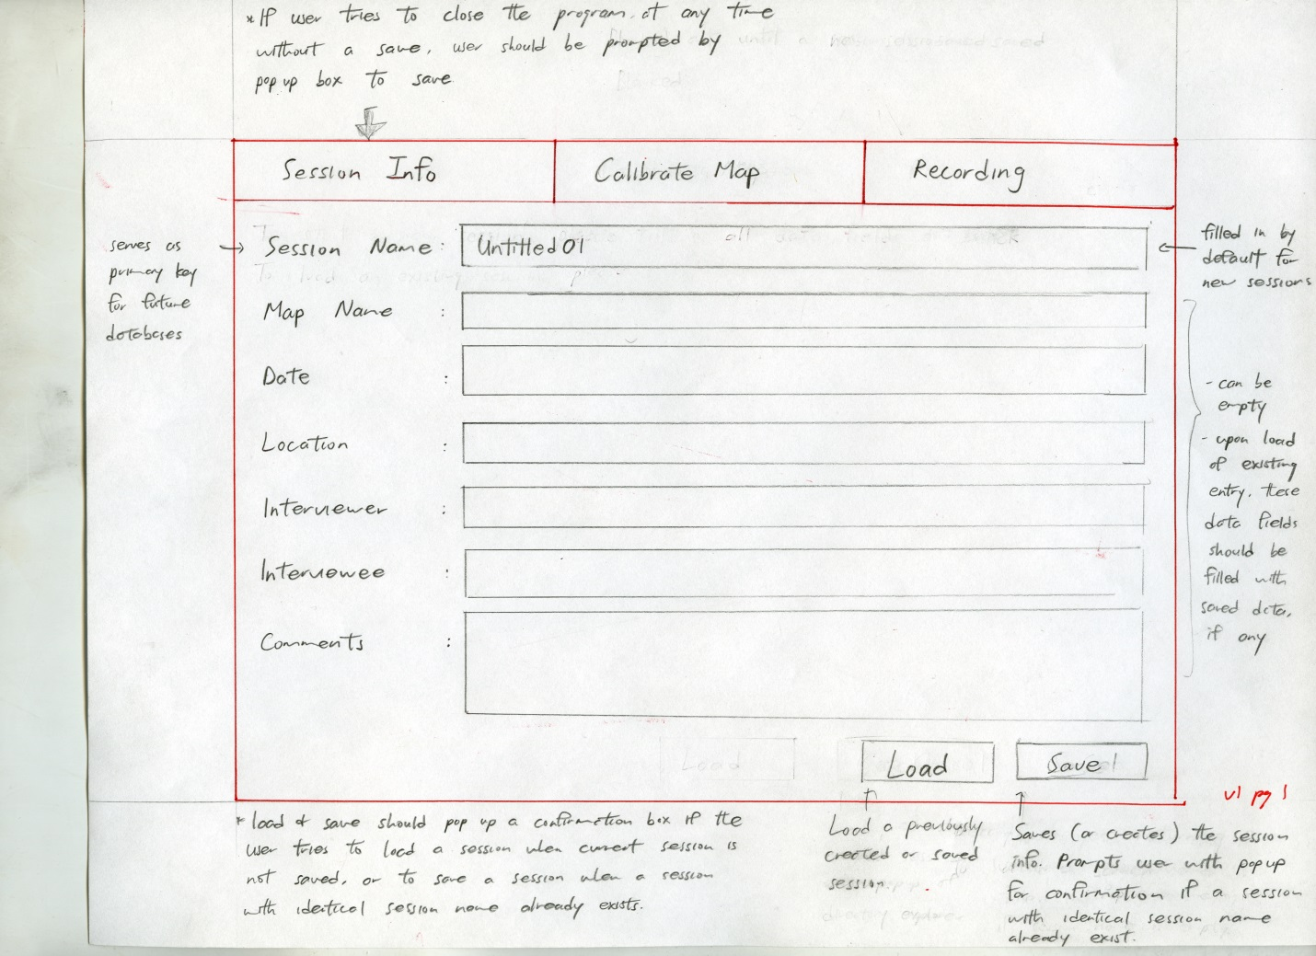

Version 1, Map Calibration Screen

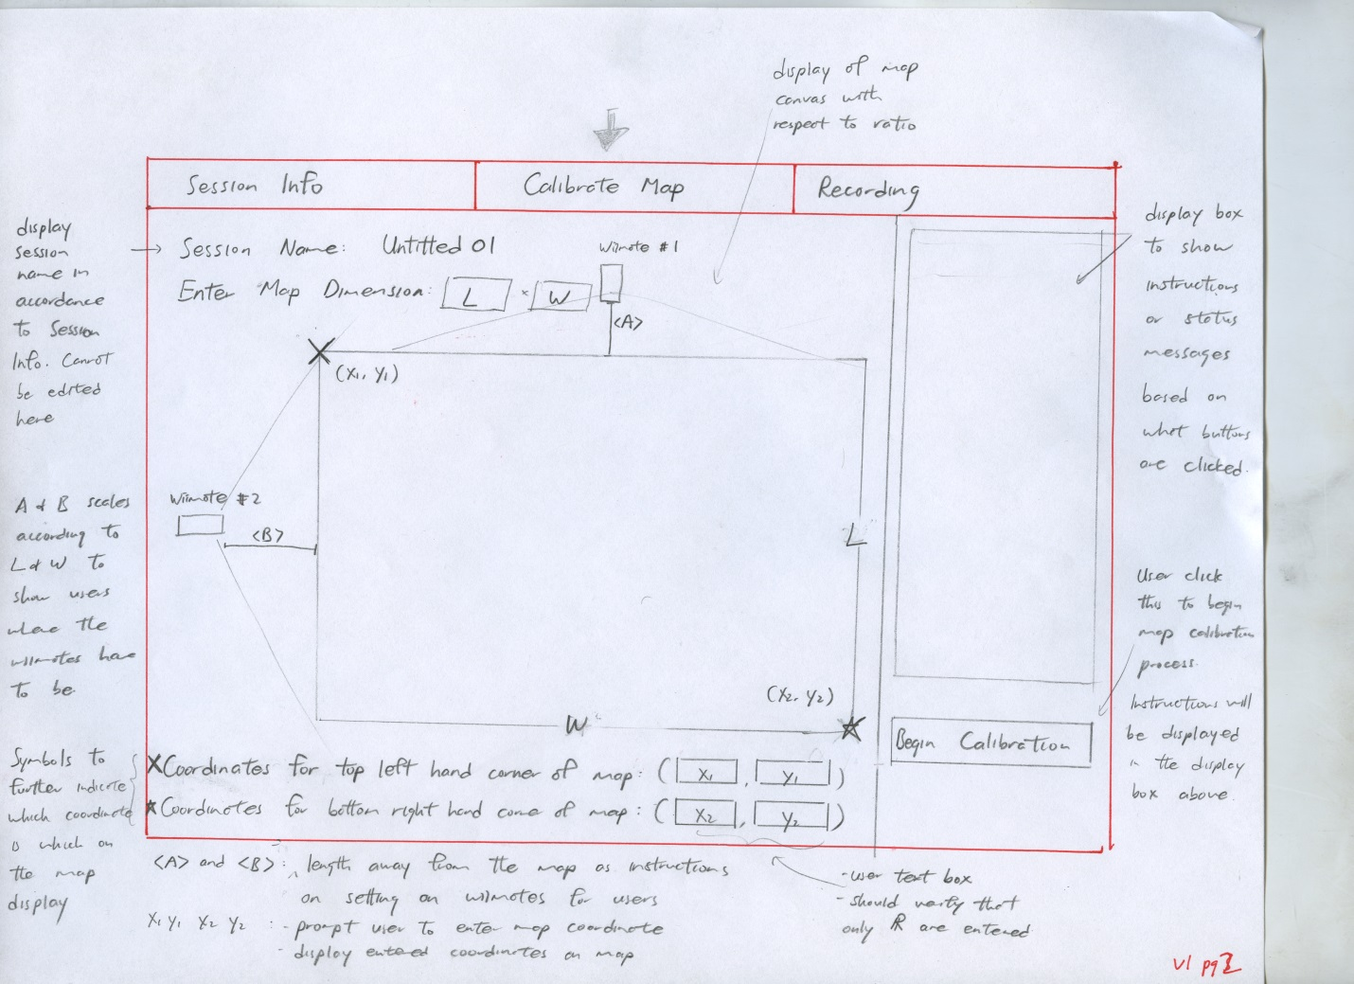

Version 1, Recording Screen

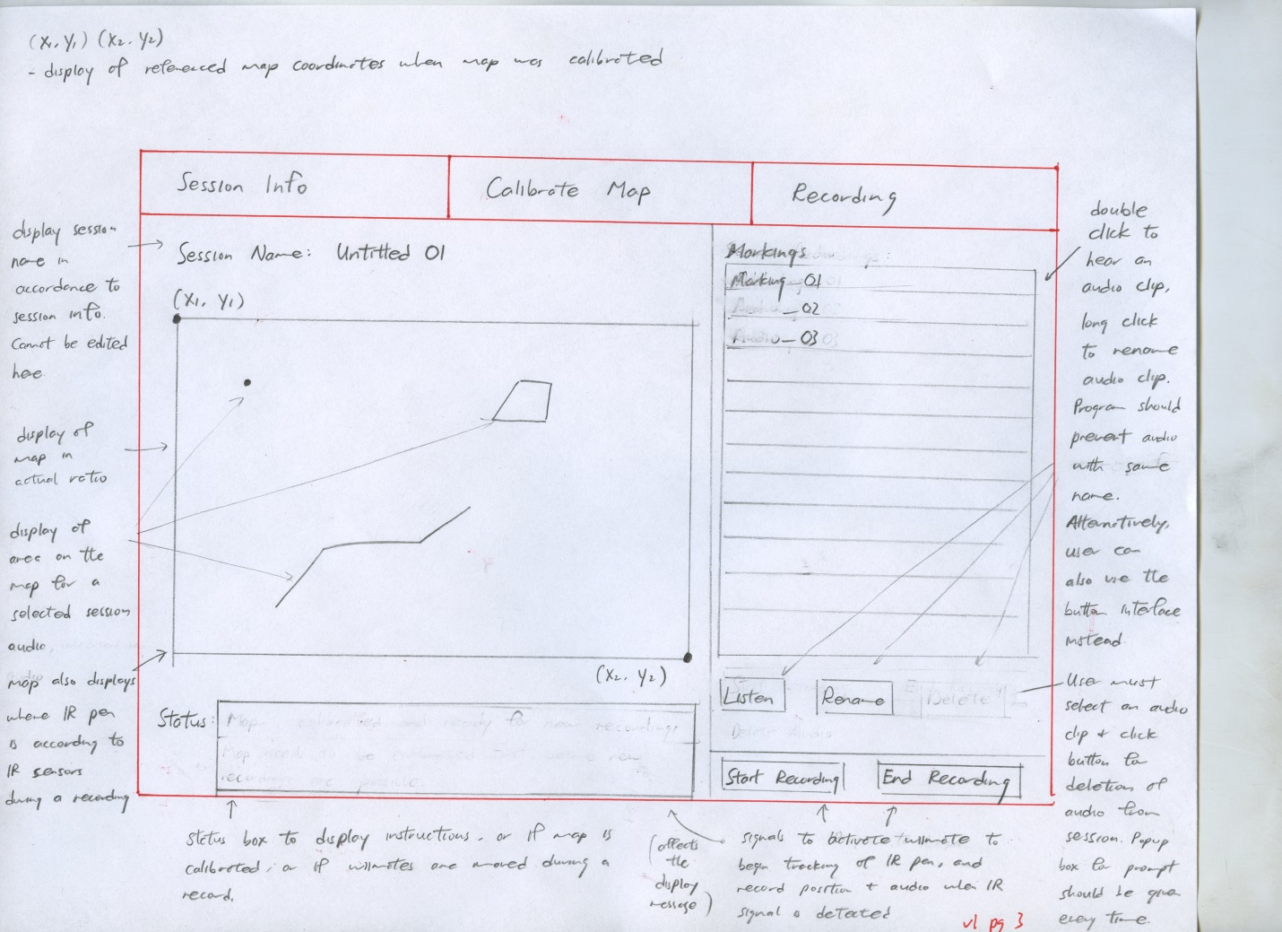

Version 2, Session Info Screen

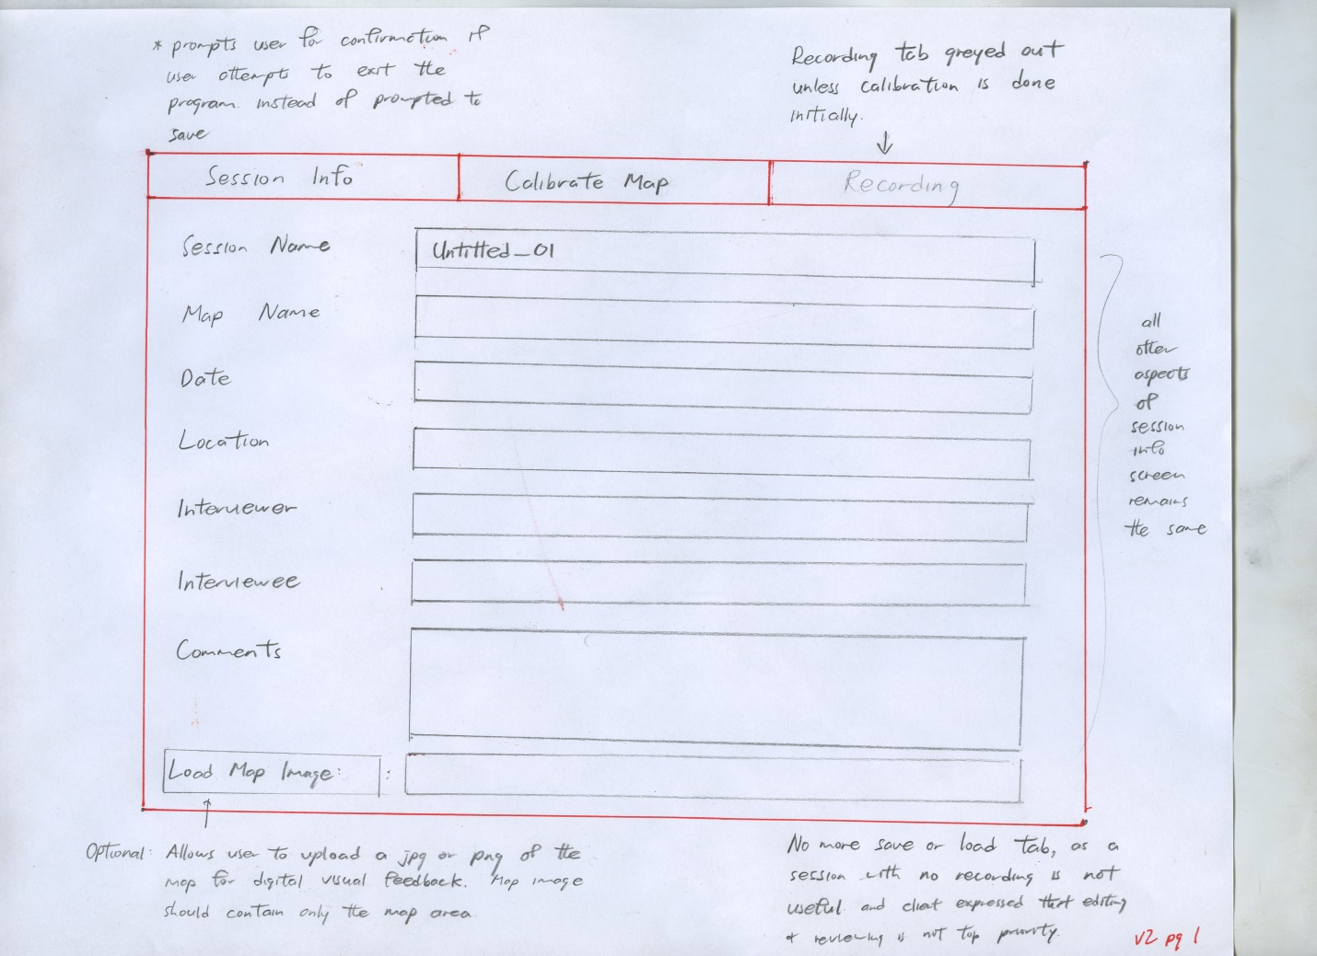

Version 2, Map Calibration Screen

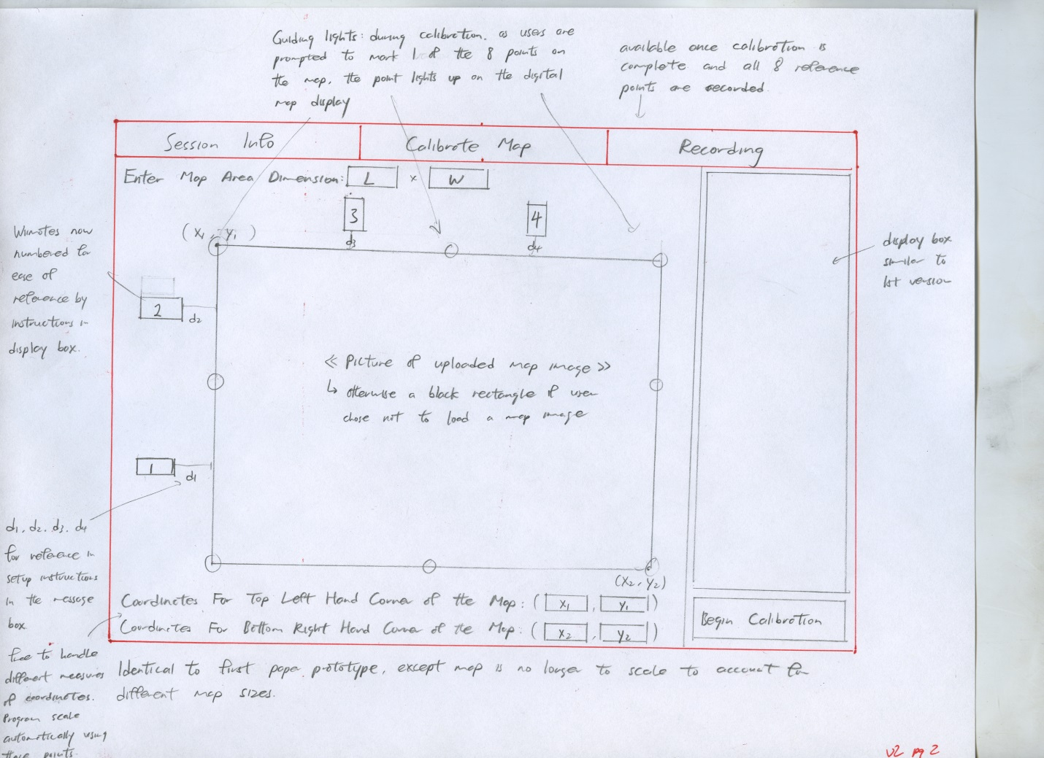

Version 2, Recording Screen

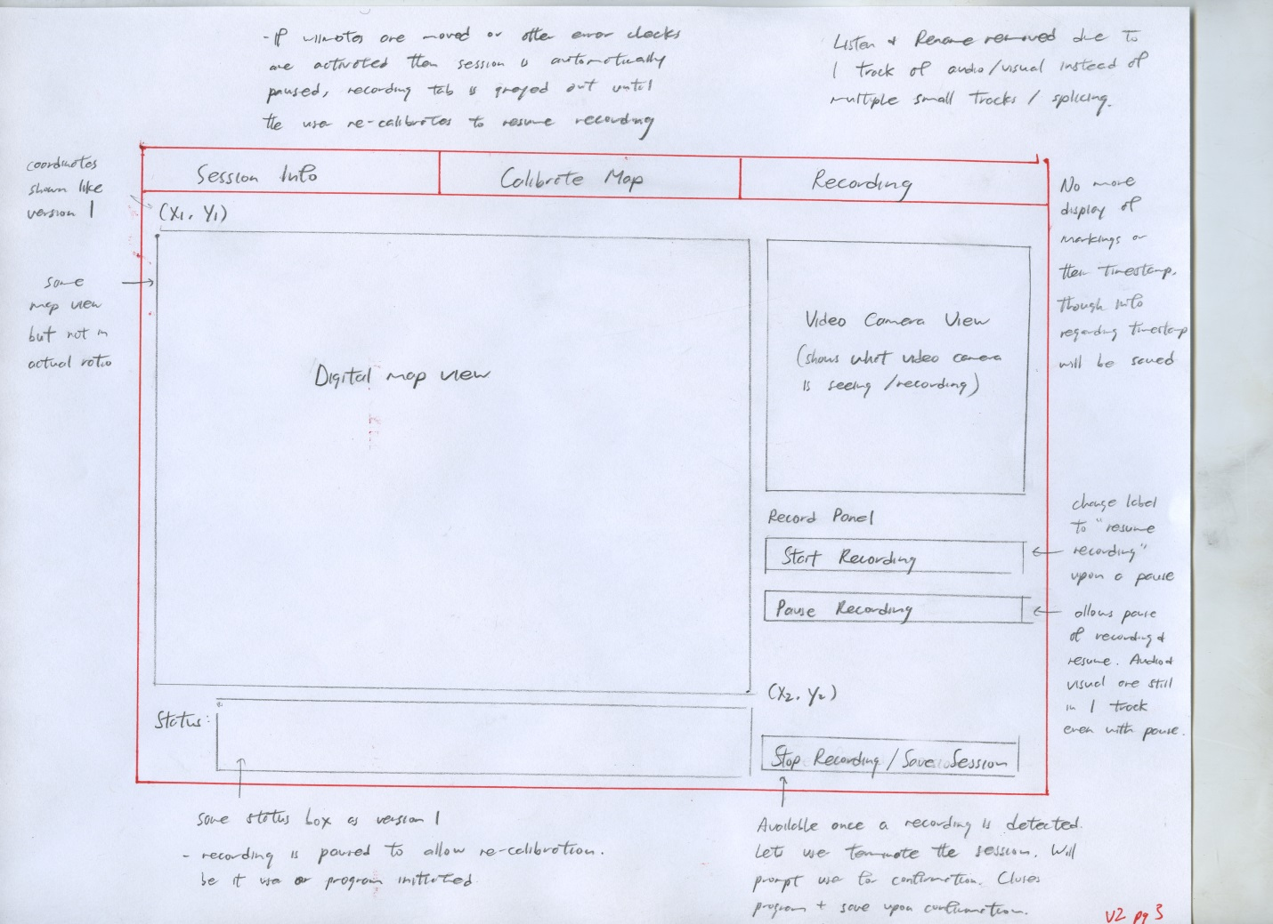

Version 3, Session Info Screen

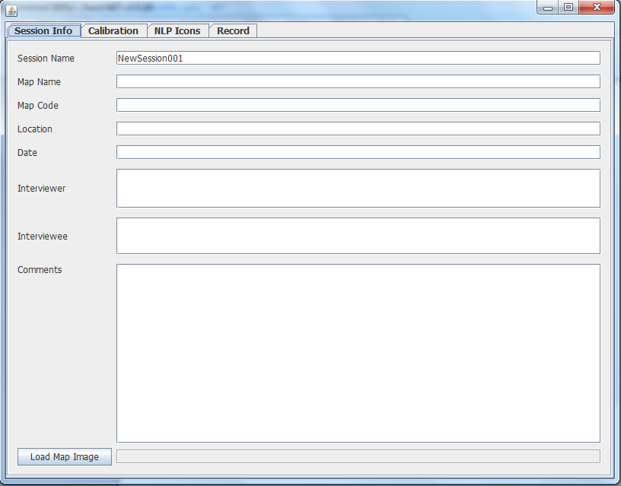

Version 3, Calibration Screen

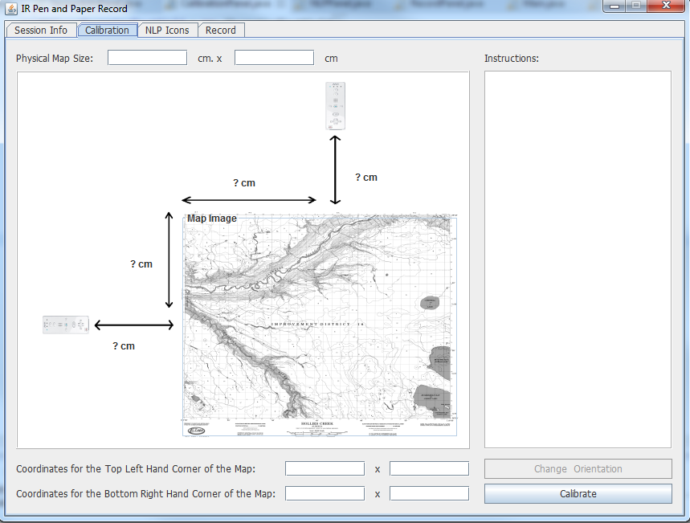

Version 3, Recording Screen

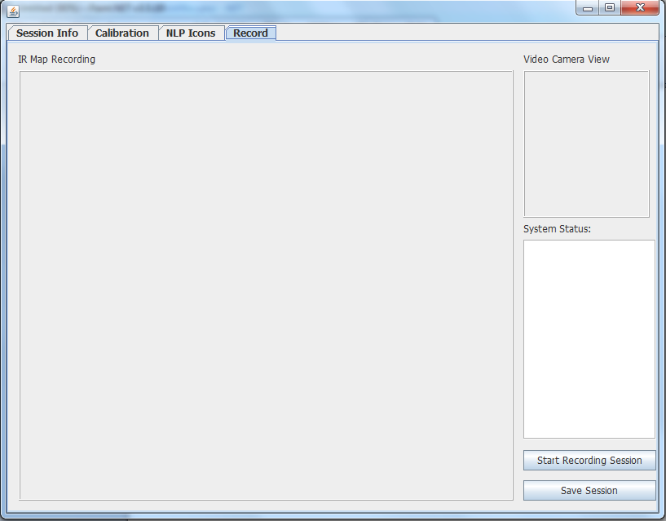

Version 3, NLP Code Screen

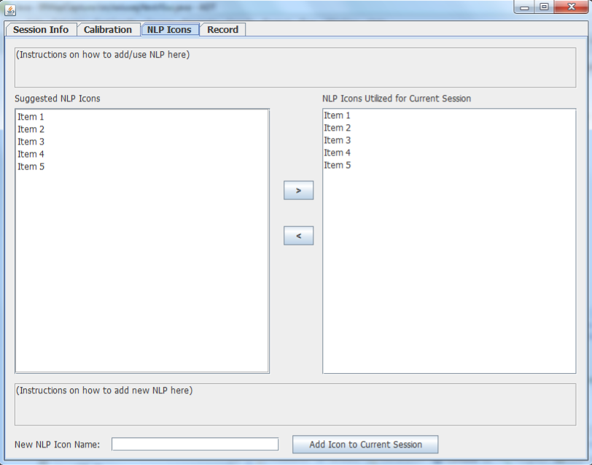

Heuristic Analysis:

A heuristic analysis will be conducted per the guidelines suggested by Jakob Neilsen. The analysis will be done by 3 evaluators, taking the average of the ratings.

<http://www.nngroup.com/articles/how-to-conduct-a-heuristic-evaluation/>

<http://www.nngroup.com/articles/ten-usability-heuristics/>

<http://www.nngroup.com/articles/how-to-rate-the-severity-of-usability-problems/>

*The following 0 to 4 rating scale will be used to rate the severity of usability problems:*

**0** = I don't agree that this is a usability problem at all   
**1** = Cosmetic problem only: need not be fixed unless extra time is available on project   
**2** = Minor usability problem: fixing this should be given low priority   
**3** = Major usability problem: important to fix, so should be given high priority   
**4** = Usability catastrophe: imperative to fix this before product can be released

*The following 10 heuristics will be used:*

**Visibility of system status**

The system should always keep users informed about what is going on, through appropriate feedback within reasonable time.

**Match between system and the real world**

The system should speak the users' language, with words, phrases and concepts familiar to the user, rather than system-oriented terms. Follow real-world conventions, making information appear in a natural and logical order.

**User control and freedom**

Users often choose system functions by mistake and will need a clearly marked "emergency exit" to leave the unwanted state without having to go through an extended dialogue. Support undo and redo.

**Consistency and standards**

Users should not have to wonder whether different words, situations, or actions mean the same thing. Follow platform conventions.

**Error prevention**

Even better than good error messages is a careful design which prevents a problem from occurring in the first place. Either eliminate error-prone conditions or check for them and present users with a confirmation option before they commit to the action.

**Recognition rather than recall**

Minimize the user's memory load by making objects, actions, and options visible. The user should not have to remember information from one part of the dialogue to another. Instructions for use of the system should be visible or easily retrievable whenever appropriate.

**Flexibility and efficiency of use**

Accelerators -- unseen by the novice user -- may often speed up the interaction for the expert user such that the system can cater to both inexperienced and experienced users. Allow users to tailor frequent actions.

**Aesthetic and minimalist design**

Dialogues should not contain information which is irrelevant or rarely needed. Every extra unit of information in a dialogue competes with the relevant units of information and diminishes their relative visibility.

**Help users recognize, diagnose, and recover from errors**

Error messages should be expressed in plain language (no codes), precisely indicate the problem, and constructively suggest a solution.

**Help and documentation**

Even though it is better if the system can be used without documentation, it may be necessary to provide help and documentation. Any such information should be easy to search, focused on the user's task, list concrete steps to be carried out, and not be too large.

Scenarios:

*Scenario One: Georeferencing Calibration of Map*

To calibrate a map for use, the map must be securely affixed to a flat surface. The user must have the dimensions of the map image and input them to the system. The user will then input the map coordinate system and geographic coordinates of the map corners into the system. The system will compute the geometry and give the user the distance measurements to place the infrared sensors in relation to the map. The user will place the infrared sensors at the specified positions. The user will then calibrate the system to the corners of the map with the infrared pen. The system will give graphical feedback to the user showing an outline of the map and the captured infrared calibration points.

*Hierarchal Task Analysis:*

1. Georeferencing Calibration of Map
   1. Secure map to flat surface
   2. Measure map image dimensions
   3. Input map image dimensions into system
   4. Input map coordinate system
   5. Input map corner coordinates
   6. Compute infrared sensor positions geometry in relation to map image
   7. Place infrared sensors at specified positions
   8. Turn on infrared sensors
   9. Mark corners of map with infrared pen
   10. Verify accuracy of corner calibration on map graphical user interface image

Plan 0: do 1 or 2 in any order before doing 3-4-5 in any order then do 6-7-8-9-10 in order

*Scenario Two: Land Usage Interview*

The interviewer will start the audio/video recording of the session. As the interviewee answers questions about land use, the interviewer will say what Natural Language Processing land usage code is being annotated on the map and make the graphic and textual annotations with the infrared pen. The system will record each captured infrared coordinates and translate them into geographic coordinates for the map. The system will also capture a timestamp for each infrared capture. When the interview is over, the interviewer will stop the audio/video recording.

*Hierarchal Task Analysis:*

1. Land Usage Interview
   1. Start audio/video recording
   2. Ask interview questions
   3. Speak land usage codes corresponding to land usage answers
   4. Use infrared pen to capture graphic land usage annotation
   5. Save geographical coordinates and timestamp
   6. Translate graphic annotation coordinates to geographical coordinates
   7. Use infrared pen to capture textual land usage annotation
   8. Save textual land usage code annotation map coordinates and timestamp
   9. Verify accuracy of infrared capture on map graphical user interface image
   10. Stop audio/video recording

Plan 0: do 1-2-3 in order

Plan 2: do 2.1-2.2-2.3-2.4-2.5-2.6-2.7 in order for each question

Need For Material:

* Hardware
  + Laptop
  + Wii remotes
  + IOGear GBU421 USB Dongle using Broadcom 2046 Bluetooth 2.1+EDR USB Dongle with First Connect driver (Windows 7)
  + Asus BT400 USB Dongle using Broadcom 2046 Bluetooth 2.1+EDR USB Dongle with First Connect driver (Windows 7)
  + Infrared pen, 940nm frequency
  + Paper land use map (22” by 34” on average)
  + USB video camera
  + Line in microphone
  + Measuring Tape
  + Tape, or other means to hold the land use map in place
* Software
  + Wiiusej API (wii remote java interface)
  + Windows 7
    - MS required dlls: Gpsvc.ddl, ieshims.dll, msvcr100.dll, sysntfy.dll
  + Java and IDE suitable for coding with Java, such as Eclipse and/or Netbeans

IR Pen

BOM:

Sharpie Fluorescent Yellow Highlighter #25162

N Size 1.5 volt battery

N Size battery holder with solder tabs

3/8 in dia SPST momentary switch

(17/64 in push button dia, 3/8 in mounting hole dia)

Vishay TSAL5300 IR led (940nm), 44 degree emission angle

24 gauge solid core wire (red and black)

Wiring Schematic

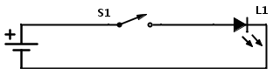

Equipment:

9/64 bit for pilot holes

13/64 bit for led in nib holder

17/64 bit for switch pushbutton

3/8 bit for switch body

Variable temperature soldering station

.025 in dia resin core solder

Manufacturing Procedure:

Remove end cap of marker, pull out & discard ink reservoir

Remove and discard ink nib

Drill out pen nib for IR Led with a 13/64 bit. Make sure to remove internal ribs.

Drill pilot hole with 9/64 bit with centre 1.055 inches from end of pen nib. Centre the hole on the midpoint of barrel width. Drill through both sides of barrel.

For side of barrel where you are inserting switch, expand pilot hole with 3/8 drill bit. When you are done expanding the hole, cut two notches extending from hole at nib end and butt end. These notches are to keep wires out of way while assembling the button. The notches should be ¼ inch long by 1/8 inch wide.

For other side of barrel (where switch button will protrude), expand pilot hole with 17/64 drill bit.

Trim the IR led leads to 0.9 inches (based on led tip flush with end of pen nib). Keep the positive cathode slightly longer than negative anode.

Solder a length of 22 gauge solid core wire to each lead. Black wire, 5 inches, on negative (anode) lead, red wire, 1 inches, on positive (cathode) lead.

Insert led into nib holder, wires first. Fish red wire out the larger switch hole and secure temporarily in slot cut from hole. Run black wire out the butt end of marker body. Gently push the top of the led flush with the pen nib.

Black wire goes to negative terminal of battery holder. Red wire goes to 1st lead of switch.

Another red 22 gauge wire length 4 goes from 2nd lead of switch to positive terminal of battery holder. Solder the red wire to 2nd lead of switch, and then run the red wire out the butt of marker body. Secure wire temporarily.

Solder red wire from IR led to 1st lead of switch. Gently insert switch into marker body, push button going through smaller hole on opposite side. Secure switch with locking nut, then wrap electrical tap around barrel of marker to cover large mounting hole.

Solder black wire to negative terminal of battery holder, then red wire to positive terminal. Use low temp setting on solder station (5-10 watts) and use 22 gauge solder. Insert N size battery and test voltage with multimeter. Carefully feed extra wire back into marker body and then insert battery holder. Replace butt cap of marker.

Finally, hold the switch on and aim pen at a cell phone camera or other digital camera. You should see a purple glow from led.

Sources:

https://github.com/CMPUT302W14T04/Interface/wiki

http://aproposinfosystems.com/

http://louistk.ca/EN/heritage-home/

http://louistk.ca/EN/heritage-home/heritage-features/

http://en.wikipedia.org/wiki/Interactive_whiteboard#Operation_of_a_portable_ultrasonic.2C_IR_pen-based_interactive_whiteboard

http://www.anoto.com/lng/en/mode/sublist/documentId/1150/pid/480/

http://www.nngroup.com/articles/how-to-conduct-a-heuristic-evaluation/

http://www.nngroup.com/articles/ten-usability-heuristics/

http://www.nngroup.com/articles/how-to-rate-the-severity-of-usability-problems/