FSJ Awards Software Design Document

January 31, 2018

Authors: Jacqueline Forest, Pierre (Shu-Jun) Lin

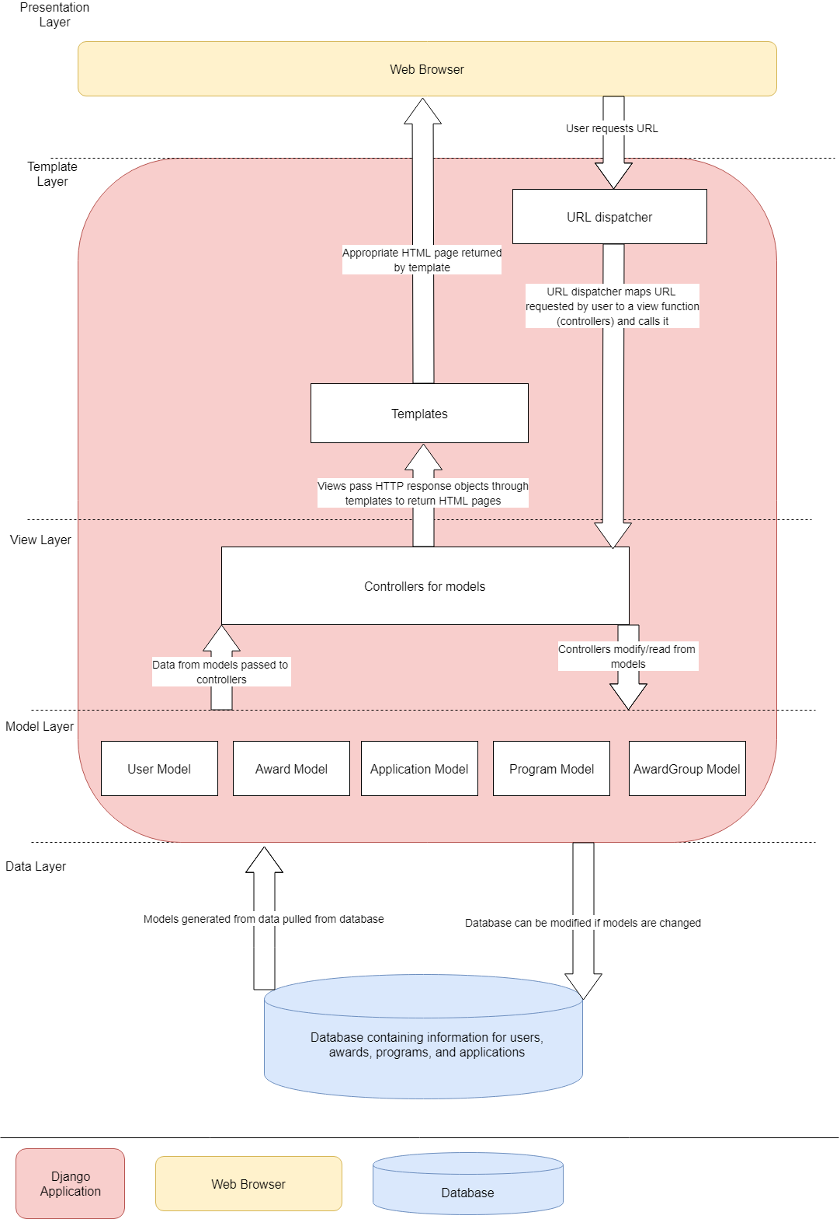**Component Diagram**

**Class Diagram**

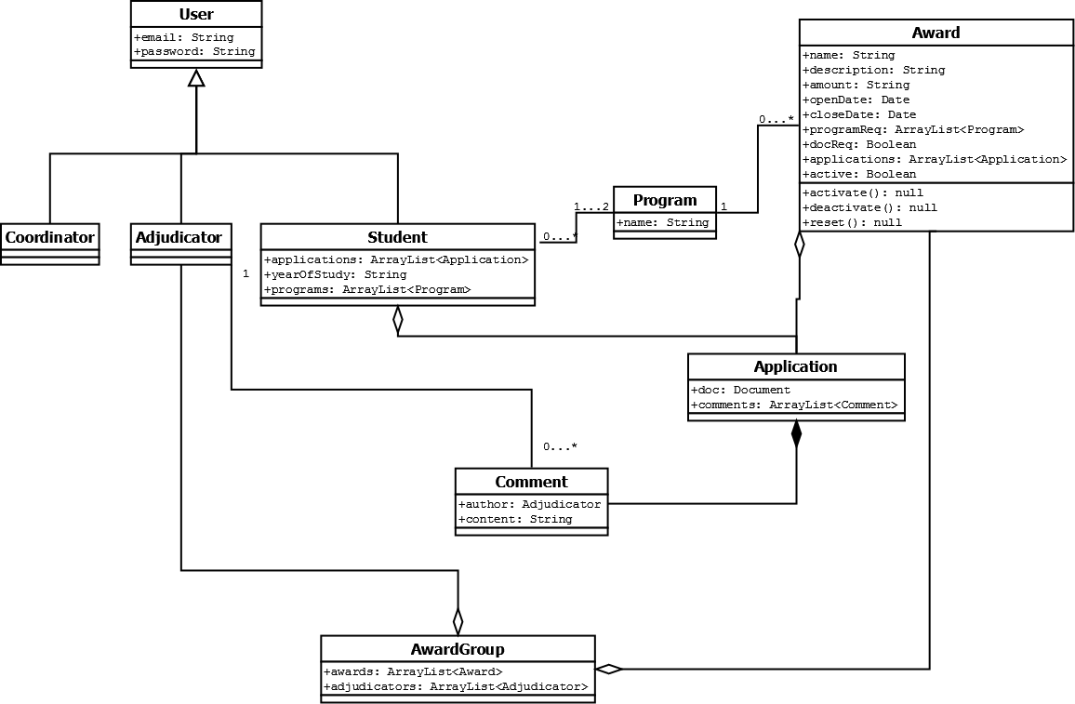

**User:** This superclass is used only as a template for the concrete users of the system. All users of the system must belong to one of the subclasses of User.

**Coordinator:** A subclass of User, the Coordinator class represents the award coordinator of the system, who has the most privileges and the most open access to the system of any user. Users with a Coordinator profile can view all backend data in the system and have almost complete liberty in changing it. Coordinators can create, edit and delete Awards, AwardGroups and Adjudicators, and edit or delete Students. They control which awards are active or nonactive, and during what time periods those qualifiers apply. They can also select recipients for an award, who are automatically notified through their UAlberta email.

**Adjudicator:** A subclass of User, the Adjudicator class represents the adjudicators or judges of the system, who are created by Coordinators and assigned to AwardGroups to help decide on recipients for awards. Adjudicators can see all applications for an award, add aomments to applications and see their own comments. Recipients of an award are decided jointly by Adjudicators and Coordinators in a face-to-face meeting.

**Student:** A subclass of User, the Student class represents the Faculté Saint-Jean students who use the system to apply for awards. Students must sign up using their UAlberta email and indicate their year of study and program(s). Students can view awards suitable for their program of study and create/submit applications for those awards on the condition that the given award is currently active. Students have a list of award applications that they are working on or have completed. Applications created by students can only be added to awards once they are complete and have been submitted. Students can update their program and year of study manually on their profile page.

**Award:** The Award class represents the various awards and scholarships available to Faculté Saint-Jean students. Awards are created by Coordinators with a set of pre-determined parameters such as the name of the award, a brief description of the award and its verifiable requirements, a program requirement, etc. Awards can be activated or deactivated by Coordinators, and Students can apply for awards while they are active. When an award has closed a Coordinator can assign it to an AwardGroup (with or without other awards), which is also assigned to a list of Adjudicators who can view the award and comment on its applications. Once the Adjudicators and the Coordinator have decided on the recipients for an award, the Coordinator can select those recipients to be notified.