**CMPUT 414**

**Integration of Hands and Body Animation using LEAP motion Capture**

**Team A+**

**Chris Wang**

**Di Meng**

**Ghazal Jangani**

**Hong Wang**

**Jan 27th, 2016**



**Abstract**

In the past few decades, 3D animation technologies had brought us significant changes in our daily live. Movie industry, in a very large scale, had benefited a lot from the revolution of 3D animation technologies. From 90s’ movie *Toy story* to today’s *Transformers* and *Avatar* we can see the 3D animation technologies undergo dramatically improvements in a short period of time. Comparing *Toy story* and *Avatar* we found out the animation of *Avatar* had better facial expression, hand and finger motions which provide audience strong realistic tastes. However, build up 3D model and implement animation onto hand and fingers could consider a challenge task for developers since there are 27 bones on each hand and every bone has its own animation data when hand moves. Because of this difficulty, many human animation models do not implement proper animation details of hand and fingers onto their skeleton. Our goal for this project will try to find a solution to improve the animation of hand and fingers.

In this project, first we will focus on capturing 3D animation of hand and fingers and convert the recording data into any given hand model. Second, we will try to combine the hand model that generated in first step into the full body skeleton. To accomplish this goal we will use a small piece USB device called Leap. Leap motion is very recent technology, which launched in 2013. This device is able to track human’s hands and fingers motions. There are two IR build-in cameras and three infrared LEDs that created roughly hemisphere, which is able to recognize every bone on each finger, palm, wrist and forearm. Leap motion is accurate, simple and inexpensive, this is best choice for us to use on our project. However, there are also limitations for Leap motion. First, It only allows developer to record the position in coordinates without video data and depth data. Second, leap only provide data of hand and part of the arm motion. It requires further analysis and adjustments to combine the hand animation into the whole body animation.

Our project is divided into 5 different sub-tasks. First, we will capture some hand motion by leap. Second, we will convert the data into files which are compatible to use for the hand model in the next step. Third, we will build up our hand models with exactly same amount of bones and joints which captured by leap. Fourth, we will try to apply some algorithms to mapping our converted data into our hand models so that our hand will move as the way as we recorded. Finally, as a core step of the whole project, we will rescale our model and combine it into the whole body skeleton. In this finally process, we will do a lot of experiments in order to find a best algorithm and let the whole human body movement looks naturally.

There are many unfinished body animation with poor or none hand animations. We will try to find a solution to improve animations on hands. Since we will use leap to capture our hand motion data instead of generating motion data by our own, we will surely make improvement for hands movements on body animation in terms of accuracy and efficiency.

**Work Plan**

We will divide our project into 2 tasks, namely coding part and documentation part. For the coding part we divide it into five sub-tasks. The tasks including capture data, convert data, build hand models, mapping data into hand models,and rescale hand models then fit into body models.

***Coding Part:***

Capture data *(by Chris Wang)*

In this part, we will write a python program, which able to detect hands in details include the coordinate bones for each fingers, palm and wrist. Then our program will record motions of hands and fingers and create output files that contain the information of movements.

Convert data *(by Di Meng)*

Once having output data from previous step, we will need to convert them into the format that is compatible for Motionbuilder. It will require some programming work in order to achieve this process.

Building hand models *(by Hong Wang and Ghazal Jangani)*

We will use MotionBuilder to build our own hands models. It is necessary for us to simplify both hands into bones and joints. To be more specific, we will use points to represent joints of hand and lines for bones.

Mapping data into hand model *(Teamwork)*

What we want to do in this part is to build and model a hand to track all its movement and interactions with objects in real world space. We will do that by using Motion Builder to load the data that we converted from different images of a hand, and it will generate all the captured motion that we observed. In other words software demo brings these two worlds together by projecting the raw images of the hands into a 3D mesh that can interact with other objects in reality. So, we can observe the whole animations and find any motion that is unnatural, and modify the data until the whole motions looks natural.

Rescale hand models and fit into human model (*Teamwork*)

In this part, we are going to combine both hand models to the body model. The difficulty of this part is finding a proper algorithm that allow hands, and the rest of whole body move integrally. We need to do a lot of adjustments in order to make two separate pieces into one coordinate, natural piece.

***Documentation part:*** (*Teamwork*)

The documentation includes project proposal, literature review and final report. For each part, we all members of team will work together. In order to generate good ideas and complete decent literature works, any member is free to write and edit any part of the documentation.

**Release schedule (***Week 1 to Week 4***):**

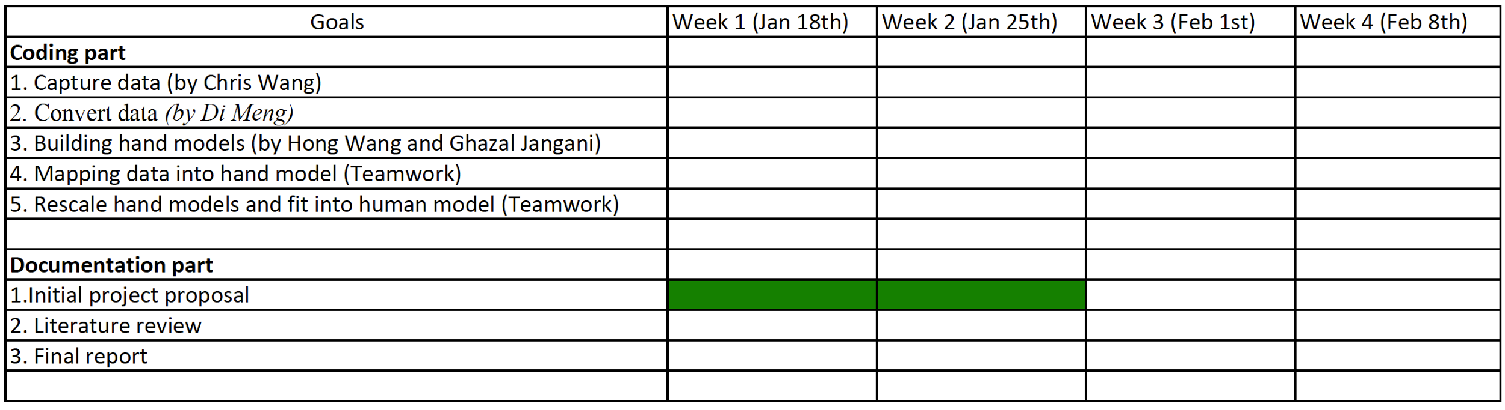

*\*We will update our release schedule weekly, and for complete version can be found in our GitHub.*

**Group meeting/discussion schedule**:

Our group meeting is:

Weekly:

|  |  |
| --- | --- |
| Time | 4PM - 6PM |
| Day | Mondays |
| Date | From Jan18th till project due |

* *Depends on project process, we can meet on weekends or any other days during the week. (If needed)*

Our group shared all the codes through GitHub and documents through google drive, so we are able to follow each other's notes and changes, and and through these tools we are able to chat or put comments for each other's work. In addition, we made a google calendar that will let us to be more organize in completing our tasks for project procedures.

GitHub repository: <https://github.com/CMPUT414W16TEAMAPLUS/LeapAnimationProject.git>