**TITLE**

A report submitted to the Department of English, AIUB, in part-fulfillment of the requirements of the final examination in Business Communication, Fall 2017-18.

**Prepared & Submitted by:**

**Sarkar, Christine Monisha 16-31255-1  
 Utsab, Fahim Faisal 17-33309-1  
 Muntasir, Fardin 16-31198-1  
 Hossain, Md. Mir 17-33232-1  
 Ghosh Tanmoy 16-31993-2**

**Course Teacher:**

**Jannatul Farhana**

**Date of Submission:**

18-04-2018

**American International University-Bangladesh (AIUB)**

18th April 2018

Jannatul Farhana

Course Instructor

Business Communication

American International University Bangladesh

Subject: Submission of our report

Dear Madam,

We have the pleasure to submit our report titled ‘Crypto currency’. The report gave us the opportunity to know what Crypto currency is. Crypto currency is secure, trustful and transparent digital currency to deal with and the world is generally moving towards that. Since Crypto currency is digital and cannot be counterfeited or reversed arbitrarily by the sender as with credit card chargeback. It cuts out the need for a third party in exchanges and protects wealth against exchange controls or capital controls.

Our research was on the whole encourages exchanges free of regulatory meddling and promotes what is referred to as low-cost banking because it can be done anywhere as long as the consumer has access to a cell phone. Crypto currency uses a ‘push’ mechanism that allows the Crypto currency holder to send exactly what he or she wants to the merchant or recipient with no further information.

From the research we found out that, report we can come down to some factual conclusion about all the people. We can find out some problems and reasons behind it from this report. This report will help us to point out the problems people are facing and the reason behind it.

We ourselves thank you for giving us the chance to do this report. Yours sincerely,

Name: Ghosh Tanmoy

ID:16-31993-2

Preface

In this report we tried to inform that Crypto currency is a future and updated version of hard money. Mainly we conducted a research and did some survey on general people to know how much they actually know about crypto currency and how they are implementing this in their lives. We collected data from random general people and made some analysis by which we were able to show some statics and their graphical representations. Firstly we made three different sets of questionnaires. We distributed each sets of questionnaires on our university campus, and to people who seemed interested in this. We collected both qualitative & quantitative data from approximately 50 people. We also personally interviewed some of them.

Acknowledgement

**We are heartily thankful to our course instructor, whose encouragement, supervision and support from the preliminary to the concluding level enabled us to develop an understanding of the subject.**

**We are thankful to all the students, ex-students and teachers who participated of this study. We greatly appreciate their sincere co-operation.**

**Also we want to thank some of my friends who helped us with collecting all analytical data and interviewing all the subjects.**

**Lastly, we offer our regards and blessings to all of those who supported us in any respect during the completion of the study**.

**Table of Contents**

|  |
| --- |
| **Chapter Title Page no.**    Forwarding letter i  Preface ii  Acknowledgement iii  Table of contents iv  List of illustrations v  Abstract vi  1.0 Introduction  1. 1 Importance of Crypto currency 8  1.2 Job sectors of Crypto currency 8  1.3 Overview of the research report 9  1.4 Rationale of research report 10  2.0 Chapter 2: Methodology 11  2.1 Method used 11  2.2Selection of subjects/participants 11  2.3 Data analysis 12  3.0 Chapter: Findings and Analysis 15  3.1 Findings 15  3.2Analysis of the result 16  4.0 Chapter: Conclusion 17  4.1Summery 17  4.2 Limitation 17  4.3Future direction 17  5.0Recommendation 18 |
|  |
|  |

**List of illustration**

Figure: 01- “Knowledge of Crypto currency”----------------------------------- on page 12

Figure: 02- “Why people would not buy Crypto currency”------------------ on page 13

Figure: 03- “Why consumers invest on Crypto currency----------------------on page 14

Abstract

In our research report we wanted to find out the basic idea about crypto currency of general people. In a word, a static analysis of their knowledge of crypto currency, how they are using it, how they are choosing not to use it is shown in this research report. The purpose of our report is to find out how people are reacting to this new technology. Our objective was to collect data from different places and analysis it to find out the results. We took data from 50 general people among them were 20 students, 10 job holders and 20 bankers. Mainly a survey was carried out in the form of questionnaire. We took both quantitative data and qualitative data to do our research. The data showed that varies people have different view on crypto currency, how it works, and how they choose to use it and their awareness of the benefits and risks involved in crypto currency. Finally to conclude we provided the information on the limitations and future direction for crypto currency for general people to acknowledge this new technology.

1. **Introduction  
     
   1.1. Importance of Crypto currency**

Crypto currency is secure, trustful and transparent digital currency to deal with and the world is generally moving towards that. Since Crypto currency is digital and cannot be counterfeited or reversed arbitrarily by the sender as with credit card chargeback. It cuts out the need for a third party in exchanges and protects wealth against exchange controls or capital controls. Because Bit coin and other forms of Crypto currency are basically digital, the location of the two parties of the transaction is irrelevant. The transaction can be done anywhere. It makes a transaction to be highly non-disclosure or anonymous which appeals to consumers who prefers non-disclosure and privacy. It encourages exchanges free of regulatory meddling and promotes what is referred to as low-cost banking because it can be done anywhere as long as the consumer has access to a cell phone. Crypto currency uses a ‘push’ mechanism that allows the Crypto currency holder to send exactly what he or she wants to the merchant or recipient with no further information. This helps prevent identity theft as seen in the case of credit card where you give a merchant your credit card details and access to your full credit line .They help to complement existing services that now rely on standard currencies as seen in M-Pesa in Kenya where every 1 in 3 Kenyans now owns a Bit coin wallet .Lower fees: There aren’t usually transaction fees for Crypto currency exchanges because the miners are compensated by the network .Most importantly you are in full ownership of your account, unlike another electronic cash system where there is a company managing your account. With Crypto currency you own the private key and the corresponding public key that makes up for your Crypto currency address and no one can take that from you.

**1.2.Job market of Crypto currency**

Crypto currencies have been an increasingly hot topic in the past several years. After a bumpy start, they have seen unparalleled market growth in 2017. Based on the innovative block chain technology, bit coin and others (known as alt coins – ie. Ethereum, Litecoin) offer decisive advantages over traditional payment methods, such as transaction security, speed, or applicability on a global level. This year, cryptocurrencies are slowly entering the mainstream; as a report by AngelList outlines, “The cryptocurrency industry is at an inflection point, expanding the early-adopter crowd to a more mainstream audience.” Indeed, this year both the value of older crypto currencies and the number of new ones sprouting into existence through Initial Coin Offerings (ICOs), has massively increased.Consequently, such growth has created a surge in demand for employment in cryptocurrencies: AngelList’s report saw a 100% increase in advertised jobs in the past six months. This surge in recruitment was not just in Tech roles, but in all functions across the board; with such an influx of capital, cryptocurrency businesses are boldly investing into expanding their headcount. Factors that attract candidates include higher median salaries, more flexible contracts, and better benefits. Growth in the crypto market also ties into the expanding FinTech sector, explored by Vacancysoft in a report from earlier this year.How the job market in cryptocurrencies will look in the future depends on the industry itself. Will it keep growing? What will its consensus with the corporate and political world be? Aside from spectacular growth, 2017 also unravelled a number of challenges. September saw China banning ICOs, followed by JP Morgan’s CEO publicly denouncing bitcoin. JP Morgan itself is one of the largest corporate names in the Enterprise Ethereum Alliance, which is an attempt to create a blockchain platform rival to bitcoin. Another challenge is regulators’ concern over effectively controlling the crypto market to protect consumers from fraudulent ICOs. These factors temporarily sent bitcoin value plummeting.The volatile activity of bitcoin’s market value that we saw over the past year may indicate what to expect in the near future. However, vacancies in this area of FinTech are expected to remain strong; as Next Web comments, “While bitcoin value fluctuations may be testing investor confidence, the hiring market for blockchain-based technology remains overtly bullish.”  
  
**1.3 Overview of the research report**

This research report is on the knowledge of cryptocurrency of general people, if they are willing to buy or invest in cryptocurrency and why.

We approached to almost 50 people with questionnaire and also interviewed some of them personally. We collected all the quantitative and qualitative data and made a statistical analysis.

**1.4 Rationale of research report**

From the analysis of this report we can come down to some factual conclusion about all the people . We can find out some problems and reasons behind it from this report. This report will help us to point out the problems people are facing and the reason behind it. Such as-

*problems of cryptocurrency  
 *why general people cannot yet trust in cryptocurrency  
 *privacy facts of cryptocurrency

**2.0 Chapter 2: Methodology**

**2.1 Method used**

In this report we used both quantitative and qualitative data.

As a statically analytical report the main method we used is quantitative method. Because we needed to make statistics comparing all the data’s. So quantitative method should be used to make such an analytical statistic.

Also we used qualitative method to survey the psychology of general people. It helps us to identify the problems by comparing the quantitative data’s.

**2.2 Selection of subjects/participants**

We prepared several questions for each individual segment of problems we are presenting here.

The first problem is the knowledge of cryptocurrency of general people. We took data from 10 individuals just asking if they know what cryptocurrency is.

Then we moved to multiple questions regarding why they would not buy cryptocurrency, which helped us determine their idea about this system.

Finally we for specification we asked consumers why they are investing on Bitcoin.

These results help in observing the people behavior and predicting how successful and promising a cryptocurrency might become in the future.

**2.3 Data analysis**

I gave questionnaire to all the subjects and interviewed some of them personally. Using those data I did some different static graph compared them with each other.

Graph and analysis:

2.3.1 Knowledge of Cryptocurrency

The data showed that most people do not know what cryptocurrency is. Most of them answer they are not familiar at all, few answered they are slightly familiar and very few answered they are very or extremely familiar with cryptocurrency.

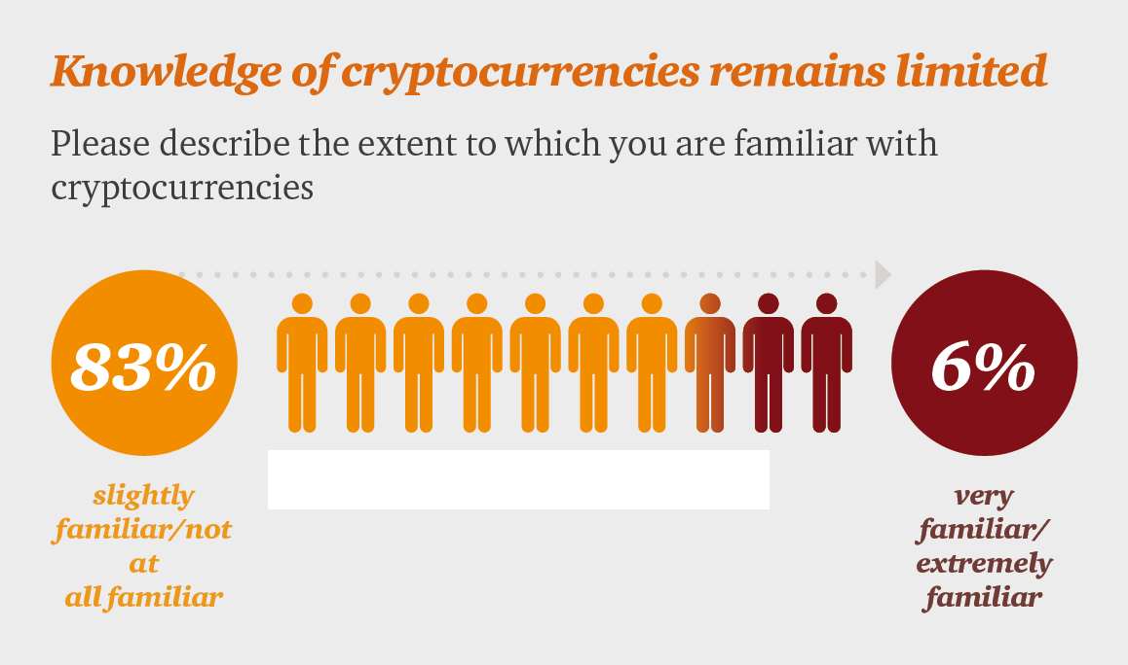Figure: 01

2.3.2 Why people won’t buy cryptocurrency

When it comes to buying cryptocurrency the scenario is somewhat different. We asked a list of questions on our survey and calculated the percentage of agrees on those questions.

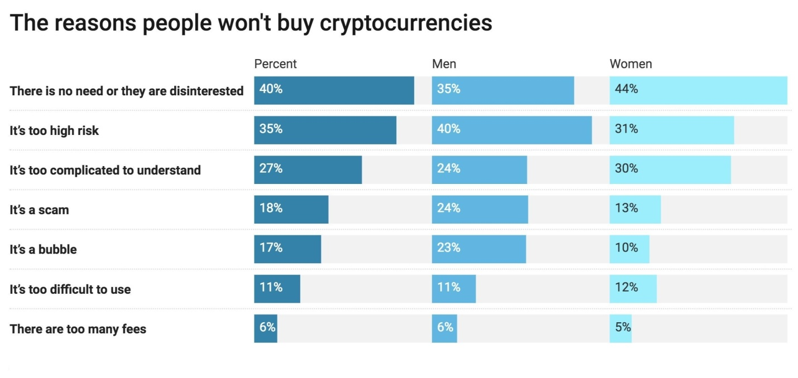

Figure: 02

2.3.3 Why consumers are investing

Bitcoin is the first decentralized payment network. We used Bitcoin as an example to do our survey on how consumers are willing to invest on cryptocurrency. We simply provided a agree/disagree questionnaire.

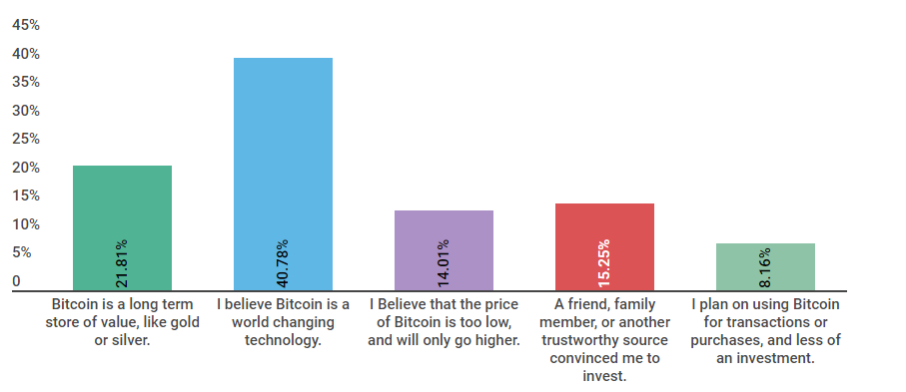

Figure: 03

**3.0 Chapter: Findings and Analysis**

**3.1 Findings**

From the data taken from 10 general people the statistic result of the “knowledge of crypto currency”:

|  |  |
| --- | --- |
| Not at all familiar | 83% |
| Slightly familiar | 7% |
| Very familiar | 6% |
| Extremely familiar | 4% |
|  |  |
|  |  |

Why people won’t buy crypto currency :

|  |  |
| --- | --- |
| There is no need/ they are disinterested | 40% |
| It’s too high risk | 35% |
| It’s too complicated to understand | 27% |
| It’s a scam | 18% |
| It’s a bubble | 17% |
| It’s too difficult to use | 11% |
| There are too many fees | 6% |

Why consumers are investing on Bitcoin:

|  |  |  |
| --- | --- | --- |
|  |  |  |
| Is a long term stored value | | 21.81% |
| Believes it is a world changing technology |  | 40.78% |
| Believes the price will get higher |  | 14.01% |
| Reference of others |  | 15.25% |
| Plans on using rather than investment |  | 8.16%% |
|  |  |  |

**3.2 Analysis of the result**

Firstly we can see, the knowledge of existence of this technology is very low among general people. From the interview it appeared most of them never hard of them term crypto currency before. We handed out three sets of questionnaires.

Before handing out the questionnaires, we briefed them a bit on crypto currency and how its recent market demand and value is. Even though the name is quite famous around the world, at least Bit coin, 83% of the people are still in the dark.

And there are more specific reasons for this, and the list follows as:

* Of all the people who are unfamiliar with it, they seemed to not pay a heed. And there only saying was what is the point where there is ATM and hard cash which does exactly the same work.
* People who knew about it, had a sound idea of how it works. But even though they lacked the idea of how it actually worked.
* Even though this holds more value than almost any currency in this world right now, people does not know it value.
* The risk for the general people was a huge part in leaving this thing not to work. They generalized that it maybe be a scam and they could lose all.
* But most of the people who invested on it, invested due to the hope that the value would be sky rocketing in the near future, which is quite currently happening.
* Even after all this explaining, the mass people still opposes the idea.

**4.0 Chapter: Conclusion**

**4.1 Summery**

Cryptocurrency is a digital currency that functions as a medium of exchange, utilizing the process of cryptography enables users to transact securely using these digital coins. Cryptocurrencies operate on a distributed ledger called a blockchain, where all transactions using a cryptocurrency is made public and permanently recorded. Units of a cryptocurrency are produced through a process known as mining, where special computer software is used to solve mathematical problems in exchange for a unit or more of that cryptocurrency. Due to the decentralized technology on which cryptocurrencies operate, the supply of a cryptocurrency is not subject to the control of a central authority; the total supply of a cryptocurrency is normally predetermined, which is made clear to all users.Bitcoin possesses the title as the first ever decentralized cryptocurrency, originally conceived in 2009 by an individual or group under the pseudonym Satoshi Nakamoto. However, there are now numerous cryptocurrencies since the inception of Bitcoin, the number being well above 800+. These cryptocurrencies are known as ‘altcoins’, signifying an alternative to Bitcoin.

**4.2 Limitation**

The limitation of our research is we couldn’t reach all the people who can help us with our data. The more depth we tried to go, it let us. The knowledge on this is awe striking.

Also the time of research was very short to cover such a vast topic. So we couldn’t study enough in internet to know more.

**4.3 Future direction**

In future if someone does this research, our advice will be to take more articles and do more study online on international sites.

**5.0 Recommendation**

Cryptocurrency is a future and updated version of hard money. But it has many limitations. We all need to know more about this technology. So that we can use it to run with the new technologies. Without knowing more, privacy will be broken and other many problems will come in front of us.

More people who be known to this amazing piece of technology in this century. The idea itself is so great when you know its decentralized.