Section 5: Phase I Source Code Implementation
This section documents the Phase I Source Code deliverables for the CyberRisk Monitor project, organized according to the Unit 4 evaluation criteria: Project Setup, Core Functionality, Documentation, and Unit Testing.

5.1 Project Setup

5.1.1 Development Environment Configuration
The CyberRisk Monitor project uses Python 3.10+ as the primary development language, selected for its robust standard library, cross-platform compatibility, and team familiarity. Each team member configures their local development environment using the following tools:
Tool | Purpose | Version
Python | Programming Language | 3.10+
Visual Studio Code / PyCharm | Integrated Development Environment | Latest
Git | Version Control | 2.40+
pytest | Testing Framework | 7.0.0+
pip | Package Management | 23.0+

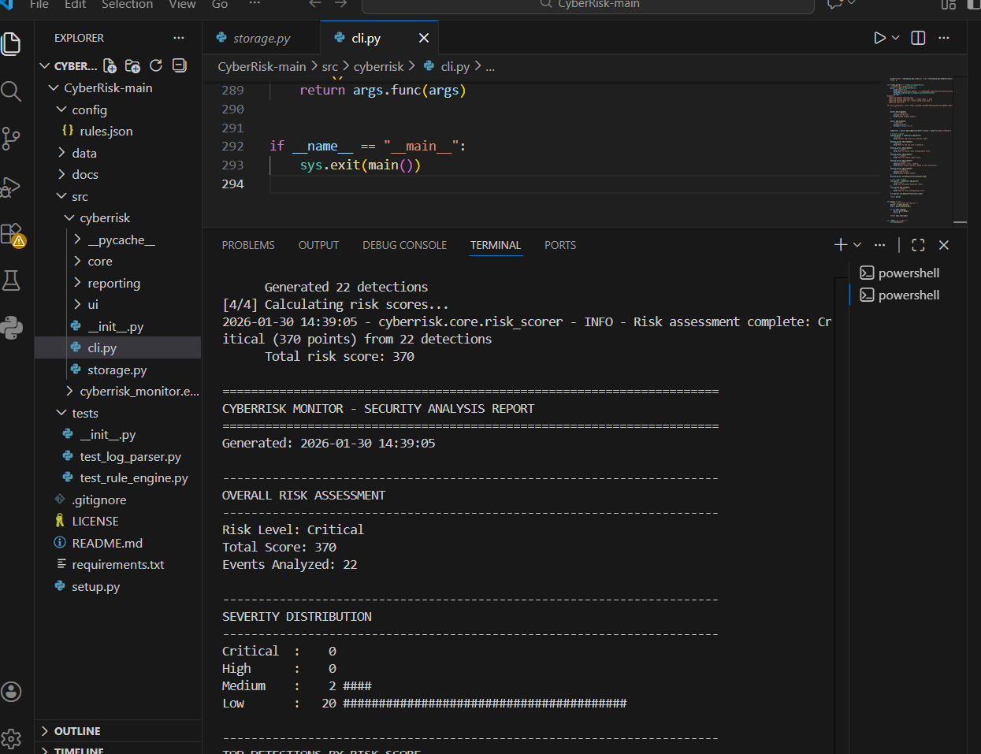
Figure 5.1: Visual Studio Code Development Environment with Project Structure and CLI Output

5.1.2 Library and Package Installation
Dependencies are managed through requirements.txt and kept intentionally minimal to reduce setup complexity and ensure cross-platform compatibility. The project distinguishes between core and development dependencies:
Core Dependencies (Standard Library Only):
- json - Configuration and data serialization
- csv - CSV log format parsing
- re - Regular expression pattern matching
- datetime - Timestamp handling and time window calculations
- logging - Application logging and debugging
- pathlib - Cross-platform file path handling
- dataclasses - Data structure definitions
- collections - defaultdict for event aggregation
- math - Risk scoring calculations (log2 frequency multiplier)

Development Dependencies (requirements.txt):
- pytest>=7.0.0
- pytest-cov>=4.0.0
- black>=23.0.0
- isort>=5.12.0
- mypy>=1.0.0

Installation commands:
pip install -e . # Install package in development mode
pip install -e ".[dev]" # Include development dependencies

5.1.3 Version Control Integration
The project uses Git with a shared GitHub repository as the central collaboration platform. Version control practices include:
- Branching Strategy: Feature branches for isolated development (e.g., cassandra-backend for storage features)
- Commit Standards: Descriptive commit messages explaining the "why" of changes
- Pull Request Workflow: Code review through GitHub before merging to main
- Issue Tracking: GitHub Issues for task management and bug tracking
- Protected Main Branch: Direct commits to main are discouraged; changes flow through reviewed branches

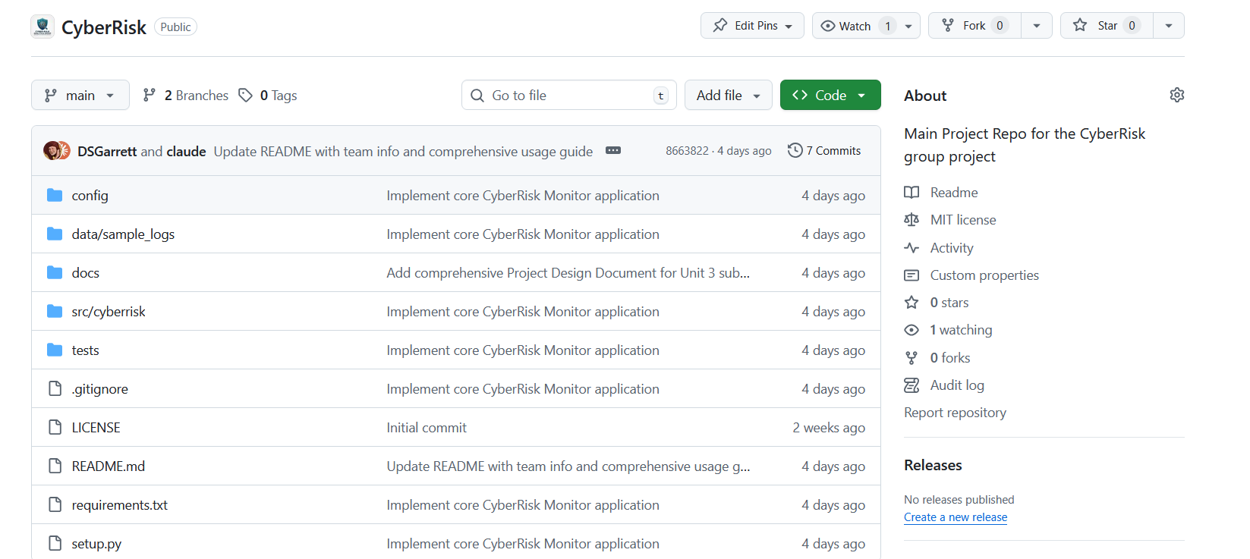
Figure 5.2: GitHub Repository Structure and Commit History

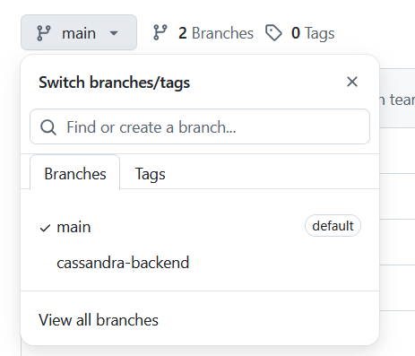
Figure 5.3: Git Branching Structure (main and cassandra-backend)

5.1.4 Project Structure and Organization
The repository follows a well-organized structure that separates source code, configuration, test data, and documentation:
CyberRisk/
+-- src/
| +-- cyberrisk/
| +-- __init__.py # Package initialization
| +-- cli.py # Command-line interface
| +-- core/
| | +-- log_parser.py # Log ingestion and normalization
| | +-- rule_engine.py # Detection rule evaluation
| | +-- risk_scorer.py # Risk scoring algorithm
| +-- reporting/
| +-- report_generator.py # Report generation
+-- config/
| +-- rules.json # Detection rules (15 rules)
+-- data/
| +-- sample_logs/ # Test datasets
+-- tests/
| +-- test_log_parser.py # 16 tests
| +-- test_rule_engine.py # 14 tests
| +-- test_risk_scorer.py # 45 tests
+-- setup.py # Package configuration
+-- requirements.txt # Dependencies
+-- README.md # Project documentation

This structure ensures clear separation of concerns with core business logic in src/cyberrisk/core/, output generation in src/cyberrisk/reporting/, external configuration in config/, and test files mirroring the source structure.

5.2 Core Functionality

5.2.1 Implementation of Project Requirements
Phase I implements the foundational features outlined in the project requirements document. The following table maps requirements to implementation status:
Req ID | Requirement | Implementation | Status
FR-01 | Parse syslog, JSON, CSV formats | LogParser class with auto-detection | Complete
FR-02 | Apply detection rules to logs | RuleEngine with 15 rules | Complete
FR-03 | Identify security patterns | Pattern matching for attacks | Complete
FR-04 | Calculate numerical risk scores | RiskScorer with multipliers | Complete
FR-05 | Categorize risks | Threshold-based (0-25/26-50/51-75/76+) | Complete
FR-06 | Generate summary reports | ReportGenerator (text/JSON/HTML) | Complete
FR-07 | User interface | CLI via cyberrisk analyze | Complete
FR-08 | Adjustable thresholds | Rules configurable via JSON | Complete

5.2.2 Algorithm Design and Efficiency
Log Parsing Algorithm: The LogParser class implements efficient format detection using signature analysis rather than attempting all formats. Time Complexity: O(1) for format detection, O(n) for parsing where n = number of log entries.
Rule Evaluation Algorithm: The RuleEngine uses compiled regular expressions for pattern matching and maintains an event buffer for threshold-based detection within time windows. Events outside the time window are pruned during each match evaluation.
Risk Scoring Algorithm: The scoring algorithm balances simplicity with meaningful risk differentiation:
Final Score = Base Score x Frequency Multiplier x Context Multiplier
Where:
- Base Score = Rule severity (1-10)
- Frequency Multiplier = log2(event_count + 1) - provides diminishing returns
- Context Multiplier = Based on patterns (root: 1.5, admin: 1.4, localhost: 0.7)

5.2.3 Modular Code Organization
Module | Responsibility | Dependencies
log_parser.py | Data ingestion and normalization | Standard library only
rule_engine.py | Detection rule evaluation | log_parser.LogEntry
risk_scorer.py | Risk calculation and categorization | rule_engine.Detection
report_generator.py | Output formatting | risk_scorer.RiskAssessment
cli.py | User interaction | All core modules

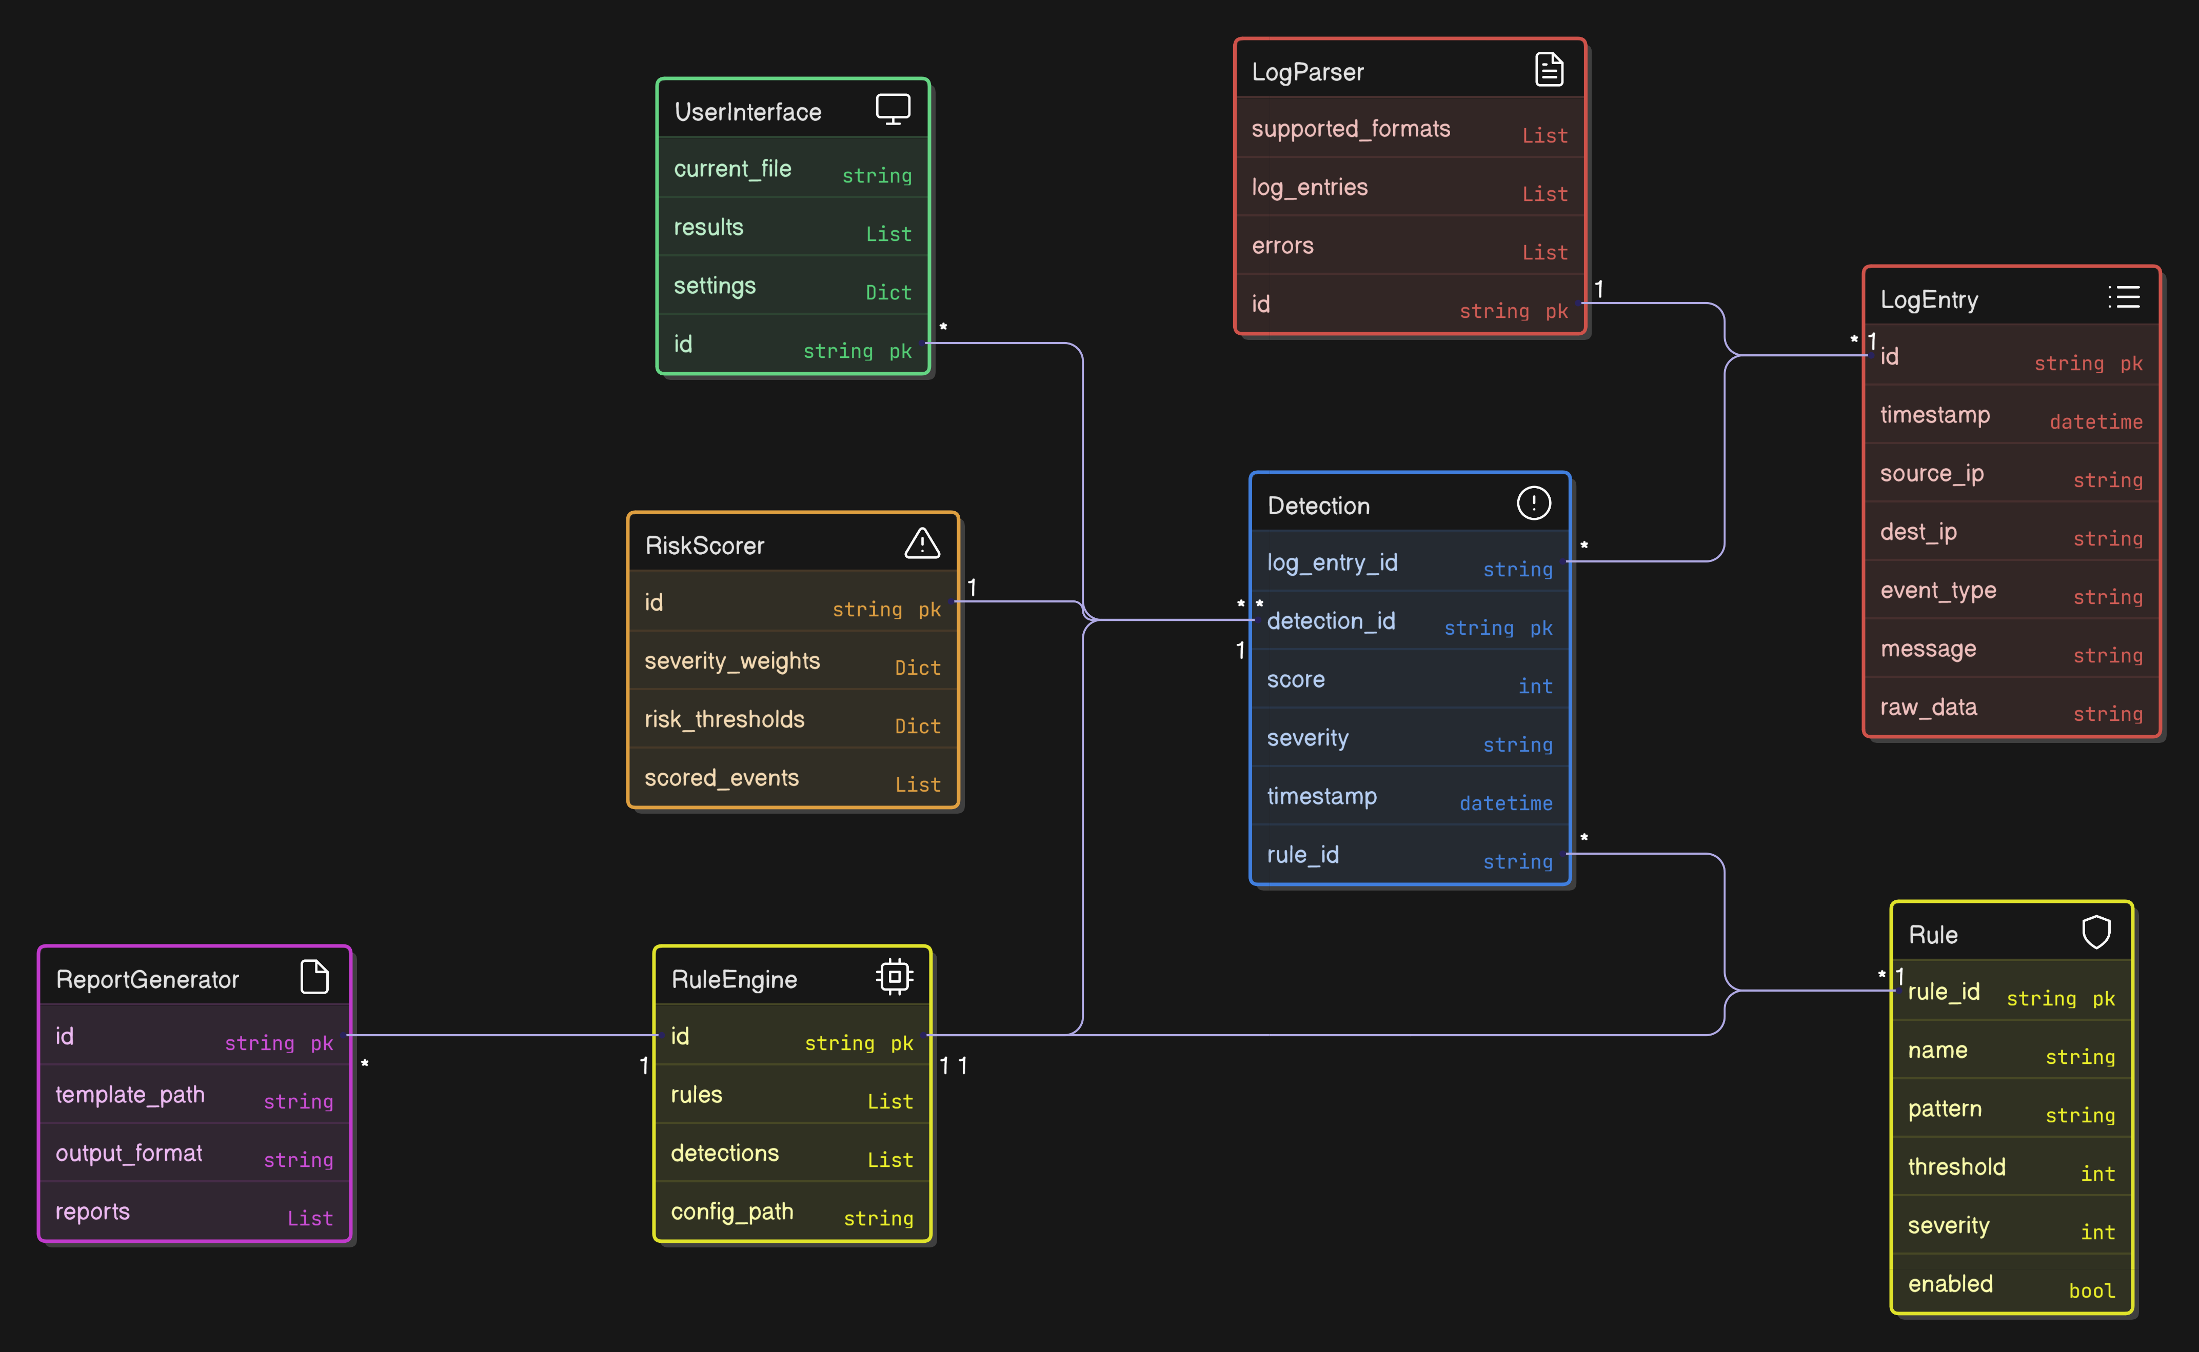
Figure 5.4: CyberRisk Monitor Data Model and Class Relationships

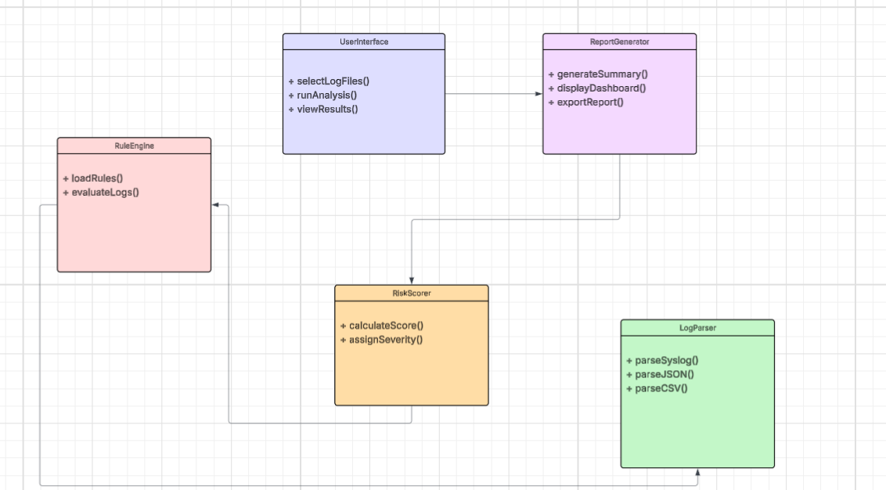
Figure 5.5: Conceptual UML Class Diagram

Dependency Flow: LogParser -> RuleEngine -> RiskScorer -> ReportGenerator -> CLI
Each module exposes clean interfaces through dataclasses (LogEntry, Rule, Detection, ScoredEvent, RiskAssessment), enabling independent testing, easy substitution, and minimal code duplication.

5.3 Documentation

5.3.1 Code Formatting Standards
The project enforces consistent code formatting through automated tools:
- Black: Code formatter with 88-character line length
- isort: Import statement organization
- Type Hints: All public functions include type annotations

Example of documented function:
def score_detections(self, detections: list[Detection]) -> RiskAssessment:
"""
Score a list of detections and produce a risk assessment.
Args:
detections: List of Detection objects to score
Returns:
RiskAssessment containing scored events and overall risk
"""

5.3.2 Inline Documentation and Comments
All modules include comprehensive docstrings following Google style. Module-level docstrings explain purpose and authorship. Class docstrings document attributes, usage examples, and behavioral notes. Method docstrings describe parameters, return values, and exceptions.

5.3.3 README and Project Documentation
The project README (README.md) provides comprehensive documentation including:
- Project Overview: Description of CyberRisk Monitor and its capabilities
- Installation Instructions: Step-by-step setup for all platforms
- Usage Examples: CLI commands and Python API usage
- Supported Log Formats: syslog, JSON, CSV with examples
- Detection Rules: Table of 15 built-in rules with severity levels
- Architecture Overview: Module descriptions and data flow
- Testing Instructions: How to run the test suite

5.3.4 Dependencies and Version Documentation
setup.py documents package metadata including name, version (0.1.0), description, Python requirement (>=3.10), and optional development dependencies. requirements.txt specifies exact minimum versions for reproducible builds.

5.4 Unit Testing

5.4.1 Testing Framework and Approach
The project uses pytest as the testing framework, selected for:
- Simple test discovery and execution
- Powerful fixture system for test data management
- Rich assertion introspection
- Extensive plugin ecosystem (coverage, parallel execution)

5.4.2 Test Coverage by Module
Module | Test File | Tests | Coverage Areas
log_parser.py | test_log_parser.py | 16 | Format detection, parsing, error handling
rule_engine.py | test_rule_engine.py | 14 | Rule creation, pattern matching, thresholds
risk_scorer.py | test_risk_scorer.py | 45 | Scoring, categorization, context multipliers
TOTAL |  | 75 | All core modules

5.4.3 Test Case Documentation
Tests are organized into logical test classes with descriptive names:
RiskScorer Tests (test_risk_scorer.py):
- TestScoredEvent - ScoredEvent dataclass creation and serialization
- TestRiskAssessment - RiskAssessment dataclass and to_dict()
- TestRiskScorerInit - Default/custom thresholds and weights
- TestScoreCategorization - Low/Medium/High/Critical boundaries
- TestThresholdManagement - get_thresholds(), set_thresholds()
- TestSingleDetectionScoring - calculate_score(), frequency multiplier
- TestContextMultiplier - root, admin, ssh, /etc/shadow, localhost
- TestMultipleDetectionScoring - score_detections(), aggregate_risk()
- TestSummaryGeneration - Statistics, by_category, by_rule, timeline
- TestEdgeCases - Empty inputs, minimum scores, large datasets
- TestIntegration - Full workflow test

5.4.4 Running Tests
Tests can be executed using the following commands:
pytest tests/ -v # Run all tests
pytest tests/ --cov=src/cyberrisk # With coverage
pytest tests/test_risk_scorer.py -v # Specific file
pytest tests/ -k "test_categorize" -v # Pattern matching

Current Test Results: 75 passed in 0.09s

5.4.5 Test Fixtures and Data Management
Tests use pytest fixtures to provide reusable test data, ensuring consistent test data across test cases, reduced code duplication, easy modification of test scenarios, and clear documentation of expected data formats.

5.5 Phase I Summary
Deliverable | Status | Evidence
Functional development environment | Complete | Cross-platform setup verified
Version control integration | Complete | GitHub repository with commit history
Core modules implemented | Complete | LogParser, RuleEngine, RiskScorer, ReportGenerator
15 detection rules | Complete | config/rules.json
CLI interface | Complete | cyberrisk analyze command
Comprehensive unit tests | Complete | 75 tests, all passing
Code documentation | Complete | Docstrings, README, type hints

The Phase I implementation establishes a stable foundation for continued development in subsequent phases, with clean architecture, thorough testing, and comprehensive documentation supporting maintainability and extensibility.

