CyberRisk Monitor
A Lightweight Rule-Based Cybersecurity Monitoring and Risk Assessment Tool

UMGC CMSC 495 - Computer Science Capstone
Project Design Document
Spring 2026

Team Members:
Mustafa Black-Castle, Daniel S. Garrett, Nicholas Porpora, and Cassandra Santacruz

Table of Contents
1. Introduction
2. Project Scope
3. Project Requirements
4. Project Methodology
5. Work Breakdown Structure and Project Tasks
6. Project Schedule
7. Project Resources
8. Project Risks
9. Project Evaluation Plan
10. System Design
11. Testing and Validation Strategy
12. Conclusion
Appendix A: Detailed Class Specifications
Appendix B: Detection Rules Catalog

1. Introduction
This Project Design document presents the execution roadmap for CyberRisk Monitor, a lightweight rule-based cybersecurity monitoring and risk assessment tool developed as part of the UMGC CMSC 495 Computer Science Capstone. The purpose of this document is to translate the approved Project Plan into a structured design and implementation strategy that guides development, scheduling, risk management, and evaluation activities throughout the project lifecycle.
CyberRisk Monitor is designed as a proof-of-concept system rather than a full-scale enterprise solution. The project focuses on analyzing simulated or sample security logs using predefined detection rules to identify indicators of suspicious or potentially malicious activity. The system emphasizes clarity, interpretability, and accessibility, making it suitable for educational environments and small teams seeking an introductory cybersecurity monitoring capability.
This document builds upon the previously established Project Plan by expanding on technical requirements, task decomposition, scheduling logic, and evaluation criteria. It serves as a comprehensive reference for how the project will be executed, monitored, and assessed to ensure alignment with course objectives and successful capstone delivery.

1.1 Document Purpose
This design document serves multiple purposes:
- Provide a detailed roadmap for project execution from Week 3 through Week 8
- Define clear scope boundaries, deliverables, and success criteria
- Establish a structured work breakdown with accurate time and resource estimates
- Identify and analyze potential risks with corresponding mitigation strategies
- Create measurable evaluation criteria aligned with project objectives
- Guide the development team through a systematic implementation process

1.2 Intended Audience
This document is intended for course instructors evaluating the project plan, team members executing the development work, and any stakeholders interested in understanding the project's scope and approach.

2. Project Scope
The scope of the CyberRisk Monitor project defines the objectives, deliverables, boundaries, and limitations necessary to ensure successful completion within the fixed academic timeline of the capstone course.

2.1 Project Objectives
The primary objective is to design, implement, and deliver a functional cybersecurity monitoring tool capable of analyzing structured log data and identifying indicators of suspicious or potentially malicious activity using predefined detection rules. The following specific objectives guide the project:
Objective ID | Objective Description | Success Criteria
OBJ-01 | Develop a log parsing system supporting multiple formats | Successfully parse syslog, JSON, and CSV formats with >95% accuracy
OBJ-02 | Implement rule-based detection engine | Execute 10-15 detection rules with correct pattern matching
OBJ-03 | Create risk scoring and categorization system | Accurately categorize events into Low/Medium/High/Critical levels
OBJ-04 | Build user-friendly reporting interface | Generate clear summary reports and visualizations
OBJ-05 | Deliver documented, maintainable codebase | Complete documentation with >80% code coverage in tests

Table 2.1: Project Objectives and Success Criteria

2.2 Project Deliverables
The following deliverables will be produced upon project completion:
- Functional CyberRisk Monitor application with all core modules
- LogParser module supporting syslog, JSON, and CSV formats
- RuleEngine module with 10-15 predefined detection rules
- RiskScorer module with configurable scoring algorithms
- ReportGenerator module producing summary reports and visualizations
- UserInterface providing command-line and/or graphical interaction
- Sample log datasets for testing and demonstration
- Comprehensive code documentation and user manual
- Final project presentation and demonstration materials

2.3 Scope Boundaries
The following table clearly defines what is included and excluded from this project:
In Scope | Out of Scope
Analysis of simulated/sample security log data | Real-time monitoring of live network traffic
Implementation of 10-15 predefined detection rules | Integration with production/enterprise environments
Basic risk scoring and categorization (Low/Medium/High/Critical) | Machine learning or AI-based detection techniques
Summary dashboards and structured reports | Automated incident response or remediation
Support for syslog, JSON, and CSV formats | Enterprise-scale log aggregation or storage
Command-line and/or simple graphical interface | Regulatory compliance frameworks (HIPAA, PCI-DSS)
Offline batch processing of log files | Network packet capture or deep packet inspection

Table 2.2: Project Scope Boundaries

2.4 Constraints and Limitations
Constraint Type | Description
Time Constraint | Project must be completed within 6 weeks (Weeks 3-8 of the course)
Team Size | Limited to 4 team members with varying availability
Budget | Zero budget; all tools and resources must be free or open-source
Technical | Cross-platform compatibility required (Windows, macOS, Linux)
Data | Must use simulated/sample data only; no access to real security logs
Complexity | Proof-of-concept level; not production-ready enterprise software

Table 2.3: Project Constraints and Limitations

2.5 Assumptions
- All team members have access to suitable development environments
- Team members possess foundational Python programming skills
- Adequate sample log data is available or can be generated for testing
- Team members can dedicate approximately 8-12 hours per week to the project
- Git/GitHub is accessible for version control and collaboration
- Internet access is available for research and tool downloads

3. Project Requirements
Project requirements for CyberRisk Monitor were derived from capstone course objectives, foundational cybersecurity practices, and the intended educational use of the system. These requirements ensure that the project demonstrates essential monitoring and risk assessment capabilities while remaining achievable within time and resource constraints.

3.1 User Needs Analysis
The target users of CyberRisk Monitor are students, educators, and small teams who need an accessible introduction to cybersecurity monitoring concepts. User needs include:
User Need | Description
Transparency | Users need to understand why alerts are generated and how risk scores are calculated
Simplicity | Users require an intuitive interface that does not require extensive cybersecurity expertise
Education | Users benefit from clear explanations of detected security patterns
Flexibility | Users need the ability to adjust detection thresholds based on their environment
Accessibility | Users require cross-platform support and minimal installation complexity

Table 3.1: User Needs Analysis

3.2 Functional Requirements
Functional requirements define the specific behaviors and capabilities the system must exhibit:
Req ID | Requirement Description | Priority | Verification Method
FR-01 | The system shall parse security logs in syslog-style text, JSON, and CSV formats | High | Unit Testing
FR-02 | The system shall apply predefined and configurable detection rules to parsed log data | High | Integration Testing
FR-03 | The system shall identify common security patterns (failed logins, port scanning, privilege escalation) | High | Functional Testing
FR-04 | The system shall calculate numerical risk scores for detected events | High | Unit Testing
FR-05 | The system shall categorize detected risks as Low, Medium, High, or Critical | High | Validation Testing
FR-06 | The system shall generate summary reports of detected findings | Medium | Functional Testing
FR-07 | The system shall present results through a dashboard or structured report interface | Medium | User Acceptance
FR-08 | The system shall allow users to adjust detection rule thresholds | Low | Configuration Testing

Table 3.2: Functional Requirements

3.3 Non-Functional Requirements
Non-functional requirements define the quality attributes and constraints on system behavior:
Req ID | Requirement Description | Category | Acceptance Criteria
NFR-01 | Process up to 10,000 log entries within 30 seconds on standard hardware | Performance | Benchmark testing shows <30s processing time
NFR-02 | User interface understandable for users with basic technical knowledge | Usability | User can perform analysis without documentation
NFR-03 | Include error handling and internal logging for debugging | Reliability | No unhandled exceptions; errors logged
NFR-04 | Codebase documented and follows consistent coding standards | Maintainability | Code review approval; docstrings present
NFR-05 | Cross-platform compatibility (Windows, macOS, Linux) | Portability | Successful execution on all three platforms
NFR-06 | Modular architecture supporting future enhancements | Extensibility | Clear separation of concerns in design

Table 3.3: Non-Functional Requirements

3.4 Technical Requirements
Component | Specification
Programming Language | Python 3.10 or later
Operating System | Cross-platform (Windows, macOS, Linux)
Version Control | Git with shared GitHub repository
Core Libraries | Standard Python libraries (json, csv, re, datetime, logging)
Optional Frameworks | Flask or Streamlit for web-based visualization
Configuration Format | JSON or YAML files for rules and settings
Data Storage | File-based; optional SQLite for persistence
Testing Framework | pytest for unit and integration testing

Table 3.4: Technical Requirements

4. Project Methodology

4.1 Methodology Selection: Agile-Inspired Iterative Development
The CyberRisk Monitor project follows an Agile-inspired iterative development methodology adapted to the structure of the CMSC 495 capstone course. This approach organizes development activities into short, iterative cycles aligned with weekly course milestones, allowing for incremental progress and regular reassessment of project status.

4.2 Justification for Methodology Selection
The Agile-inspired approach was selected based on the following project characteristics:
Project Characteristic | How Agile Addresses It
Fixed Timeline | Weekly iterations ensure continuous progress within the 6-week constraint
Small Team | 4-person team benefits from lightweight processes over heavy documentation
Educational Context | Iterative demos allow instructor feedback and course alignment
Technical Uncertainty | Flexibility to adapt as team learns cybersecurity concepts
Integration Complexity | Early and continuous integration reduces end-of-project risk
Deliverable Focus | Each iteration produces working software demonstrating progress

Table 4.1: Methodology Justification

4.3 Iteration Structure
Each weekly iteration follows a structured pattern that balances development work with team coordination and quality assurance:
- Planning (Monday): Review tasks for the week, assign responsibilities, identify blockers
- Development (Monday-Friday): Execute assigned tasks, implement features, write tests
- Integration (Thursday): Merge code, resolve conflicts, verify component compatibility
- Testing (Thursday-Friday): Run unit tests, integration tests, and manual verification
- Review (Friday): Team meeting to demonstrate progress, discuss issues, plan next iteration
- Documentation (Ongoing): Update code comments, maintain user documentation

4.4 Communication and Collaboration
The team employs the following communication practices:
- Weekly team meetings (virtual) for planning and review
- Shared GitHub repository for code collaboration and version control
- Issue tracking via GitHub Issues for task management
- Direct messaging (Discord/Slack) for quick questions and coordination
- Shared documentation repository for design documents and notes

4.5 Comparison with Waterfall Approach
A traditional Waterfall approach was considered but rejected due to its limitations in this context. The following table compares both approaches:
Aspect | Waterfall | Agile (Selected)
Feedback Timing | Late (after full implementation) | Continuous (each iteration)
Risk of Failure | High (issues found late) | Low (issues found early)
Flexibility | Low (changes are costly) | High (changes are expected)
Progress Visibility | Limited until end | Demonstrated weekly

Table 4.2: Methodology Comparison

5. Work Breakdown Structure and Project Tasks
The project work is decomposed into manageable tasks organized by development phase and functional responsibility. This work breakdown structure supports parallel development while maintaining clear dependencies between system components.

5.1 Work Breakdown Structure Diagram
The following diagram illustrates the hierarchical decomposition of project work:
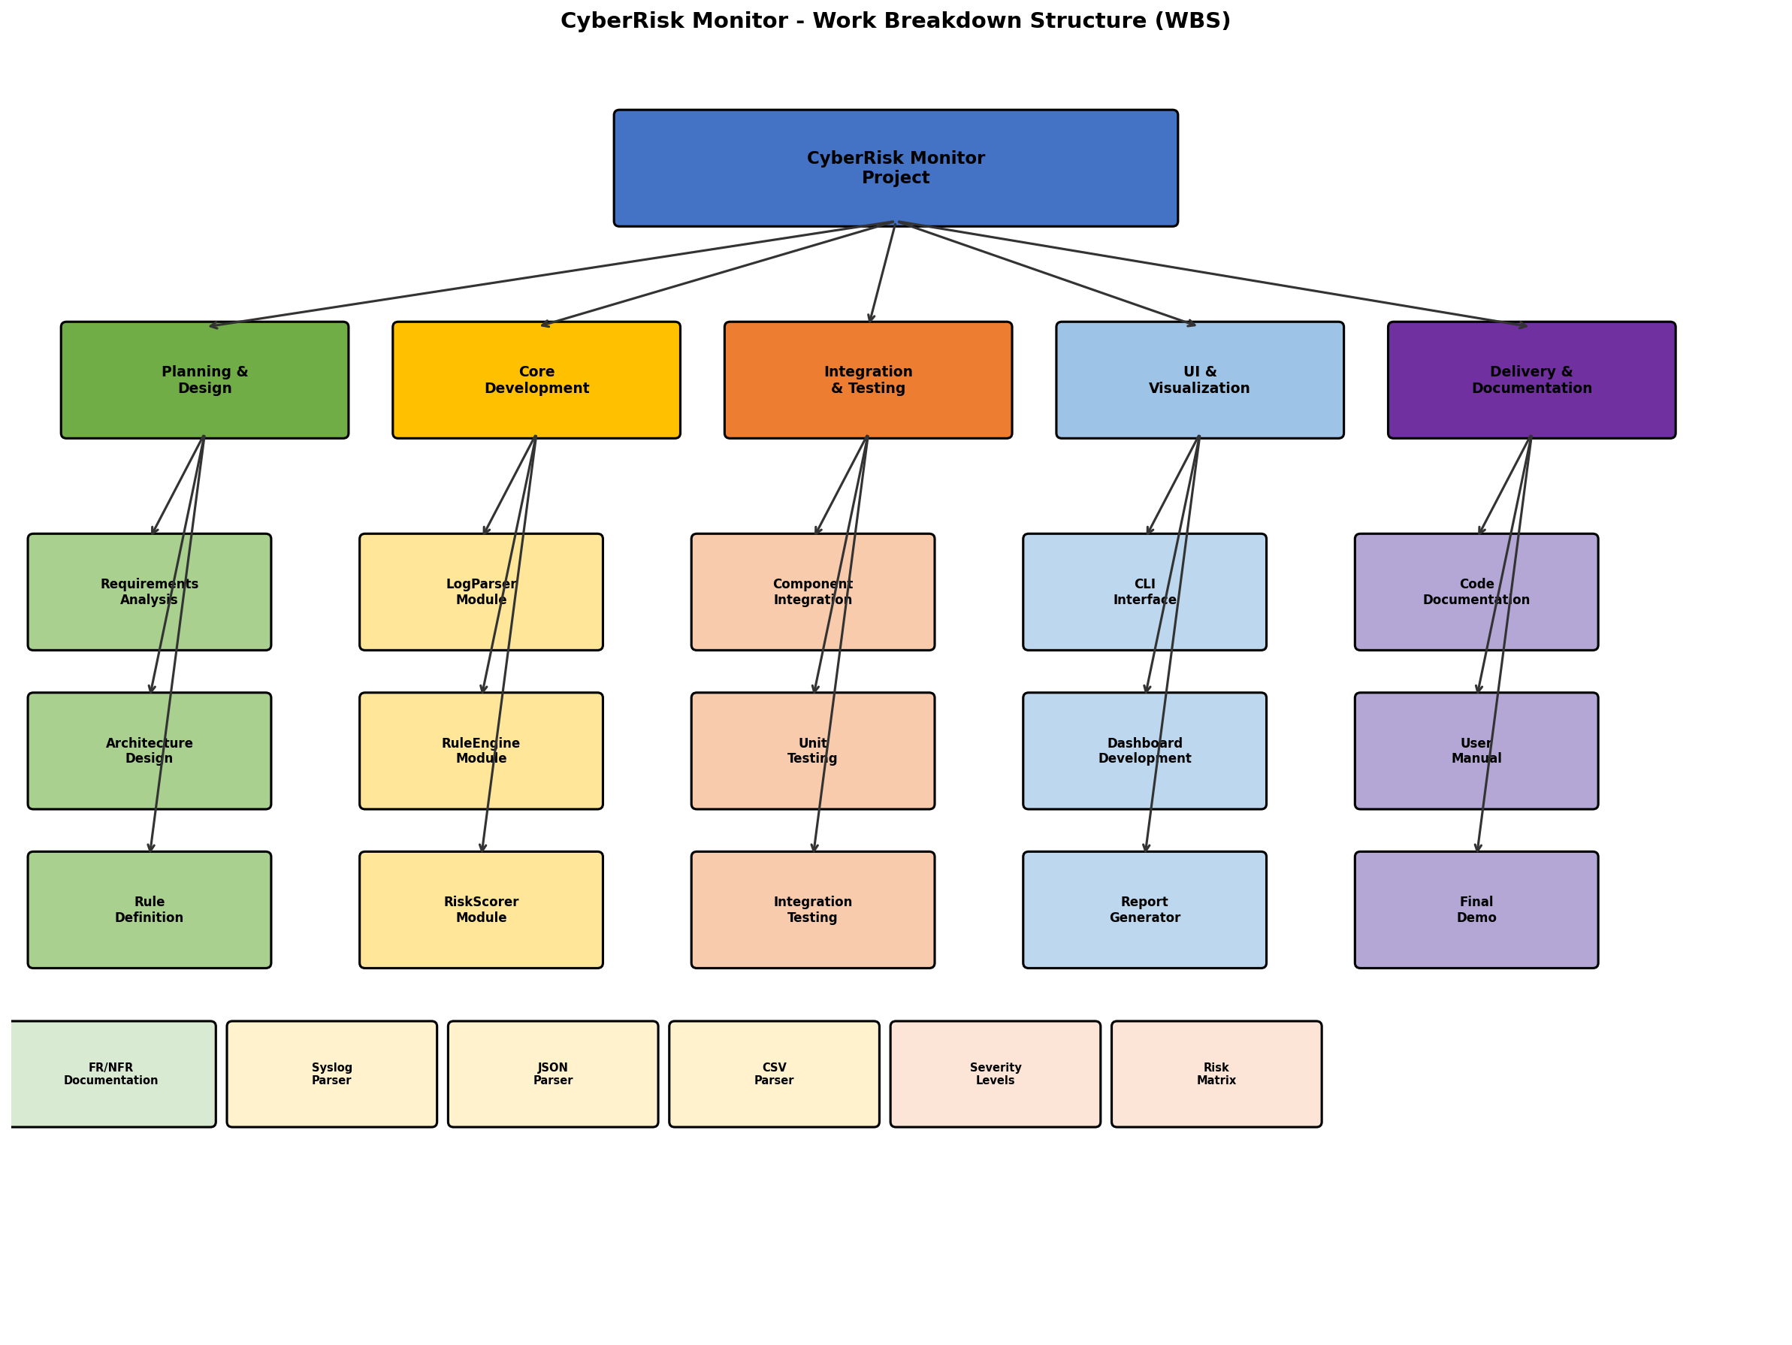
Figure 5.1: Work Breakdown Structure (WBS) Diagram

5.2 Task Breakdown by Phase

Phase 1: Planning and Design (Week 3)
Task ID | Task Description | Owner | Est. Hours | Deliverable
T1.1 | Finalize requirements documentation | Mustafa | 6 | Requirements Document
T1.2 | Design system architecture | Nicholas | 8 | Architecture Diagram
T1.3 | Define detection rules catalog | Daniel | 6 | Rules Specification
T1.4 | Set up development environment | All | 4 | Working Dev Environment

Phase 2: Core Development I (Week 4)
Task ID | Task Description | Owner | Est. Hours | Deliverable
T2.1 | Implement LogParser base module | Daniel | 10 | LogParser.py
T2.2 | Implement syslog format handler | Daniel | 6 | Syslog parser
T2.3 | Implement JSON/CSV format handlers | Daniel | 6 | JSON/CSV parsers
T2.4 | Create unit tests for parsing | Daniel | 4 | test_logparser.py

Phase 3: Core Development II (Week 5)
Task ID | Task Description | Owner | Est. Hours | Deliverable
T3.1 | Implement RuleEngine module | Mustafa | 12 | RuleEngine.py
T3.2 | Implement RiskScorer module | Nicholas | 10 | RiskScorer.py
T3.3 | Create detection rules (10-15 rules) | Mustafa | 8 | rules_config.json
T3.4 | Unit tests for rules and scoring | Nicholas | 6 | test_rules.py

Phase 4: Integration (Week 6)
Task ID | Task Description | Owner | Est. Hours | Deliverable
T4.1 | Integrate LogParser with RuleEngine | Nicholas | 6 | Integrated pipeline
T4.2 | Integrate RiskScorer with pipeline | Nicholas | 6 | Full analysis chain
T4.3 | Implement ReportGenerator module | Cassandra | 10 | ReportGenerator.py
T4.4 | Integration testing | All | 8 | Integration test suite

Phase 5: UI and Testing (Week 7)
Task ID | Task Description | Owner | Est. Hours | Deliverable
T5.1 | Implement UserInterface (CLI) | Cassandra | 8 | cli.py
T5.2 | Implement dashboard visualization | Cassandra | 10 | Dashboard module
T5.3 | System testing and bug fixes | All | 10 | Test reports
T5.4 | Performance optimization | Mustafa | 4 | Optimized code

Phase 6: Final Delivery (Week 8)
Task ID | Task Description | Owner | Est. Hours | Deliverable
T6.1 | Finalize code documentation | All | 6 | Documented codebase
T6.2 | Create user manual | Cassandra | 6 | User Manual
T6.3 | Performance validation | Daniel | 4 | Benchmark results
T6.4 | Prepare final demonstration | Mustafa | 6 | Demo presentation

5.3 Task Dependencies
The following critical dependencies exist between tasks:
- T2.1-T2.4 (LogParser) must complete before T4.1 (Integration with RuleEngine)
- T3.1 (RuleEngine) must complete before T4.1 (Integration)
- T3.2 (RiskScorer) must complete before T4.2 (Pipeline Integration)
- T4.1-T4.2 (Integration) must complete before T5.1-T5.2 (UI Development)
- T4.3 (ReportGenerator) must complete before T5.2 (Dashboard)
- All development tasks must complete before T6.3 (Performance Validation)
- T6.1-T6.3 must complete before T6.4 (Final Demonstration)

5.4 Total Effort Summary
Phase | Total Hours | Team Members Involved
Phase 1: Planning & Design | 24 | All (6 hrs each)
Phase 2: Core Development I | 26 | Daniel (primary)
Phase 3: Core Development II | 36 | Mustafa, Nicholas
Phase 4: Integration | 30 | Nicholas, Cassandra
Phase 5: UI & Testing | 32 | Cassandra, All
Phase 6: Final Delivery | 22 | All
TOTAL | 170 | ~42.5 hrs per member

Table 5.1: Total Effort Summary by Phase

6. Project Schedule
The project schedule spans six weeks, corresponding to Weeks 3 through 8 of the capstone course. Milestones are structured to ensure consistent progress while allocating sufficient time for integration, testing, and refinement.

6.1 Project Timeline (Gantt Chart)
The following Gantt chart illustrates the project timeline with task durations, dependencies, and milestones:
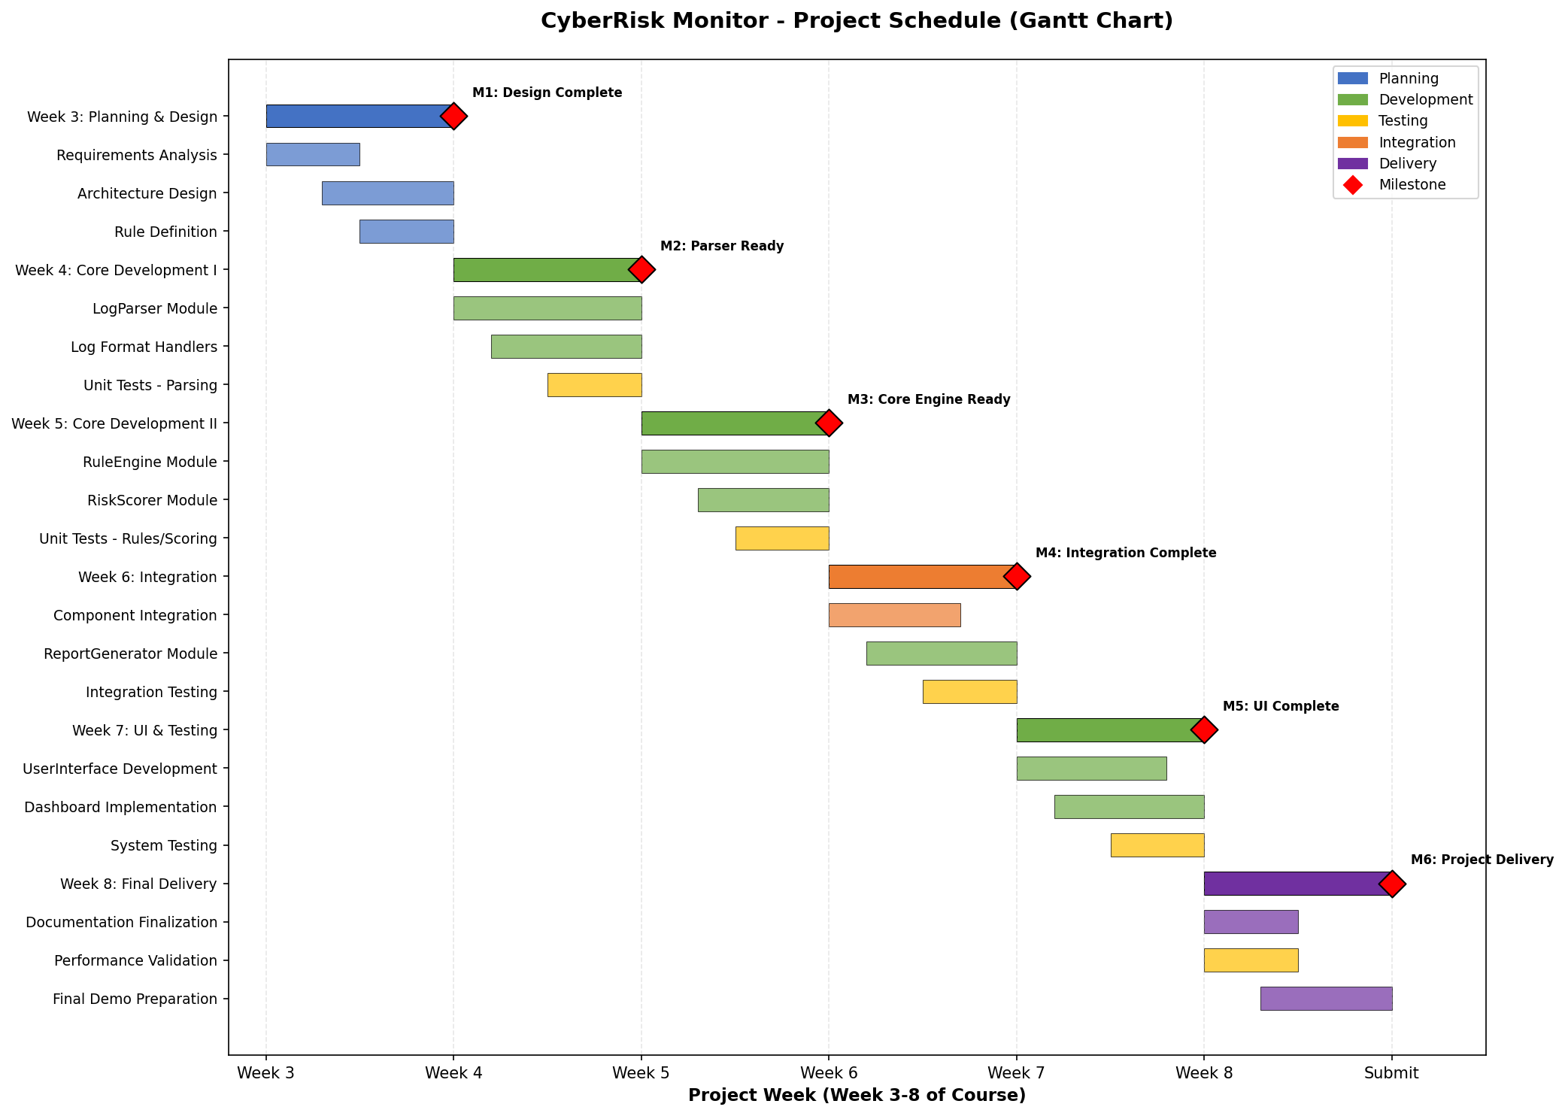
Figure 6.1: Project Schedule Gantt Chart

6.2 Milestones and Deadlines
Milestone | Target Date | Deliverables | Success Criteria
M1: Design Complete | End of Week 3 | Design document, Architecture diagram | Approved by team lead
M2: Parser Ready | End of Week 4 | LogParser module, Unit tests | All format handlers tested
M3: Core Engine Ready | End of Week 5 | RuleEngine, RiskScorer modules | Rules execute correctly
M4: Integration Complete | End of Week 6 | Integrated pipeline, ReportGenerator | End-to-end test passes
M5: UI Complete | End of Week 7 | UserInterface, Dashboard | User can run full analysis
M6: Project Delivery | End of Week 8 | Final code, Documentation, Demo | All requirements met

Table 6.1: Project Milestones and Deadlines

6.3 Weekly Schedule Detail
Week | Primary Focus | Key Activities
Week 3 | Planning & Design | Requirements finalization, Architecture design, Rule definition, Environment setup
Week 4 | Core Development I | LogParser implementation, Format handlers (syslog, JSON, CSV), Unit testing
Week 5 | Core Development II | RuleEngine implementation, RiskScorer implementation, Detection rules creation
Week 6 | Integration | Component integration, ReportGenerator development, Integration testing
Week 7 | UI & Testing | CLI and Dashboard development, System testing, Performance optimization
Week 8 | Final Delivery | Documentation, Performance validation, Demo preparation, Final submission

Table 6.2: Weekly Schedule Detail

6.4 Critical Path
The critical path for this project runs through the following sequence of dependent tasks:
Critical Path: Requirements Analysis (Week 3) -> LogParser Module (Week 4) -> RuleEngine Module (Week 5) -> Component Integration (Week 6) -> UserInterface Development (Week 7) -> Final Demo Preparation (Week 8)
Any delays in these tasks will directly impact the final delivery date. Buffer time has been allocated within each phase to absorb minor delays without affecting subsequent milestones.

7. Project Resources
This section identifies and allocates the personnel, equipment, and budget resources required for successful project completion.

7.1 Team Member Allocation
Team Member | Role | Primary Responsibilities | Availability | Est. Hours
Mustafa Black-Castle | Project Lead | RuleEngine, Coordination, Demo | 10-12 hrs/week | 40
Daniel S. Garrett | Lead Developer | LogParser, Testing Lead | 10-12 hrs/week | 40
Nicholas Porpora | Developer | RiskScorer, Integration | 10-12 hrs/week | 40
Cassandra Santacruz | Developer | UI, Documentation, Reports | 10-12 hrs/week | 40

Table 7.1: Team Member Allocation

7.2 Resource Allocation Visualization
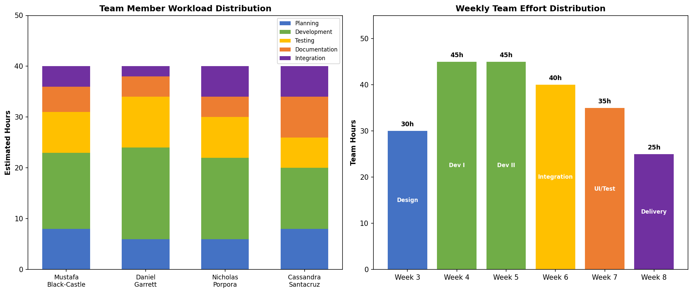
Figure 7.1: Team Workload and Weekly Effort Distribution

7.3 Equipment and Software Resources
Resource | Type | Cost | Availability
Personal Computers | Hardware | $0 (owned) | All team members
Python 3.10+ | Software | $0 (free) | Available
Git/GitHub | Version Control | $0 (free tier) | Available
VS Code/PyCharm | IDE | $0 (free editions) | Available
pytest | Testing Framework | $0 (open source) | Available
Streamlit/Flask | Web Framework | $0 (open source) | Available
Discord/Slack | Communication | $0 (free tier) | Available
Internet Access | Infrastructure | Personal expense | All team members

Table 7.2: Equipment and Software Resources

7.4 Budget Summary
This project operates with a zero-dollar budget. All tools, frameworks, and resources utilized are free, open-source, or already owned by team members. The only implicit costs are team member time (estimated at 160 total person-hours) and personal internet access.
Cost Category | Amount
Software Licenses | $0
Hardware | $0 (existing equipment)
Cloud Services | $0 (not required)
TOTAL PROJECT BUDGET | $0

Table 7.3: Budget Summary

8. Project Risks
Cybersecurity projects often involve technical complexity and integration challenges, making proactive risk management essential. This section identifies potential risks, assesses their impact and likelihood, and outlines mitigation strategies.

8.1 Risk Assessment Matrix
The following matrix visualizes identified risks based on their likelihood and potential impact:
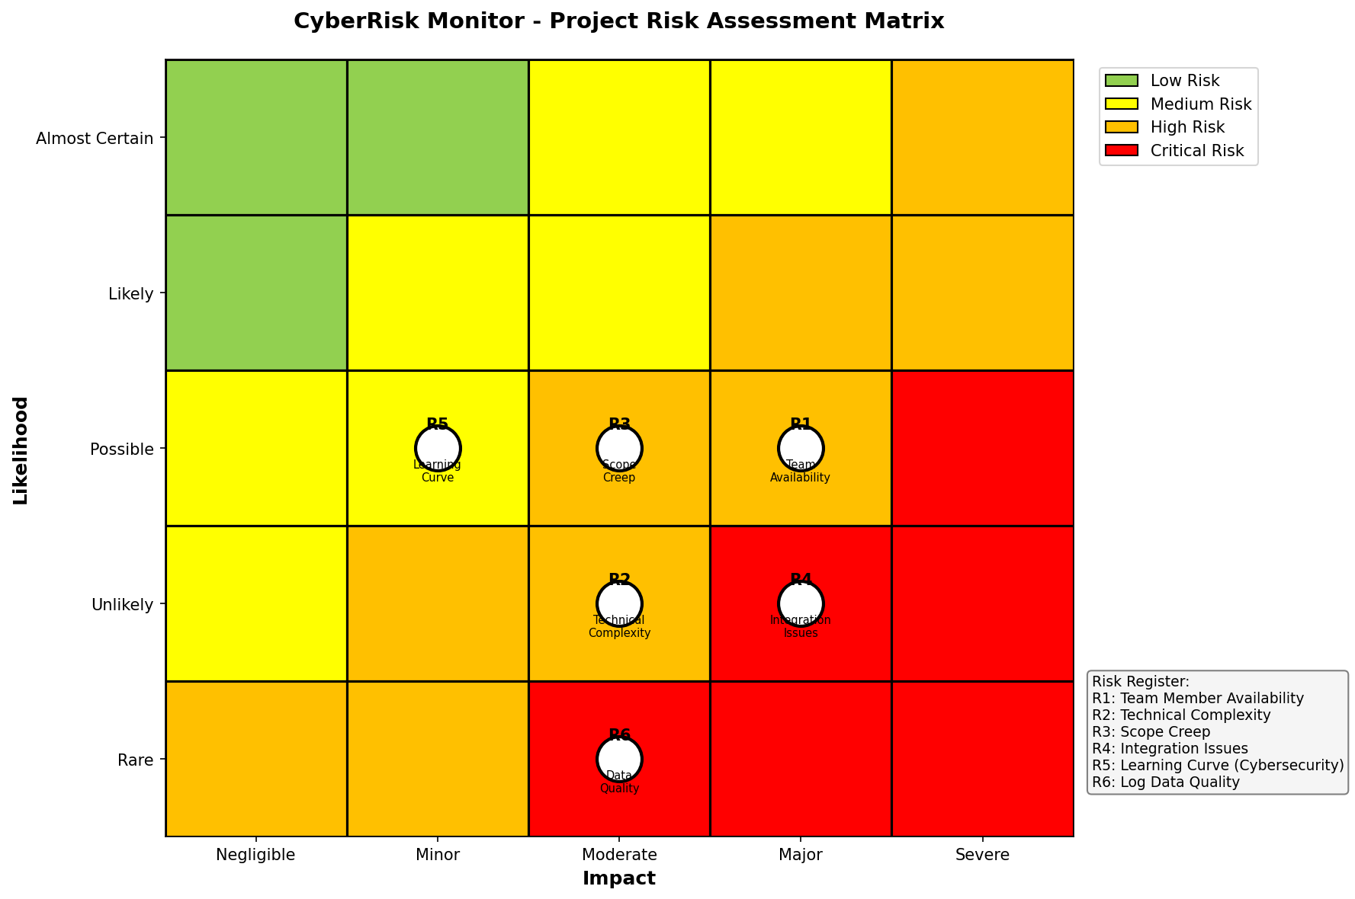
Figure 8.1: Risk Assessment Matrix

8.2 Risk Register
Risk ID | Risk Description | Likelihood | Impact | Risk Level | Mitigation Strategy
R1 | Team member unavailability due to other commitments | Possible | Major | High | Cross-train on modules; maintain documentation; buffer time in schedule
R2 | Technical complexity exceeds team expertise | Unlikely | Moderate | Medium | Early research; leverage online resources; simplify scope if needed
R3 | Scope creep from feature requests | Possible | Moderate | Medium | Strict scope boundary enforcement; change control process
R4 | Integration issues between modules | Unlikely | Major | Medium | Define clear interfaces early; continuous integration testing
R5 | Learning curve for cybersecurity concepts | Possible | Minor | Medium | Early research; focus on educational resources; team knowledge sharing
R6 | Poor quality or insufficient test data | Rare | Moderate | Low | Create synthetic datasets early; validate data quality before testing

Table 8.1: Risk Register

8.3 Detailed Mitigation Plans

R1: Team Member Unavailability
Impact: Delays in task completion; potential knowledge gaps. Mitigation Actions:
- Maintain comprehensive documentation for all modules
- Ensure at least two team members understand each critical component
- Hold weekly sync meetings to share progress and knowledge
- Build buffer time into schedule for unexpected absences
- Use GitHub Issues to track all tasks with clear descriptions

R2: Technical Complexity
Impact: Extended development time; potential feature reduction. Mitigation Actions:
- Conduct early research during Week 3 planning phase
- Identify online tutorials and resources for unfamiliar concepts
- Start with simple implementations and iterate
- Seek instructor guidance when facing significant blockers
- Be prepared to simplify scope while maintaining core functionality

R3: Scope Creep
Impact: Delayed delivery; incomplete core features. Mitigation Actions:
- Document clear scope boundaries in this design document
- Require team consensus for any scope changes
- Maintain a "future enhancements" list for ideas outside current scope
- Prioritize core functionality over nice-to-have features
- Review scope weekly during team meetings

R4: Integration Issues
Impact: System fails to work as a cohesive unit. Mitigation Actions:
- Define clear interfaces between modules during design phase
- Use consistent data structures across all components
- Implement continuous integration from Week 4 onwards
- Write integration tests before full integration begins
- Conduct code reviews to ensure interface compliance

8.4 Contingency Plans
Scenario | Trigger Condition | Contingency Action
Major delay (>1 week) | Milestone missed by >3 days | Reduce detection rules to 8; simplify UI to CLI only
Team member dropout | Member unavailable for >1 week | Redistribute tasks; focus on critical path items
Technical blocker | Issue unresolved for >3 days | Seek external help; simplify affected component

Table 8.2: Contingency Plans

9. Project Evaluation Plan
Project success will be evaluated using both qualitative and quantitative criteria. This section establishes clear, measurable evaluation criteria aligned with project goals.

9.1 Evaluation Criteria
Criterion | Metric | Target | Measurement Method
Functional Completeness | Requirements implemented | 100% of FR-01 to FR-08 | Requirements traceability matrix
Detection Accuracy | Rules correctly identify patterns | >90% true positive rate | Testing with known datasets
Performance | Log processing speed | <30 sec for 10,000 entries | Benchmark testing
Code Quality | Test coverage | >80% code coverage | pytest-cov report
Documentation | Completeness | All modules documented | Documentation review
Usability | User can complete analysis | Without documentation reference | User acceptance testing
Maintainability | Code follows standards | Passes linting checks | Automated code analysis
Milestone Adherence | On-time delivery | 100% milestones met | Schedule tracking

Table 9.1: Evaluation Criteria and Metrics

9.2 Progress Monitoring
Progress will be monitored throughout the project using the following methods:
Weekly Status Reviews: Team meeting every Friday to assess progress against milestones
GitHub Metrics: Track commits, pull requests, and issue closure rates
Test Results: Monitor unit and integration test pass rates
Code Reviews: Peer review of all code before merging to main branch
Milestone Checkpoints: Formal review at each milestone completion

9.3 Quality Assurance Checkpoints
Checkpoint | Week | Quality Gate Criteria
Design Review | 3 | Architecture approved; requirements documented
Parser Quality Gate | 4 | All format tests pass; code reviewed
Engine Quality Gate | 5 | Detection rules validated; scoring correct
Integration Quality Gate | 6 | End-to-end test passes; no critical bugs
UI Quality Gate | 7 | User acceptance criteria met
Final Quality Gate | 8 | All criteria met; demo ready

Table 9.2: Quality Assurance Checkpoints

9.4 Success Definition
The project will be considered successful if:
- All functional requirements (FR-01 through FR-08) are implemented and working
- The system can process 10,000 log entries within 30 seconds
- At least 10 detection rules are implemented and validated
- The user interface allows complete analysis workflow without errors
- Code documentation covers all public interfaces
- Final demonstration successfully shows all capabilities
- All six milestones are completed by their target dates

9.5 Post-Project Evaluation
Following project completion, a retrospective evaluation will assess:
- What worked well in the development process
- What challenges were encountered and how they were addressed
- Lessons learned for future projects
- Potential improvements if the project were to continue
- Team collaboration effectiveness

10. System Design

10.1 System Architecture Overview
CyberRisk Monitor follows a modular system architecture that separates data ingestion, rule evaluation, risk assessment, and presentation. This separation of concerns supports maintainability, testability, and clear responsibility boundaries.
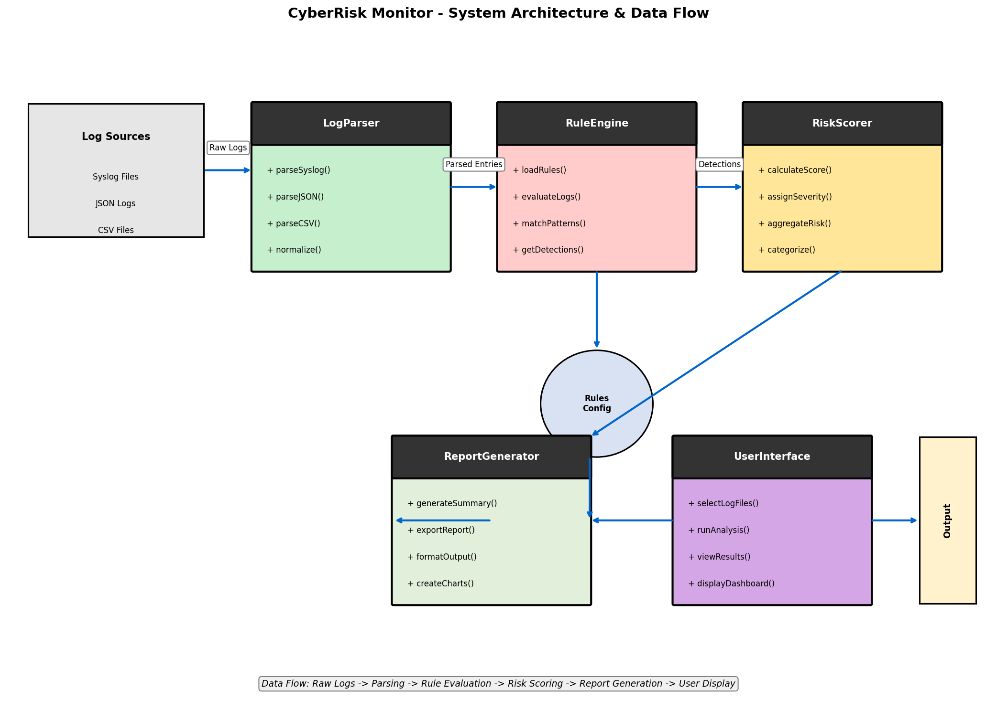
Figure 10.1: System Architecture and Data Flow Diagram

10.2 Component Descriptions
LogParser: Ingests and normalizes log data from multiple input formats (syslog, JSON, CSV). Responsible for format detection, parsing, validation, and conversion to a unified internal representation.
RuleEngine: Applies detection rules to parsed log entries. Loads rule configurations, evaluates conditions against log data, and generates detection events for matching patterns.
RiskScorer: Calculates risk scores and assigns severity levels. Implements the scoring algorithm based on rule severity, event frequency, and contextual factors.
ReportGenerator: Produces summary reports and visualizations. Aggregates detection results, calculates statistics, and formats output for display or export.
UserInterface: Provides user interaction and output display. Supports command-line interface and optional graphical dashboard for analysis workflow.

10.3 UML Class Diagram
The following detailed UML class diagram illustrates the object-oriented design of the system:
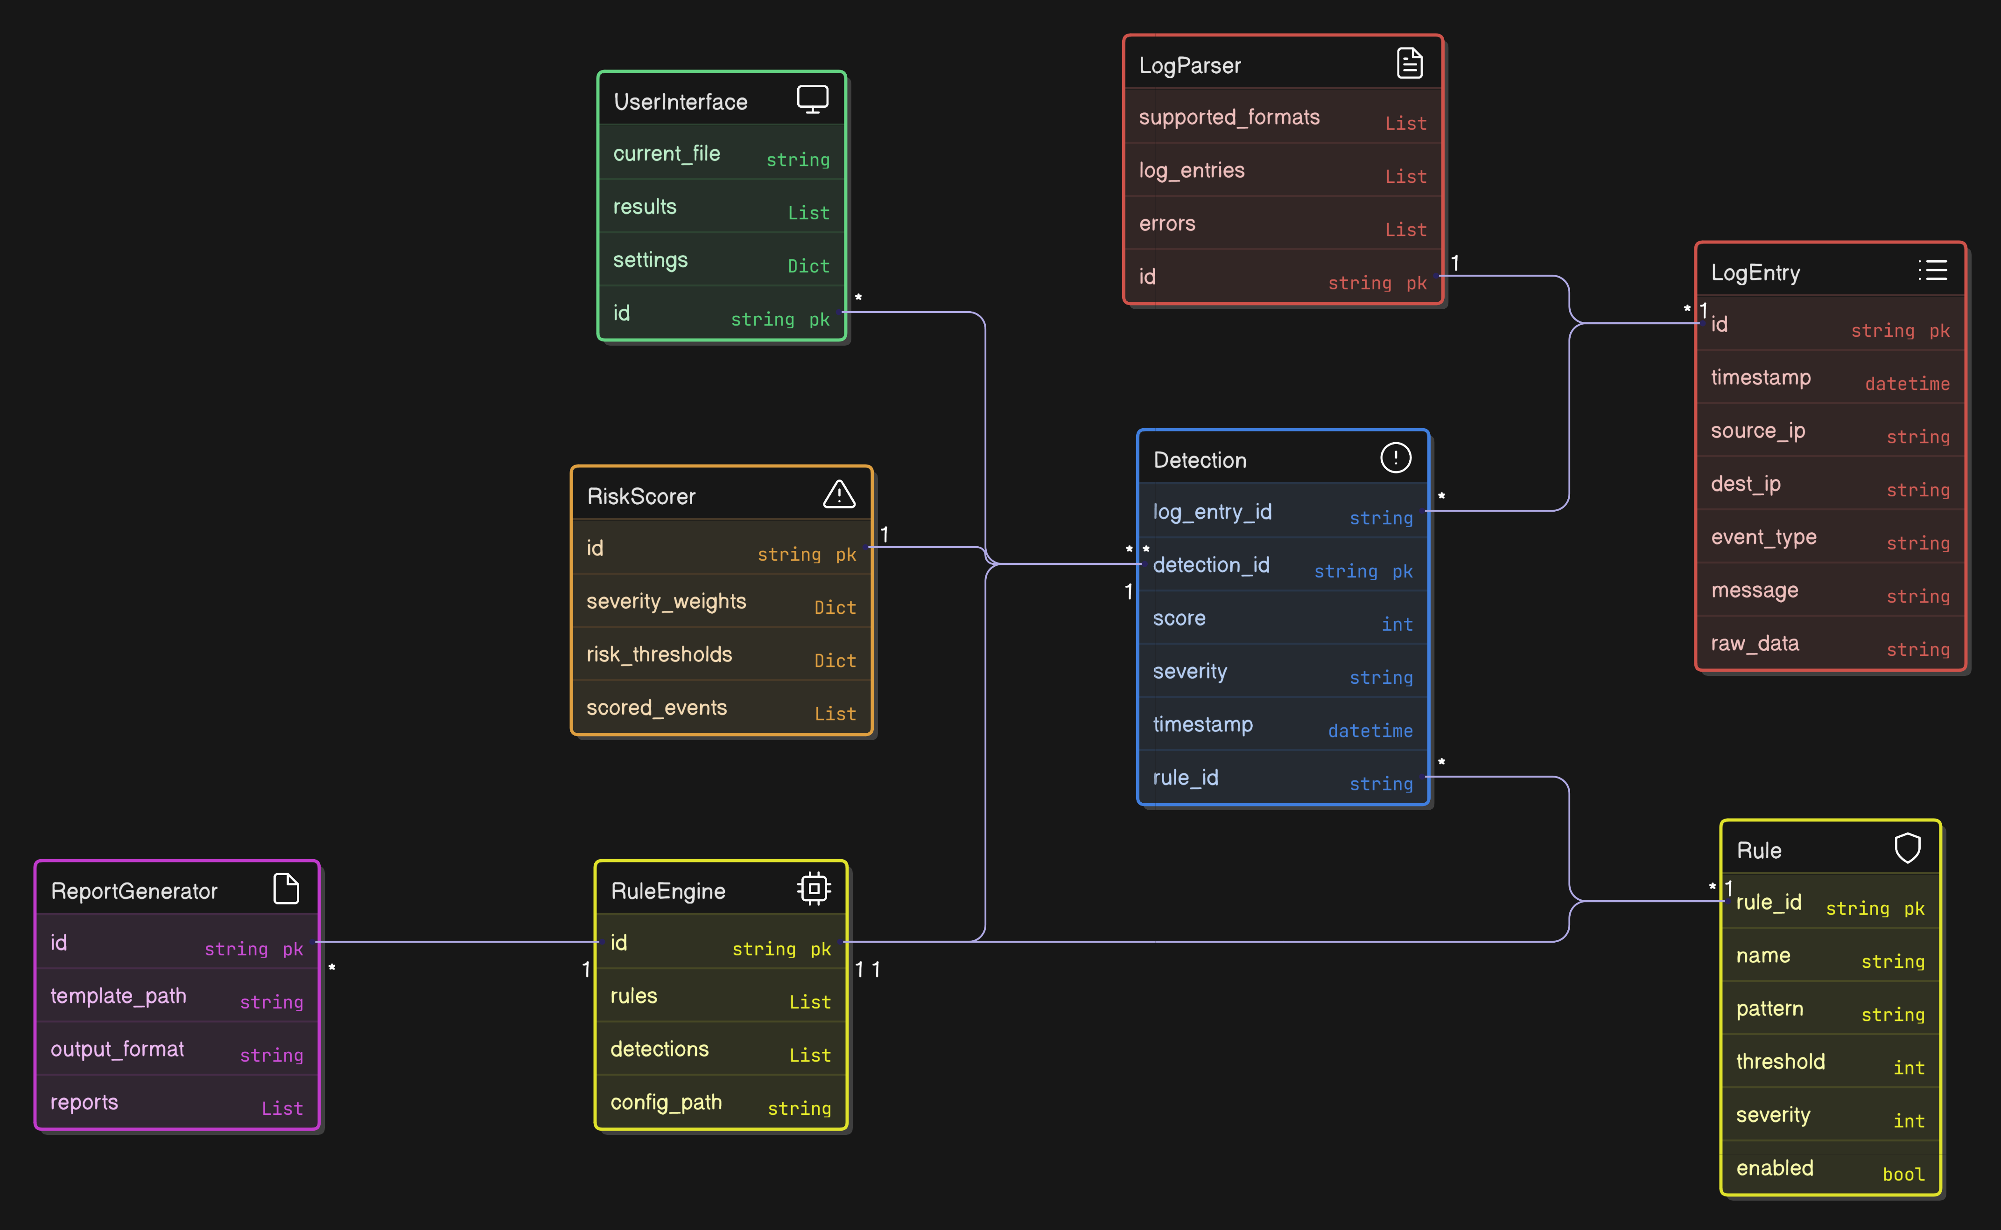
Figure 10.2: Detailed UML Class Diagram

10.4 Original Conceptual Class Diagram
The following diagram shows the initial conceptual design that guided the detailed implementation:
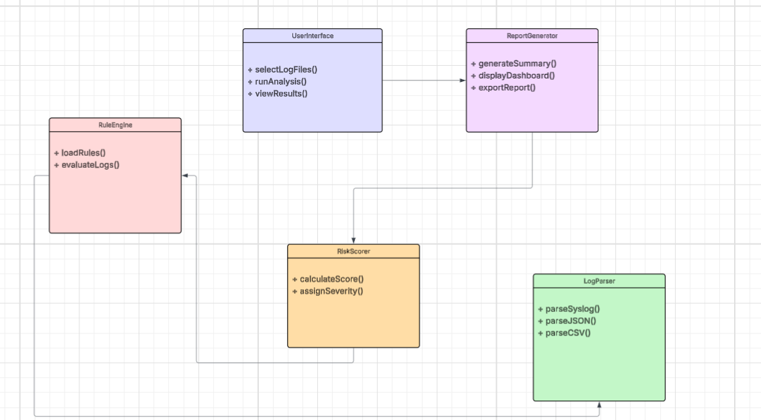
Figure 10.3: Conceptual UML Class Diagram

10.5 Data Flow Description
The data flow within CyberRisk Monitor follows a deterministic and sequential processing model:
1. User selects one or more log files through the UserInterface
2. LogParser identifies the format of each input file and parses entries
3. Parsed entries are normalized into a unified LogEntry representation
4. RuleEngine evaluates each LogEntry against all active detection rules
5. Matching rules generate Detection events with associated metadata
6. RiskScorer calculates scores for each Detection based on severity and context
7. Detections are categorized into Low, Medium, High, or Critical severity levels
8. ReportGenerator aggregates results and generates summary statistics
9. UserInterface displays results through dashboard or exports reports

10.6 Rule Design
Detection rules are designed to identify common security patterns. Each rule consists of:
Rule ID: Unique identifier for tracking and reference
Name: Human-readable description of the detection pattern
Pattern: Regular expression or condition to match against log entries
Threshold: Number of occurrences required to trigger detection
Time Window: Duration over which threshold is evaluated
Severity: Impact level (1-10) assigned to matched events
Enabled: Flag to enable/disable the rule

10.7 Risk Scoring Model
The risk scoring model aggregates individual rule detections into cumulative risk scores:
- Base Score = Rule Severity (1-10)
- Frequency Multiplier = log2(occurrence count + 1)
- Event Score = Base Score * Frequency Multiplier
- Total Risk Score = Sum of all Event Scores
- Risk Level = Categorized based on thresholds (Low: 0-25, Medium: 26-50, High: 51-75, Critical: 76+)

11. Testing and Validation Strategy
Testing and validation are conducted throughout the development lifecycle to ensure functional correctness, reliability, and alignment with project requirements.

11.1 Testing Levels
Testing Level | Scope | Tools/Approach
Unit Testing | Individual functions and methods | pytest with assertions
Integration Testing | Component interactions | pytest with test fixtures
System Testing | Complete end-to-end workflow | Manual and automated scenarios
Performance Testing | Processing speed and efficiency | Benchmark with 10K entries

Table 11.1: Testing Levels

11.2 Test Cases by Component

LogParser Test Cases
- TC-LP-01: Parse valid syslog format file successfully
- TC-LP-02: Parse valid JSON format file successfully
- TC-LP-03: Parse valid CSV format file successfully
- TC-LP-04: Handle malformed log entries gracefully
- TC-LP-05: Handle empty files without error
- TC-LP-06: Normalize timestamps across formats consistently

RuleEngine Test Cases
- TC-RE-01: Load rules from configuration file
- TC-RE-02: Detect repeated failed login attempts
- TC-RE-03: Detect port scanning patterns
- TC-RE-04: Detect privilege escalation attempts
- TC-RE-05: Handle rules with different threshold values
- TC-RE-06: Enable/disable individual rules

RiskScorer Test Cases
- TC-RS-01: Calculate correct score for single detection
- TC-RS-02: Aggregate scores for multiple detections
- TC-RS-03: Categorize Low severity correctly (0-25)
- TC-RS-04: Categorize Medium severity correctly (26-50)
- TC-RS-05: Categorize High severity correctly (51-75)
- TC-RS-06: Categorize Critical severity correctly (76+)

11.3 Validation Approach
Validation testing ensures the system meets defined requirements and user needs:
Functional Validation: Verify all FR-01 through FR-08 requirements are implemented correctly
Performance Validation: Confirm processing of 10,000 entries completes within 30 seconds
Usability Validation: Verify users can complete analysis workflow without documentation
Accuracy Validation: Test detection rules against known attack patterns in sample data

11.4 Test Data
Testing will use synthetic log data containing known patterns:
- Normal baseline logs representing typical system activity
- Failed login sequences with varying patterns and frequencies
- Port scanning simulation data
- Privilege escalation attempt patterns
- Mixed datasets combining normal and malicious patterns
- Edge cases including empty fields, unusual timestamps, and malformed entries

12. Conclusion
This Project Design document provides a comprehensive roadmap for the successful execution of the CyberRisk Monitor capstone project. By defining clear scope boundaries, detailed system requirements, appropriate development methodology, structured task breakdown, realistic scheduling, thorough risk management strategies, and measurable evaluation criteria, the project establishes a solid foundation for development, testing, and final delivery.
The modular architecture design ensures maintainability and supports the educational objectives of the capstone course. The rule-based detection approach provides transparency and interpretability, making the system suitable for learning cybersecurity monitoring concepts. The Agile-inspired methodology enables iterative progress with continuous feedback and adaptation.
Successful completion of this design and its associated implementation will demonstrate the team's ability to apply computer science principles in a structured, real-world context. CyberRisk Monitor serves as both a functional monitoring prototype and an educational tool, reinforcing core concepts such as log analysis, rule-based detection, and risk assessment.
This design document establishes the clear foundation required for development, testing, and final demonstration in fulfillment of the CMSC 495 capstone requirements.

Appendix A: Detailed Class Specifications

A.1 LogEntry Class
class LogEntry:
"""Represents a normalized log entry from any supported format."""
Attributes:
timestamp: datetime - When the event occurred
source_ip: str - IP address of the event source
dest_ip: str - IP address of the destination (if applicable)
event_type: str - Category of the event
user: str - Username associated with the event
message: str - Human-readable event description
raw_data: str - Original unparsed log line
metadata: dict - Additional format-specific fields
Methods:
toDict() -> dict: Convert to dictionary representation
fromDict(data: dict) -> LogEntry: Create from dictionary
__str__() -> str: Human-readable string representation

A.2 Rule Class
class Rule:
"""Represents a detection rule for identifying security patterns."""
Attributes:
rule_id: str - Unique identifier
name: str - Human-readable name
description: str - Detailed explanation
pattern: str - Regex pattern or condition
field: str - LogEntry field to match against
threshold: int - Occurrences needed to trigger
time_window: int - Seconds for threshold evaluation
severity: int - Impact level (1-10)
enabled: bool - Whether rule is active
Methods:
matches(entry: LogEntry) -> bool: Check if entry matches rule
getSeverity() -> int: Return severity level
enable() -> None: Activate the rule
disable() -> None: Deactivate the rule

A.3 Detection Class
class Detection:
"""Represents a detected security event."""
Attributes:
detection_id: str - Unique identifier
rule_id: str - ID of triggering rule
rule_name: str - Name of triggering rule
log_entries: List[LogEntry] - Entries that triggered detection
timestamp: datetime - When detection was generated
score: int - Calculated risk score
severity: str - Categorized severity level
Methods:
toDict() -> dict: Convert to dictionary
getSeverity() -> str: Return severity category
getScore() -> int: Return risk score

Appendix B: Detection Rules Catalog
The following detection rules will be implemented in the initial release:
Rule ID | Rule Name | Detection Pattern | Severity
RULE-001 | Brute Force Login | 5+ failed logins from same IP in 5 min | 8
RULE-002 | Port Scan Detection | 10+ connection attempts to different ports | 7
RULE-003 | Privilege Escalation | User gains admin/root privileges | 9
RULE-004 | After-Hours Access | Login outside business hours (6PM-6AM) | 4
RULE-005 | Multiple Failed SSH | 3+ failed SSH attempts in 1 min | 6
RULE-006 | Suspicious File Access | Access to sensitive paths (/etc/shadow) | 8
RULE-007 | Account Lockout | Account locked due to failed attempts | 5
RULE-008 | New Admin Account | New account created with admin rights | 9
RULE-009 | Service Stopped | Critical service stopped unexpectedly | 7
RULE-010 | Unusual Data Transfer | Large outbound data transfer detected | 6
RULE-011 | Multiple Source IPs | Same user logged in from 3+ IPs | 5

Table B.1: Detection Rules Catalog

