**# Pocket Pilot for Web**

- Group 4 (Marielle Jong, Shayne Hewitt, Natalie McCourt, Preston King)

Welcome aboard passengers! I will be your friendly user interface for your flight this afternoon! Please enjoy numerous features we have to offer, such as:

- Profile configurations

- A dashboard to glance at flight information quickly

- Entertainment (music, TV, and movies)

- Shopping

- Travel tips for the area you will be heading to

- Quick help from our magnificent flight attendants

- Navigation bar to access our pages at an instant

- Flight information to see where we are and how long until landing

- Feedback for letting our crew know anything you think!

WHEN YOU LOAD THE WEB APP, PLEASE LAUNCH LIVE SERVER FROM:

```/login/login.html```

**# Details on features**

**## Login**

This is the login page. Here, users can choose to either log into an existing account (or automatically create one if none exists) or continue as a guest. If they choose to go as guest, they cannot access profile specific features, such as favoriting shows.

**## Phone**

This is the phone call screen. As shown, there is a placeholder number there from the beta build. Users can select the numbers on-screen to dial the phone number they wish to call. To the right, there is an option to pay with PayPal or with a credit/debit card, where there are text fields for entering each piece of information needed. Once the web app is finalized, the PayPal function will change when selected to enter the username they wish to be charged from. Same with the duration and cost of the call; those are placeholders until finished.

**## Feedback**

We want our users to be able to let us know about whether our staff was awesome to them or not; so why not give them the ability to tell us! Users can pick however many stars the crew deserves, their words on it, and the category they think it falls under. Once they hit submit, the crew is notified of those entries made.

**## Help**

This is the help page. Users can get here by clicking an icon of a person holding their hand up. Here, users can request help from the crew members for specific choices, including a specific task that isn’t listed. They can also choose the level of priority their request is.

**## Travel Tips**

**## Flight Info**

This is the flight information page. Users can see where they are in their travel along with other information, such as departure time, ETA, speed, altitude, etc. The other tab can be clicked and brings up any safety announcements made from the crew. The safety information is always displayed so users can assure they know what to do in the event of an emergency.

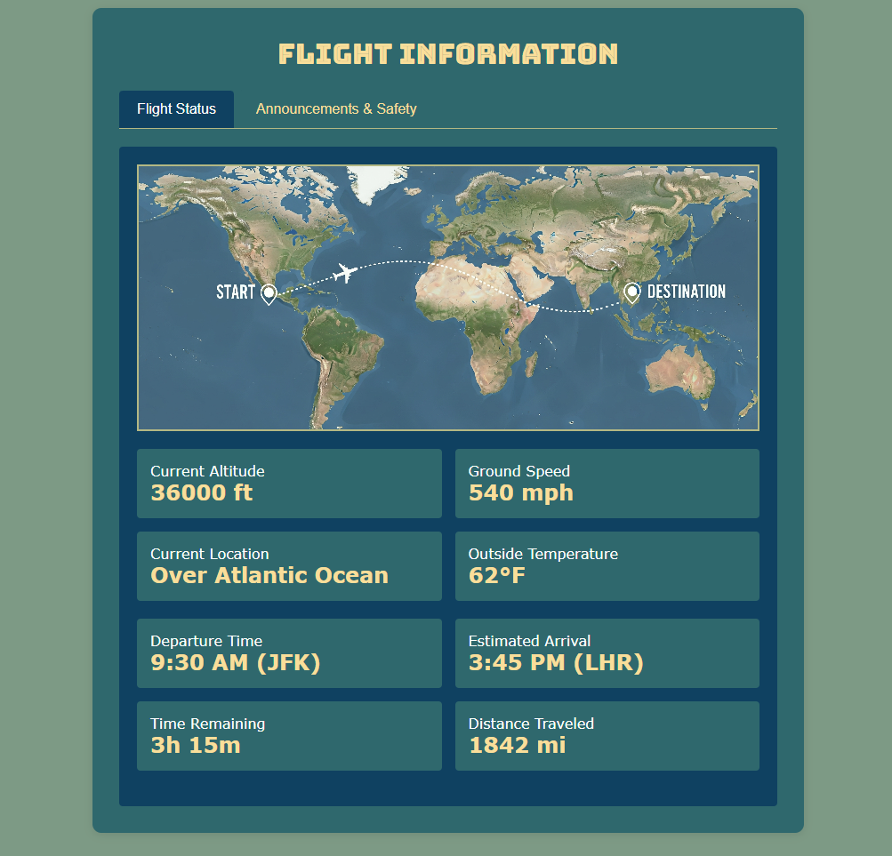

**## Entertainment**

**## Shopping**

The shopping feature presents users with a shopping cart and list of items they can choose from our catalog. (BETA BUILD, NO FINAL STYLES ADDED YET)

Each button can jump to a different view on the page. Everything is listed already, but the buttons are for those who have a larger screen view and don’t want to scroll forever just to select items at the bottom.

The shopping cart can also account for items added and allows for increments and decrements in item choices. It also shows a total price for the items selected. Here is an example.

