**InSPECK It Out!**

Introduction

In this activity, you will learn how clean the air is around you and how everyday things that we use can affect the air quality. Students will be challenged to see what everyday activities cause the worst air quality, and to come up with solutions for how to improve the air quality in school and at home.

Targeted Grade Level

4-8

Time Required

2 class periods (about 45 minutes each) plus more time for extension activities

Learning Outcomes

* Students will be able to assess the air quality using Speck sensors.
* Students will assess what causes the worst air quality given a list of everyday materials.
* Students will brainstorm ways to improve air quality at home and in school.

Materials

* Speck Sensor
* Portable battery pack
* 5 Plastic containers (clear works best)
* 5 Everyday materials, such as:
  + Febreeze
  + Perfume
  + Spray Deodorant
  + Candle
  + Chalkboard erasers
* Worksheet (attached)

Directions

1. Hold up an empty box, and ask students what is in the box. Although students may be tempted to answer “nothing,” guide them toward the answer that there is air in the box, and air is not nothing.
2. Discuss what makes up the air that we breathe. Students often jump to oxygen, but did the students know that our air is mostly nitrogen? What else could be in the air? Is the air inside different than the air outside? Have a student volunteer begin to make a list on the board of all of the things that could be in our air.
3. Ask the students about air pollution. Begin to make another list of things that could cause pollution in our air.
4. Show students a Speck sensor, and explain how to use it. Make sure that the Speck sensor is plugged into a battery pack, and that the units are on “C.” Show students the air intake opening on the Speck, and remind them not to cover that opening when they are holding the Speck. Explain how the Speck sensor is taking in air through that opening, and analyzing it to see how many small particles (smaller than the human eye can see) and reporting that number on the screen.
5. Give groups of students (about 3 students per group) a Speck sensor, and allow them to practice turning the sensor on and getting readings from different areas in the room.
6. Hand out the student worksheet. Explain to students that they will be testing different everyday materials to see which ones produce the best and worst air quality. Have the students make a prediction (on their student worksheets) about which materials will impact the air quality the most.
7. Hand out the plastic boxes and everyday materials. (Depending on your class size, you may want to give each group one box and one material, and then pass the boxes around the room in a rotation pattern until all of the groups have experimented with each box.)
8. Place the Speck sensor in the box, close the lid, and wait 15 seconds for a stable reading (read the number through the side of the clear box). Record the reading in the data table on the student worksheet.
9. Open the lid, and spray the Febreeze inside the box. Quickly close the lid.
10. Wait for a stable reading, and then record the value in the data table on the student worksheet.
11. Air the container out for a minute. Repeat this process 2 more times. Then, take the average of your three readings.
12. Repeat steps 8-11 with the other everyday materials (light the candle, or clap the erasers together to create dust) and record all data in the table on the student worksheet.
13. Have students answer the questions on the student worksheet regarding their data.
14. Discuss the answers as a class, and address the students’ predictions to determine which groups were correct.
15. Ask students what they could have done to decrease the readings in the box. One common answer might be to add a vent or poke holes in the lids of the box. How does this apply to a more realistic situation, such as using perfume or spray deodorant in the gym locker room? (This can lead to a discussion about ventilating indoor areas to improve air quality.)
16. Make a new list of ideas for how to improve air quality. Take suggestions from the class about things that can be done in the home and at school.

Extension Activities

* Have students design a poster to raise awareness about air quality issues. The poster should identify the problem as well as suggest several solutions for how we can improve air quality. Hang the posters around the school or community.
* Have students think of some areas around the school that may have poor air quality (gym locker room, art room, cafeteria kitchen, stairwells, etc.) and set up a location to place a Speck there and take readings over the course of a few days. Ask students to analyze the data and propose solutions for any problem areas that are located.

Name: ___________________________________________ Period: ___________

**InSPECK It Out!**

**Student Worksheet**

Make a prediction about which everyday item will cause the most particulate matter in the air. Why did you pick that item?

____________________________________________________________________________________________________________________________________________________________

Make a prediction about which everyday item will cause the least particulate matter in the air. Why did you pick that item?

____________________________________________________________________________________________________________________________________________________________

**Data Table**

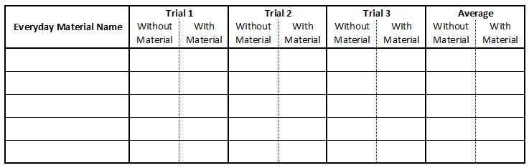

Analysis and Conclusion Questions:

Were your predictions correct? Explain why or why not.

____________________________________________________________________________________________________________________________________________________________

What material had the least effect on air quality? Why do you think this was?

____________________________________________________________________________________________________________________________________________________________

What could you have done to make sure that the materials did not have as much of an effect on air quality? Explain your reasoning.

____________________________________________________________________________________________________________________________________________________________

Do you think that the air that you breathe in school and at home could be impacted by pollutants? Why or why not? What could be done to minimize air pollution?

____________________________________________________________________________________________________________________________________________________________