Robot Universal Remote
(Practicum Project Fall 2006)

Expressions Design Proposal
v 1.0

Carnegie Mellon University West
Team Atari5
_________________________________________________________________

Robot Universal Remote

Expressions Design Proposal
V1.0

 | Prepared by | Reviewed by | Approved by
NAME | Robert Newport  Jerry Pattenaude  Eric Wan | Dr Ed Katz
DATE | 10/05/06

VERSION HISTORY

Version No. | Date | Changed By: | Changes Made:
1.0 | 10/05/2006 | Team Atari5 | Initial draft

Robot Universal Remote

Statement of Work

Table of Contents

1 Overview 4
2 User Story 5
2.1 Saving an Expression 5
2.2 Loading an Expression 5
2.3 Sharing an Expression 5
2.4 Loading a Shared Expression 5
3 State Diagram 6
4 User Interface 7
5 Risks 8

Overview

Students should be able to save the current state of their hardware configuration for quick and easy retrieval. Students should be able to share this state with others. For the purpose of this document, a predetermined saved hardware configuration will be called an “expression.”

User Story

Saving an Expression

Jane has just finished using the Robot Universal Remote to configure here custom robot to smile using the servos and motors that came with her kit. She wants to save the configuration so she can show her sister Amanda later in the day. She’s not sure where she can find the option to save and expression so she goes into the logical place where it should be – in the File Menu. There, she finds the option titled “Save Expression” right underneath the “Save” and “Save As…” options. She chooses to save the expression by selecting the option in the file menu. She saves it as “HaHaLOL” and it automatically gets stored in a special “Expressions” folder.

Loading an Expression

Later in the day, Jane would like to show her sister Amanda the expression she made earlier. She powers up her Qwerk and launches the Robot Universal Remote. Once it is loaded, she simply goes into the “Expressions” menu between “File” and “Help” to find the “HaHaLOL” menu item she saved earlier. She selects the menu item and immediately her previous expression is loaded and activated.

Sharing an Expression

After seeing the funny expression her sister Jane just made, Amanda asks if she could load it onto her own Qwerk. Luckily, sharing expressions is easy. Jane enters the “File” menu and finds “Share Expression” right underneath “Save Expression” and “Save As…” After she chooses “Share Expression” a dialog comes up saying “Choose Expression.” Jane chooses the “HaHaLOL” expression. The Expression file then gets duplicated to Jane’s Desktop. Jane copies the expression to Amanda’s USB thumb drive and takes it to her own machine.

Loading a Shared Expression

Amanda knows she has Jane’s expression on her USB thumb drive. She mounts her drive and finds the expression file. After launching and connecting her Robot Universal Remote, she looks under the “File” menu and finds “Load Expression.” After selecting “Load Expression” she is asked to find her expression to load. She navigates to her USB thumb drive and the expression is now loaded. She then goes into the “Expressions” menu between “File” and “Help” to find the “HaHaLOL” menu item she just imported. There it is! She selects it and sees her sister’s goofy expression and laughs.

State Diagram

The State Diagram shows how the application will negotiate the acts of saving, sharing, and loading an expression. Careful consideration is taken to prevent confusion on the user’s part during the sharing process.

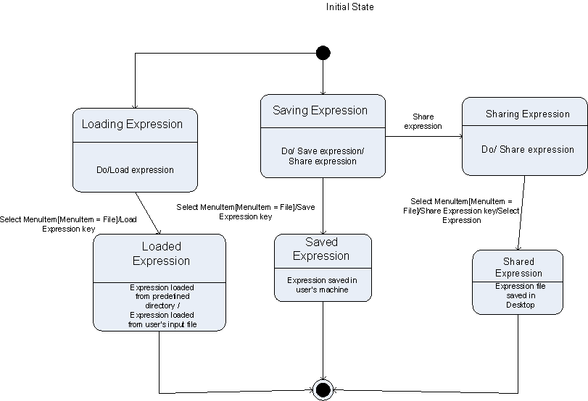

User Interface

The most logical place to put the “Save Expression” menu item is in the “File” main menu. However, some members of the team wonder if this should be in the “Expressions” main menu. For the purpose of this document we have placed it in the “File” main menu, though focus testing should determine if this makes sense to most users.

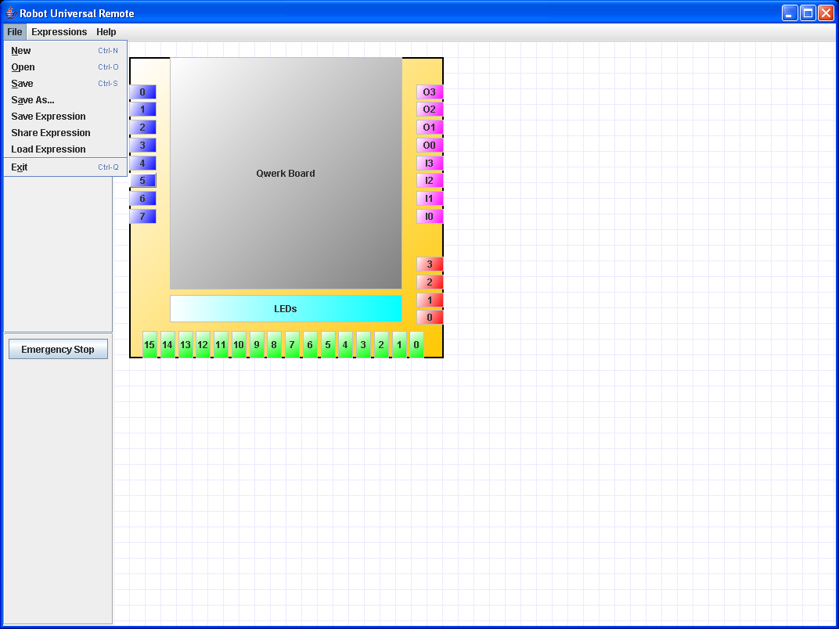
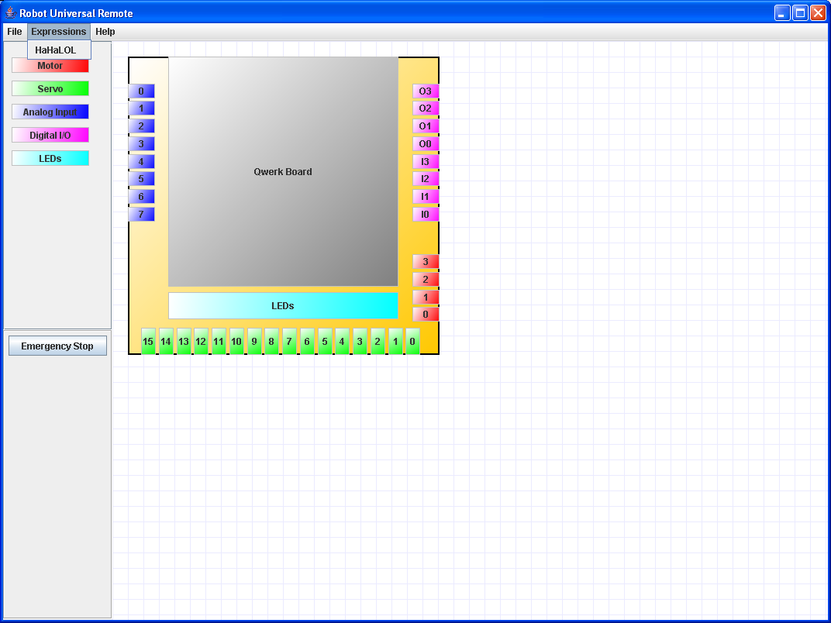

Risks

Risk | Impact | Mitigation Plan
User will not know where the save expressions box will be. | - User will not save an expression. | - Put the “Save Expression” item in the “Expressions” main menu.
Users will not understand what an expression does. | - Diminished user experience. | - Add a help section.
Users will not be able to share expressions without removable media. | - Sharing will not happen. | - Create a file transfer method for sharing using the web site.

