Robot Universal Remote (RUR)
DETAILED DEsign document
Team Number 5, Carnegie Mellon University, West Campus

Authors:
Olya Flores, Jago Macleod, Anthony Parker, Amlan Sengupta
Summer 2006

Client:
Mobile Robotics Programming Lab
Carnegie Mellon University Robotics Institute

Illah Nourbakhsh (illah@cs.cmu.edu)
Emily Hamner (etf@andrew.cmu.edu)

Supervising Faculty and Staff:
Faculty, Carnegie Mellon University West
Ed Katz (ed.katz@west.cmu.edu)

Coach, Carnegie Mellon University Pittsburgh
Sujata Telang (stelang@andrew.cmu.edu)
Table of contents

Introduction 3
Team and Client Information 3
Team 5 Information: 3
Client Information: 3
Document Overview 3
High Level Design 3
Description 3
Robot Universal Remote (Main App) 3
Control Panels 3
Services 3
Components 3
Detailed design 3
Main Application 3
Control Panels 3
Services 3
Components 3
Complete Class Diagram 3
A1. Design Patterns 3
A2. Tools and Technologies 3
Client-Side Technologies 3
Server-Side Technologies (Middleware) 4
References 4

Introduction

Introduction
Robot Universal Remote is a lightweight application used to control a basic Qwerk board robot. Its primary purpose is to allow the user to exercise different devices attached to the Qwerk board ports on the user’s robot.
Robot Universal Remote connects to the user’s robot through using the Relay Server hosted by Carnegie Mellon University. It is a precondition for running RUR that the user’s robot is able to successfully register with the relay server. The user’s robot will attempt to register with the relay server as soon as power is supplied to the Qwerk board. If the user’s robot is unable to register with the relay server (for example, if an open wireless network is not available), the Robot Universal Remote software will not be able to control the robot.
Once the user’s robot is registered and the user logs into the server using RUR’s connection wizard, Robot Universal Remote can send commands to the robot using the relay server. An easy-to-use Graphical Interface is provided to allow the user to test out several parts of the board using the Robot Universal Remote. The code is also designed to be easily extensible as to allow the users to build their own, more sophisticated robot controllers using RUR as a base.

Team and Client Information

Team 5 Information:
In alphabetical order:
Olya Flores (olya.flores@gmail.com)
Jago Macleod (jagomacleod@gmail.com)
Anthony Parker (tony@playingtitle.com)
Amlan Sengupta (amlan.sengupta@comcast.net)

Client Information:
Carnegie Mellon University
Illah Noukbaresh

Document Overview
This document contains the following sections:
- High Level Design - describes the general principles guiding the architecture of RUR, as well as individual modules that make up the architecture.
- Technologies and Frameworks - describes some of the COTS frameworks used in developing RUR. We discuss these tools before delving into detailed design, as the chosen frameworks set the bounds within which our detailed design was developed.
- Detailed Design - class diagrams, sequence diagrams and some function flows are described in this section. Each of the modules introduced in High Level Design section is described in detail here.
- References - further reading material and acknowledgments.
DESIGN

High Level Design

Description

RUR is a client-server application. The thick client uses a relay server to connect to the users’ robot, transmit commands and retrieve sensor reading values.
Diagram 1 below represents the high-level layout of the RUR application.
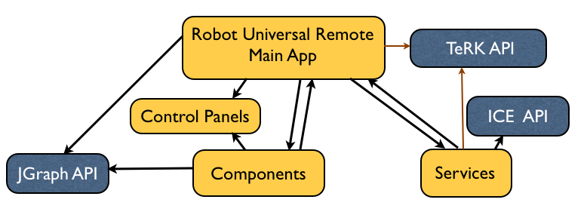
Figure 1: System High Level Design Diagram

RUR Software includes four packages: Main Application (top level package), Control Panels, Components and Services. The Control Panels package is responsible for defining the user interface panels appearing on the user’s screen. The Components package provides the behavior logic for each of the entities in the RUR system, such as motors, servos and different components of the board itself. Finally, the Services package implements the connection functionality and is responsible for the connectivity between RUR and the relay server.
Sections below describe the concepts in each of the packages in more detail, and introduce the components for each section. Class diagrams for each of the packages are included in the Detailed Design section of this document.
In addition to these packages, the code uses several non-standard libraries. The JGraph API provides User Interface functionality such as drag and drop, moving objects on the screen and others. The TeRK API provides the fundamental functions for interacting with the low-level Qwerk board devices. Finally, the ICE API is used in our Services package to provide ICE interfaces with the Carnegie Mellon relay server. Each of these external non-standard packages is described in a little more detail in the Tools and Technologies section of this document.

Robot Universal Remote (Main App)
The Robot Universal Remote class drives the application and acts as a manager class. In addition to the Robot Universal Remote class itself, this package also includes the several Listener classes and the RobotUniversalRemoteServant class.
The diagram below illustrates high-level component structure within the Main App module.
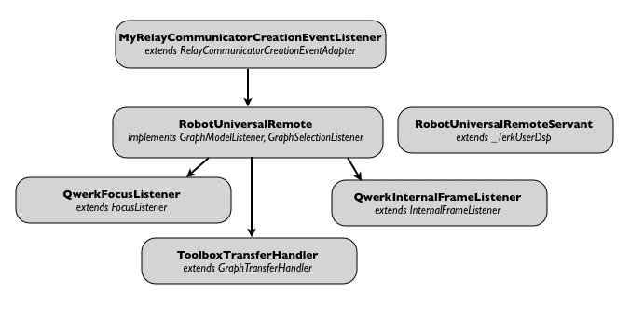Figure 2: High-Level View of the Robot Universal Remote Package

Control Panels
This package defines the look and behavior of the Robot Universal Remote User Interface. The Robot Universal Remote User Interface is broken up into several Panels, which are used to control different components on the board. A different panel is used for each type of the component; however, all control panel classes are derived from the common abstract AbstractPanel class.
The panel classes contain different UI elements, such as sliders, text fields, buttons and others that allow the user to change the settings to be transmitted to the robot. In addition to standard Java UI functions, this package relies heavily on the JGraph API to move or redraw the objects on the user’s screen.
The control panel classes also communicate with the controller objects in the TeRK API to allow transmitting commands/values to the robot when the user input has changed.
This package is extensively used by the Components and by the Robot Universal Remote (Main App) packages. Values associated with the selected component are displayed or changed in the corresponding attributes of the panel matching the selected component type.
The diagram below illustrates high-level component structure within the Control Panels module. Note that the panels serving the Input/Output component types (AnalogInputPanel and DigitalIOPanel) do not implement ChangeListeners, as their values are read-only and cannot be written to the robot.
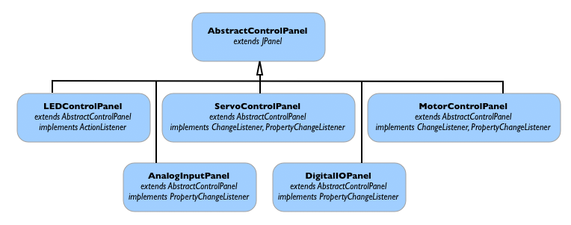
Figure 3: High-Level View of the Control Panels Package

Services
The Robot Universal Remote Services component handles the connection between the relay server at CMU and the application. The connection is started as a separate thread, allowing the application to perform processing without being delayed by data transmission.
The connection class extends the TeRK Connection API provided by CMU. All commands and sensor readings are sent between the robot and the Robot Universal Remote by passing through the relay server and then being interpreted by the connection class. When any of the components need to send information to the robot (through the relay), they request the relay information or connection from the connection service.

Components
The Components Module extends the basic JGraph Vertex concept to create cells that represent different objects in the Robot Universal Remote system. These include representations for the Qwerk board itself, the ports on the board, and different types of components that can be attached to the board’s ports.
The DefaultCell class is derived from the DefaultGraphCell class in JGraph API. DefaultCell serves as the base class for MotorCell, ServoCell, LEDCell, AnalogInputCell and DigitalIOCell classes. All of these classes handle displaying the interface panel for the corresponding component. QwerkCell class supports the diagram of the actual Qwerk board and its associated ports on the user’s screen. QwerkBoardPortInfo class handles the definition for each of the ports of the Qwerk board and its connection with the attached component on the robot (through the CMU relay server).
Each of these entities is represented as a class within the Components package. Note that none of the classes in the Components package contain controller functionality. They simply define the component type and specify what user interface (panel) type is paired with this component type. The user interface panel handle actual control functionality of the component and its inputs/outputs.
The diagram below illustrates high-level component structure within the Components Module.

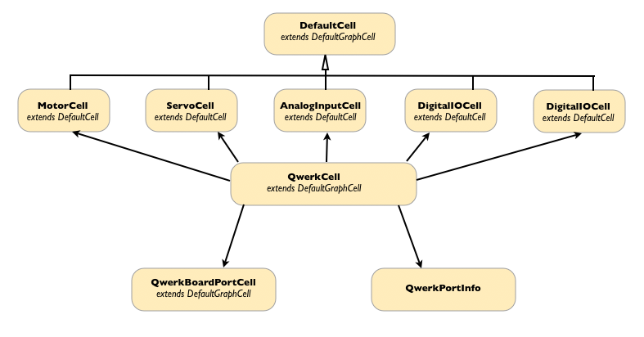
Figure 4: High-Level View of the Components Module

Detailed design
In this section, we present class and sequence diagrams that describe the design of Robot Universal Remote application. Please note that all class diagrams below follow these rules:
- Each class diagram has areas for private, protected and public attributes and methods. If the area is empty, then no attributes or methods of that type exist.
- Each package has a different color for readability
- All getters and setters have been omitted, except where significant.
- All constructors and destructors have been omitted, except where significant (singleton classes, etc)
- All arguments to methods have been omitted.
- Methods/attributes of importance are highlighted in red

Main Application
The main application is responsible for initializing all components of the User Interface, establishing a connection with the CMU East relay server and managing all communication from the UI to the user’s robot. The main application also supports interfaces to the TeRK library code and ICE library API.
The main application includes RobotUniversalRemote, RobotUniversalRemoteServant, and several Listener classes. We discuss each of these classes in the sections below.
RobotUniversalRemote

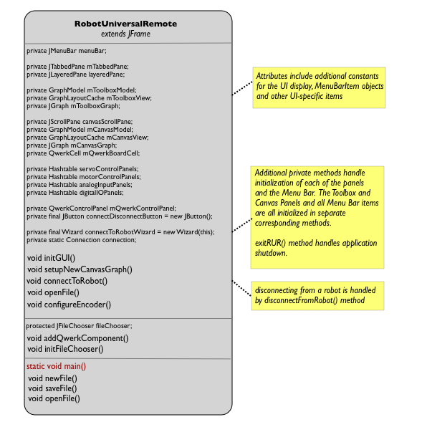

RobotUniversalRemote class serves as the main class in the application. On startup, it initializes the User Interface representation and establishes connection to the CMU East Relay server and to the user’s robot. (If the connection to the robot or the relay server cannot be established, RobotUniversalRemote gracefully exits the application.)
The first few private attributes in the diagram above specify the JGraph canvas and model for the graph itself, as displayed on the user screen. They include several standard user interface elements, such as the menu bar and application controls. Finally, they include a QwerkCell object, which contains a specification for the Qwerk board display.
Following the attributes that specify the user interface, we define several hashtables that contain different User Interface panel types. As the user can choose to attach multiple components of the same type to different ports on the Qwerk board, we must have storage that distinguishes which panel object is associated with which port and component. The hashtable structure allows us to do that.
In addition to handling initialization, shutdown and connection functionality in RobotUniversalRemote application, RobotUniversalRemote class also supports storing and retrieving configuration files that the user wishes to save or load. See the implementation of initFileChooser(), newFile(), openFile() and saveFile() functions for more information on this area of RobotUniversalRemote.

RobotUniversalRemoteServant and ToolboxTransferHandler
RobotUniversalRemote application allows the user to transfer components from one area of the UI to another. When the user transfers components from the Toolbox area to the Canvas, the components acquire some new properties (becoming editable, etc) that were not available in the Toolbox area.
To handle the transition from the Toolbox area to the Canvas, the ToolboxTransferHandler class is provided. Its handleExternalDrop() function performs the necessary operations when a component has been moved out of the Toolbox. The RobotUniversalRemote object passes the initialized ToolboxTransferHandler object to the JGraph graphCanvas object to set how the drag and drop transfer behaviour should be performed.
RobotUniversalRemoteServant class is only used by the Services package. It is entirely derived from TeRK API and provides an interface between RobotUniversalRemote and Connection classes.
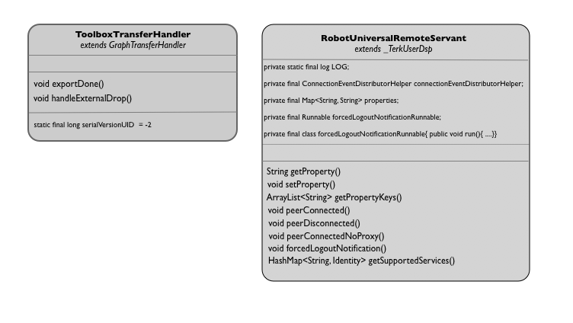
Listener Classes (MyRelayCommunicatorCreationEventListener, QwerkInternalFrameListener and QwerkFocusListener)
RobotUniversalRemote package contains several listener classes. As this is both a connection-driven and a user input-driven application, we have to ensure that there are listeners for each event of interest.
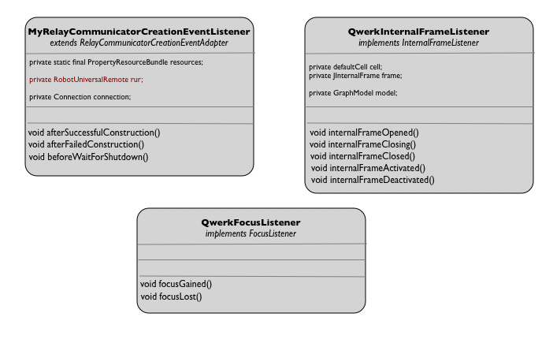
MyRelayCommunicatorCreationEventListener
MyRelayCommunicatorCreationEventListener class is used by the Connection class in the Services package. Its primary functionality is to listen on an established connection between the RobotUniversalRemote application and the CMU Relay server. As connection functionality is run as a separate thread, the User Interface thread must be interrupted when a new value has been retrieved from the robot and should be displayed to the user.
To support its functionality, MyRelayCommunicatorCreationEventListener class includes both RobotUniversalRemote and Connection objects in its private attribute list. Both of these atributes must be initialized in the constructor call to MyRelayCommunicatorCreationEventListener class.
BeforeWaitForShutdown() function is called when the connection between RobotUniversalRemote and the Carnegie Mellon relay server has been established. Once called, it creates a new thread and initializes the UI for the RobotUniversalRemote application in the new thread. At this point, the RUR application is ready to use.
QwerkInternalFrameListener
As its name suggests, this class listens to events occuring in the inner frame of the Robot Universal Remote user interface display. The inner frames are added and removed multiple times during the RobotUniversalRemote runtime.
To support this functionality, the QwerkInternalFrameListener class provides internalFrameOpen() and internalFrameClosed() methods. When the internalFrameClosed() method is called, the internal frame is removed from the user’s screen.
This class is only used by the RobotUniversalRemote class.
QwerkFocusListener
This class is used only by the RobotUniversalRemote class; its controls the behavior of the user interface when the user brings a component in or out of focus. The focusGained() function of this class determines the inner frame that has been selected and brings it to the front of the display.

Control Panels
Individual classes in the Control Panels Package do not have interactions among themselves. Most of the classes in this package represent different input panels for devices that can be attached to the Qwerk board. Other classes represent the canvas of the drawing are that represents the Qwerk board, or the individual cells on the drawing area.
Because most of the interactions of these classes are with entities in external packages, they are presented here individually. The classes representing input or control panels are described together as their function and their methods are very similar.
The Robot Universal Remote UI has a main functionality area and then several component-specific panes. The main functionality area consists of Toolbox and Canvas areas. When the UI is first initialized, it appears in the main screen, with the Toolbox area displaying each possible type of a component, and with the Canvas area blank. When the user configures the robot, the user will transfer a component from the Toolbox areas onto the Canvas. When the user wishes to remove a component from the Canvas area, the user simply selects the component’s icon in the Canvas and chooses the Remove option.
Once the component attaches itself to the nearest cell/port to the user’s cursor location, a component-specific panel appears. In the component-specific panel, the user can set values or parameters for each of the components attached in the configuration screen. These functions require manipulating sliders and text fields as user controls.
We will discuss each of the UI classes below, and show their relationship to the screens and functionality areas.
AbstractControlPanel
This class contains the common functions that must be implemented by each component control panel. It contains an attribute for a DefaultCell object - this attribute in each of the subclass panels will hold a specific DefaultCell subclass (MotorCell, ServoCell, LEDCell, AnalogInputCell, DigitalIOCell, etc). The AbstractControlPanel class provides a public method for retrieving the component cell associated with the panel.
Every other class in the ControlPanels package is a child class of the AbstractControlPanel. As such, the AbstractControlPanel class is shown in every class diagram below for reference.
Control Panels for Motors, Servos and LEDs
The command screen of the Robot Universal Remote application allows the user to issue commands to the robot once it is configured.
The controllable items include LEDs, Servos and Motors attached to the robot. The classes described in this section define the UI panels needed to command each of these types of components.
The LEDControlPanel class controls the LED components and contains constants defining the LED parameters. There are 8 LEDs on the Qwerk board, and each of the LEDs can be lit continuously, turned off, or blink.
The initGUI() function of the LEDControlPanel initializes the LED controls and their handlers. RobotUniversalRemote object in the system uses the LEDControlPanel class to initialize the LED panel in the command screen.
ServoControlPanel and MotorControlPanel classes define the command screen control panels for servo components and open loop motors. Each of these control panels includes text fields that allow the user to input a value directly, sliders that allow the user to select a value by varying the control’s position and buttons that allow the user to select or commit their desired action.
Note that the MotorControlPanel class also has the stopButton attribute. This attribute is designed to allow the user to stop the motor in case the motor speed is too disparate from the user’s desired speed and the user would like to discontinue any input to the motor.
Just as in the LEDControlPanel class, both of these classes provide the initGUI() function that’s used by the RobotUniversalRemote object to initialize the corresponding panel in the command screen.
In all three of the control panels, the actual controller object is stored as a protected attribute (LEDService, MotorService or ServoService class).
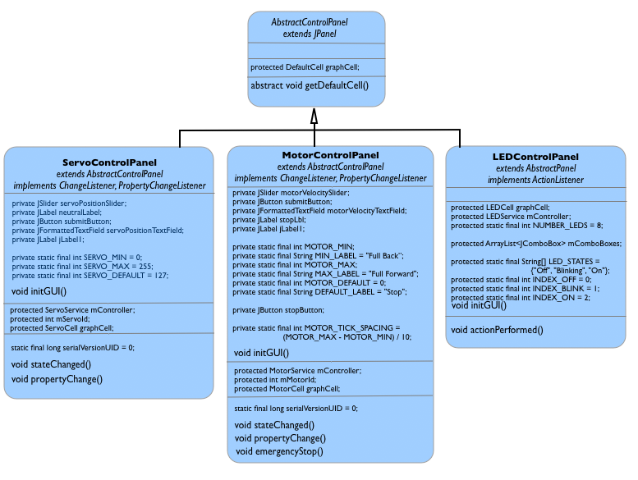
Input Panels
The user can connect Analog or Digital input/output devices to ports on the Qwerk board. The classes described in this section provide the UI for screen areas that display the values retrieved from these sensors.
Robot Universal Remote allows the user to retrieve sensor values ad hoc, or to set a regular time interval at which the values should be automatically updated by the Robot Universal Remote. To support this capability, both input panels have an auto-refresh time text field and an auto-refresh checkbox control. When the checkbox is selected, the input value will be read at the intervals the user specified in the text field. These panels also provide a refreshButton, which, when clicked, refreshes the value from the sensor and displays it.
Similarly to the control panels in the previous section, both input panels provide a initGUI() method, which will be used by the RobotUniversalRemote object to create the panel displays on the screen.
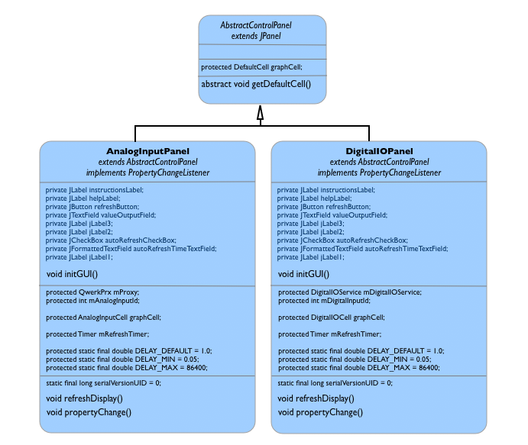

Services
The single class in this package is responsible for handling all connectivity between the RobotUniversalRemote application, the robot itself and the CMU relay server. As RobotUniversalRemote functionality is entirely dependent on its ability to communicate with the remote server, the functionality presented in this class is vital to the application.
Connection
The Connection class uses the ICE interface provided by the CMU server. This class initiates and handles all communication with the relay server and retrieves controller objects needed by the QwerkControlPanel, MotorControlPanel and ServoControlPanel objects described above.
RobotUniversalRemote only allows one robot to be controlled at a time. As communication with any and all robots must take place through the CMU relay server, this also means that RobotUniversalRemote can only support one connection with the relay server at a time.
To enforce this rule, the Connection class is a singleton. Only one instance of this class will exist in the RobotUniversalRemote system, and all communication between any of the objects in the system and the relay server must go through the one Connection object. 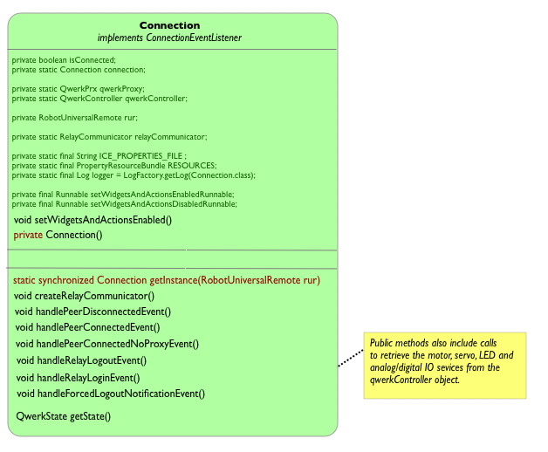

Components

The components package contains the majority of the business logic in the RobotUniversalRemote application. It provides the generic definitions for a component (a Qwerk-specific JGraph cell) and a controller (an object determining what settings can be associated with a specific RobotUniversalRemote cell).
This package interacts heavily with the User Interface package; it is also used by the main application. Of all the external libraries in the system, this package only interacts with the JGraph library; the classes defined here extend basic JGraph classes to make the graph vertices more specific to the RobotUniversalRemote application.
DefaultCell
The DefaultCell class extends the JGraph library’s DefaultGraphCell to introduce functionality that’s specific to the Qwerk UI. The class defines constants specific to all components for the Qwerk board, such as the deviceID and the description of the component.
In addition to standard set and retrieve functions, DefaultCell also provides a method to initialize the ControlPanel for the specified component. CreateControlPanel() method uses a connection object the device ID attribute to create an AbstractControlPanel object that will be associated with the component represented by the DefaultCell object that invoked the method.
DefaultCell class is used as the base class for MotorCell, ServoCell, LEDCell, AnalogInputCell and DigitalIOCell classes.
QwerkCell
The QwerkCell class contains a representation of the Qwerk board as used by the RUR User Interface. It defines constants that configure representation of each component type and sets up the board display on the screen. The initQwerkPorts() function sets up graphical representations of each of the Qwerk ports on the UI picture of the board. Each of the ports is unique and can be associated with only one component at a time.
In addition to setting up the board representation, QwerkCell class also includes methods that determine whether the user’s cursor is within a specific cell in the graph. As every component is represented as a cell, QwerkCell class must determine which cell has been clicked in order to invoke the appropriate response method.
QwerkCell class uses QwerkBoardCell and QwerkPortInfo classes to define the ports on the Qwerk board and process their events. The class diagram and detailed descriptions of QwerkBoardCell and QwerkPortInfo classes are shown below.
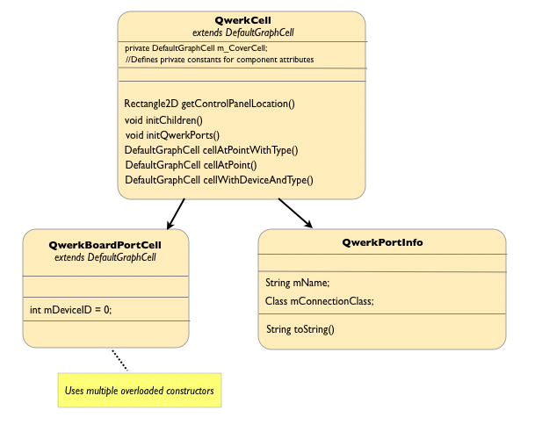
QwerkBoardPortCell
QwerkBoardPortCell class defines the attributes for each of the individual ports on the Qwerk board. The visual representation of the ports is handled by the QwerkCell class as described above. The QwerkBoardPortCell class contains the association between the port and the device ID of the component that is attached to the port.
This class is used by the RobotUniversalRemote and ToolboxTransferHandler classes when the user is attempting to add or remove an association between a component and a port on the Qwerk board using the Robot Universal Remote interface.
QwerkPortInfo
The QwerkPortInfo class is used by the QwerkCell class to define the representation for individual ports on the Qwerk board display in Robot Universal Remote application.
This class handles the connection object which allows communication between Robot Universal Remote and the actual component that is connected to the corresponding port on the user’s robot.

DefaultCell Subclasses: MotorCell, ServoCell, AnalogInputCell, DigitalIOCell and LEDCell
Each of the attachable components (Motor, Servo, LED, Analog Input and Digital Input) is represented by a separate class in RobotUniversalRemote system. Each of these classes is a child class of the Component class described above; all of the classes override the getColor() and getDefaultName() specified in the parent class.
Each of the DefaultCell subclasses also includes a call to createControlPanel(). This method returns an subclass instance of AbstractControlPanel that will be associated with teh component represented by teh DefaultCell subclass that calls the method.
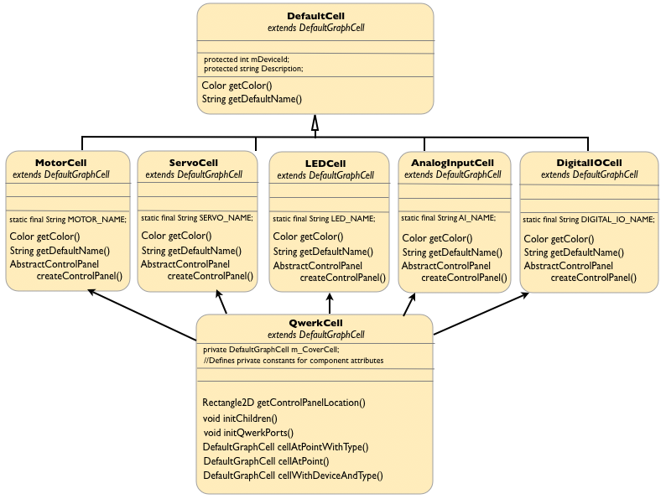

Complete Class Diagram
Appendices

A1. Design Patterns

Service Locator
Borrowed from the J2EE patterns, the Service Locator pattern is used in RUR to abstract the implementation details of creating a connection to a remote service, and to provide a single point of reference to the exposed services. In RUR, the pattern provides a paradigm for the RUR Presentation tier to act as a client in a service-oriented architecture, while maintaining loose coupling between the client-side objects and the server-side services they access. Client objects (usually business delegates) can make a call to the service locator and request a connection to the required service.

Singleton
The Connection between Robot Universal Remote and CMU East relay server is managed by a singleton Connection object. The singleton design here ensures that only one connection can be open at a time, as currently RUR does not support multi-connection management.

A2. Tools and Technologies

Client-Side Technologies

JGraph
JGraph is an easy-to-use open source graph component available for Java; it provides a range of graph-drawing functionality for many applications. JGraph has a simple but powerful API, making it easy to reuse, interact with, layout and perform analysis of the graphs.
RUR uses the JGraph framework to implement the basic drawing, drag-and-drop and UI object moving behavior. The following key features made JGraph the most desirable choice:
- The JGraph technology provides a graph visualization library.
- JGraph has the ability to provide the means to associate a context or metadata with those displayed elements.
- JGraph provides the ability to configure how the graph is displayed.
- JGraph has the ability to drag and drop UI objects, accompanied with the pop-up dialog functionality.
- JGraph has an extensive manual, community support, and is licensed under the LGPL. It is possible to include the library for JGraph in RUR without any additional payments or legal requirements, as long the JGraph library itself is not modified.
JGraph API can be found at http://www.jgraph.com/doc/jgraph/
Java Web Start
Java Web Start software provides a flexible and robust deployment solution for Java technology-based applications based on the Java Community Process program (JCP). The technology is being developed through the JCP program as JSR-56: The Java Network Launching Protocol & API (JNLP), which provides a browser-independent architecture for deploying Java 2 technology-based applications to the client desktop. Java Web Start technology works with any browser and any Web server. Each application developed for use with the Java Web Start software specifies which version of the Java 2 platform it requires, e.g., version 1.4 or 1.5, and each application runs on a dedicated Java Virtual Machine (JVM). [2]

The web start technology can be used for deploying and updating the runtime RUR environment.

Server-Side Technologies (Middleware)

ICE
Ice, the Internet Communications Engine, is a high-performance Internet communications platform. The mission of the ICE protocol is to facilitate the controlled exchange and management of electronic assets between partners and affiliates across the Web.
For RUR, Ice is used between the client and the relay server to exchange information relating to the connected robots as well as for managing and administering the robots.
related READING

References

Robot Universal Remote Use Case Listing - Team 5

