

**DATABASE DOCUMENT**

**RESTAURANT MANAGEMENT SYSTEM**

|  |  |
| --- | --- |
| **Mentor:** | Nguyen Thi Anh Dao |
| **Team Members:** | Hoang Nghia Khue  Phan Minh Phu  Nguyen Ngoc Thanh  Huynh Viet Tri  Pham Hung Dat |

*Da Nang, 2021*

**PROJECT INFORMATION**

|  |  |  |  |  |
| --- | --- | --- | --- | --- |
| **Project Acronym** | RMS | | | |
| **Project Title** | RESTAURANT MANAGEMENT SYSTEM | | | |
| **Start Date** | May 13, 2021 | **End Date** | | June 24, 2021 |
| **Lead Institution** | CMU, Duy Tan University | | | |
| **Project Mentor** | Nguyen Thi Anh Dao | | | |
| **Scrum master / Project Leader & contact details** | Hoang Nghia Khue  Email: hoangnghiakhue@gmail.com  Phone: 0793618988 | | | |
| **Partner Organization** | ABC Restaurant | | | |
| **Project Web URL** | https://abcrestaurant.com | | | |
| **Members** | Hoang Nghia Khue | | hoangnghiakhue@gmail.com | 0793618988 |
| Phan Minh Phu | | phu1237@gmail.com | 0365225603 |
| Huynh Viet Tri | | trihuynh11102000@gmail.com | 0365225603 |
| Nguyen Ngoc Thanh | | nguyenngocthanh99qna@gmail.com | 0387943672 |
| Pham Hung Dat | | dat8112000@gmail.com | 0123123123 |

Table 1: Project Information

**PROJECT PLAN DOCUMENT**

|  |  |  |  |
| --- | --- | --- | --- |
| **Document Title** | Database Document | | |
| **Reporting Period** | May 2021 | | |
| **Author(s)** | Phan Minh Phu, Hoang Nghia Khue | | |
| **Date** | May 13, 2021 | **Filename** | 4.Database_Group1_RestaurantManagementSystem.docx |
| **Access** | Project and FIT program | | |

Table 2: Project Plan Document

REVISION HISTORY

| **Version** | **Date** | **Comments** | **Author** | **Approval** |
| --- | --- | --- | --- | --- |
| 1.0 | May 13, 2021 | Create Document | Phu, Khue |  |
|  |  |  |  |  |
|  |  |  |  |  |

Table 3: Revision History

Contents

1. Introduction 5

1.1. Purpose 5

1.2. Scope 5

2. Hardware and Software Requirement 5

3. Database Design Decision 6

3.1. Database Relationship Diagram 6

3.2. Table detail 6

3.2.1. Table 01: users 6

3.2.2 Table 02: dishes 7

3.2.3. Table 03: tables 7

3.2.4. Table 04: invoices 7

3.2.5. Table 05: invoice_dishes 8

4. Examples 9

# 1. Introduction

## 1.1. Purpose

* Database design document describes structure of database and file structure of system. Database Design document will introduce all attribute the Application that will help developer and tester base on this design to implement and test.

## 1.2. Scope

* This Database Design Document provides the basic for “Restaurant Management System” Database design
* It defines the database that will support the “Restaurant Management System” Data Model.
* The database design for “Tournament Tracker Admin” is composed of definitions for database objects derived by mapping entities to tables attributes to columns.

# 2. Hardware and Software Requirement

* This section provides an overview of the software and hardware architecture. The following describes the technology components of SCT.

|  |  |
| --- | --- |
| **Description Attribute** | **Description Database** |
| **MySQL** |  |
| **Hardware** | **Mobile phone, computer with internet** |

Table 4: Technology Component

# 3. Database Design Decision

## 3.1. Database Relationship Diagram

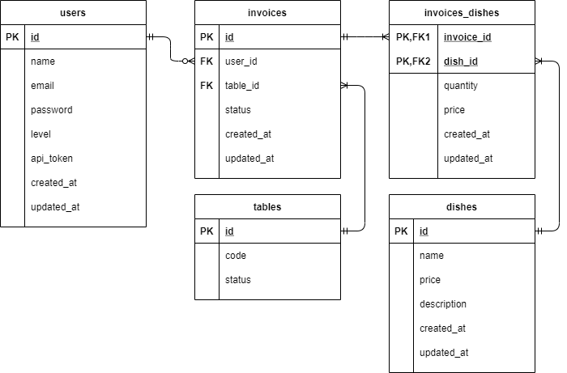

Figure 1: Relational Data Model

## 3.2. Table detail

### 3.2.1. Table 01: users

|  |  |  |  |
| --- | --- | --- | --- |
| **ID** | **Field** | **Type** | **Description** |
| 01 | id | unsignedInteger | id of user |
| 02 | name | string | name of user |
| 03 | email | string | email of user |
| 04 | password | string | password of user |
| 05 | level | tinyInteger | level of user (role) |
| 06 | api_token | string | token of user after login |
| 07 | created_at | timestamp | time when the user account created |
| 08 | updated_at | timestamp | the last time user update account information |

Table 5: Users Detail

### 3.2.2 Table 02: dishes

|  |  |  |  |
| --- | --- | --- | --- |
| **ID** | **Field** | **Type** | **Description** |
| 01 | id | unsignedInteger | id of dish |
| 02 | name | string | name of dish |
| 03 | price | double | price of dish |
| 04 | description | text | description of dish |
| 05 | created_at | timestamp | time when the dish created |
| 06 | updated_at | timestamp | the last time dish update information |

Table 6: Dishes Detail

### 3.2.3. Table 03: tables

|  |  |  |  |
| --- | --- | --- | --- |
| **ID** | **Field** | **Type** | **Description** |
| 01 | id | unsignedInteger | id of dish |
| 02 | code | string | code of table |
| 03 | status | tinyInteger | status of table |

Table 7: Tables Detail

### 3.2.4. Table 04: invoices

|  |  |  |  |
| --- | --- | --- | --- |
| **ID** | **Field** | **Type** | **Description** |
| 01 | id | unsignedInteger | id of dish |
| 02 | name | string | name of dish |
| 03 | price | double | price of dish |
| 04 | description | text | description of dish |
| 05 | created_at | timestamp | time when the dish created |
| 06 | updated_at | timestamp | the last time dish update information |

Table 8: Invoices Detail

### 3.2.5. Table 05: invoice_dishes

|  |  |  |  |
| --- | --- | --- | --- |
| **ID** | **Field** | **Type** | **Description** |
| 01 | invoice_id | unsignedInteger | id of invoice |
| 02 | dish_id | unsignedInteger | id of dish |
| 03 | quantity | unsignedInteger | quantity of dishes |
| 04 | price | tinyInteger | price of dish |
| 05 | created_at | timestamp | time when the dish added first time |
| 06 | updated_at | timestamp | the last time invoice dish update information |

Table 9: Invoice_Dishes Detail

# 4. Examples

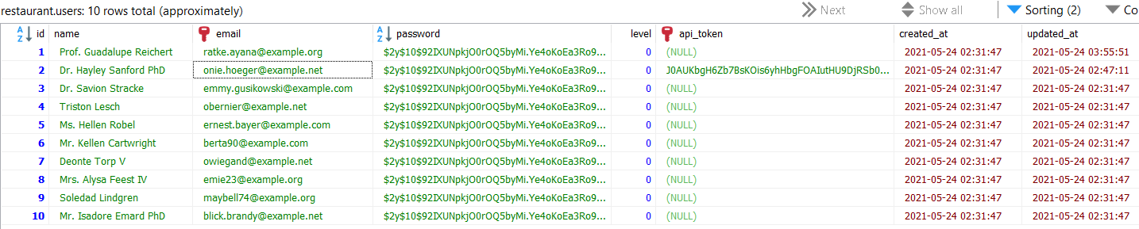

Figure 1: Example (Users)

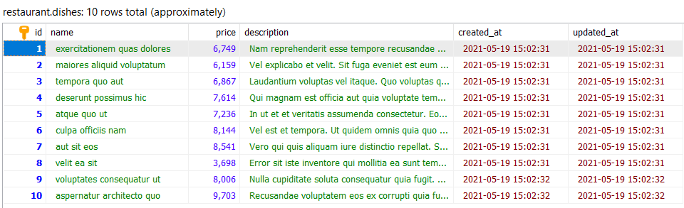

Figure 2: Example (Dishes)

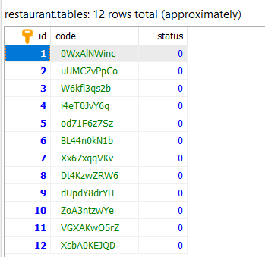

Figure 3: Example (Tables)

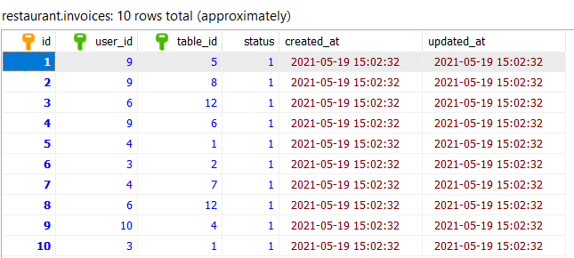

Figure 4: Example (Invoices)

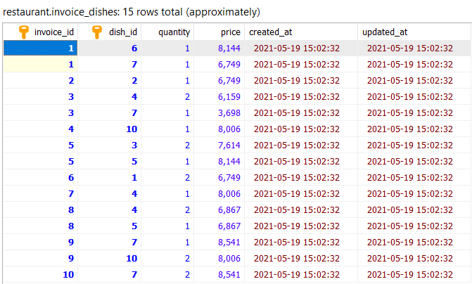

Figure 5: Example (Invoices_Dishes)