

**USER INTERFACE DOCUMENT**

RESTAURANT MANAGEMENT SYSTEM

|  |  |
| --- | --- |
| **Mentor:** | Nguyen Thi Anh Dao |
| **Project Team:** | Group 1 |
| **Team Members:** | Hoang Nghia Khue  Phan Minh Phú  Nguyen Ngoc Thanh  Huynh Viet Tri  Pham Hung Dat |

**PROJECT INFORMATION**

|  |  |  |  |  |  |
| --- | --- | --- | --- | --- | --- |
| **Project Acronym** | RMS | | | | |
| **Project Title** | Restaurant Management System | | | | |
| **Start Date** | 13 May 2021 | | **End Date** | 24 June 2021 | |
| **Lead Institution** | CMU, Duy Tan University | | | | |
| **Project Mentor** | Nguyen Thi Anh Dao | | | | |
| **Scrum master / Project Leader & contact details** | Hoang Nghia Khue  Email: hoangnghiakhue@gmail.com  Phone: 0793618988 | | | | |
| Team members | Name | Email | | | Tel |
| Hoang Nghia Khue | hoangnghiakhue@gmail.com | | | 0793618988 |
| Phan Minh Phu | phu1237@gmail.com | | | 0349853202 |
| Huynh Viet Tri | trihuynh11102000@gmail.com | | | 0905339310 |
| Nguyen Ngoc Thanh | nguyenngocthanh99qna@gmail.com | | | 0123123123 |
| Pham Hung Dat | dat8112000@gmail.com | | | 0904352317 |

**PROPOSAL DOCUMENT**

|  |  |  |  |
| --- | --- | --- | --- |
| **Document Title** | User Interface Document | | |
| **Reporting Period** | May 2021 | | |
| **Author(s)** | Team | | |
| **Date** | May 20, 2021 | **Filename** | User_Interface.docx |
| **Access** | Project and FIT program | | |

**DOCUMENT HISTORY**

|  |  |  |  |
| --- | --- | --- | --- |
| **Version** | **Person** | **Date** | **Description** |
| 1.0 | Team | May 20, 2021 | Create Document |

**SIGNATURE**

***Document Approvals:*** *The following signatures are required for approval of this document.*

|  |  |  |
| --- | --- | --- |
| Nguyen Thi Anh Dao  Mentor |  | Date |
| Hoang Nghia Khue  Scrum Master |  | Date |
| Phan Minh Phu  Member |  | Date |
| Nguyen Ngoc Thanh  Member |  | Date |
| Huynh Viet Tri  Member |  | Date |
| Pham Hung Dat  Member |  | Date |

**Table of Contents**

I. Introduction 6

1. Purpose 6

2. Related Documents 6

3. List of Interface 6

II. Describe User Interface 7

1. UI-01: Login 7

2. UI-02: Logout 7

3. UI-03: See dish information 8

4. UI-04: Create dishes 9

5. UI-05: Update dishes 11

6. UI-06: Delete dishes 13

7. UI-07: Choose Table 15

8. UI-08: Choose Dish 16

9. UI-09: Choose Table 18

10. UI-10: Choose Dish 20

11. UI-11: Cart 21

# Introduction

## Purpose

* This document helps to better understand the interface of the software, detailed specification components, and function of the system.
* With this document, the development team can understand detail the structure and composition to create a consistent and complete system.

## Related Documents

* Product Backlog
* Architecture Design Document
* Database Design Document

## List of Interface

|  |  |  |
| --- | --- | --- |
| **User Interface**  **ID** | **UI Name** | **Description** |
| UI-01 | Login | Login will be used as the function to allow the user to log into the system, it needs to be put in moderation. |
| UI-02 | Logout | User will be log out of the system |
| UI-03 | See dish information | Manage can view dishes information |
| UI-04 | Create dishes | Manager can create new dishes |
| UI-05 | Update dishes | Manager can update dishes information |
| UI-06 | Delete dishes | Manager can delete dishes |
| UI-07 | Choose Table | Cashier can choose table |
| UI-08 | Choose Dish | Cashier can choose dishes |
| UI-09 | Choose Table (Web) | User can choose table in website |
| UI-10 | Choose Dish (Web) | User can choose dishes in website |
| UI-11 | Cart (Web) | User can see their cart |

*Table 1: List of Interface*

# Describe User Interface

## UI-01: Login

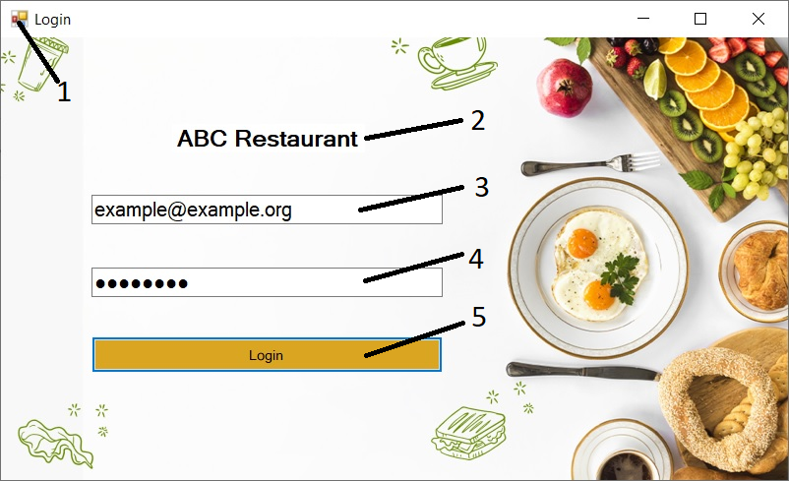

|  |  |  |  |
| --- | --- | --- | --- |
| **ID** | **Condition** | **Control type** | **Target** |
| 1 |  | Image | Display logo of the system |
| 2 |  | Text view | Display name title |
| 3 | Click | Text input | This is where users enter their username |
| 4 | Click | Text input | This is where users enter their password |
| 5 | Click | Button  Login | The user can login to the system. After login, the user can use the functions included in the system |

*Table 2: Describe User Interface Login*

## UI-02: Logout

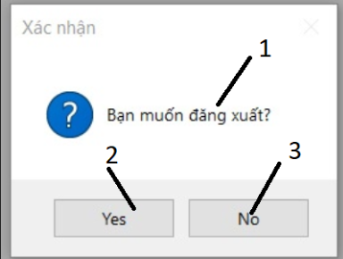

|  |  |  |  |
| --- | --- | --- | --- |
| **ID** | **Condition** | **Control type** | **Target** |
| 1 |  | Text view | Display name title |
| 2 | Click | Button Yes | Logout the system |
| 3 | Click | Button No | Close the Logout form |

*Table 3: Describe User Interface Logout*

## UI-03: See dish information

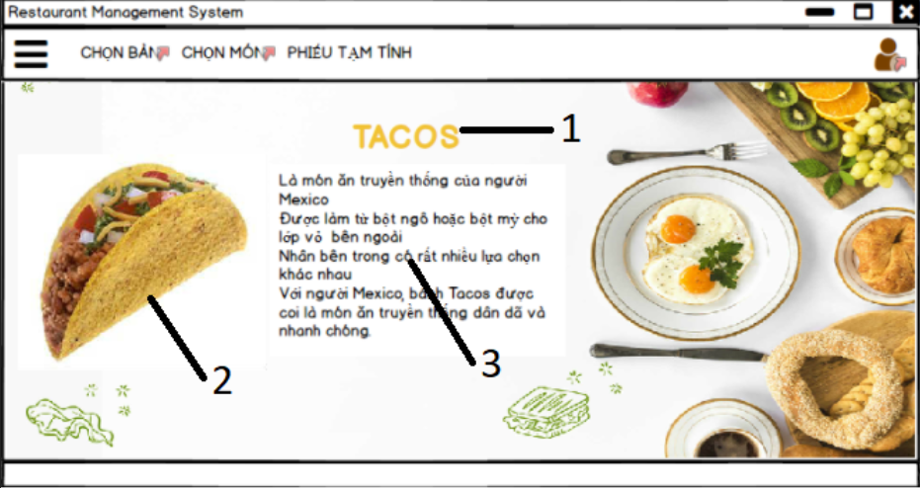

|  |  |  |  |
| --- | --- | --- | --- |
| **ID** | **Condition** | **Control type** | **Target** |
| 1 |  | Text view | Display name of dish |
| 2 |  | Image | Display photo of the dish |
| 3 |  | Text view | Display description of dish |

*Table 4: Describe User Interface See dish information*

## UI-04: Create dishes

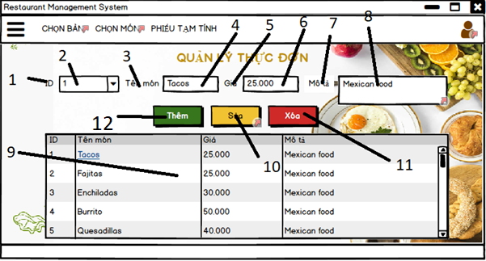

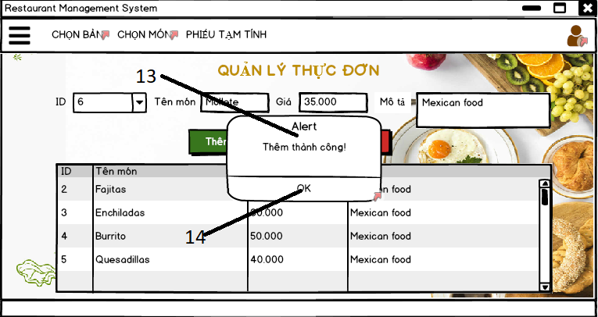

|  |  |  |  |
| --- | --- | --- | --- |
| **ID** | **Condition** | **Control type** | **Target** |
| 1 |  | Label | ID label |
| 2 | Click | ComboBox | Input the ID |
| 3 |  | Label | Name label |
| 4 | Click | Text input | Input name of dish |
| 5 |  | Label | Price label |
| 6 | Click | Text input | Input price of dish |
| 7 |  | Label | Description label |
| 8 | Click | Text input | Input description of dish |
| 9 |  | DatagridView | Show all information of dish |
| 10 | Click | Button | Update dish |
| 11 | Click | Button | Delete dish |
| 12 | Click | Button | Add dish |
| 13 |  | Text view | Display name title |
| 14 | Click | Button | Close the alert table |

*Table 5: Describe User Interface Create dishes*

## UI-05: Update dishes



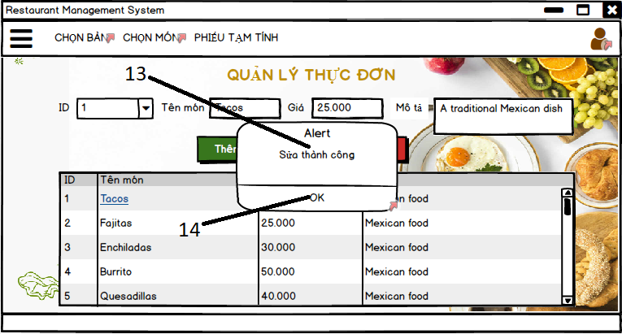

|  |  |  |  |
| --- | --- | --- | --- |
| **ID** | **Condition** | **Control type** | **Target** |
| 1 |  | Label | ID label |
| 2 | Click | ComboBox | Input the ID |
| 3 |  | Label | Name label |
| 4 | Click | Text input | Input name of dish |
| 5 |  | Label | Price label |
| 6 | Click | Text input | Input price of dish |
| 7 |  | Label | Description label |
| 8 | Click | Text input | Input description of dish |
| 9 |  | DatagridView | Show all information of dish |
| 10 | Click | Button | Update dish |
| 11 | Click | Button | Delete dish |
| 12 | Click | Button | Add dish |
| 13 |  | Text view | Display name title |
| 14 | Click | Button | Close the alert table |

*Table 6: Describe User Interface Update dishes*

## UI-06: Delete dishes



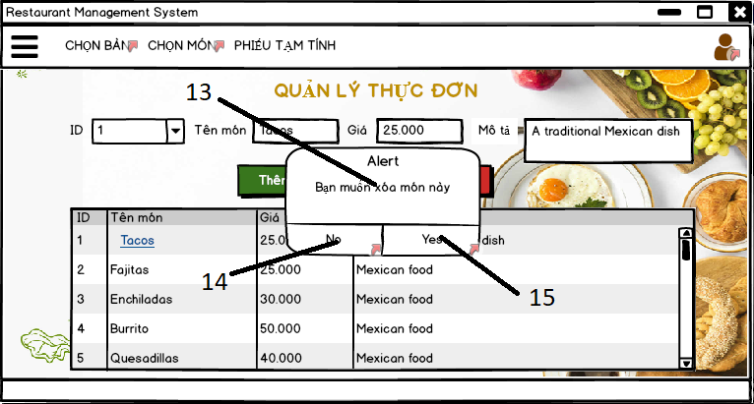

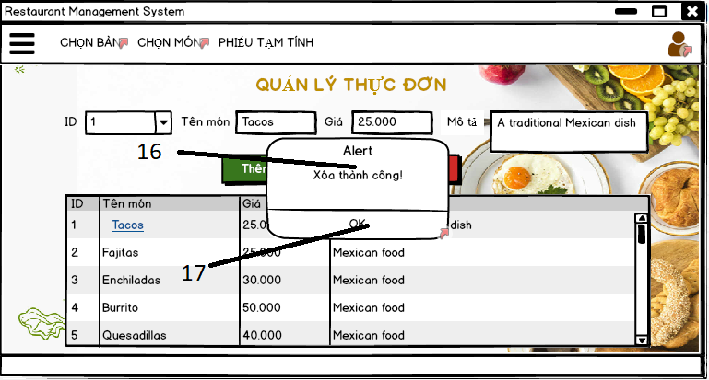

|  |  |  |  |
| --- | --- | --- | --- |
| **ID** | **Condition** | **Control type** | **Target** |
| 1 |  | Label | ID label |
| 2 | Click | ComboBox | Input the ID |
| 3 |  | Label | Name label |
| 4 | Click | Text input | Input name of dish |
| 5 |  | Label | Price label |
| 6 | Click | Text input | Input price of dish |
| 7 |  | Label | Description label |
| 8 | Click | Text input | Input description of dish |
| 9 |  | DatagridView | Show all information of dish |
| 10 | Click | Button | Update dish |
| 11 | Click | Button | Delete dish |
| 12 | Click | Button | Add dish |
| 13 |  | Text view | Display name title of alert table |
| 14 | Click | Button | Close the alert table |
| 15 | Click | Button | Delete dish |
| 16 |  | Text view | Display name title of alert table |
| 17 | Click | Button | Close the alert table |

*Table 7: Describe User Interface Delete dishes*

## UI-07: Choose Table

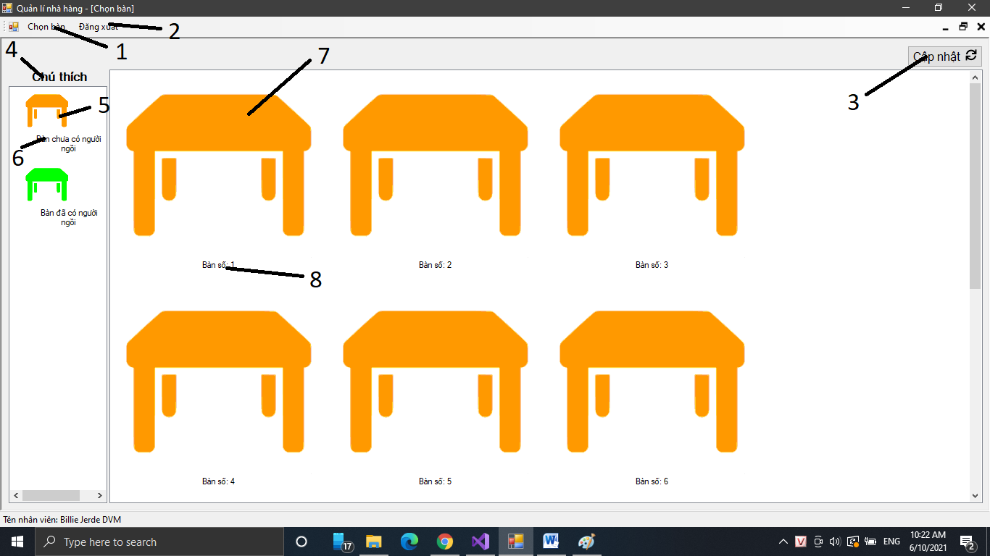

|  |  |  |  |
| --- | --- | --- | --- |
| **ID** | **Condition** | **Control type** | **Target** |
| 1 | Click | Button | Choose table |
| 2 | Click | Button | Logout |
| 3 | Click | Button | Update this page |
| 4 |  | Text view | Display name title |
| 5 |  | Image | Display status of table |
| 6 |  | Text view | Display description |
| 7 | Button | Image | Choose table |
| 8 |  | Text view | Display name of table |

*Table 8: Describe User Interface Choose Table*

## UI-08: Choose Dish

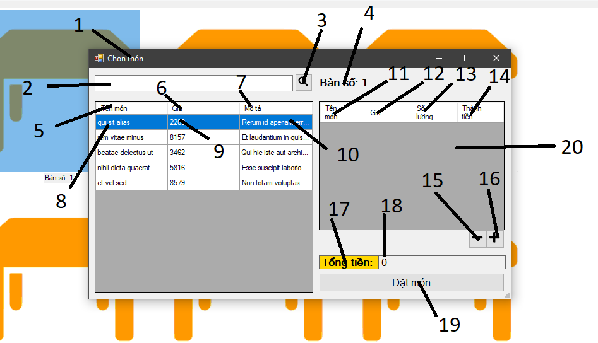

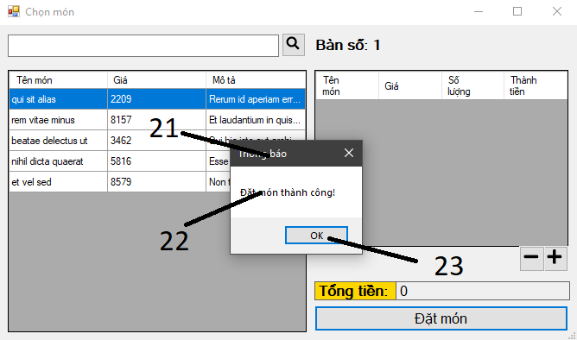

|  |  |  |  |
| --- | --- | --- | --- |
| **ID** | **Condition** | **Control type** | **Target** |
| 1 |  | Text view | Display name title |
| 2 | Click | Text input | Input name of dish |
| 3 | Click | Button | Search dish |
| 4 |  | Text view | Display name of table |
| 5 |  | Text view | Display name title |
| 6 |  | Text view | Display name title |
| 7 |  | Text view | Display name title |
| 8 |  | Text view | Display name of dish |
| 9 |  | Text view | Display price of dish |
| 10 |  | Text view | Display description of dish |
| 11 |  | Text view | Display name title |
| 12 |  | Text view | Display name title |
| 13 |  | Text view | Display name title |
| 14 |  | Text view | Display name title |
| 15 | Click | Button | Quantity of dishes reduced by 1 |
| 16 | Click | Button | Quantity of dishes increased by 1 |
| 17 |  | Text view | Display name title |
| 18 |  | Text view | Display total of price |
| 19 | Click | Button | Order |
| 20 |  | DataGrid view | Display all dishes which are choosen |
| 21 |  | Text view | Display name title |
| 22 |  | Text view | Display content of the table |
| 23 | Click | Button | Close the alert table |

*Table 9: Describe User Interface Choose Dish*

## UI-09: Choose Table

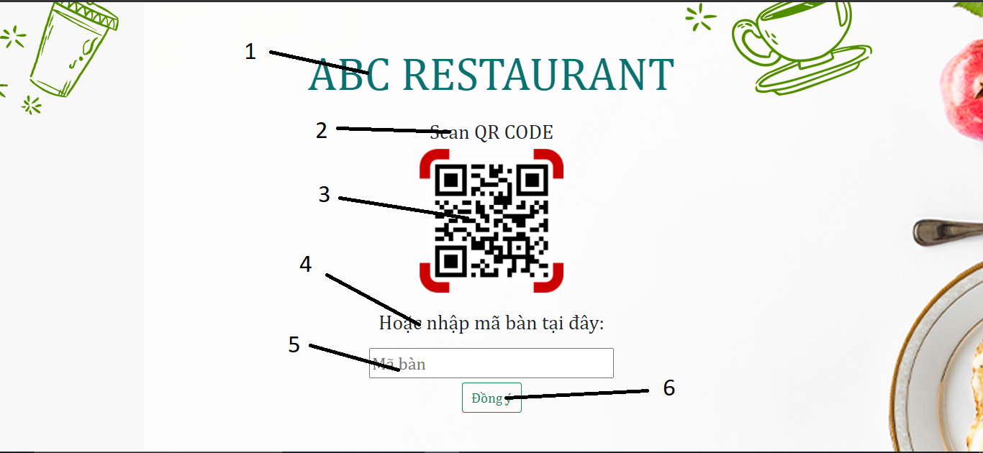

|  |  |  |  |
| --- | --- | --- | --- |
| **ID** | **Condition** | **Control type** | **Target** |
| 1 |  | Text view | Display name title |
| 2 |  | Text view | Display name title |
| 3 | Click | Button | Open QRCode camera |
| 4 |  | Text view | Display name title |
| 5 | Click | Text input | Input table ID |
| 6 | Click | Button | Accept to choose table |

*Table 10: Describe User Interface Choose Table (Website)*

## UI-10: Choose Dish

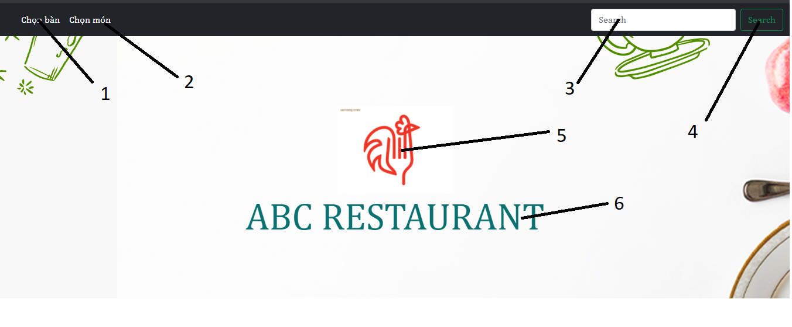

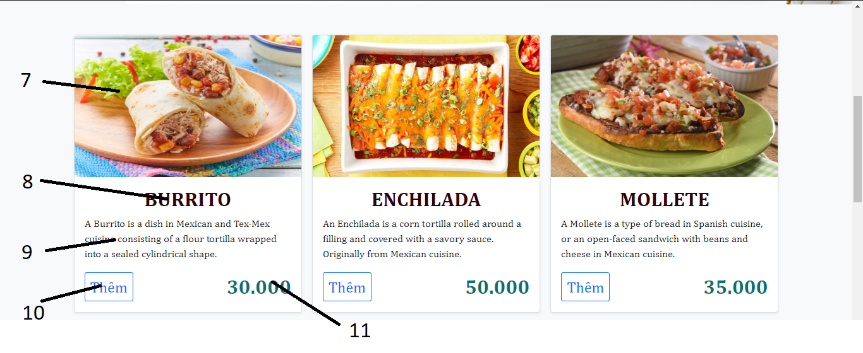

|  |  |  |  |
| --- | --- | --- | --- |
| **ID** | **Condition** | **Control type** | **Target** |
| 1 | Click | Button | Choose table button |
| 2 | Click | Button | Choose dish button |
| 3 | Click | Text input | Search dish |
| 4 | Click | Button | Search |
| 5 |  | Image | Logo of the Website |
| 6 |  | Text view | Display name title |
| 7 |  | Image | Display photo of dish |
| 8 |  | Text view | Display name of dish |
| 9 |  | Text view | Display description of dish |
| 10 | Click | Button | Add dish to cart |
| 11 |  | Text view | Display price of dish |

*Table 11: Describe User Interface Choose Dish (Website)*

## UI-11: Cart

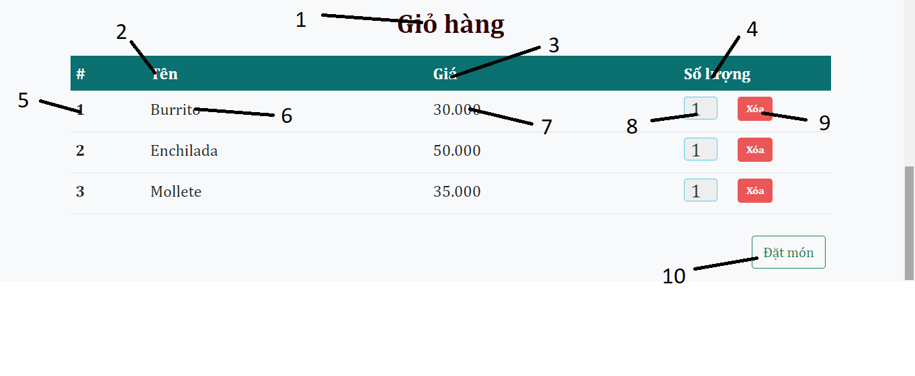

|  |  |  |  |
| --- | --- | --- | --- |
| **ID** | **Condition** | **Control type** | **Target** |
| 1 |  | Text view | Display name title |
| 2 |  | Text view | Display name title |
| 3 |  | Text view | Display price title |
| 4 |  | Text view | Display quantity title |
| 5 |  | Text view | Display number |
| 6 |  | Text view | Display name of dish |
| 7 |  | Text view | Display price of dish |
| 8 | Click | Text input | Input quantity of dish |
| 9 | Click | Button | Delete dish from cart |
| 10 | Click | Button | Order |

*Table12: Describe User Interface Cart (Website)*