Project 4 – Fish Distribution Mapping App
by zhiyang3 Zhiyang Zhang

Description:
My application allows users to search for fish species and view their geographical distribution on a map. It uses the GBIF API to fetch distribution data for selected fish species, processes the data on a server, and displays it on an interactive map within an Android application. The web service also includes an analytics dashboard for tracking user interactions and system usage.
Here is how my application meets the task requirements:

1. Implement a native Android application
The name of my native Android application project in Android Studio is: FishDistributionApp.

a. Has at least three different kinds of views in your Layout (TextView, EditText, ImageView, etc.)
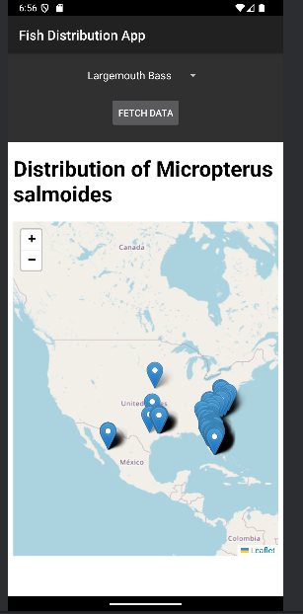
My application uses TextView, Spinner (dropdown menu), Button, and WebView. See activity_main.xml for details of how these views are arranged.
Here is a screenshot of the layout before the fish distribution map is displayed:
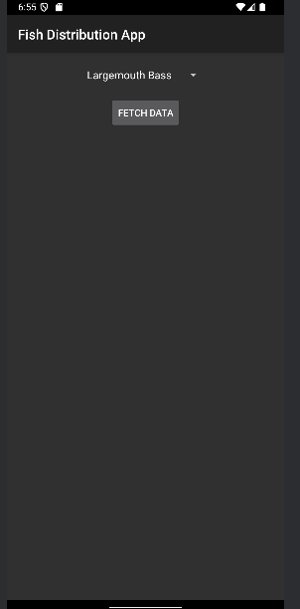

b. Requires input from the user
The user selects a fish species from a dropdown menu (Spinner) and clicks a button to fetch the distribution map for the selected fish species.

c. Makes an HTTP request (using an appropriate HTTP method) to your web service
My application performs an HTTP GET request in MainActivity.java.
The request URL is dynamically generated based on the selected fish species and is structured as follows:
"https://bookish-parakeet-69rvjx4974vvc5r6w.github.dev/fishSelector/<selectedFishSpecies>"

d. Receives and parses an XML or JSON formatted reply from the web service
The Android application receives a JSON response from the web service.
An example JSON response looks like this:
json
Copy code
{
"fishName": "Largemouth Bass",
"distributionData": [
{"latitude": 38.89, "longitude": -77.03},
{"latitude": 40.71, "longitude": -74.01}
],
"mapHtml": "<HTML content for Leaflet.js map>"}
The application extracts and displays the HTML content (mapHtml) in a WebView.

e. Displays new information to the user
The fish distribution map, displaying markers for geographical points, is dynamically rendered in a WebView based on the server's response.

f. Is repeatable (i.e., the user can repeatedly reuse the application without restarting it)
The user can repeatedly select different fish species from the dropdown menu and fetch their corresponding distribution maps without restarting the app.

2. Implement a web application, deployed to GitHub Codespaces
The URL of my web service deployed to GitHub Codespaces is:
https://bookish-parakeet-69rvjx4974vvc5r6w.github.dev

a. Using an HttpServlet to implement a simple (can be a single path) API
The web service is implemented using HttpServlet in FishSelectorServlet.java. The servlet exposes a RESTful API endpoint /fishSelector/<fishName> that handles requests from the Android application.

b. Receives an HTTP request from the native Android application
FishSelectorServlet.java receives an HTTP GET request with the selected fish species as a path parameter.

c. Executes business logic appropriate to your application
The servlet performs the following tasks:
- Fetches fish species data from the GBIF API.
- Processes and filters the geographical distribution data (latitude and longitude).
- Generates an interactive HTML map using Leaflet.js.

d. Replies to the Android application with an XML or JSON formatted response
The server responds with a JSON object containing:
- The fish name.
- A list of geographical distribution data points (latitude and longitude).
- The HTML content for rendering the map.
Example response:
json
Copy code
{
"fishName": "Largemouth Bass",
"distributionData": [{"latitude": 38.89, "longitude": -77.03}],
"mapHtml": "<HTML content>"}

4. Log useful information
The following data is logged for each request in MongoDB:
- Timestamp of the request.
- Selected fish species.
- HTTP status of the response.
- Request processing time (latency).
- User's IP address.
- Details of the 3rd-party API request and response.

5. Store the log information in a database
Log data is stored persistently in a MongoDB Atlas database. The connection URI is:
perl
Copy code
mongodb+srv://zy:<password>@fishlogdatabase.mongodb.net/

6. Display operations analytics and full logs on a web-based dashboard

a. A unique URL addresses the dashboard
The dashboard is accessible at:
https://bookish-parakeet-69rvjx4974vvc5r6w.github.dev/dashboard

b. Displays formatted full logs
The dashboard presents a table with the following details for each log entry:
- Timestamp.
- Selected fish species.
- Response status.
- Request processing time.
- User's IP address.

7. Deploy the web service to GitHub Codespaces
The web service and dashboard were deployed to GitHub Codespaces using Docker.
- The ROOT.war file for the servlet application is deployed automatically within the container.
- Ports were exposed to allow public access.

