Hercules Benchmarks
In progress
Leonardo Ramirez-Guzman
April 2007

Introduction

In the present document summarize some examples tailored to test the Hercules (see, Tu et al., 2006).

Benchmarks

B1.-A dipole in a homogeneous full space.

The properties are summarized in Table 1. No damping is included. The reference solution is computed evaluating numerically the convolution of the analytical solution of a planar dislocation with strike= 0, dip= 90 and rake =0. The slip rate function is triangle with raise time T_{r} = 1 s and M_{w}= 4.242716. The value of the moment is arbitrary in this case.

The domain is a 30 x 30 x 30 km. The stations are recorded in the plane x-y with a 250 m space grid.

ρ( kg/m3 ) | V_{p} | V_{s} | Q
1500 | 3474 | 2000 | Infinity  
Table B1

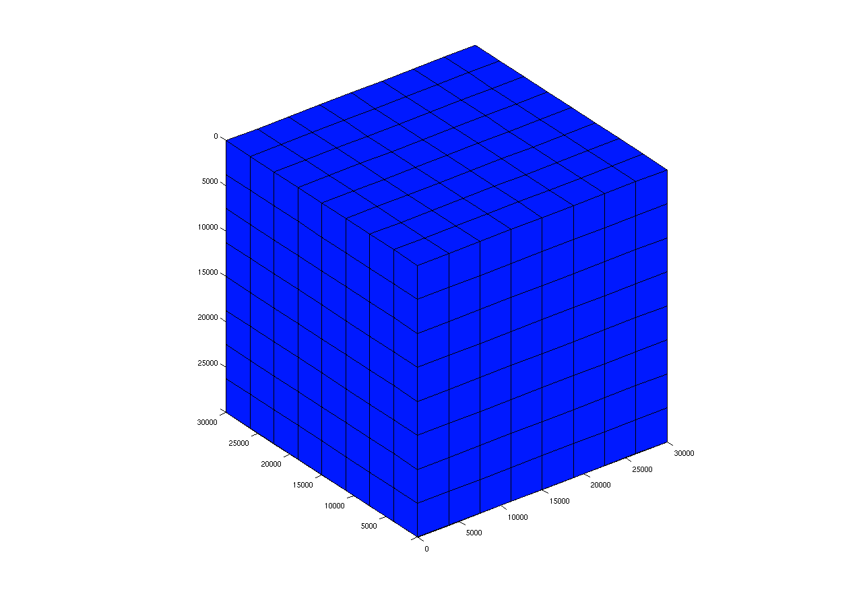
Figure 1.- Coarse mesh. All elements have the same size.

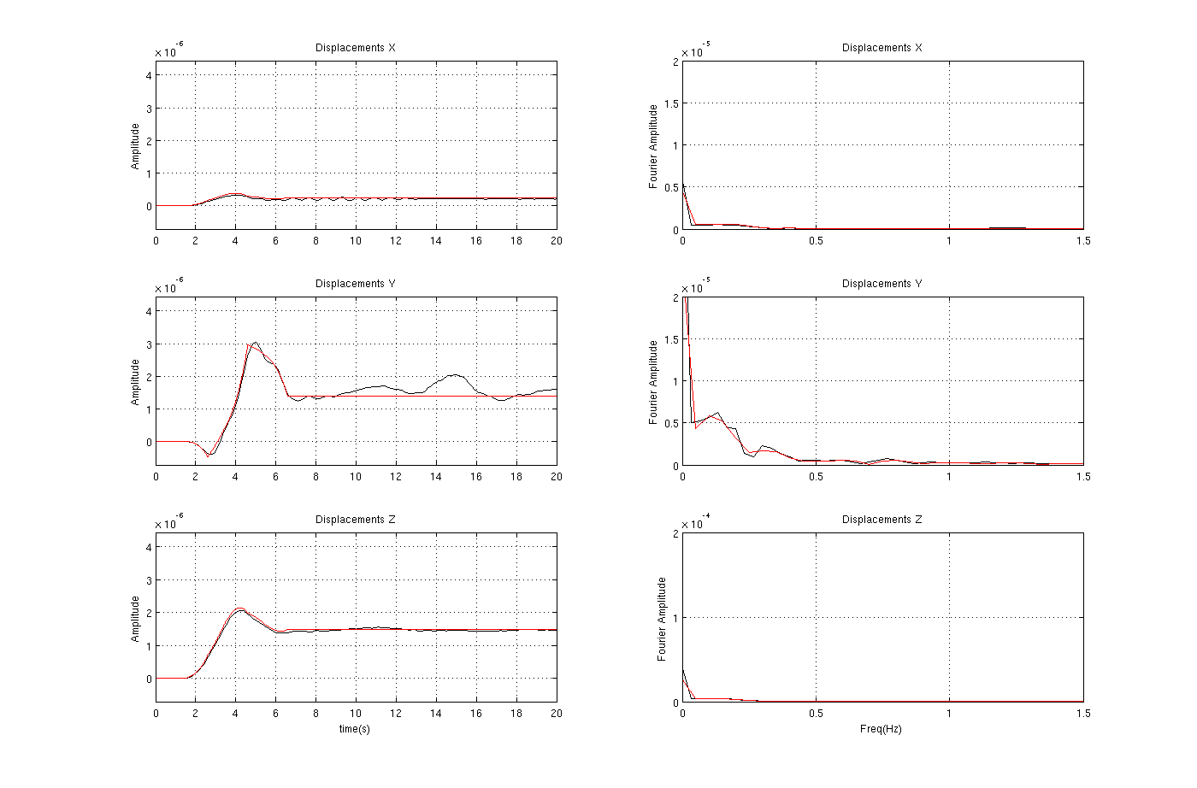
Figure 2.- Displacements and Fourier spectrum.

Note.- You need to recompile Hercules changing in common.mk such that SOLVE_CFLAGS = -DBOUNDARY.

Source Input example

#############################################################################
# #
# source.in: Source quantities input file to CMU FEM toolchain. #
# Lines start with # are comments. Empty lines are ignored. #
# #
# Revised version that facilitate parameter conversions. #
# Leonardo Ramirez 2006 #
# #
#############################################################################

#############################################################################
#
# FILTER RELATED (ONLY BUTTERWORTH )
#
#############################################################################

source_is_filtered = 0

threshold_frequency = .3

number_of_poles = 22

##########################################################################
#
# SOURCE DESCRIPTION
#
##########################################################################

type_of_source = point

source_function_type = quadratic

average_risetime_sec = 4.0

moment_amplitude = 7.2E+12
#moment_magnitude = 3.0

# 0-lon lat 1- cartesian
lonlat_or_cartesian = 1

hypocenter_x = 15000

hypocenter_y = 15000

hypocenter_depth_m = 15000

source_strike_deg = 90

source_dip_deg = 0

source_rake_deg = 0

B2.-A dipole: layer on a half space. No damping

This problem is named LOH.1 in the SCEC benchmarks. I changed the frequency content via T.

Material Properties.- Table B2 summarizes the properties. Both Q’s are infinite everywhere.
Thicknes | ρ( kg/m3 ) | V_{p} | V_{s}
1000 | 2600 | 4,000 | 2,000
Inf | 2700 | 6,000 | 3,464
Table B2
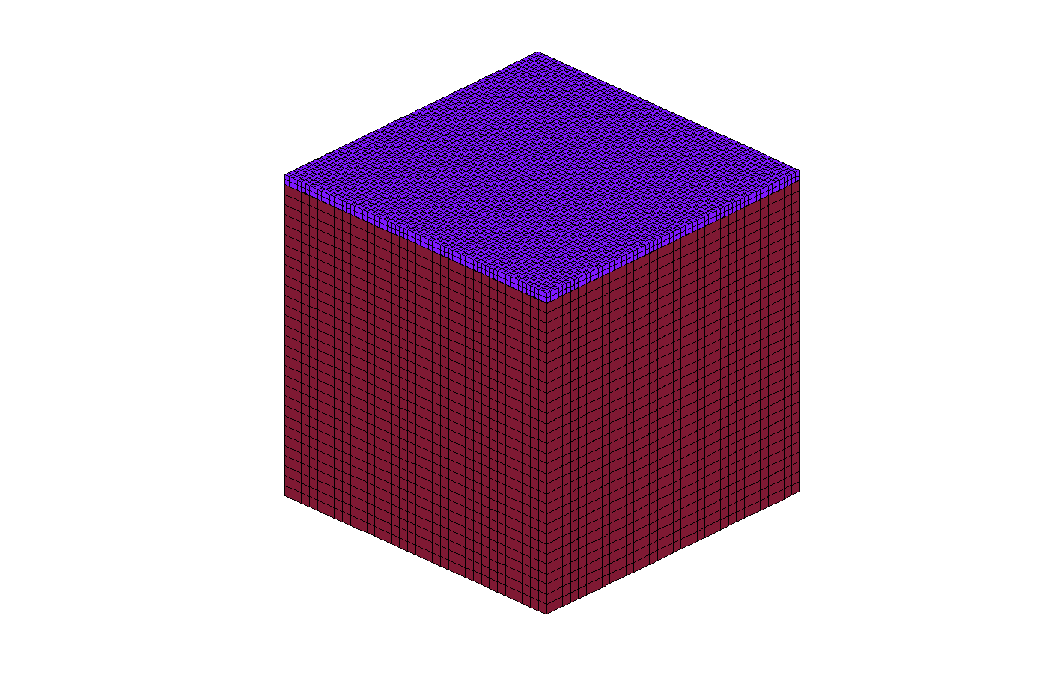
Figure 3.- Coarse mesh.

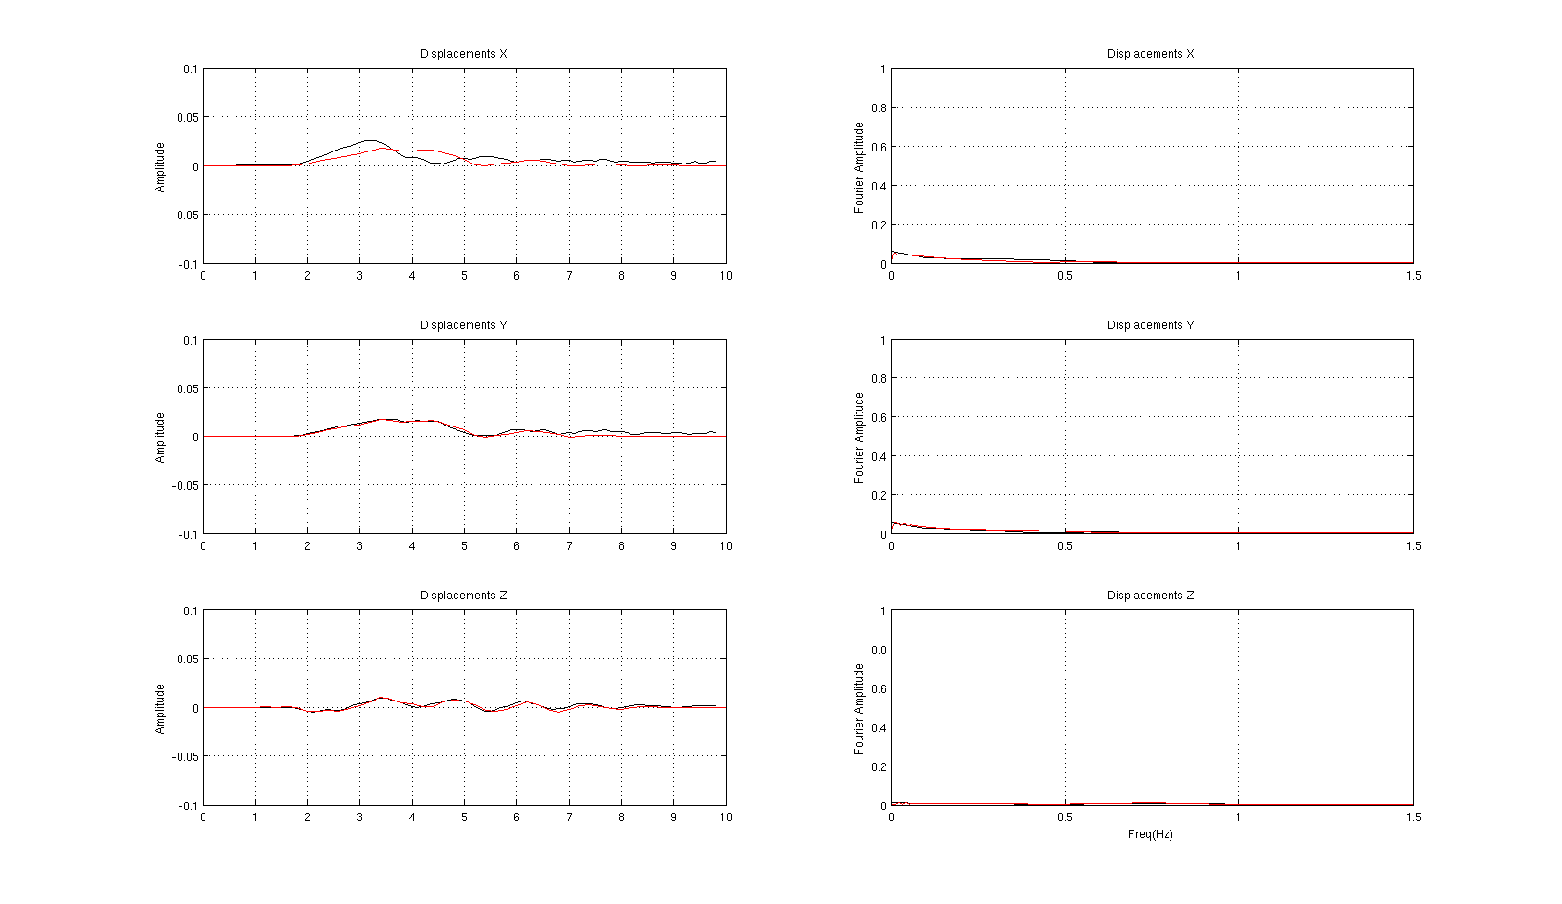
Figure 4.- Displacements and Fourier spectrum.
Source.-Point dislocation. The only non-zero moment tensor component is Mxy (equal to
Myx), which has value M0=10¹⁸ Nm. Moment-rate time history is M0*(t/T2)*exp(-t/T), where T=2 sec. (Equivalently, the moment time history is M0*(1-(1+t/T)*exp(-t/T)), where T=2sec).

Source Depth = 2000 m. That is, taking the epicenter as the origin, the source is
at (0,0,2000).

###############################################################################
# #
# source.in: Source quantities input file to CMU FEM toolchain. #
# Lines start with # are comments. Empty lines are ignored. #
# #
# Revised version that facilitate parameter conversions. #
# Leonardo Ramirez 2006 #
# #
###############################################################################

###############################################################################
#
# FILTER RELATED (ONLY BUTTERWORTH )
#
###############################################################################

source_is_filtered = 0

threshold_frequency = .3

number_of_poles = 22

###############################################################################
#
# SOURCE DESCRIPTION
#
###############################################################################

type_of_source = point

source_function_type = exponential

average_risetime_sec = 2

moment_amplitude = 1E18
#moment_magnitude = 3.0

# 0-lon lat 1- cartesian
lonlat_or_cartesian = 1

hypocenter_x = 15000

hypocenter_y = 15000

hypocenter_depth_m = 2000

source_strike_deg = 0

source_dip_deg = 90

source_rake_deg = 0

B3.-A small earthquake in the Terashake domain. Comparison SDSC and Data

The terashake domain is defined by the coordinates

-121 | 34.5
-118.951292 | 36.621696
-113.943965 | 33.122341
-116.032285 | 31.082920

Material Properties.-The Data base was constructed using the SCEC CVM model 4 and quake etree tools ( Taborda et al, )

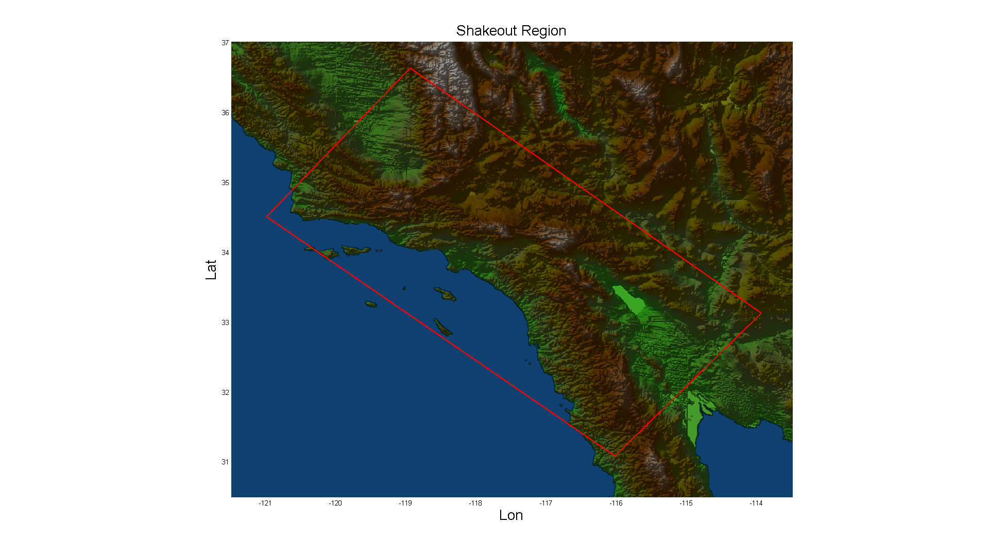
Figure 5

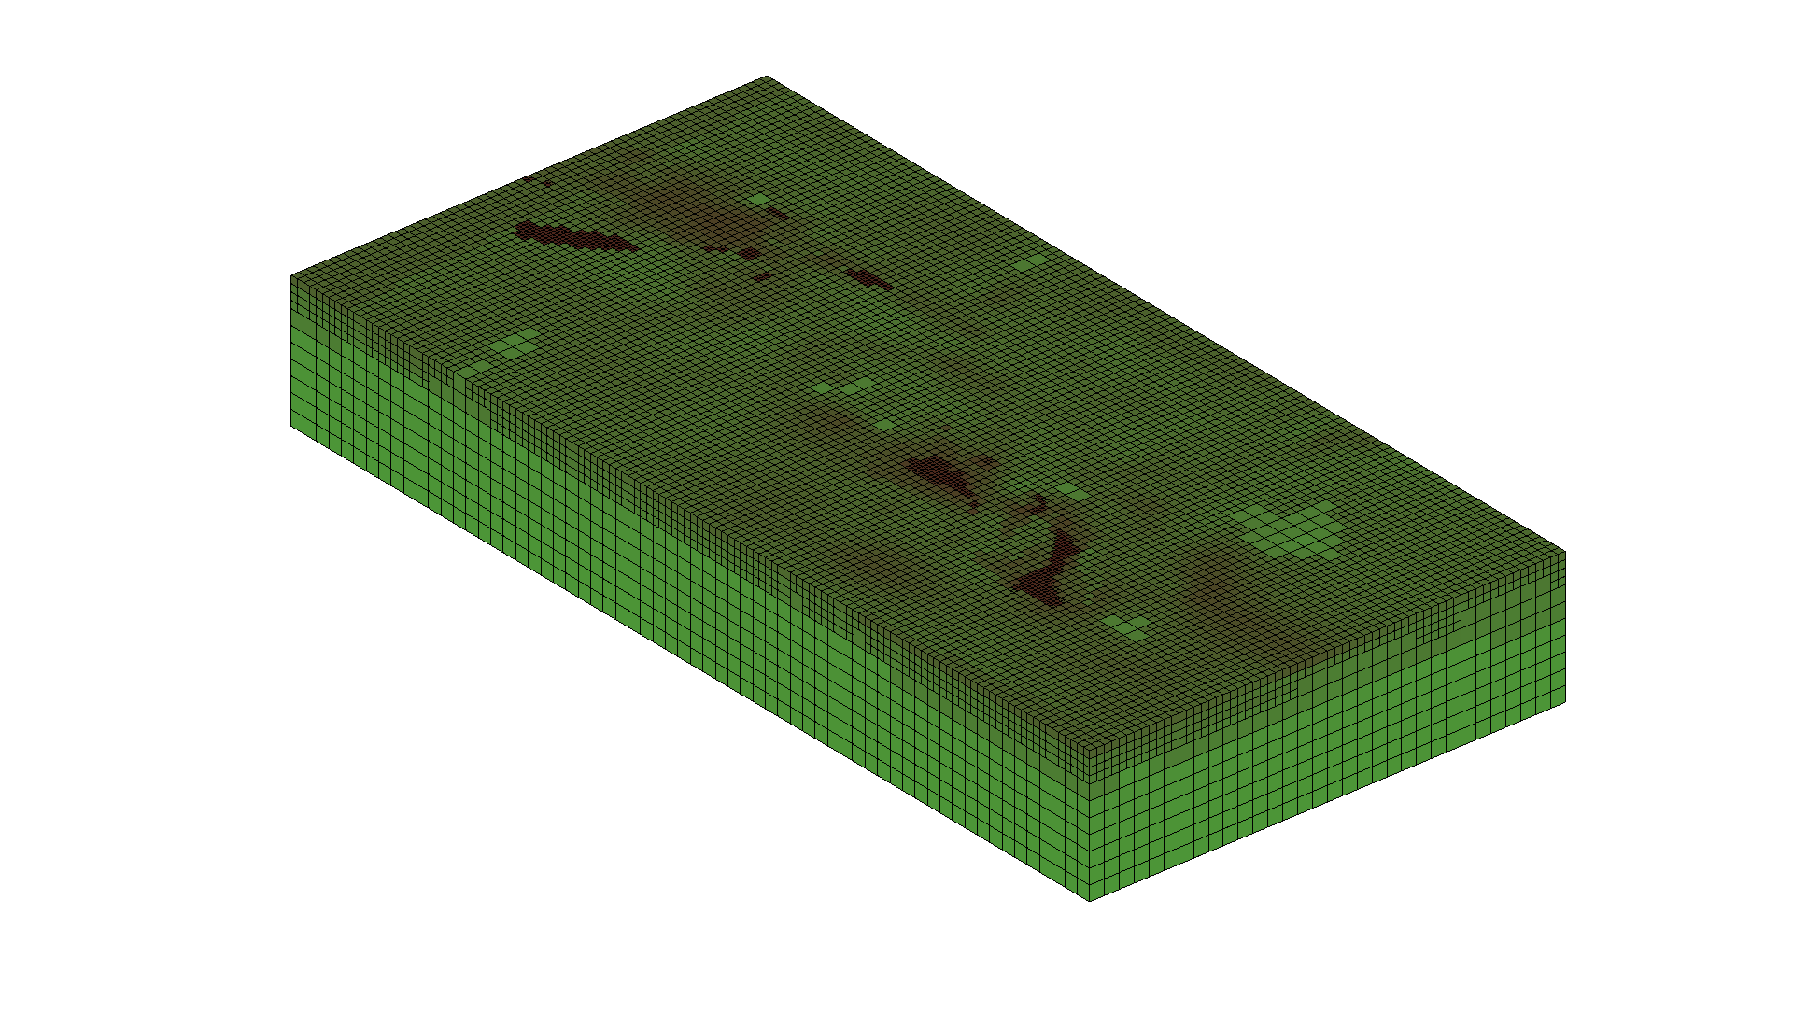
Figure 6

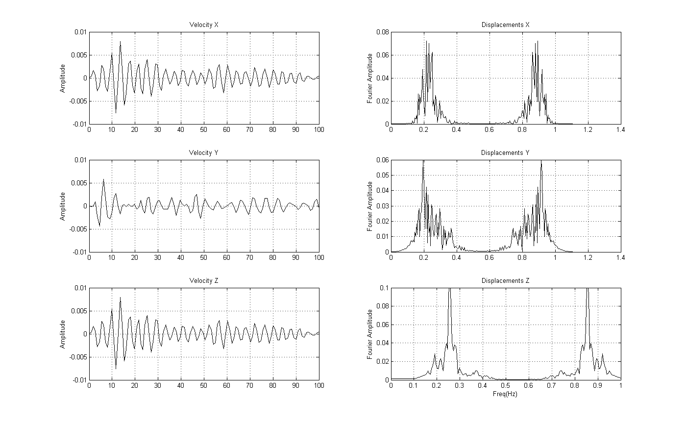
Figure 7

###############################################################################
# #
# source.in: Source quantities input file to CMU FEM toolchain. #
# Lines start with # are comments. Empty lines are ignored. #
# #
# Revised version that facilitate parameter conversions. #
# Leonardo Ramirez 2006 #
# #
###############################################################################

###############################################################################
#
# FILTER RELATED (ONLY BUTTERWORTH )
#
###############################################################################

source_is_filtered = 0

threshold_frequency = .3

number_of_poles = 22

###############################################################################
#
# SOURCE DESCRIPTION
# Event ID: 14179736 (Ml5.1, 1 Sep 2005)
#
###############################################################################

type_of_source = point

source_function_type = quadratic

average_risetime_sec = 1.474

#moment_amplitude = 5.82E+16
moment_magnitude = 5.11

# 0-lonlat 1-cartesian
lonlat_or_cartesian = 0

hypocenter_lat_deg = 33.16

hypocenter_long_deg =-115.62

hypocenter_depth_m = 5000

source_strike_deg = 241

source_dip_deg = 77

source_rake_deg = -15

###############################################################################
#
# Given the corners we make a mapping to localize the source in the "box
# domain". The interpolation is linear. If lonlat_or_cartesian = 1 it is not
# necessary
#
###############################################################################

domain_surface_corners =
-121.0 34.5
-118.951292 36.621696
-113.943965 33.122341
-116.032285 31.082920

B4.-A small earthquake in the Terashake domain. Comparison SDSC and Data

###############################################################################
# #
# source.in: Source quantities input file to CMU FEM toolchain. #
# Lines start with # are comments. Empty lines are ignored. #
# #
# Revised version that facilitate parameter conversions. #
# Leonardo Ramirez 2006 #
# #
###############################################################################

###############################################################################
#
# FILTER RELATED (ONLY BUTTERWORTH )
#
###############################################################################

source_is_filtered = 1

threshold_frequency = .5

number_of_poles = 22

###############################################################################
#
# SOURCE DESCRIPTION
#
###############################################################################

source_function_type = discrete

type_of_source = srfh

number_of_point_sources = 1

domain_surface_corners =

-121.0 34.5
-118.951292 36.621696
-113.943965 33.122341
-116.032285 31.082920

Appendix
Source parameters description

Type of source and filter parameters.-Four types of formats are allowed and a Butterworth filter is implemented in Hercules. The options are as follow

Parameter | Description
source_is_filtered | 0 if no filtering  1 if the source is filtered
threshold_frequency | the frequency threshold
number_of_poles | the number of poles in the Butterworth filter
type_of_source | point  plane  planewithkinks  srfh

type_of_source = Point

This type of source is a good representation for small earthquakes.

Parameter | Description
source_function_type | Is the function that describes the slip time history. Hercules has implemented the following:  ramp  sine  quadratic  ricker  exponential  discrete ( only if srhf )
average_risetime_sec | The meaning differs depending on the source function type, but in most of them is the time the dislocation takes to reach its maximum value of slip.
Moment_amplitude | M0 you can give either this quantity or Mw
Moment_magnitude | Mw
Lonlat_or_cartesian | - GMT system  - Cartesian system
hypocenter_x or hypocenter_lat_deg | Location of the source
hypocenter_y or hypocenter_long_deg
hypocenter_depth_m
Source_strike_deg | Strike
Source_dip_deg | Dip
Source_rake_deg | Rake
If Lonlat_or_cartesian == 0
domain_surface_corners | The list of the corners of the surface  Lon1 Lat1  Lon2 Lat2  Lon3 Lat3  Lon4 Lat4

type_of_source = SRFH

Is the Standard Rupture Fault format in Hercules

Parameter | Description
source_function_type | Is the function that describes the slip time history. Hercules has implemented the following:  ramp  sine  quadratic  ricker  exponential  discrete ( only if srhf )
number_of_point_sources
domain_surface_corners | The list of the corners of the surface  Lon1 Lat1  Lon2 Lat2  Lon3 Lat3  Lon4 Lat4
Files
coords.in | A list ( size = number_of_point_sources ) of coordinates with  Lon[0] Lat[0] Depth[0]  Lon[1] Lat[1] Depth[1]  … … …
area.in
strike.in
dip.in
rake.in
slip.in
Slipfunction.in | Slip function for every point source, the format:  np delay dt s[0] … s[np]  …  A linear interpolation is assumed and if necessary the last value will be repeated.

