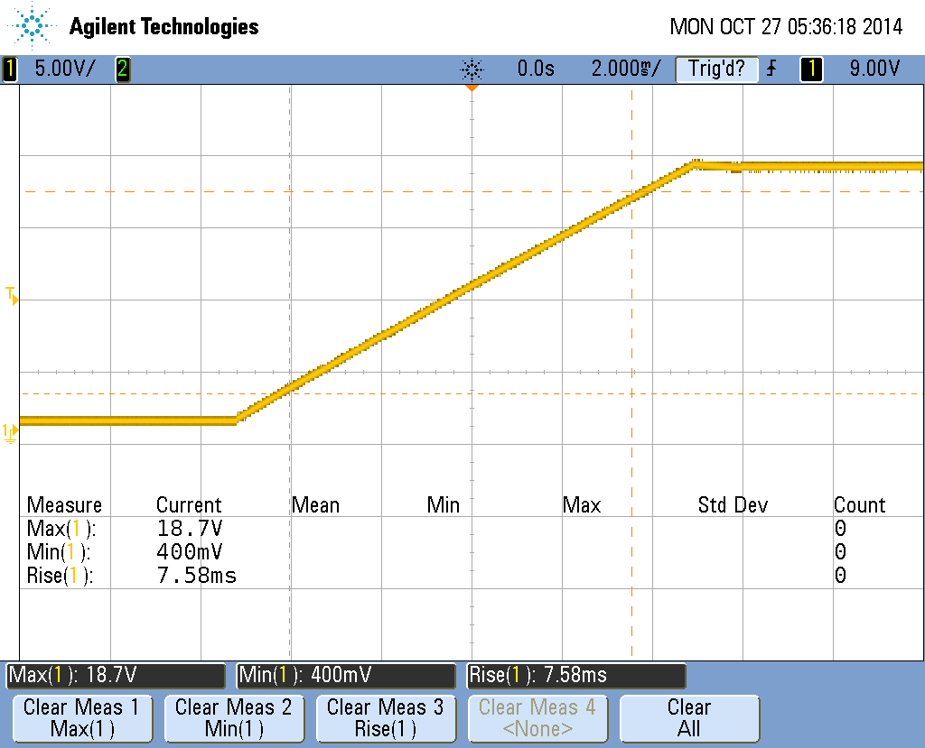

Rise, full swing (0x08 to 0xff), No load

Scope_0

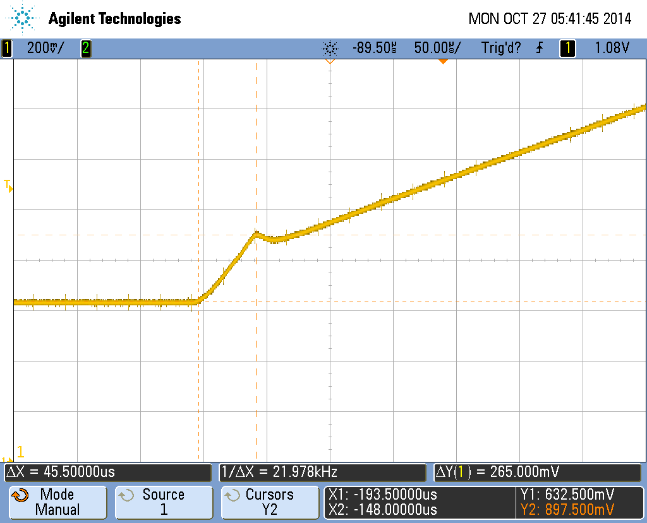

Rise, full swing (0x08 0xff), no load

Focus on startpoint

Scope_1

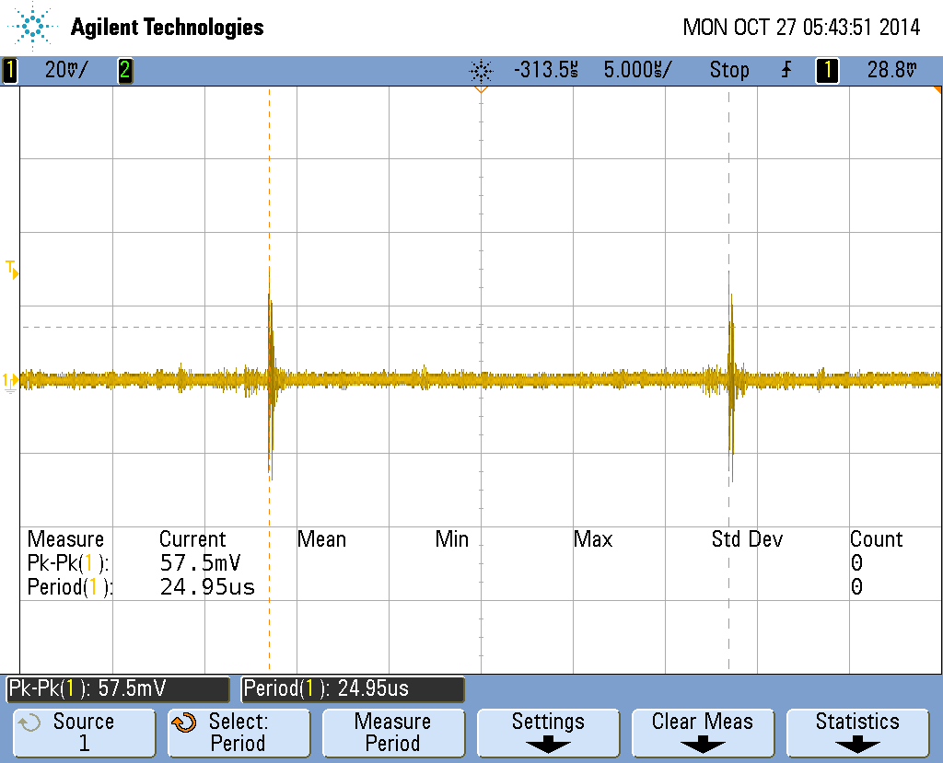

Ripple, 18V, no load

Scope_2

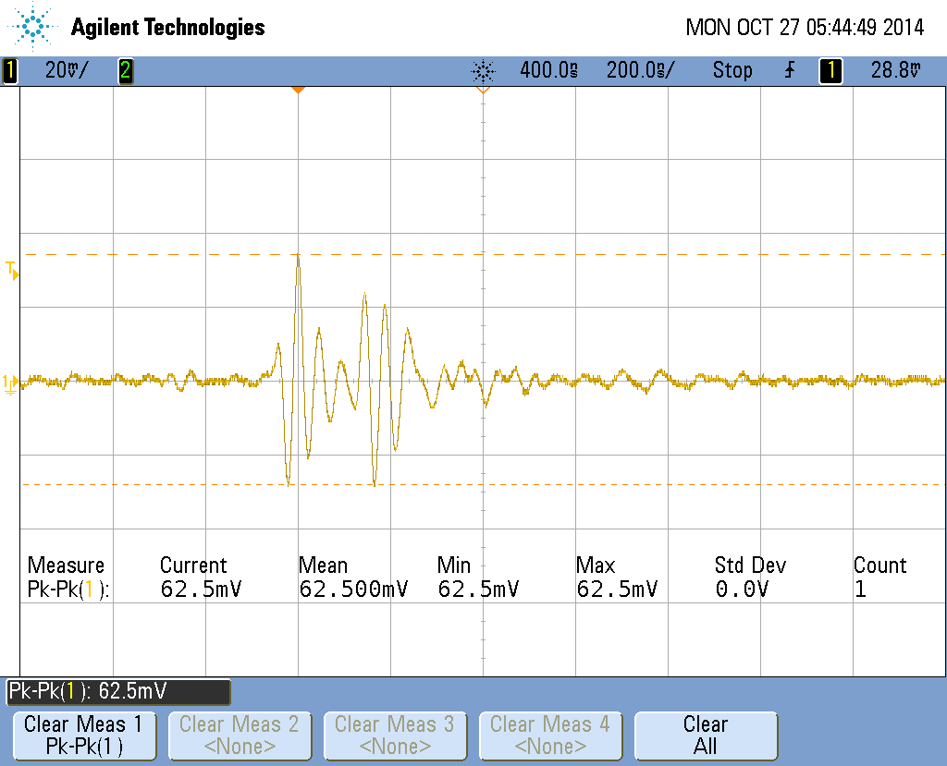

Ripple, 18V, no load

Scope_3

Ripple same for low

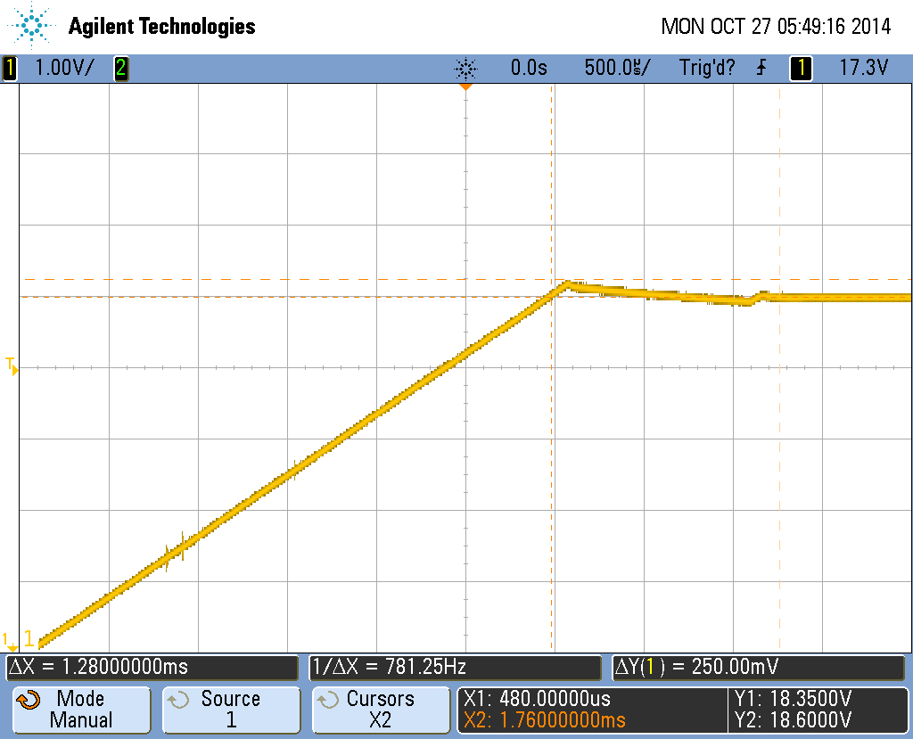

Rise, full swing, no load

End of rise

Scope_4

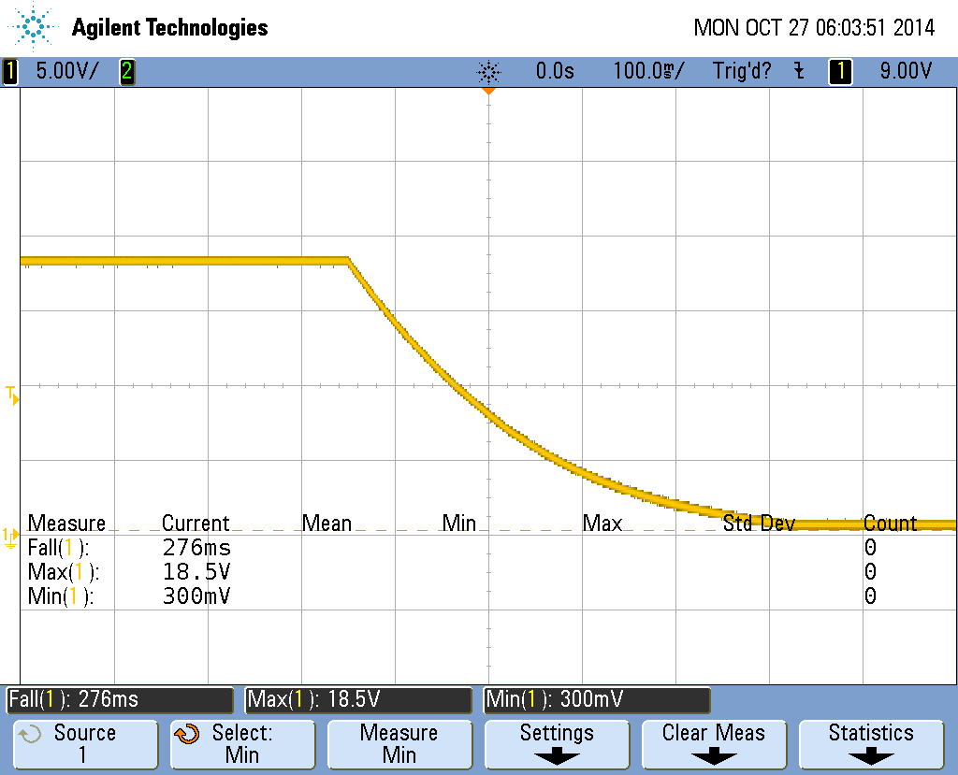

Fall, full swing, no load

Scope_5

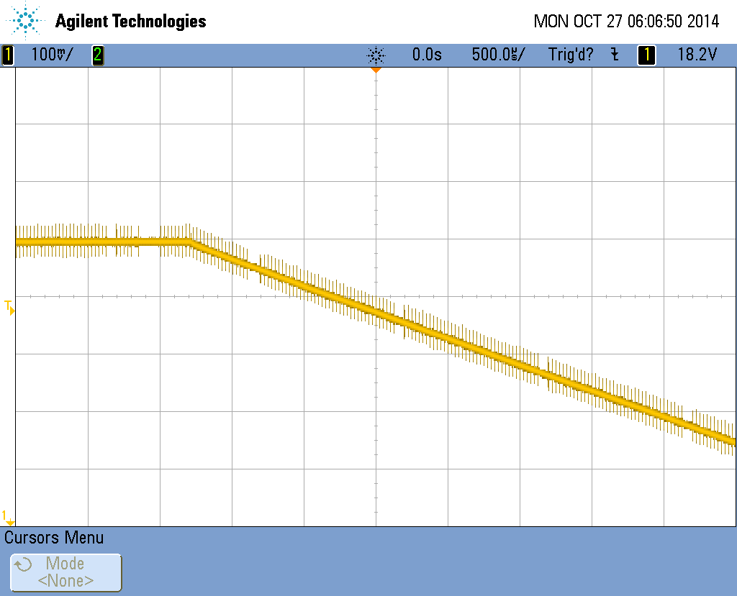

Fall, full swing, no load

Start point

Scope_6

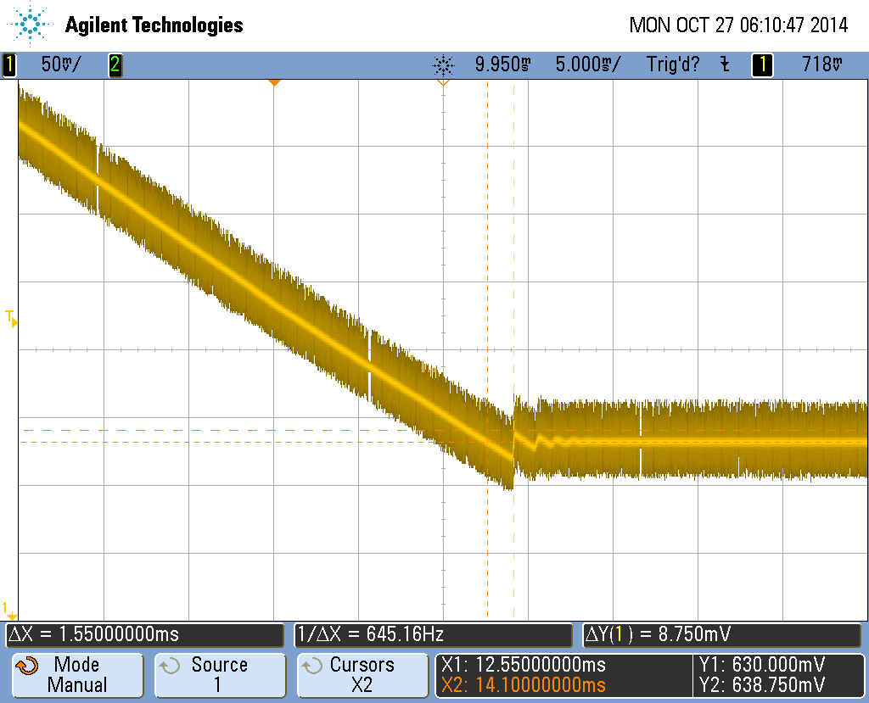

Fall, full swing, no load

Endpoint

Scope_7

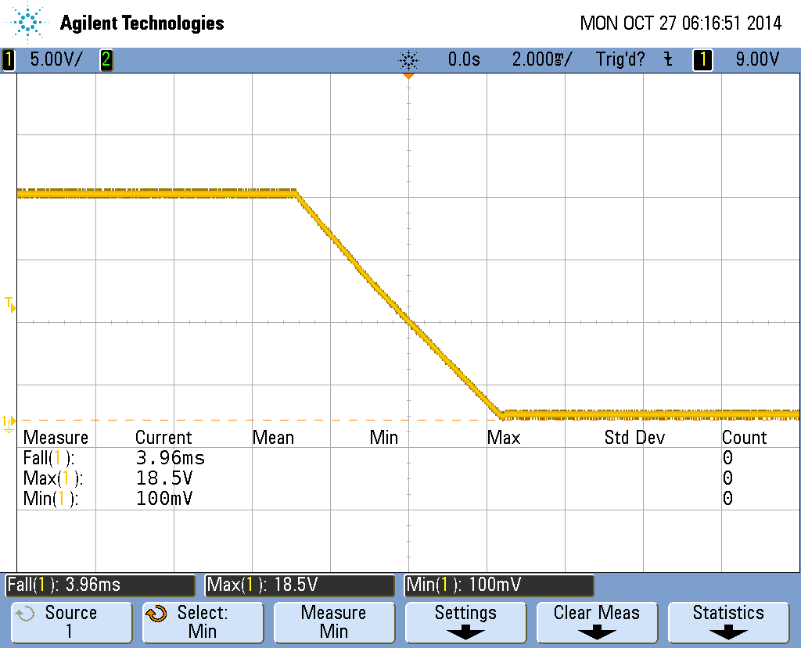

Fall, full swing, 2A load

Scope_8

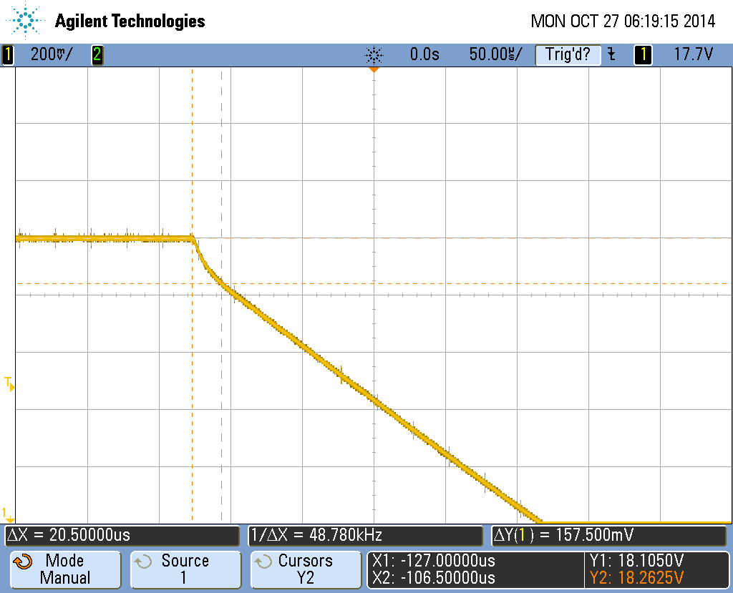

Fall, full swing, 2A load

Scope_9

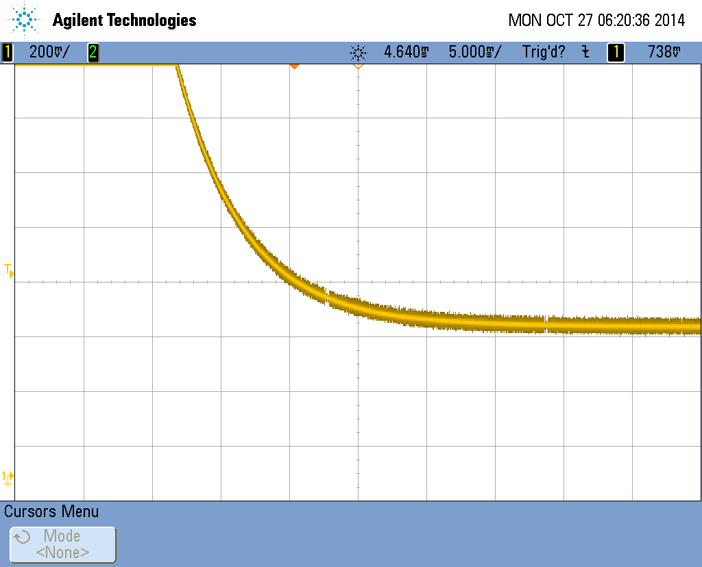

Fall, full swing, 2A load

Scope_10

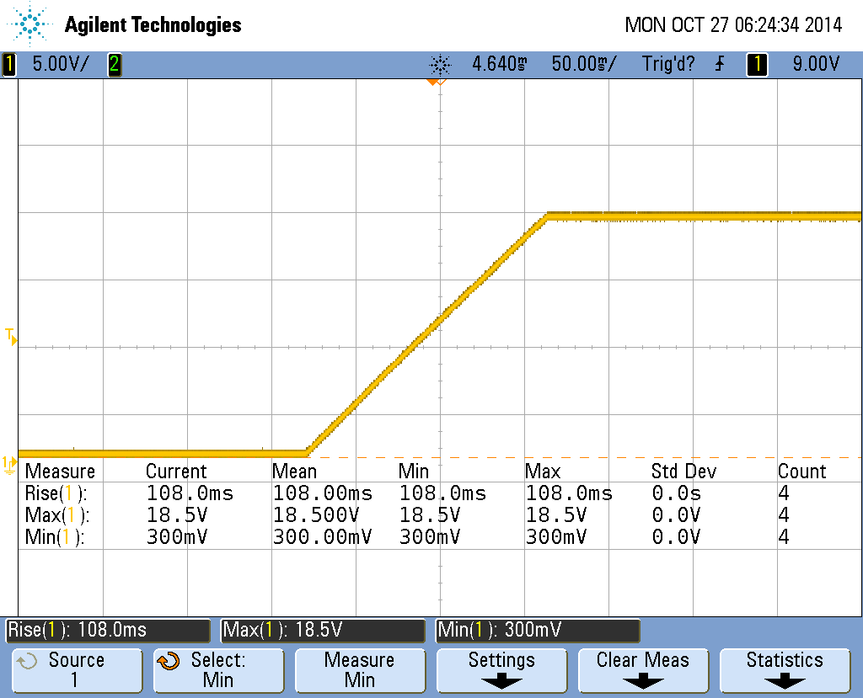

Rise, full swing, 2A load

Scope_11

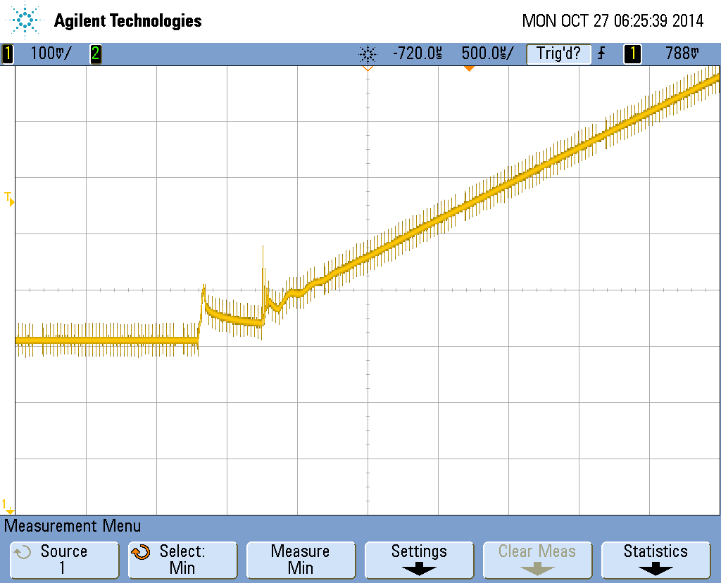

Rise, full swing, 2A load

Scope_12

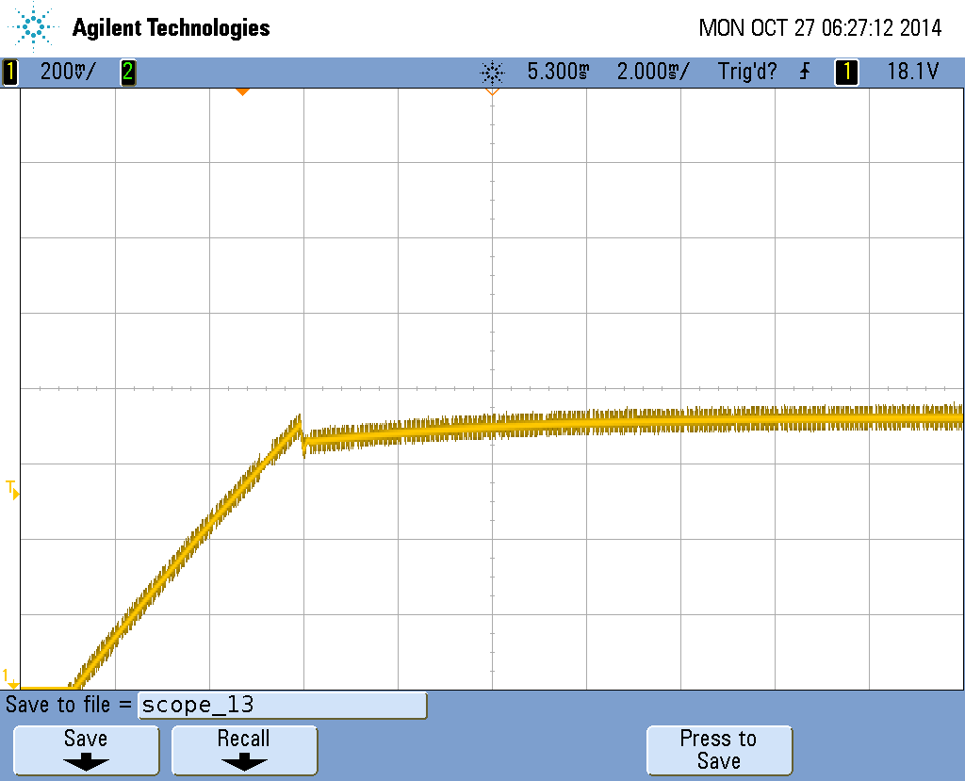

Rise, full swing, 2A load

Scope_13