MatriCalc Link: https://cmu-vis-2021.github.io/assignment-3-rref/

Tile generator visualizer.

On the side, I’m currently working with a team in The Game Creation Society at Carnegie Mellon in making a VR mini-golf game. The thing that makes this game stick out from other virtual reality golfing games is that it is done entirely within the guardian space, which is a user defined safe space outline where they won’t walk into real objects in VR.

The maps are generated procedurally as no two guardians are the same. Currently, mini-golf maps are done by putting tiles into a bounding box. This is not ideal as It severally limits useable space as most guardian outlines are not rectangular shapes, but are instead are contours.

“There has to be a better way,” I thought. So I went to office hours for my Linear Algebra class after taking a midterm and asked the professor what he thought about the problem. He drew something like this:

I haven’t had time to implement into the game just yet, but I figured making a visualization in javascript using p5.js would be a pretty good idea to prototype and understand the algorithm.

I decided to use p5.js for this job as I worked with it before freshmen year and I know that it can handle graphics and animations good enough for what I want to do.

The first thing I programmed was a way to plot define coordinates of an outline by mouse click.

Then, draw a shape out.

Then, draw the outlines out.

Then, make the grid apparent.

At this point, I realized that I got distracted doing visualizations when I should’ve been writing the algorithm 😅. So, I thought about what to do next, “Well, I need to make tile regions and then parse through each of them and see if it’s inside the outline”. That was easy enough, two nested for loops for rows and cols to create points every tileSize.

The hard part was the parsing. So, I googled it. I found this [Geeks for Geeks page](https://www.geeksforgeeks.org/how-to-check-if-a-given-point-lies-inside-a-polygon/#:~:text=1)%20Draw%20a%20horizontal%20line,true%2C%20then%20point%20lies%20outside.), found that they wrote up exactly what I needed in JavaScript and so I copy/pasted it into my algorithm and worked!

The Geeks for Geeks code was actually a pretty large help, as I didn’t realize that by parsing the coordinates and seeing if they were in the shape or not, it removes everything that partially in the shape as well. So now I have only had points that were in the shape. The rest of the algorithm should have been trivial to write up.

At this stage, I was generating tiles mostly in correct places, the problem was is that I was generating them in areas out of bounds. I decided to add another “in shape” check for edges of the tiles. There’s probably a more efficient way of doing it, but it was 1:44AM and the deadline was in less than 24 hours.

At 1:54 (I procrastinated a little bit), I implemented the check… and there was no change. I then stepped through it via debugger:

And there’s the culprit… cubes are being spawned in on the lowest points. I needed to figure out how to prevent that from happening. Before going to bed, I wrote up a check to prevent the square from going out of bounds.

It didn’t work.

The next day, I revisited the function and realized I forgot to initialize something and it worked perfectly.

Thinking about it some more, I realized that I wouldn’t be able to animate this within a timely manner to meet the now extended deadline…

I need to go simpler.

How about matrix addition? Ok. Well I need to in a matrix… let’s hard code it to a 2 by 2 matrix.

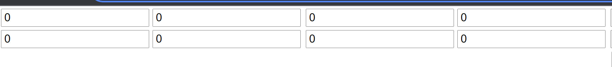

Okay, now I need to have some sort of buttons to parse the data into javascript.

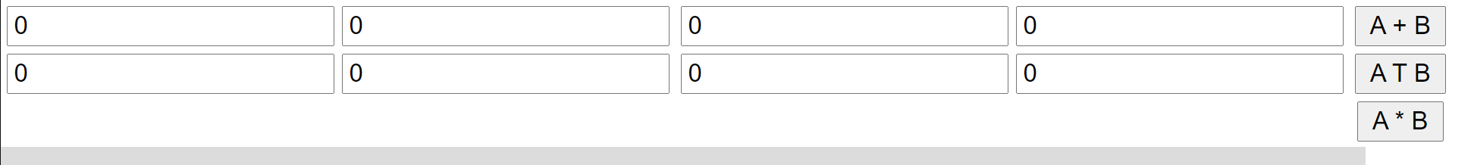

Now I need to get the p5.js canvas going.

So then I programmed back end and displayed the visualization. Easier said than done, it took me like 4 hours because I had to build a data structure that keeps track of the points and the data of each element in the point, as well as the dimensions of the matrix.   
  
Now, when user presses ENTER key work pops up.

Hooray! We now have a Matrix A + Matrix B… I now want to press the down arrow and the work will pop up, element by element. Let’s try doing this automatically at first:

The early signs of a visualization! This took me 2 hours. But now if I make it go by button press it should be easy right?

Press 1

Press 2

Press 3

Press 4… nothing. Damn. And look at the time it’s 3AM. Perhaps there’s something else I can do make it simpler? If I do something like this, I have a basic interactive visualization.

Step 1: User inputs matrice A and B.

Step 2: User presses either the ADD or SUBTRACT button (both functionality implemented already)

Step 3: Program outputs this:

Step 4: Right below that it outputs this:

And there’s my interactivity. Time to do it.

See it works! Hooray 😊

Hmmm… thinking about it now, I kind of want it to output latex. Would be pretty cool as there aren’t (I think) any other calculators out there that implement latex output.

I done.