14. Jan. 2026
15-112 Recitation: Week 2
(NO COMPUTERS ALLOWED !!)
Topics covered:
- Introduction to Computing
- Data and Expression
- Variables and Functions
- Conditionals
- Concept Review: For 5 minutes, discuss with your peer about the topics mentioned above. If something is unclear, we will discuss it during reciprocal questioning.
- Code Tracing
Code | Output
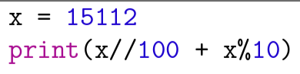
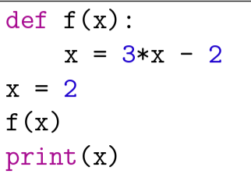
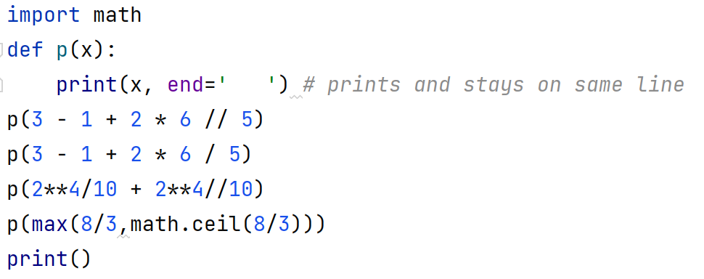
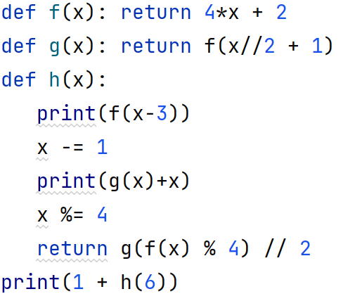
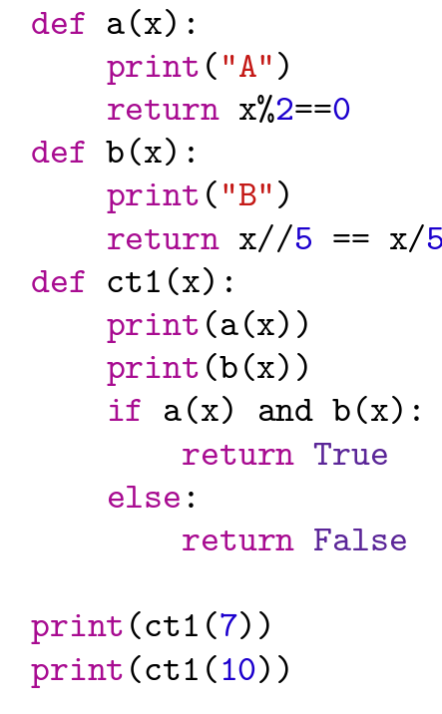
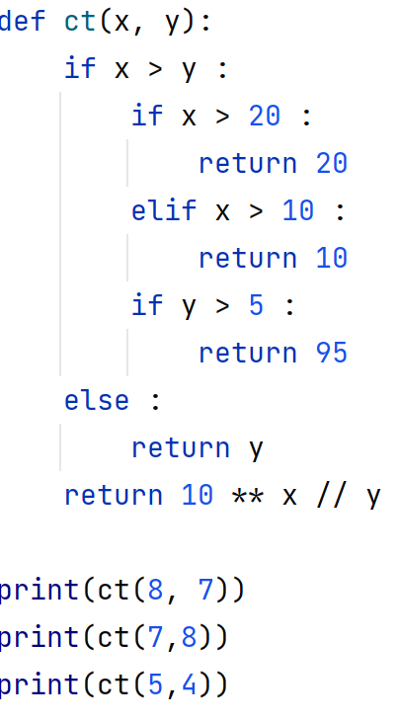
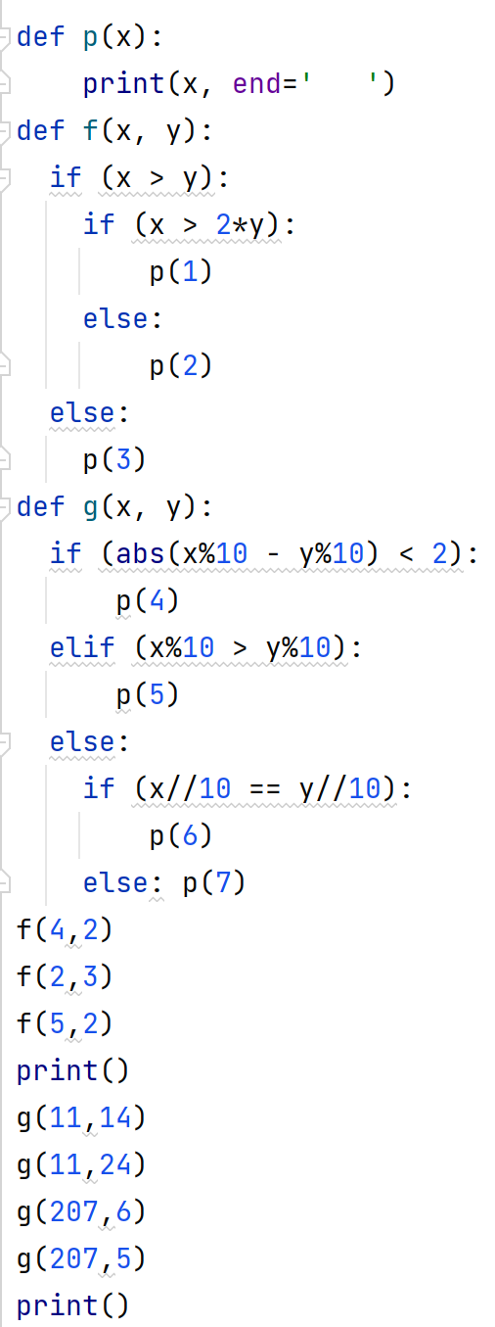

- Free Response
  - Motaz and Wael are playing with spherical balloons. Motaz’s balloon starts to shrink and became smaller than Wael’s. Motaz asks Wael to share his balloon, but Wael says that he will share only if Motaz guesses how many small balloons the big balloon can hold. Since Motaz does not have a calculator, he calls you and gives you the radii of both balloons. Please help Motaz by creating a function which takes r1 and r2 as radii of the big and small balloons respectively and finding how many small balloons will fit into the big balloon.
Example :
balloon_theory(16 , 8 ) returns 8
balloon_theory(7 , 4) returns 5
balloon_theory(7.5, 2.5) return 27
  - A number is termed funny if the number has exactly 4 digits and the second digit is even, while the third digit is odd. 1234 is funny, but 1324 is not. Create a function isFunny(n) which would take a number as input and return True if the number is funny and False otherwise.
  - Write a function significant(x) which takes a 1-, 3- or 5-digit integer x, and returns an integer y that has the number of digits ‘n’ at ten’s place and the most significant digit of x at one’s place. (Most significant digit is the left most digit). For example, if x is equal to 313, y should be equal to 33.
  - Write the function pairedNumber(n) that returns True if the six digit number n contains a matching set of three, two digit numbers in order, and False otherwise. For example... pairedNumber(121212) returns True (the three, two digit numbers are 12, 12, and 12) pairedNumber(121312) returns False (one of the two digit numbers is 13) pairedNumber(1212) returns False (there are only two, two digit numbers) pairedNumber(565656) returns True
pairedNumber(555) returns False
- Reciprocal Questioning
This time can be used to ask me problems you want to solve, or review concepts that needs explanation. Bring it.

