Jan. 21, 2026
15-112 Recitation For Quiz 2 - Loops

- Concept Review
Rewrite the code below using while loop.
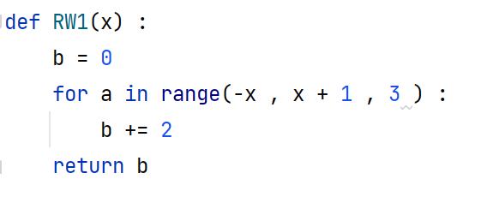
- Code Tracing
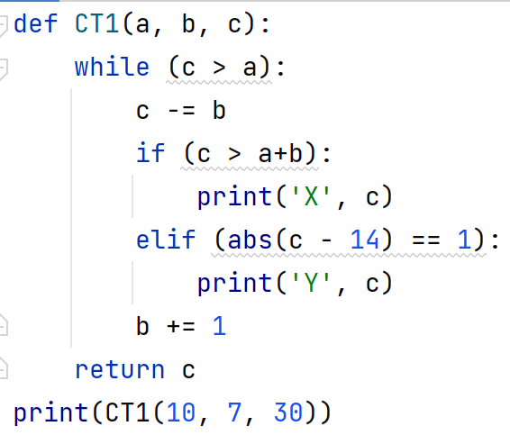
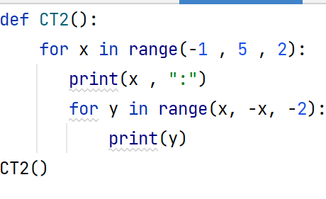
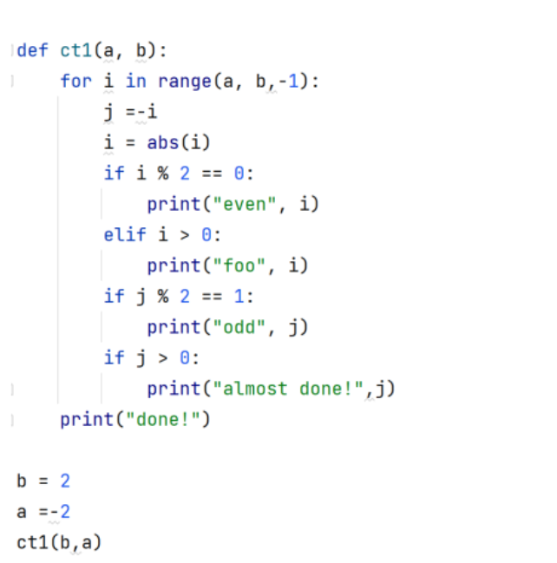
- Free Response

FR1. A number is termed Witty if the number begins or ends with an even number, but not both. 2 is a not a Witty number, but 21 is. Create a function nthWittyCompositeNumber(n) to find the nth witty number which is also a composite. Use helper functions wherever necessary.

FR2. Two numbers are twins if they both consist of the same digits. For example, -12321213132 and 213 are twins while 123 and 12 are not. Create a function areTwins(num1, num2) which takes in two numbers and returns True if they are twins, and False otherwise.

FR3. Count Narrow Numbers: A narrow number (coined term) is an integer whose digit sum is equal to its length (without leading zeros); for example, 1 is a narrow number because its length equals 1, and the sum of its digits also equals 1. 12 is not a narrow number, as the sum of its digits is not equal to 2. 20 is a
narrow number because its length and the sum of its digits are both equal to 2.

Write the function countNarrowNumbers(a, b), which takes two positive integers a and b
and returns the number of narrow numbers that exist between a and b (inclusive).

countNarrowNumbers(1, 20) returns 3 (1, 11, and 20 )
countNarrowNumbers(1,50) also returns 3 (1, 11, and 20 )
countNarrowNumbers(1,300) returns 9 (1, 11, 20, 102, 111, 120 201, 210, 300)
countNarrowNumbers(100, 150) returns 3 (102, 111, and 120)

