Jan. 28, 2026
15-112 Recitation For Quiz 3 - Strings
- Code Tracing
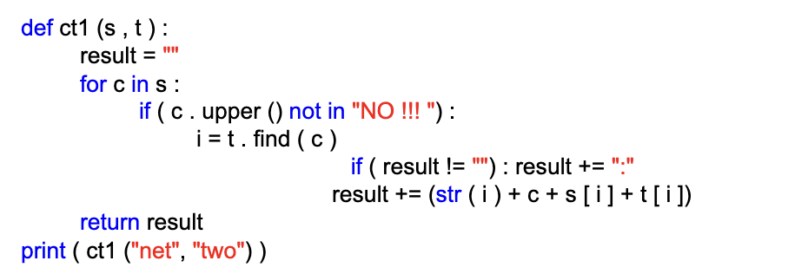
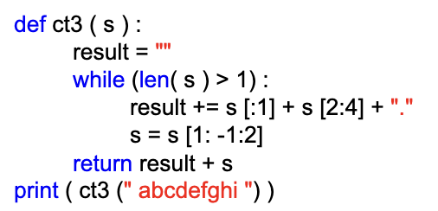
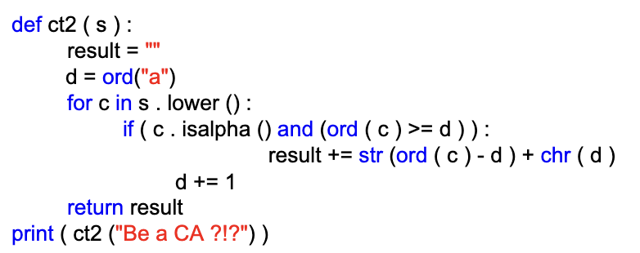

- Free Response
FR1. Write the function hasBalancedParentheses(s) which takes a string and re turns True if that code has balanced parentheses and False otherwise
We say that parentheses are balanced if each right parenthesis closes (matches) an open (unmatched) left parenthesis, and no left parentheses are left unclosed (unmatched) at the end of the text. So, for example, ”( ( ( ) ( ) ) ( ) )” is balanced, but ”( ) )” is not balanced, and ”( ) ) (” is also not balanced.
Hint: keep track of how many right parentheses remain unmatched as you iterate over the string.
assert hasBalancedParentheses("()") == True
assert hasBalancedParentheses("( ) ( )") == True
assert hasBalancedParentheses("((()))") == True
assert hasBalancedParentheses("())") == False
assert hasBalancedParentheses("(()") == False
assert hasBalancedParentheses("((()())(()))") == True 3

FR2. Write the function replaceWithIndex(s1, s2) that takes as input two strings (s1, s2); where s2 characters are unique and len(s2) is less than 10. It returns a modified version of s1 where all characters that appear in s2 are replaced by the index at which they appear in s2.

YOU CANNOT USE s.replace() or s.find() !!!!
# Test cases
assert(replaceWithIndex("programming", "ogm") == "pr01ra22in1") assert(replaceWithIndex("hello world", "world") == "he331 01234") assert(replaceWithIndex("persistence", "go") == "persistence") # no common chars assert(replaceWithIndex("112", "") == "112") # no common chars assert(replaceWithIndex("", "Python") == "") # no common chars
Once again, do not use s.replace() or s.find()

FR3. We will consider a word in some text to be an important word if it starts with a capital letter.
The end of an important word is signified by either a space, a comma, a period, or the end of
the text. For example, consider the string, "The Quick Red, foxJumped over the lazy brown
Dog.and got Away". The important words in this strings are: “The”, “Quick”, “Red”,
“Jumped”, “Dog”, and “Away”.

With this in mind, write the function getImpWords(s) that returns a string of all of the
important words in s. From the example above,
getImpWords("The Quick Red, foxJumped over the lazy brown Dog.and got Away")
should return 'TheQuickRedJumpedDogAway’

