Feb. 9, 2026
15-112 Recitation For Quiz 4 - Graphics and Lists

- Code Tracing
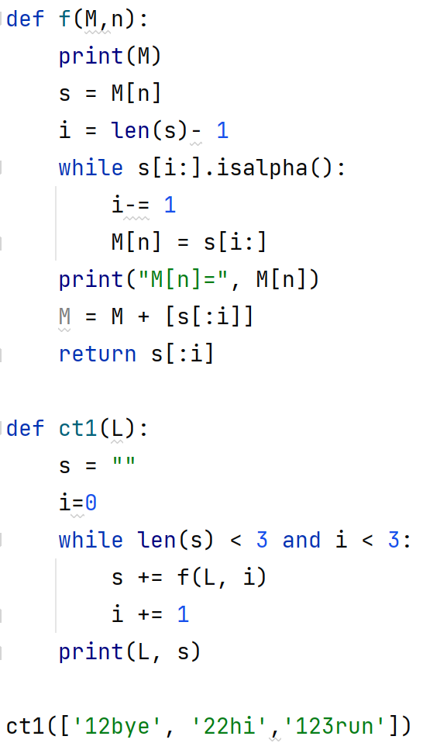
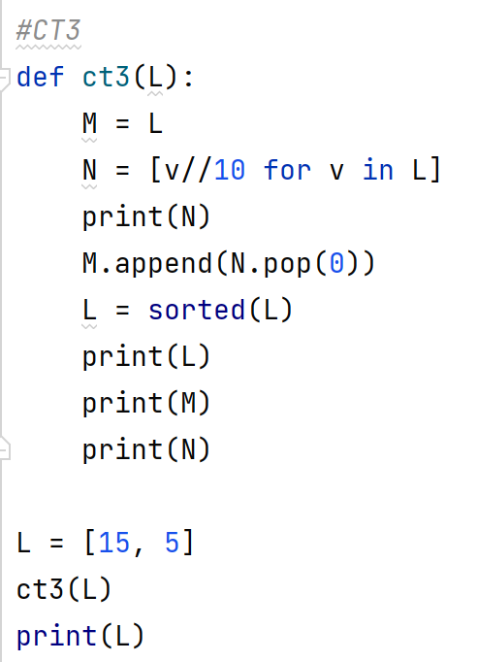
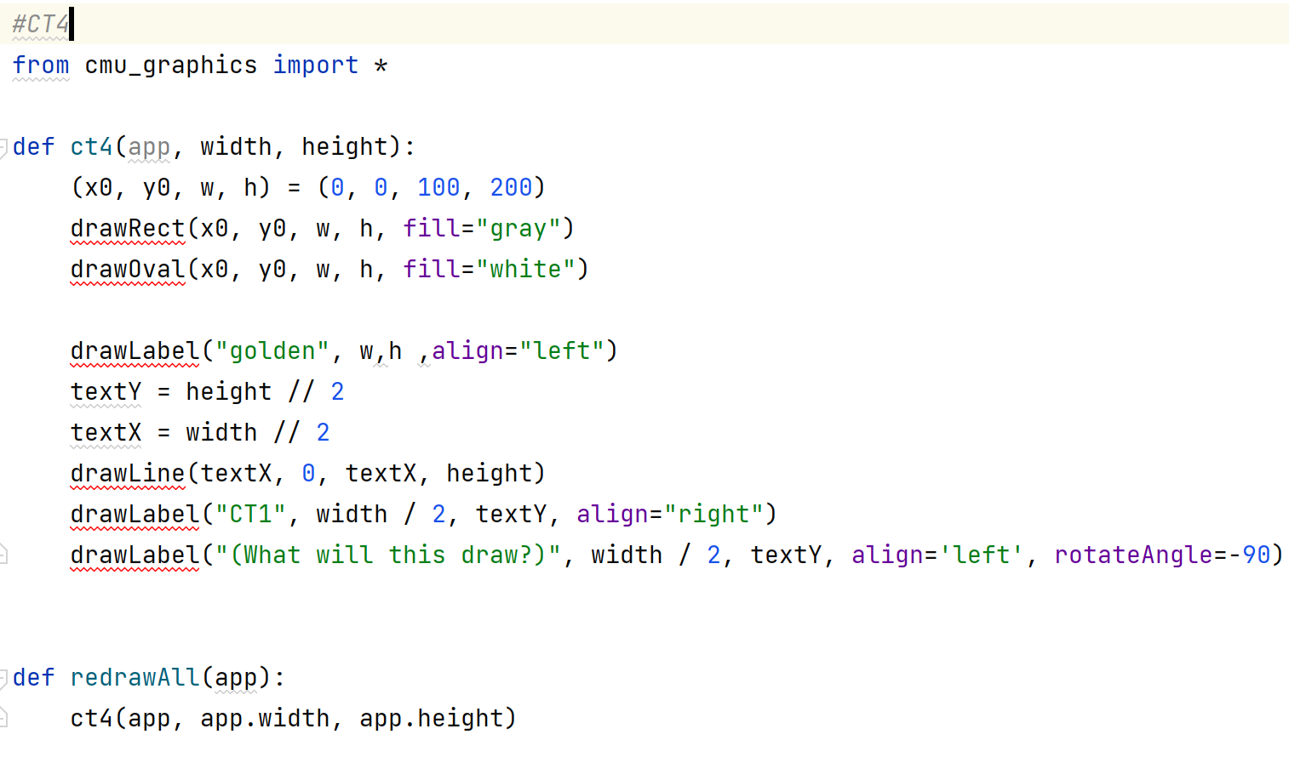 | 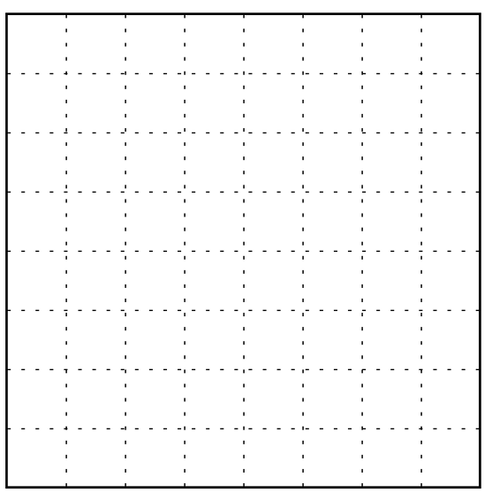

- Free Response

FR1. Graphics: Tic-Tac-Toe
Write the function drawTicTacToe(app, s), which draws a 3x3 TicTacToe board game with Xs and Os. The function takes as an input a string s that specifies the content of the nine board cells. Each character of s refers to one cell and specifies whether it has X ('x'), O ('o'), or Nothing ('_'). The first character in s corresponds to the first cell which is the top-left one and the last character corresponds to the last cell which is the right-bottom one. Consider the following two examples:

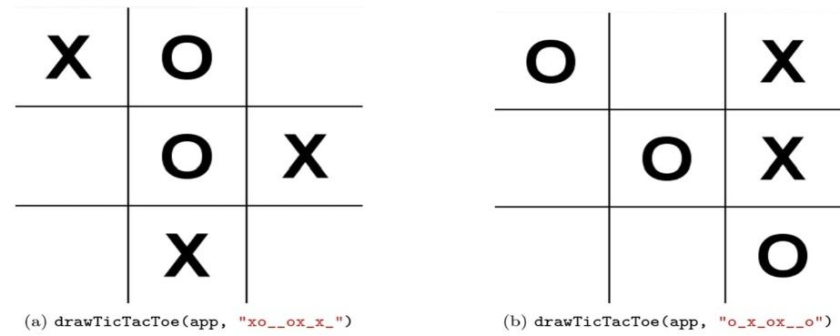

FR3. Lists: List Rotator
In this problem you will write the same function two ways. listRotator(lst, k) takes a list lst and an integer k as inputs and rotates the list k positions to the right. The function returns the rotated list. Consider the following test cases:

assert(listRotator(['CMU', '112', 'Exam'], 2) == ['112', 'Exam', 'CMU'])
assert(listRotator([1, 2, 3, 4, 5], 3) == [3, 4, 5, 1, 2])
assert(listRotator([], 5) == [])

- Write the function using a loop where, during each iteration of the loop, the list is rotated once.
- Write the function without using any loops, instead relying on list slicing. (This is not a recursion problem, so don’t do it recursively, either.)

