Project3 Workflow

Team
Edward Akoto(Co-ordinator)
Lydian Lee
Madhok Shivaratre
Rashmi Devarahalli
Vidya Pissaye

Fall, 2012
96-705 Architecture and Design
Jia Zhang
Table of Contents
Scope
Concerns
Principles
Constraints
Functional View
Information View
Data Schema
Data Flow
Deployment View
Glossary
References

Scope
The objective of the system is to provide a real-time prediction along with recommendation for user’s itinerary. By providing the airlines and the expected itinerary time and city, user can get the flight service prediction and also the alternatives if the given flight is failed to provide good service quality in the prediction.

Concerns
The key architectural concern is performance speed. We aim at designing an application architecture that leverages the use of SAP HANA’s real-time analytics capabilities, while eliminating all possible causes of delays that can be experienced when processing a cloud-based flight investigation system.

Principles
The following are the principles that are considered when designing the architecture for this project.
Separation of concerns - The application is divided into distinct features and functions with very little overlapping of functionalities. Since the functions identified are distinct with minimum interaction points, low cohesion and high coupling between the functionalities can be achieved.
Single Responsibility - Each module identified has a separate and distinct function to perform. Each module is responsible for achieving a specific feature. For example, the Travel Investigator module will only predict delays and the Data collector is responsible for collecting the past weather and flight information.
Least Knowledge - Each module is aware of only the functionality that it is responsible for. No module knows the internal details of other modules. For example, the Alternate Recommender module will only be aware of the function that it is responsible for. It will have no knowledge about what the Travel Investigator module does.
Don’t repeat yourself - a designated module achieves each feature/function. There is no feature overlapping between modules. No two modules will perform the same function.
Keep it simple - The architecture is designed to be simple so that it is easy to implement and understand.

Constraints
- The precision(quality) of prediction is based on the mathematical model that will be used. Since the mathematical model is not designed and developed by us, we do not have much control on the precision of the prediction results.

- Public data is used as the data sources for the air time delay and past weather details and the accuracy of the prediction results depends on the correctness of this public data.

- Weather is the only factor considered to investigate the delay in air travel. There might be other factors like airport construction, air flight repair, airline strikes etc., that might affect the travel.

Functional View
The functional view captures the modules in the application as per their functionality and the interaction between them.

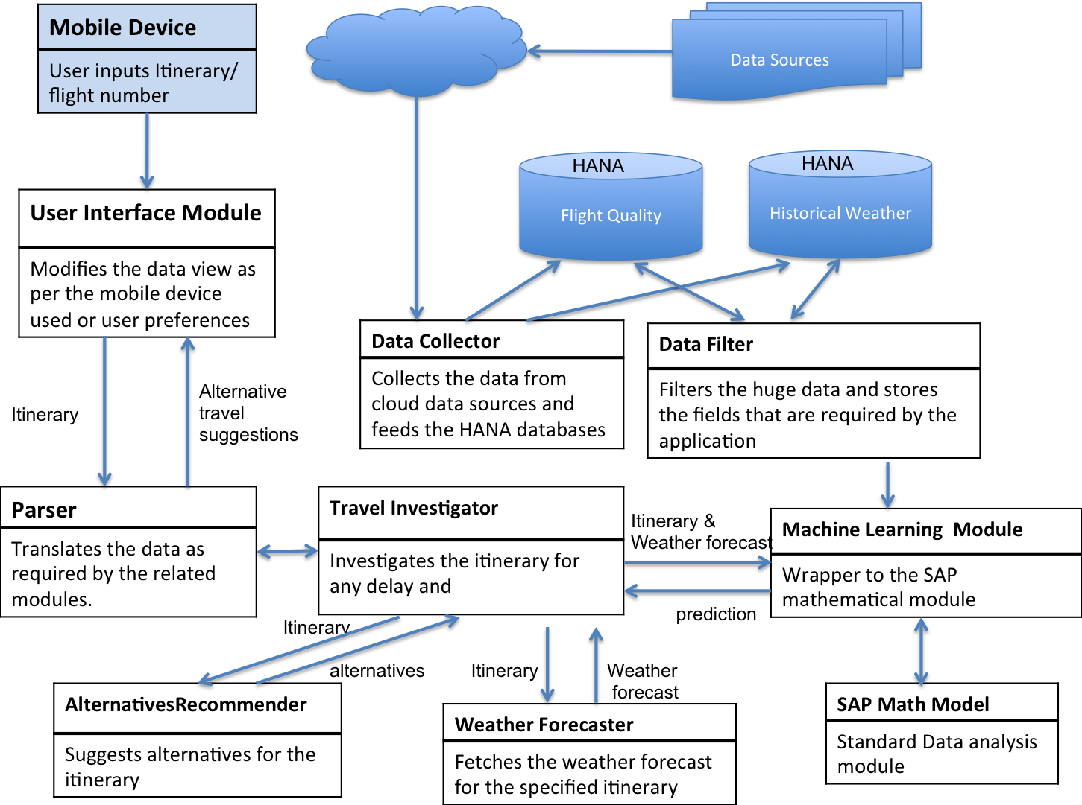
Figure 1 - Functional View

The different functional entities in the application are explained below:
1. User interface module
This module is responsible for receiving the user input and presenting the prediction data back to the user. It also takes care of rendering the view as per the mobile device used and display preferences of the user.

2. Parser
This module acts as a translator between the user interface module and the travel investigator. User can input either the flight number or the detailed itinerary. This module parses the different types of user inputs and provides the itinerary fields as required by the travel investigator module. It also translates the prediction result data of the travel investigator to the format understood by the user interface module.

3. Data Collector
This module collects the required data through the cloud from external data sources like ‘air time delay data source’ and ‘past weather data source’ and stores it in the SAP HANA database used by the application.

4. Data filter
This module filters the large volume of data and updates the HANA database to store the relevant data as required by the application. This module provides the historical data to the machine learning module.

5. Travel investigator
This module acts as the main coordinator module that communicates with other modules like the parser, weather forecaster, machine-learning module and alternatives-recommender to provide the information needed by the user.

6. Weather forecaster
This module fetches the weather forecast for the itinerary of the user.

7. Machine learning module
This module acts as a wrapper to the SAP mathematical module. It receives the itinerary and weather forecast from the travel-investigator module and historical data from the Data filter module and feeds this information to the SAP mathematical module. It then provides the prediction results as analyzed by the SAP mathematical module back to the travel-investigator.

8. SAP mathematical model
This is the standard mathematical model from SAP that does the data analysis.
9. AlternativesRecommender
This module takes in the itinerary and suggests alternative travel arrangements, by referring to external sources like flight schedules, car rentals and hotels.

Information View
The information view is comprised of the data schema (Figure 2) and data flows (Figure 3)
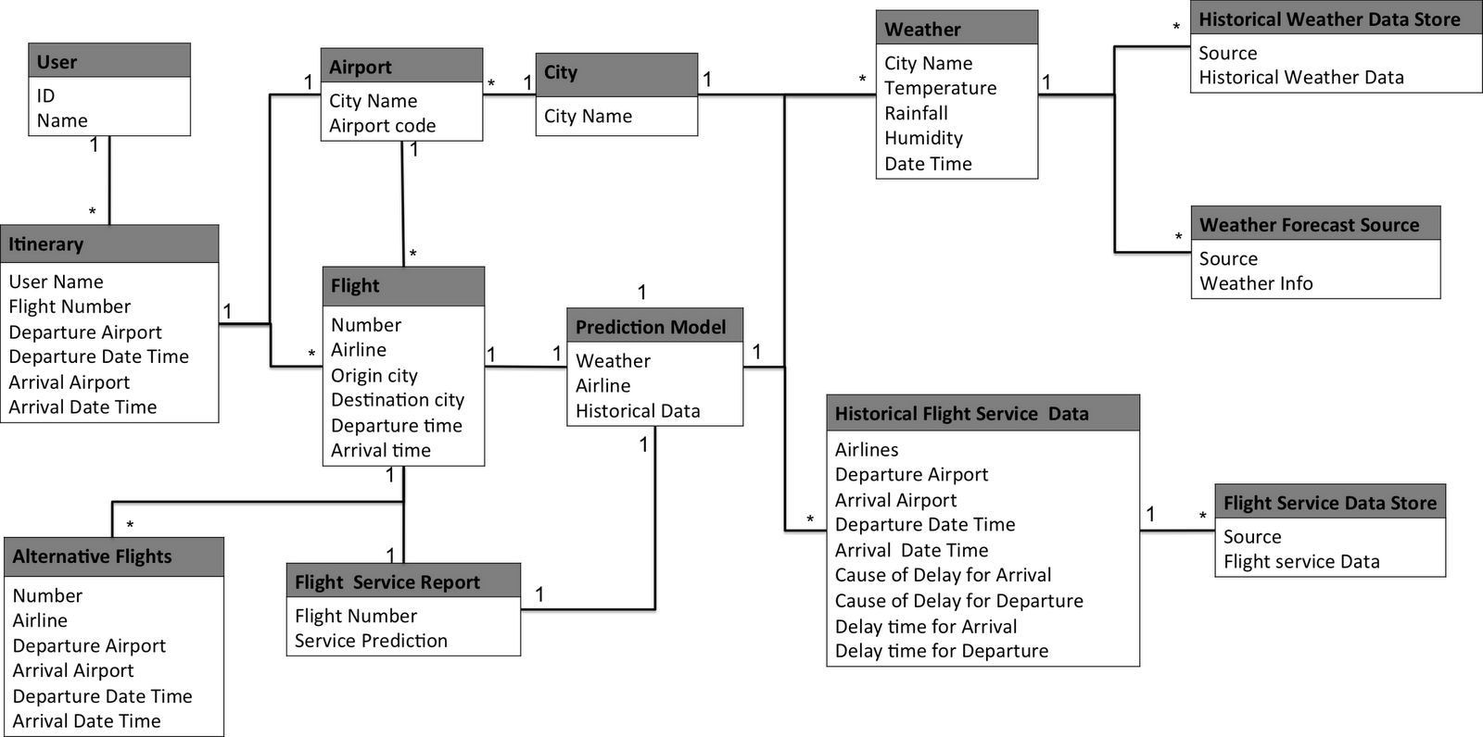

Figure 2 - Data Schema

Data Schema
The data model consists the following models:
- User: basic user information
- Itinerary: The traveling plan, including expected itinerary date time(departure/arrival) and city(departure/arrival)
- Airport: Airport code and the city it belongs to
- City: the city name and average weather
- Flight: a flight information, including airlines, departure and arrival city and time.
- Weather: represent a weather of a city at a given time
- Prediction Model: The service quality prediction based on weather and flight
- Historical Flight Service Data: the historical service quality data of the airline
- Flight Service Report: the predict result of the flight quality
- Alternative Flights: the recommendation of alternative flights
- Data Stores: The external information
  - Historical weather
  - weather forecast
  - Flight service data
A user based on his/her expectations of specific itinerary, could have multiple flights, according to user’s preference. For each city, it has multiple airports and multiple weather record( Forecast and historical data). For each airport, it contains many flight. For each flight, we also have several historical service data. Based on these information, we can than gather a prediction model. For each flight, the prediction model generates the service report as well as the alternative flights.

Data Flow

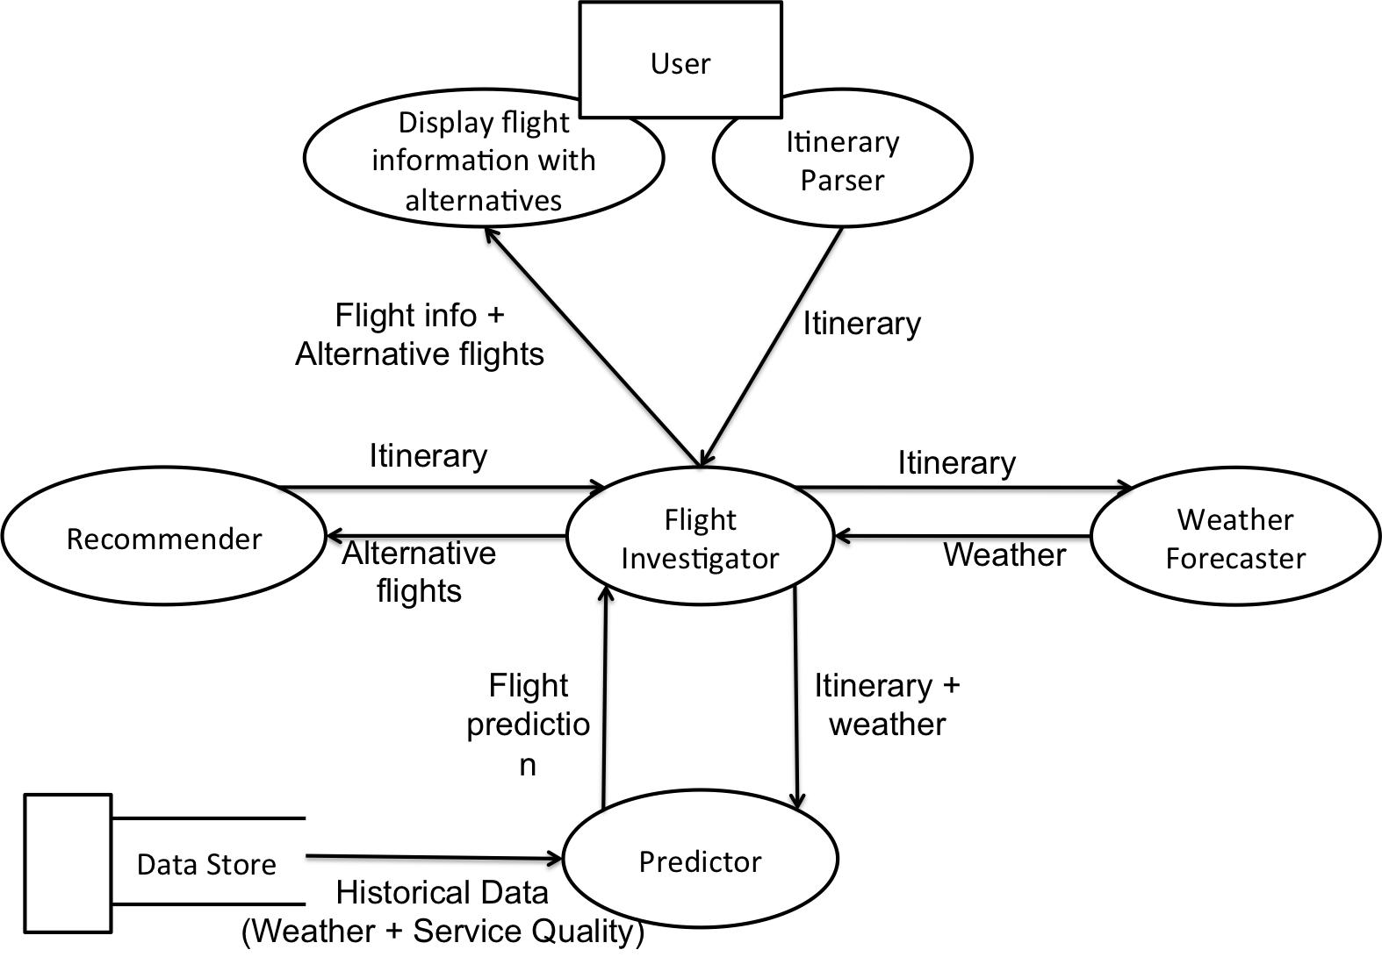
Figure 3 - Data Flow
The data flow shows that at first user given itinerary information. These given information will be parsed into itinerary object and send to flight investigator. Based on the information from itinerary, flight investigator will ask the weather forecaster for the weather information. After the investigator get the required information, it sends the itinerary and weather information and ask for the flight prediction. The predictor will based on the historical data stored in data store and give the prediction. The investigator use the itinerary to ask the recommender for the alternatives flights. The investigator then integrate all the information and send to the display object to show all the information to user.

Deployment View
The deployment view can be seen in Figure 4. We have chosen to use Google App Engine as it lets us easily scale our application on-demand with load and only pay what we use. It also manages all of the instances, infrastructure, load balancing, replication, and failover for us automatically. App Engine also uses the BigTable-based Megastore which enables our databases to scale to a large number of simultaneous users. Note the JSP instances are our stateless frontend instances spun up on-demand by App Engine.

Figure 4 - Deployment View

Glossary

Big Table. “Compresed, high performance, and proprietary data storage system built on Google File System, Chubby Lock Service, SSTable and a few other Google technologies. It is not distributed outside Google, although Google offers access to it as part of its Google App Engine.”

http://en.wikipedia.org/wiki/BigTable

