**M.S.RAMAIAH INSTITUTE OF TECHNOLOGY**

**(Autonomous Institute, Affiliated to VTU)**

[www.msrit.edu](http://www.msrit.edu)

**BANGALORE-560054**



**DESIGN**

**ON**

**Big Data Analysis Using SP Theory Of Intelligence**

**Submitted by**

Chaithra B S 1MS13CS403

Mala S 1MS13CS411

Varsha C G 1MS13CS422

Gaurav 1MS12CS141

**Guided by**

Soumyarani C N

Professor

Department of Computer Science and Engineering

**DESIGN DOCUMENT TEMPLATE**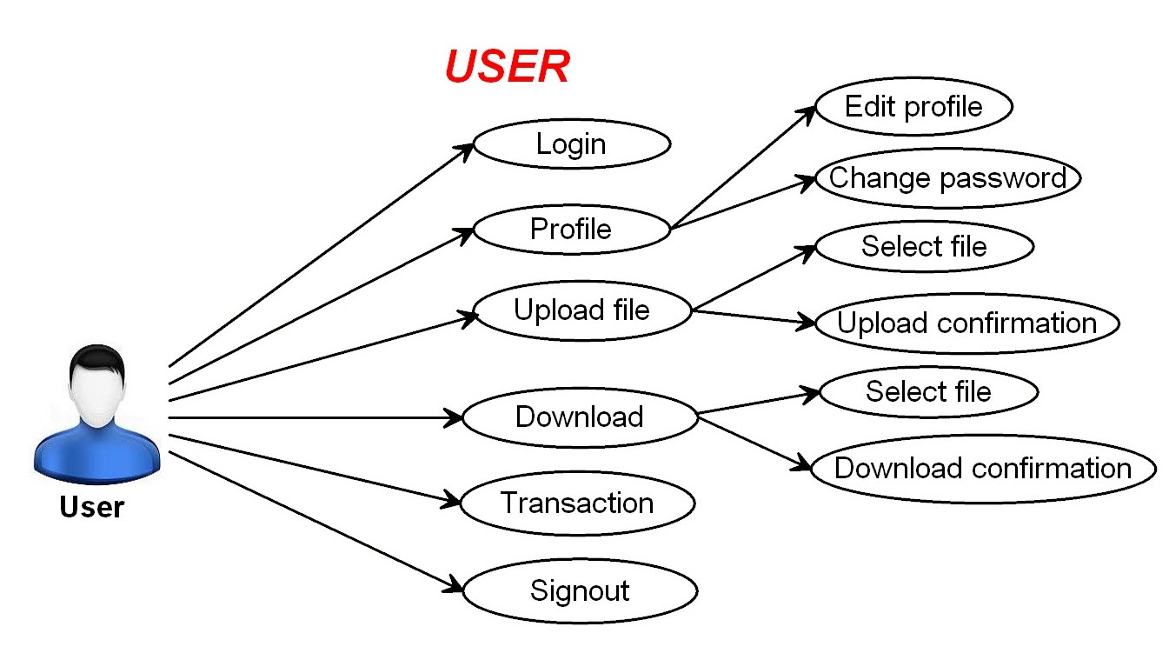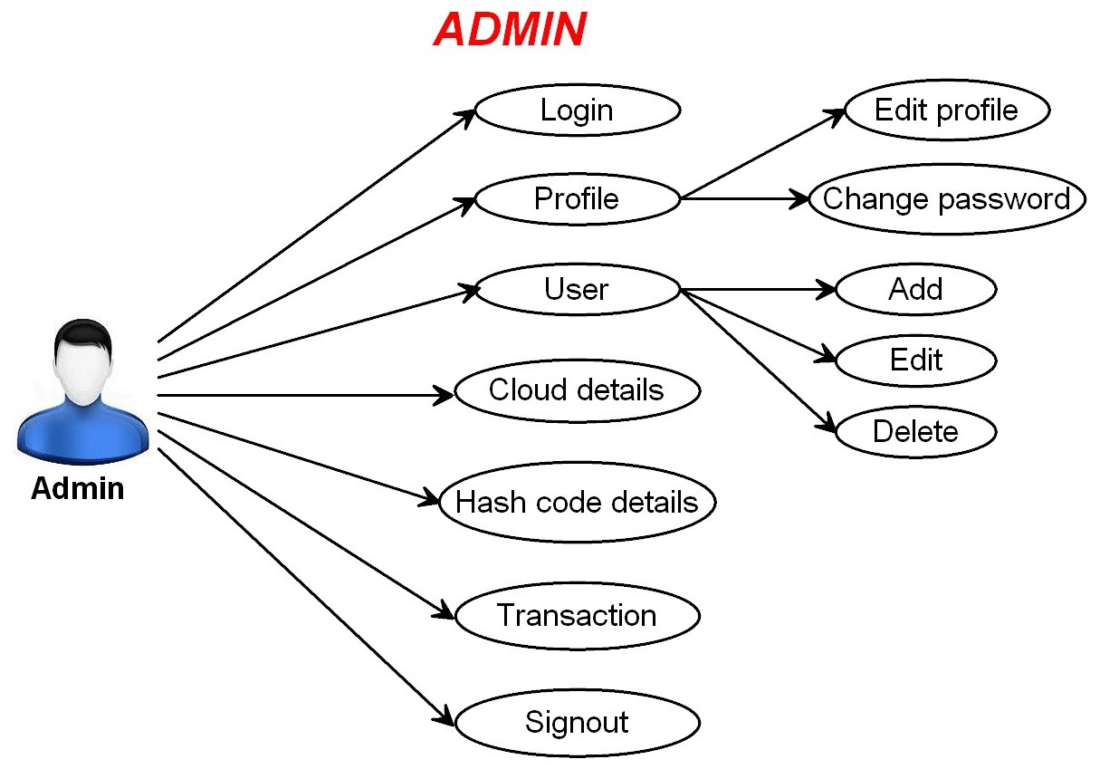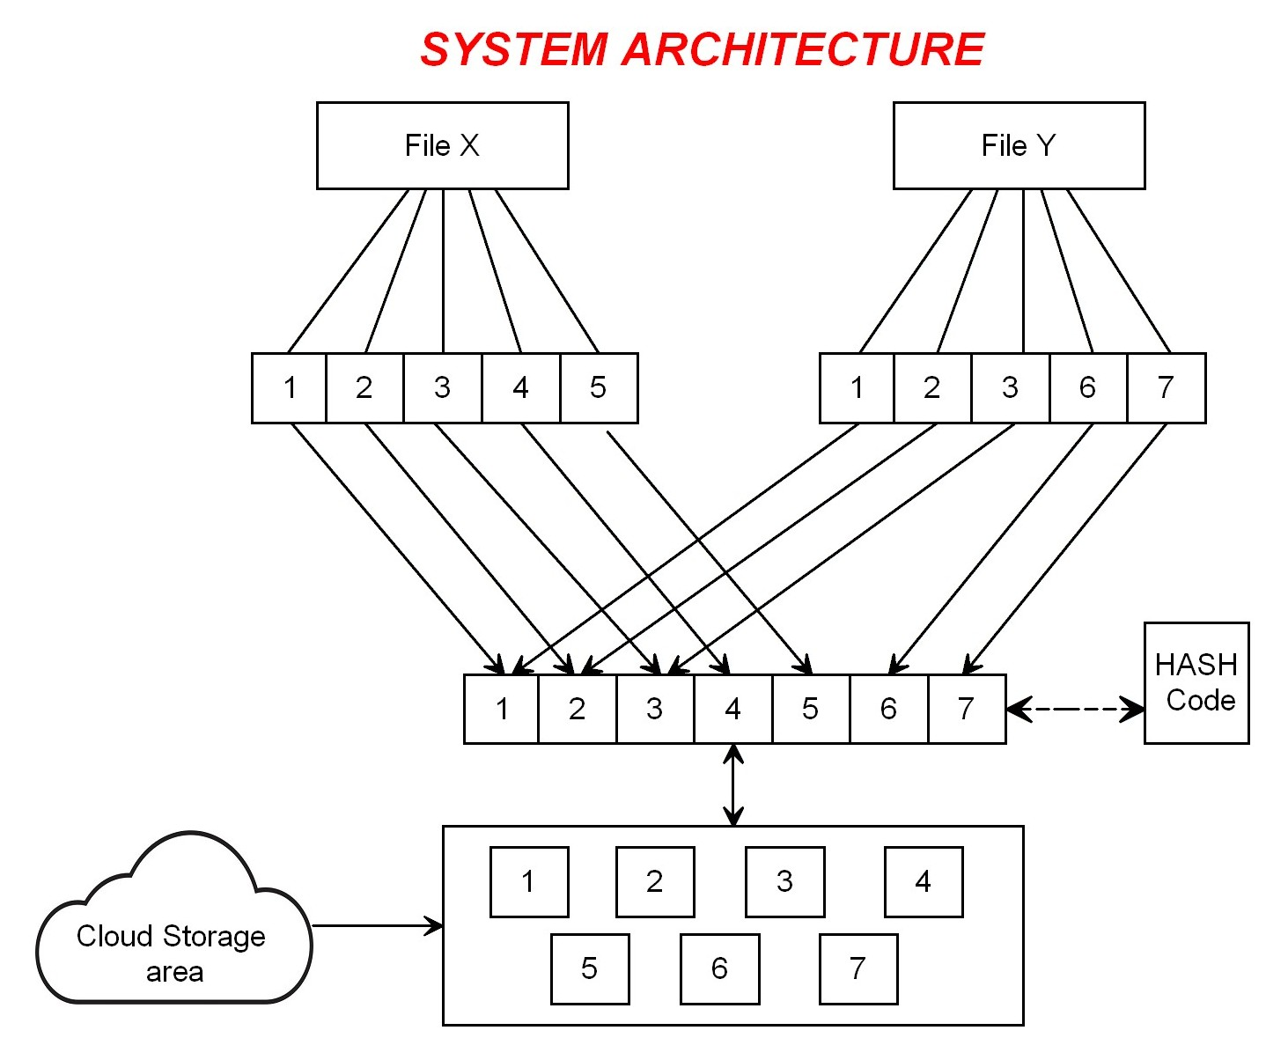

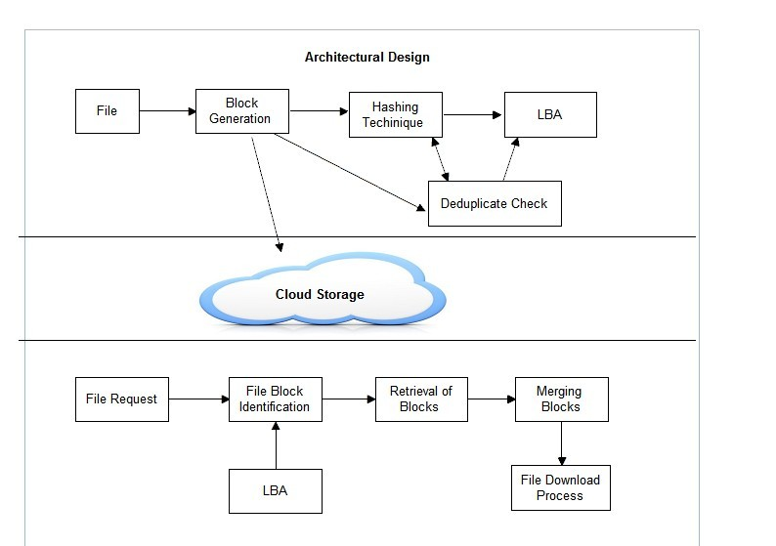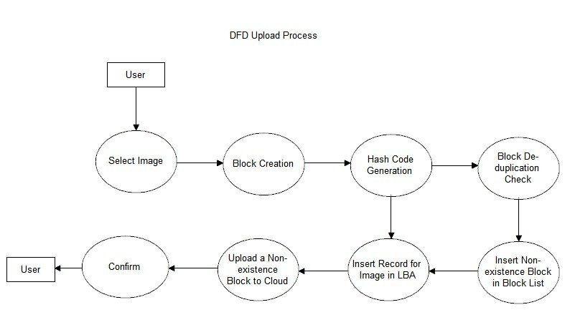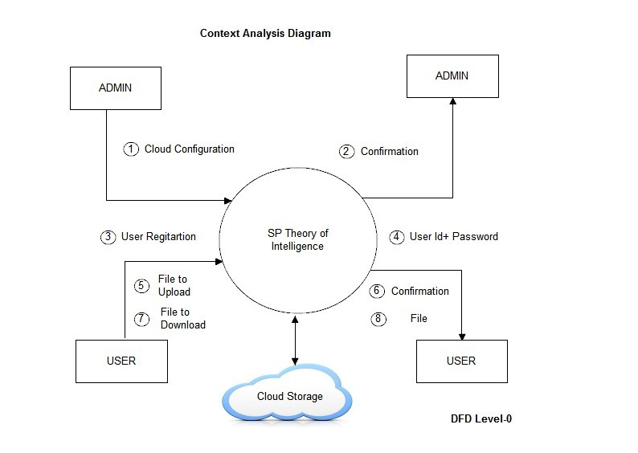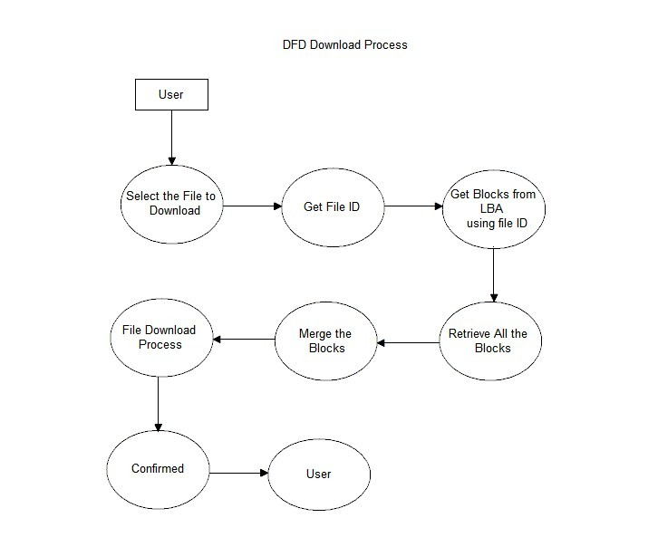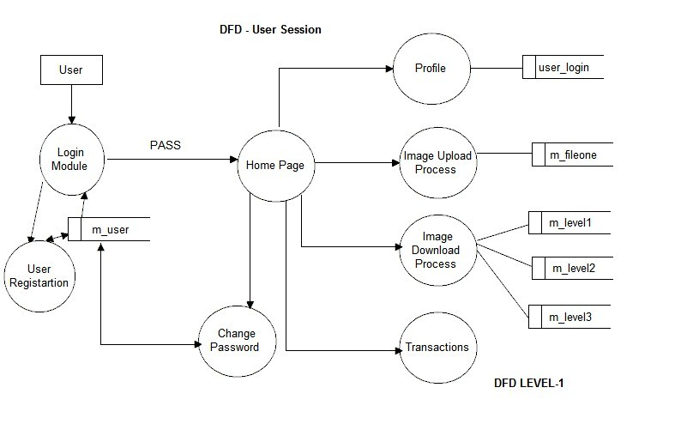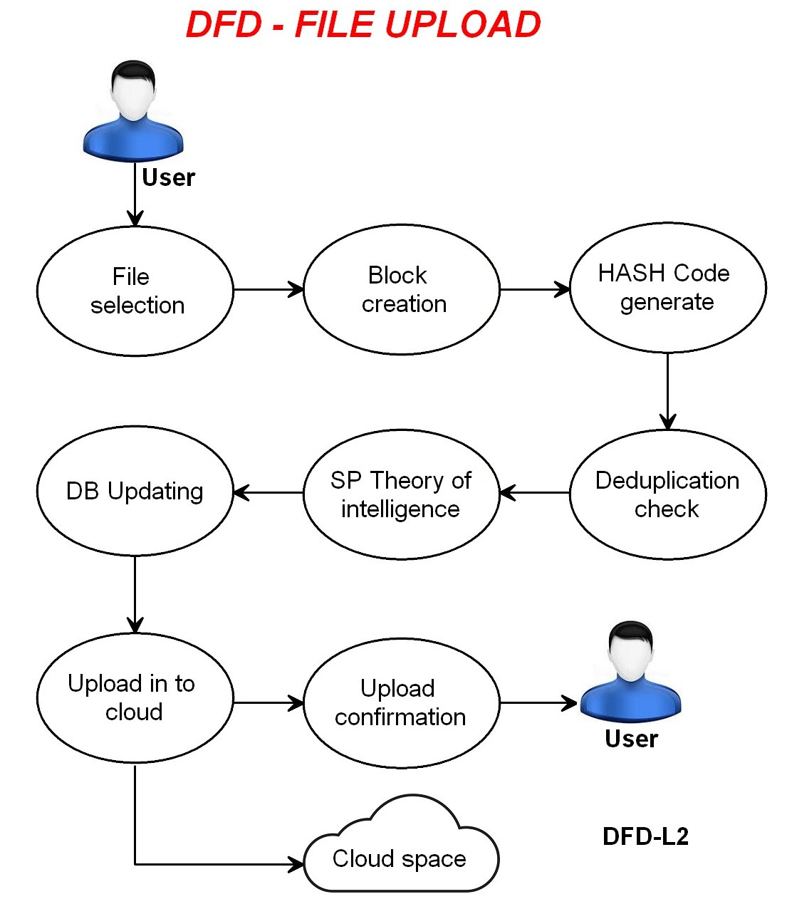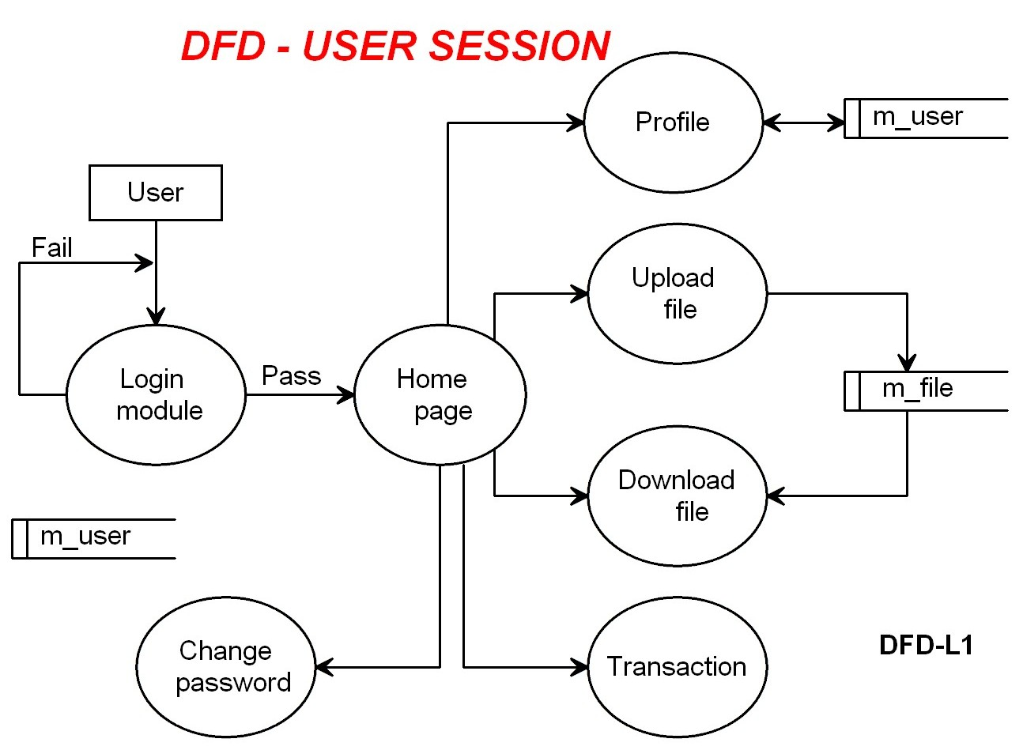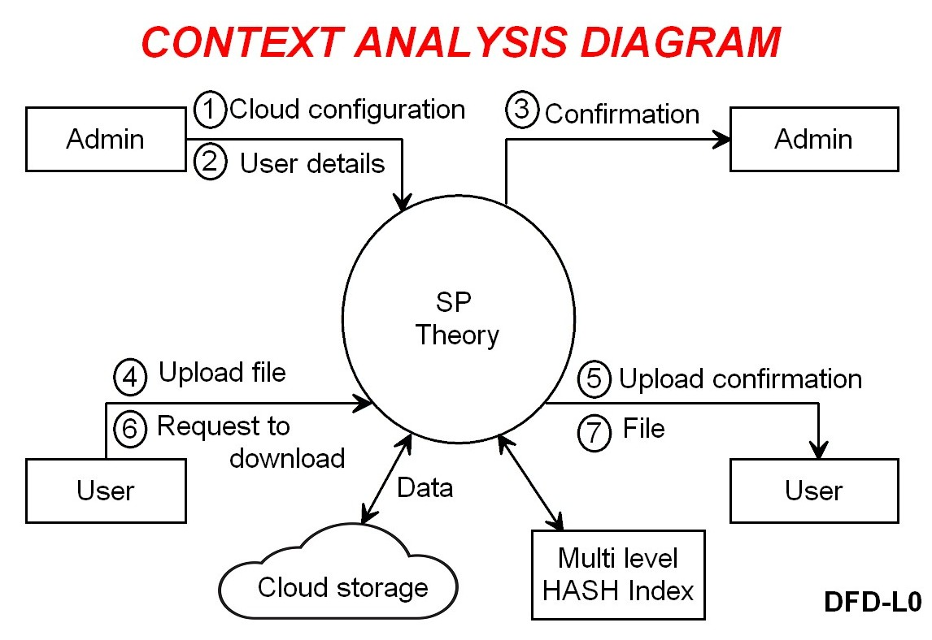

**REFERENCES**

[1] J. G. Wolff, “The SP theory of intelligence: An overview”, “Information compression, intelligence, computing and mathematics”, vol. 4, no. 3, pp. 283 341, 2013.

[2] J. G. Wolff, National Research Council, “Frontiers in Massive Data Analysis”. Washington, DC, USA: National Academies Press, 2013.

[3] J. G. Wolff, “The SP theory of intelligence: Benefits and applications”, “Information compression, intelligence, computing and mathematics’’, vol. 5, no. 1, pp. 1 27, 2014

[4] J.G.Wolff, ‘‘Application of the SP theory of intelligence to the under-standing of natural vision and the development of computer vision’’ 2013, in preparations