M.S.RAMAIAH INSTITUTE OF TECHNOLOGY
(Autonomous Institute, Affiliated to VTU)
www.msrit.edu
BANGALORE-560054

PROJECT PLAN
ON
Big Data Analysis Using SP Theory Of Intelligence

Submitted by
Chaithra B S 1MS13CS403
Mala S 1MS13CS411
Varsha C G 1MS13CS422
Gaurav 1MS12CS141

Guided by
Soumyarani C N
Professor
Department of Computer Science and Engineering

Effort Estimation using COCOMO Model

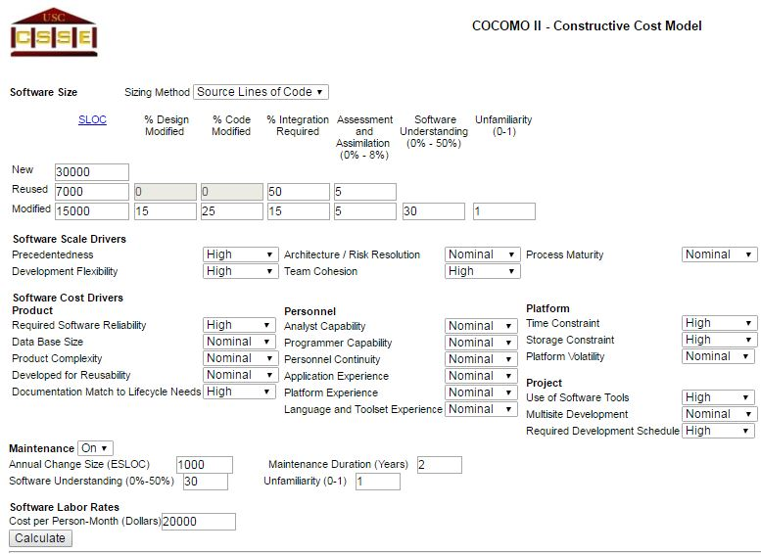

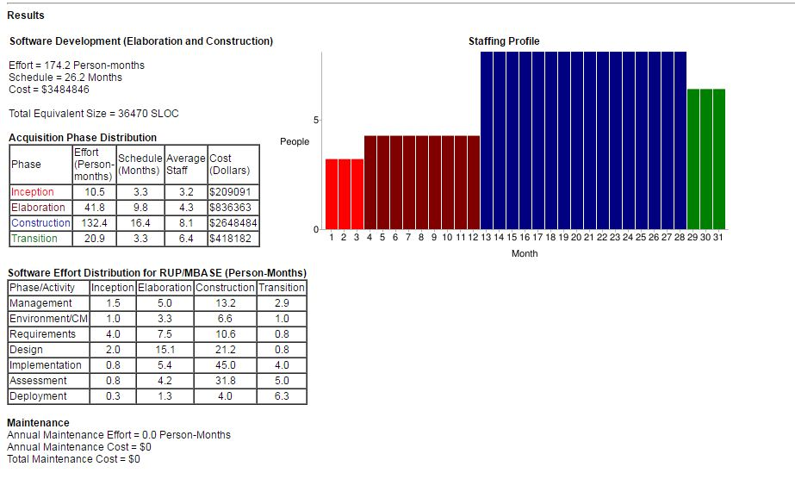

Schedule Using Gantt Chart

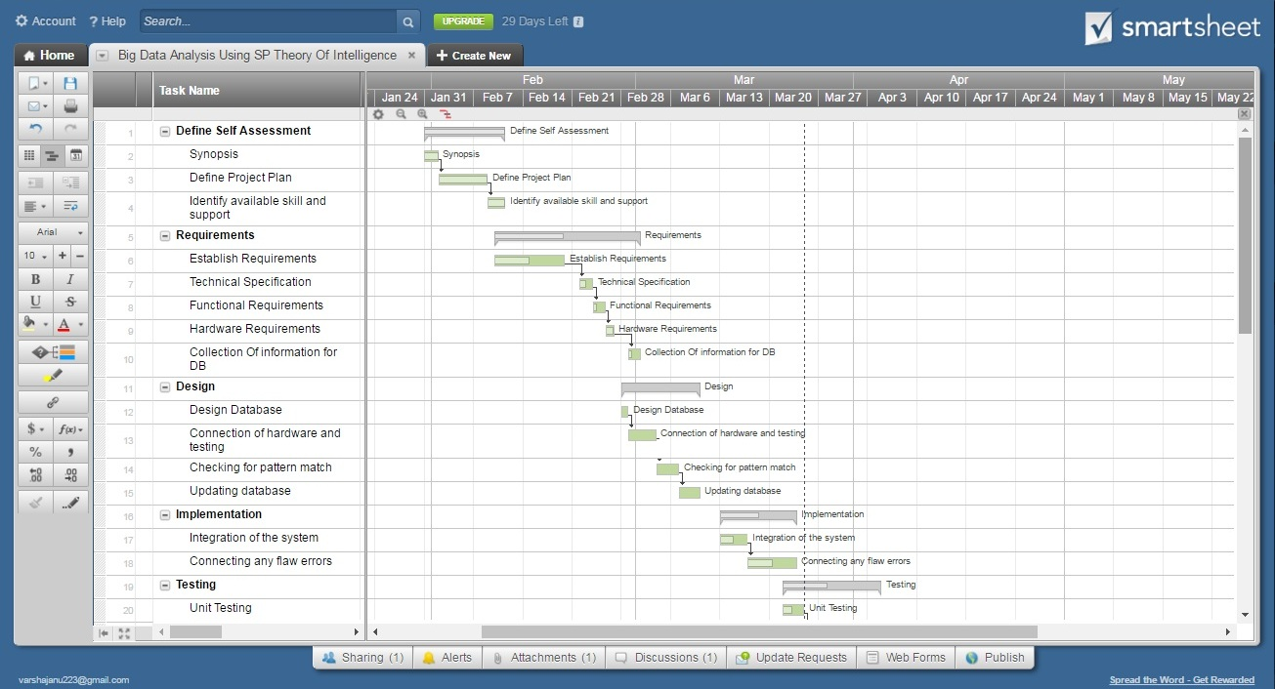

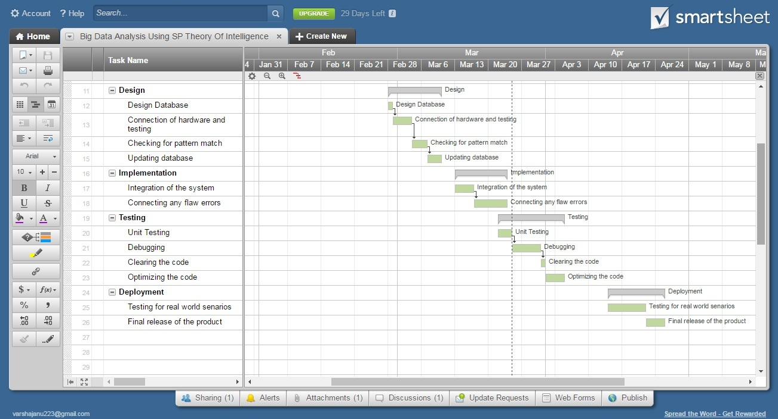

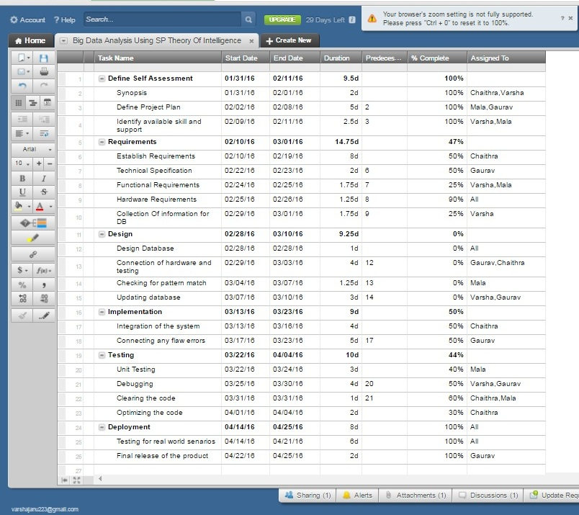

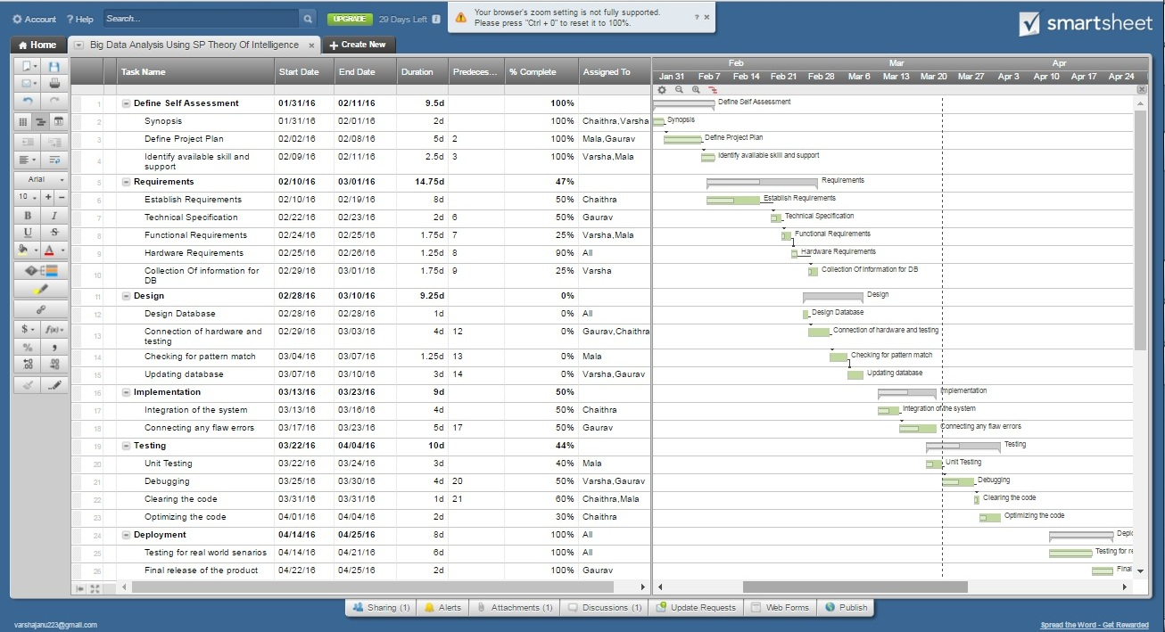

Risk Identification (Top 5 Risk) with Risk Mitigation

Risk No | Risk | Event Type | Impact | Probability Of Occurrence | Risk Rate | Mitigation Steps
1 | Personnel Shortfalls | Cost | Severe | 60% | High | - Training on the programming  - Hiring Experts
2 | Unrealistic Schedules | Schedule | Critical | 75% | High | - Consult the guide about the problem  - Proper Planning is required
3 | Developing Wrong Software Function | Performance | Critical | 70% | Medium | - Understanding the SRS  - Proper documentation of requirements
4 | Updating Database Error | Performance | Severe | 60% | Medium | - Usage of well developed software  - Proper testing before giving to the user
5 | Inexperience in the problem domain | Cost,  Schedule  ,Performance | Severe | 70% | High | - Experienced developers must be used for development of the given software  - Proper survey problem domain

